Teacher of Music
Candidate Information Pack
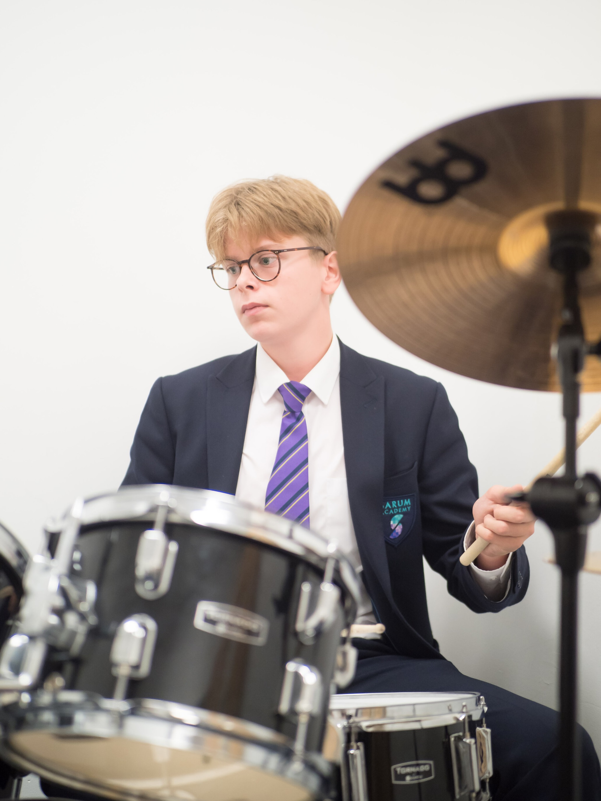

Dear potential future colleague
Thank you for taking the time to find out about our Salisbury school and the possibility of working here with us. Sarum Academy would welcome applications for the position of Music Teacher to join our fantastic team, However, we are currently in a period of significant growth due to our increasing popularity and as such this post may become full time for the right person..

Sarum Academy is a Voluntary Controlled Church of England Academy founded in 2010 delivering high quality, non-selective, personalised education to students aged 11-19 years. Sarum Academy is a highly successful school with a growing reputation; part of the Magna Learning Partnership Academy Trust. Our staff have a very real desire to make a difference to the lives of children and offer high levels of commitment and professionalism as well as a passion for their area of expertise. Students at Sarum Academy make good progress. The Academy secured a Good OfSTED judgement in October 2017 across all areas including the Sixth Form and a Good SIAMs judgement in March 2019.

As a Church of England School our ethos is underpinned by Christian values and principles. Sarum Academy recognises and celebrates diversity, welcoming students and staff of all faiths and none.

We are a happy school, one where students feel nurtured and challenged, one that values all members of the community and our success and reputation is built on professionalism and the strong partnership of students, staff, parents, governors and schools within the Salisbury learning community.
To apply, please download the application form via the school website. If you have any further questions or queries please contact Mr Smith in Human Resources on 01722 342437 or recruitment@sarumacademy.org.
Thank you again for taking the time to consider Sarum Academy – I look forward to receiving your application.

Mrs Jennifer Moore
Headteacher

The benefits of working at Sarum Academy

The Academy offers:
A very real chance of making a difference to the lives of young people.

Leadership that cares for its staff and places huge importance on trying to achieve a ‘work life balance’.

An enthusiastic and driven team of teachers and support staff.
Ongoing professional development of the highest standard with possibilities for leadership development. An outstanding programme of support and training for teachers new to the profession.
Work with professionals across the Magna Learning Partnership and the professional development opportunities this enables.
A strong support network both within the school and within the Magna Learning Partnership Academy Trust.
A fantastic working environment and wealth of resources including full access to ICT.
Job Description
Teacher of Music
Post: Teacher of Music
Salary Range: MPS 1-6
Responsible to: Headteacher, under the day-to-day management of the Curriculum Team Leader for Music

Core Purpose:
In addition to carrying out the professional duties of a teacher in accordance with the Teacher Standards, the post holder shall, in consultation with the Teaching Team Leader and the Headteacher:

Key Accountabilities
- Teach across the age and ability range, in line with the programmes of study, in such a way as to challenge and inspire students of all abilities enabling them to make ‘good’ progress. Exercising a qualified teacher’s professional skills and judgement.
- Assess, record and report on the development, progress and attainment of students assigned to him/her in line with Academy policies.
- Contribute to the planning and implementation of the curriculum under the guidance of the Curriculum Team Leader.
- Set high expectations for student behaviour establishing and maintaining a good standard of discipline through well focused teaching and through positive and productive relationships.
- Be familiar with, support and reinforce the aims, ethos, policies and procedures of the Academy.
- Contribute to the Academy’s enrichment programme.
- Attend all calendared meetings as required.

Other responsibilities:
- Act at all times as an ambassador for the Academy in a manner which upholds its Christian values and ethos and to model behaviour consistent with the Academy’s standards and aspirations.
- Take an active role in the Academy’s pastoral care of students and fulfil a pastoral and mentoring role.
- Foster good relationships with parents and the wider community.
- Have an agreed flexible working pattern to ensure that all relevant functions, including extra-curricular activities, are fulfilled.
- Demonstrate a commitment to personal professional development and the development of other staff.
- Be subject to performance objectives agreed annually and will be responsible for providing evidence of progress for key accountabilities.
- Carry out such other duties as may reasonably be assigned by the Headteacher.
- Recognise that duties of a post may vary from time to time without changing the general character of the post or level of responsibility entailed.
Person Specification
Teacher of Music

 | Essential | Desirable
Qualifications | - Qualified Teacher Status  - A degree in Music or equivalent in a subject related to Music
Professional Development | - Evidence of a commitment to own professional development. | - Recent relevant in-service training in Music
Experience | - Evidence of high achievement in teaching across Key Stage 3 and 4.  - Experience of the development of Programmes of Study and Schemes of Work across the Key Stages.  - Able to use Assessment for Learning effectively to engage pupils as partners in their learning.  - Working effectively as a Form Tutor. | - Experience of teaching BTEC Post 16.
Knowledge | - Vision for the teaching of Music  - Experience in the use of assessment and attainment information to improve practices and raise standards.  - Experience in the use of strategies to promote good pupil relationships and high achievement in an inclusive environment.  - Secure knowledge of Programmes of Study for Music across Key Stage 3 and 4.  - An understanding of the Key Stage 2 Music Curriculum | - Strategies to enhance teaching and learning of ICT within Music  - An understanding of Literacy, Numeracy & Emotional Literacy developments to support learning and teaching.
Skills | - Excellent communication and presentation skills  - Problem solver.  - Competent user of ICT.  - Evidence of the ability to plan and resource effective  - Experience of effective interventions to meet curricular objectives  - The ability to prioritise and manage multiple demands. | Ability to use and promote a wide range of teaching methodologies.
Commitment | - Commitment to inclusive education.  - Committed to the value and promotion of educational visits, journeys and field work.  - Commitment to teacher training.  - Experience of active involvement in school development.
Personal | - Passion for teaching.  - ‘Can do’ attitude.  - Energy, enthusiasm and flexibility.  - Good health and attendance record.  - Sense of humour and a positive outlook on life.  - Ability to work under pressure and determination to succeed.

Safer recruitment and equality

Sarum Academy Safer Recruitment Procedure
Sarum Academy is committed to safeguarding and promoting the welfare of children and young people and expects all staff and volunteers to share this commitment. All applicants will be subject to a full Disclosure and Barring Service check (DBS) before any appointment is confirmed.

Disclosure
Sarum Academy requires all employees to undertake an enhanced DBS check. You are required, before appointment, to disclose any unspent conviction, cautions, reprimands or warnings under the Rehabilitation of Offenders Act 1974 (Exceptions) Order 1975. Non-disclosure may lead to termination of employment. However, disclosure of a criminal record will not necessarily debar you from employment - this will depend upon the nature of the offence(s) and when they occurred.

Shortlisting
Only those candidates meeting the requirements of the Person Specification will be taken forward from application.

Interview
Those shortlisted will be invited to attend an interview process which may include (post dependent) lesson observations, tasks or role specific activities; further shortlisting may take place after lesson observations prior to moving forward to formal interviews with the Headteacher.
During the interview process candidates will be asked to address any discrepancies, anomalies or gaps in their application form.

Reference checking
References from current employers will be taken up for shortlisted candidates, and where necessary employers may be contacted to gather further information.

Probation
All support staff will be subject to a probation period of four months which may, in certain circumstances, be extended by up to 10 weeks. The probation period is a trial period, to enable the assessment of an employee’s suitability for the job for which they have been employed. It provides the academy with the opportunity to monitor and review the performance of new support staff in relation to various areas, but also in terms of their commitment to safeguarding and relationships.

A commitment to encourage diversity
Sarum Academy is committed to eliminating discrimination and encouraging diversity. Our aim is that our workforce will be truly representative of all sections of society and that each employee feels respected and able to give their best. To that end we are committed to provide equality and fairness for all in our recruitment and employment practices and not to discriminate on any grounds.

