Recruitment Booklet
Information For Applicants
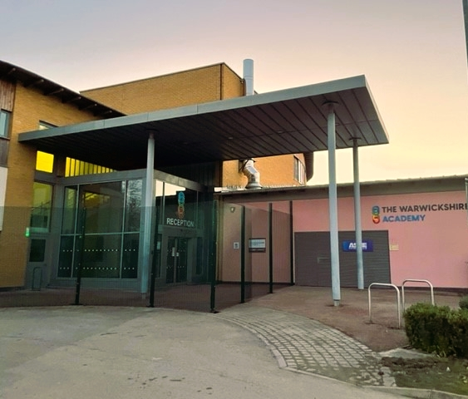

The Warwickshire Academy
Preparing young people for full and enriched lives
The Warwickshire Academy is a school for students with Social, Emotional and Mental Health needs and is situated in Warwickshire with close links to Coventry, the M6 and the surrounding areas of Ash Green, Bedworth and Nuneaton.
The school was redeveloped in 2022 and officially opened on the 7th March 2022 to our first cohort of year 5, 6 and 7 students. The school benefits from exemplary teaching spaces, designed to meet the needs of our learners as well as specialist rooms for Food Technology, Art, Science and D&T.
The Warwickshire Academy is more than a school, it is a community; bringing together children, their families and carers and dedicated staff to offer life-changing opportunities for young people that have social, emotional, and mental health needs. These outstanding children deserve the very best and we are unwavering in our determination to offer them this.
We are always aspirational about pupils’ continual success, progress, and achievement. We encourage all pupils to think big and accept no restriction on what is possible for them. Students benefit from highly individualised timetables which are designed to help them both achieve and attain and to offer them the best opportunities in further education and/or employment in the future.

To find out more about The Warwickshire Academy visit www.wa.thrive.ac

Welcome from the Headteacher

I am delighted to welcome you to The Warwickshire Academy.
The Warwickshire Academy is more than a school, it is a community; bringing together children, their families and carers and dedicated staff to offer life-changing opportunities for young people that have social, emotional and mental health needs. These outstanding children deserve the very best and we are unwavering in our determination to offer them this.
We are always aspirational about pupils’ continual success, progress and achievement. We encourage all pupils to think big and accept no restriction on what is possible for them. Students benefit from highly individualised timetables which are designed to help them both achieve and attain and to offer them the best opportunities in further education and/or employment in the future.
We love having visitors and would welcome you to enjoy The Warwickshire Academy experience for yourself.

Mr P Hostead
Headteacher

Our Staff
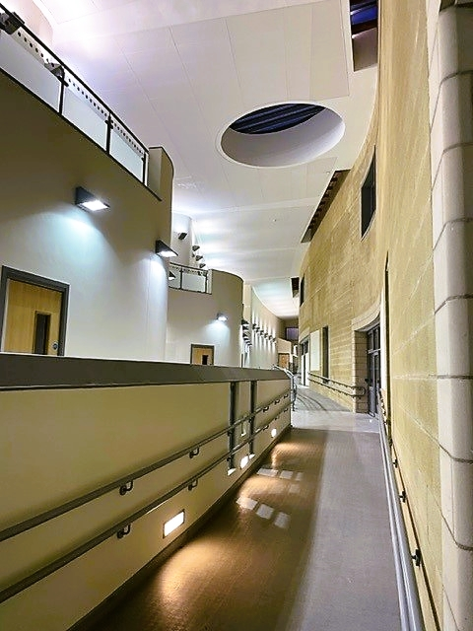
The Warwickshire Academy aim to recruit outstanding people. For this reason, we try to articulate clearly our vision, values and expectations when putting together information for applicants and we always give a lot of attention to appointing the right person.
We aim to recruit staff who:
- are excited by their role and by the prospect of working with young people;
- love the processes of learning and teaching and are keen to continually develop their own skills;
- recognise that this can be a demanding job and react positively to those demands;
- will subscribe to the ethos of the school and ‘go the extra mile’ in terms of time and commitment to get the very best from our students;
- take every opportunity, in and out of the classroom, to talk to students, model expected behaviours and build positive relationships;
- are quick to praise and slow to criticise; and
- are not afraid to admit to seeing themselves as potential leaders of the future.
This may be your first contact with The Warwickshire Academy and first impressions are very important. I hope what you read, coupled with anything else you discover about us, inspires you to apply for this post and work for the school.

Vision & Values
Our Mission statement is: Preparing young people for full and enriched lives
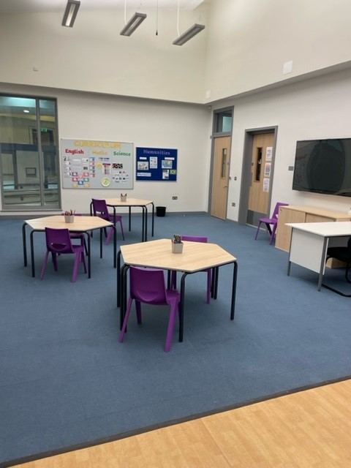
We wish to see:
Happy students who progress well and go on to thrive into adulthood as well-rounded citizens.
Passionate Staff who inspire students with excellent teaching and support. A united learning community committed to a clear common vision.
Values
- High Aspirations for all.
- Committed to Best Practice, working collaboratively, learning from mistakes.
- Focussed on the Individual.
- Inclusive, leaving no one behind.
- Committed to Shared Values
- A fair, Supportive Employer, enabling everyone to learn and develop.
- Celebrating Success, having pride in all that we do.
- Broad education, giving opportunity for human flourishing.
- Working closely with all Stakeholders.
- Connected with the Community, encouraging social responsibility.
Aims
- To challenge and inspire our children and young people
- To create a safe and happy learning environment
- To create a fun learning experience
- To promote independence
- To ensure high standards in everything we do
- To develop learners ready for adult life
- To integrate with the wider community
- To promote a healthy body and mind
- To work in partnership with others
Our Ethos
Our ethos should be evident in:
- The content of our curriculum. We offer a broad and balanced curriculum that encourages all students to experience the widest opportunities possible
- The respect for democracy, the rule of law, individual liberty and mutual respect and tolerance of those with different faiths and beliefs;
- The understanding and appreciation of the range of different cultures within school and further afield;
- The opportunities students have to develop their cultural capital is supported and encouraged for all;
- The way we encourage and lead young people into asking the deeper and harder questions about self and our place within the wider world;
- The way we regard education as formation rather than function;
- We as a school community demonstrate unwavering regard for all
- Young people are supported in all areas of their need to develop into adults that can flourish
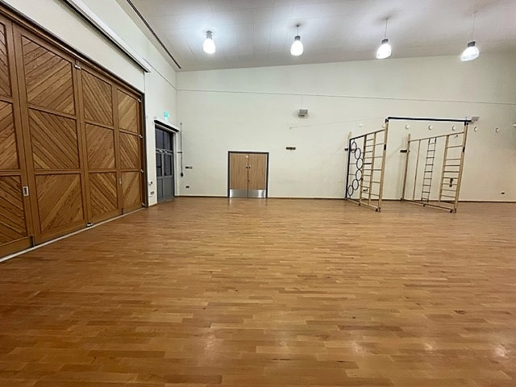

What we can offer you
For the exceptional work we know you will do with our young people what we offer goes beyond your salary.
Staff well-being is at the core of our ethos. As such we offer a broad range of additional benefits for staff who work at The Warwickshire Academy. Below is just a small selection of what you can expect:
A modern, state of the art building, fully equipped to support our staff and our learners.
Brand new gym facility open to staff after school
Free electric vehicle charging points
Tax efficient cycle to work scheme
Comfortable staff room with free tea and coffee
Friendly and supportive team
Ongoing professional development opportunities for all staff
Career progression opportunities within The Warwickshire Academy and the wider Thrive Education Partnership
The chance to change the lives of young people and to support them in enjoying success in their lives.
Additionally all staff have access to the Schools Advisory Service (SAS) which provides well-being and health services such as:
Counselling
Nurse support service
Physiotherapy
Medical services
Slimming World
Menopause Support
GP Consultations
SAS Gym and access to PT support
Mindfulness
Stress management
Manspace: Men’s Health

SAS Services
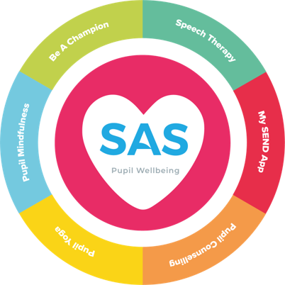
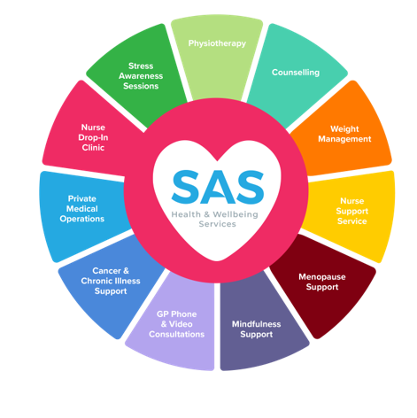
Person Specification – Teaching Staff
criteria | qualities
Qualifications and experience | - Qualified teacher status  - Degree  - Successful teaching experience  - Experience of working with young people that have Social, Emotional or Mental Health difficulties  - A broader understanding of SEN
Skills and knowledge | - Knowledge of the National Curriculum  - Knowledge of effective teaching and learning strategies  - A good understanding of how children learn  - Ability to adapt teaching to meet pupils’ needs  - Ability to build effective working relationships with pupils  - Knowledge of guidance and requirements around safeguarding children  - Knowledge of effective behaviour management strategies  - Good ICT skills, particularly using ICT to support learning  - Where appropriate to the role, experience of delivering GCSE and/or A-Level
Personal qualities | - A commitment to getting the best outcomes for all pupils and promoting the ethos and values of the school  - High expectations for children’s attainment and progress  - Ability to work under pressure and prioritise effectively  - Commitment to maintaining confidentiality at all times  - Commitment to safeguarding and equality  - High levels of resilience

Person Specification – Non-Teaching Staff
Please see the advert for role-specific Person Specifications

criteria | qualities
Qualifications  and experience | - GCSEs at grades 9 to 4 (A* to C) including English and maths  - Experience of working with young people that have Social, Emotional or Mental Health difficulties  - A broader understanding of SEN
Skills and knowledge | - Good literacy and numeracy skills  - Good organisational skills  - Ability to build effective working relationships with pupils and adults  - Skills and expertise in understanding the needs of all pupils  - Knowledge of how to help adapt and deliver support to meet individual needs  - Subject and curriculum knowledge relevant to the role, and ability to apply this effectively in supporting teachers and pupils  - Excellent verbal communication skills  - Active listening skills  - The ability to remain calm in stressful situations  - Knowledge of guidance and requirements around safeguarding children  - Good ICT skills, particularly using ICT to support learning  - Understanding of roles and responsibilities within the whole school context
Personal qualities | - A commitment to getting the best outcomes for all pupils and promoting the ethos and values of the school  - High expectations for children’s attainment and progress  - Ability to work under pressure and prioritise effectively  - Commitment to maintaining confidentiality at all times  - Commitment to safeguarding and equality  - High levels of resilience

How to Apply

If you would like to know more about a vacancy, or about The School itself, please don’t hesitate to get in touch. We would love to give you a tour or to put you in touch with the SLT who will be more than happy to give you a call to discuss the role.
If you decide to apply, please complete an application form and include a letter of no more than two sides of A4 in which you give your reasons for applying for the post, addressing information you have read in this pack, and particularly the person specification, and outline any relevant experience and personal qualities you would bring to The Warwickshire Academy.
The application form can be found on our website www.wa.thrive.ac by following the vacancies links. Please do not send a general letter; we are looking for someone prepared to respond to us as an individual school. You can be sure we will take time and care in reading your letter; we appreciate how much energy goes into it.
Please direct any enquiries or applications by email to: vacancies@wa.thrive.ac

