

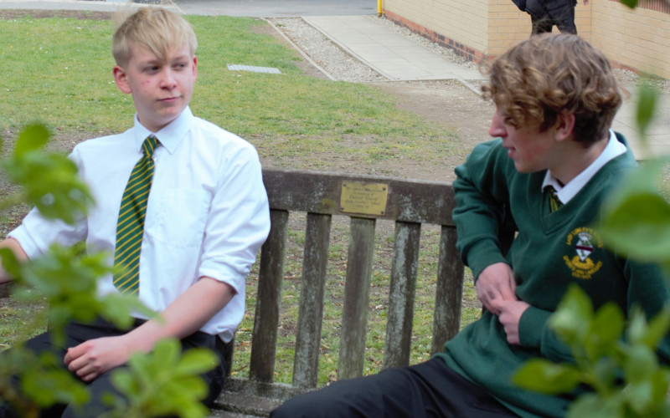

Pastoral Officer
Closing Date: Friday 24th June 2022, 12 noon
Recruitment Information Pack
Lady Lumley’s School
Swainsea Lane, Pickering, North Yorkshire
YO18 8NG

Contents

Welcome from the Headteacher 3-4
Our Visions and Values 4
Our Schools 6-7
Application Process and How to Apply 8
Job Description/Person Specification 8-12

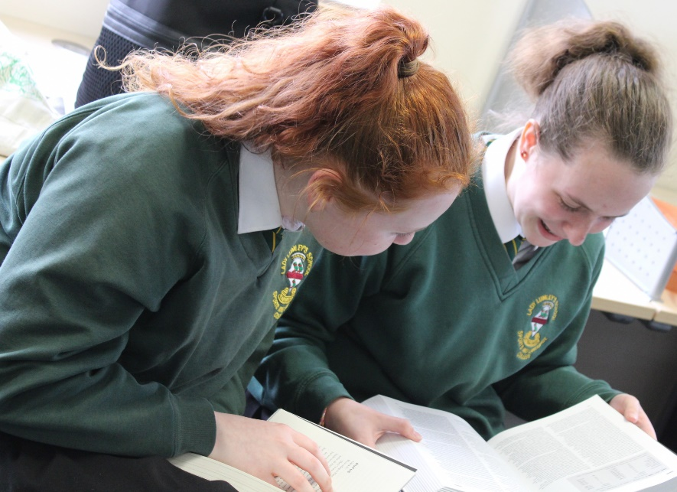

Dear Applicant,

Thank you for taking an interest in joining our staff at Lady Lumley’s. I hope reading about our school gives you a sense of a driven community school, ambitious to do all we can to see staff and students thrive.
Lady Lumley’s has a proud tradition and heritage of providing quality education. A trailblazer in the pursuit of education for all – welcoming the children of farming families and girls long before this was a requirement. Building on those foundations, Lady Lumley’s is a truly comprehensive school of 900 students drawing from the town of Pickering, surrounding rural villages, as well as from Scarborough and all points in-between.

‘Being our best’ signals Lady Lumley’s commitment to school improvement. We are ambitious for all our students and staff to strive to improve teaching and learning through constant evaluation and positivity. Our curriculum offer is broad and balanced, giving students a clear progression route through the school that builds the fundamental knowledge and understanding to allow them to specialise for Key Stage 4 then again at Key Stage 5. Lady Lumley’s curriculum gives all students the best chance of being successful at GCSE, A-Level and Vocational Provision, ensuring our above national average outcomes open doors for life chances.

Our staff are integrated into thorough well-constructed CPD that looks to build strength in the classroom, as well as modelling the pursuit of improvement. Ensuring all our strategic planning is built of evidential educational research is fundamental to ensuring we are investing staff time where it will reap rewards. A love of learning is a necessary mindset to thrive at Lady Lumley’s.

Lady Lumley’s is equally ambitious for our students to experience an enriched learning journey with a diverse offer of experiences. From trips abroad to Bordeaux, Saint Émillion, and Dune de Pyla in France and Weiz in Austria. Our students also visit Belgium and France in Year 10 for the GCSE Battlefields Experience, as well as Krakow and Auschwitz in Year 11, 12 and 13 for Religious Education. There are numerous theatre and music trips and visits taking in everything from opera to pantomime.

The excellent sporting facilities are always fully booked, offering traditional team sports, running, as well as rock climbing and table tennis. Our Duke of Edinburgh scheme is ever popular and Lady Lumley’s students show leadership in this testing qualification right through to the Gold Award. With regular orienteering, canoeing and mountain biking our students also contribute hundreds of hours to volunteering and raising thousands of pounds for charity. Nurturing the growth of students through Enriching their experience enables Lady Lumley’s to prepare students to thrive locally or to move on to different cultures and experiences.

We value our pastoral staff and system as the cement that holds the school together. There are very high expectations of students conduct and a transparent and fair policy for rewards and consequences. All our students are supported through school with dedicated tutors and a Pastoral Officer with additional expertise available from the Pastoral Team and SLT. There are weekly ‘Life’ lessons to educate students with powerful knowledge to enable them to keep themselves safe and to have well placed confidence outside of school. Our staff and students deserve to feel safe and valued throughout their time at Lady Lumley’s.

Lady Lumley’s benefits from the knowledge and experience of Coast and Vale Trust as we are a unique school with a shared Trust vision. Through leadership development, collaboration and investment Lady Lumley’s is enabled to maintain its identity whilst belonging to a larger family of schools.

If you have read this and are committed to joining a school that is driven by ambition to be better, values a comprehensive community school and thrives on being part of a team, then we look forward to meeting you.

Yours sincerely

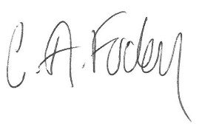
Clair Foden
Headteacher

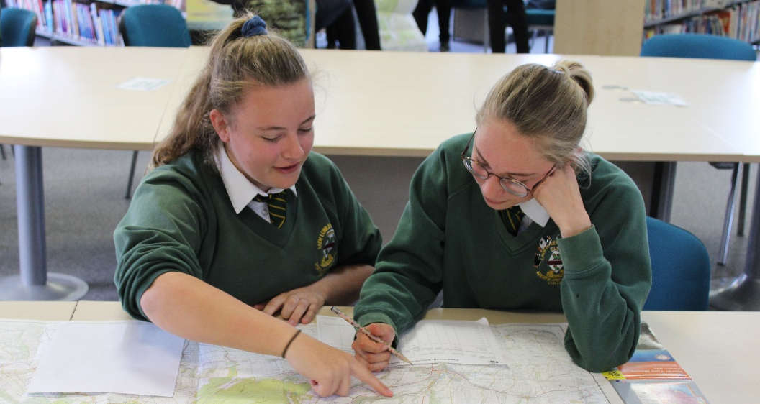

Visions and Values

Lady Lumley’s School is driven by the vision of ‘Being our best’. All staff and all students are asked to commit to our core values:

Learning
Lady Lumley’s core purpose is supporting our students and staff to make progress and continually adapt and develop to become lifelong learners.

Leading
Students and staff have regular opportunities to lead within and outside of the classroom to improve themselves and the community.

Ambition
We are relentlessly positive about improving and seeing all mistakes as ways to learn and improve and exceed our potential.

Progress
The journey through Lady Lumley’s for staff and students is a journey of improvement. Through striving to be our best we will face some setbacks but will build progress over time.

Our schools


Newby and Scalby Primary School

We are one of the schools of choice in our community and we are within commutable distance of Whitby, Teesside, York, and surrounding areas. Ofsted in 2018 judged us to be ‘good’ in all areas and as a school we are very much outward facing both in terms of teaching and learning and in constantly thinking about how we can improve.
Since our “good” Ofsted rating, we continue to build on our successes and we are a family and a team, where everyone is given the challenge and support to be the best they can possible be in a safe, welcoming and positive environment. Children and staff will work and play together developing skills so that we all become ambitious and reflective lifelong learners as well as being respectful and respected members of the community.
To learn more about us please visit us at:
Newby and Scalby Primary School - Home (coastandvale.academy)

Friarage Primary School

We are proud to serve the communities around the Castle Ward area of Scarborough as ‘Together we can’ make a real difference to the lives of children and young people in Scarborough.

Children and staff will work and play together developing skills so that we all become ambitious and reflective lifelong learners as well as being respectful and respected members of the community.
We are committed to Restorative Practice Principles to nurture respect for all in our school community.

To learn more about us please visit us at: Friarage Community Primary School - Home (coastandvale.academy)

Scalby School

Scalby School is a successful and popular 11-16 community school and in recent years we have become the school of choice in our local community. We were judged ‘good’ by Ofsted in 2019 and in 2019 we celebrated sustained results. Our provisional P8 score has placed us in the top 20% of schools nationally. We are proud of our broad and balanced GCSE based curriculum.
To learn more about us please visit us at: Scalby School - Home (coastandvale.academy)

Lady Lumley’s School

Lady Lumley’s School (11-18) in Pickering is on a transformational journey. We are a school that is popular with parents and is easily accessible across North Yorkshire, East Riding and Wolds and Vale. The communities we serve around the Pickering, Ryedale and wider Coastal area deserve and need our school to play a leading role in terms of teaching, learning, progress and outcomes.

In April 2020 we welcomed our new Headteacher Clair Foden who joined us at the same time we joined our Trust - Coast and Vale Learning Trust. Lady Lumley’s is on an ambitious journey of school improvement.

To learn more about us please visit us at Lady Lumley's School - Home (coastandvale.academy)

Scarborough University Technical College


Scarborough UTC is a growing University Technical College (year 9 to year 13) based in a new building, with fantastic technical facilities in the centre of Scarborough. As a University Technical College, we offer a high quality academic and technical education for our students through the specialisms of engineering, health and cyber security. Our unique approach provides students with an excellent range of opportunities including Combined Cadet Force (CCF Navy), strong links to our industrial partners, project-based learning and our flagship Career Development Programme for our Sixth Form students.

Our work with employers and universities ensure we are able to deliver an innovative blend of technical, practical and academic learning which ensures our students make good progress and go on to outstanding destinations.

Our staff are our greatest resource and we have invested in both our teaching and support staff teams which has ensured that educational standards have improved significantly. We have built a staff team of key support and teaching practitioners who are proud to work at our University Technical College.

To learn more about us please visit us at: https://www.scarboroughutc.co.uk

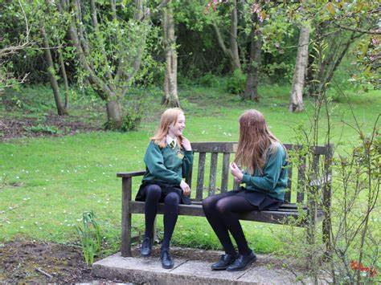

Application Process
The closing date for all applications is 12noon Friday 24th June 2022

Interviews will be held shortly after the closing date.

Completed applications must be returned to Helen Poole at helen.poole@northyorks.gov.uk

If you think you’re the person for the job, please complete the enclosed application form and send to the email address above by the closing date.

An email will be sent to shortlisted candidates with details of the interview process. If you have not heard from us within a week of the closing date please assume your application has been unsuccessful.

Queries
Please contact Helen Poole at helen.poole@northyorks.gov.uk or on
07890 055186.

Job Description

Job title: Pastoral Officer (Post specific to Year Group)

Grade: F (37 hours per week term time only)

Responsible to: Assistant Headteacher Student Welfare

Role purpose: To provide high quality leadership of a year group, setting a strong ethos and culture of Lady Lumley’s School and to support the pastoral needs of pupils in the designated year group to ensure that behaviour, safety, well-being and attendance targets are met for these pupils.

- To lead year group promoting the values and vision of the school, developing a culture of high expectations and personal responsibility to “Being our Best”.
- Support the consistent implementation of school policies, approaches and expectations; ensuring high standards of individual pastoral care and promoting high standards of behaviour, discipline, attendance, and personal appearance amongst pupils and/or students for whom responsibility is held.
- Promote and support students’ personal development in line with the PSCHEE & RSHE, Life lessons and local contextual issues.

Main Duties

1. To lead Year group promoting the values and vision of the school, developing a culture of high expectations and personal responsibility to “Being our Best”.

- To meet with each student in the year group on an individual basis once per term to support their pastoral care, good attendance and academic progress and achievement. To use information gathered to support the work of the Key Stage Leaders and other whole school processes as appropriate.
- To liaise with the Key Stage Leader, using data on student attendance together with
student progress and performance in relation to tracking against targets set for each individual, and to be responsible for planning and implementing follow-up procedures and interventions are delivered in a timely fashion and are followed through on as appropriate.
- Liaise, communicate with, and manage interactions with key internal staff and communicate outcomes to others as appropriate.
- Support the effective running of the school’s Consequence and Gateway Room including organising and managing an appropriate learning environment and resources to provide appropriate educational provision in liaison with subject staff for students temporarily excluded from lessons.
- Support and promote active pupil involvement in leadership and learning opportunities, such as Student Voice, enrichment activities, community events and school functions.
- In liaison with the Key Stage Leaders engage in actively ensuring high levels of pupil engagement in learning.
- Establish and maintain positive relationships and engagement with parents/carers.
- Ensure the smooth transition of students each year within school and externally.
- Contribute to the development and review of behaviour and associated school policies and procedures.
- To support the year group with specific, age related requirements such as, work experience, subject options or applications to sixth form.

2. Support the consistent implementation of school policies, approaches and expectations; ensuring high standards of individual pastoral care and promoting high standards of behaviour, discipline, attendance, and personal appearance amongst pupils and/or students for whom responsibility is held.

- Under the direction of the Assistant Headteacher Student Welfare be responsible for ensuring appropriate care and guidance strategies (relating to behaviour, safety, well-being, health, mentoring, transition, attendance, family, and agency liaison) are delivered within the year group to enable them to make effective decisions.
- Analyse weekly behaviour (positive and negative) and attendance data and identify key strategies/plans to support individual students and secure measurable improvements.
- Meet the Pastoral Team and Assistant Headteacher Student Welfare weekly to agree plans and review previous plans. Communicate these strategies to staff as appropriate.
- To meet weekly with the Attendance officer to analyse attendance data for the year group and identify strategies to ensure at least good attendance for all students.
- Liaise with the School Counsellor on a weekly basis to discuss well-being concerns for individuals and identify strategies and support. Communicate these strategies to staff as appropriate.
- Investigate and resolve pastoral incidents; for example (but not exhaustive) poor behaviour, lateness, poor attendance, theft, bullying and friendship break-ups, including the collation of statements where appropriate.
- Work within the school’s Behaviour Policy to anticipate and manage behaviour constructively, promoting self-control and independence.
- Work with students with behavioural problems to identify reasons for poor behaviour and develop strategies with teaching staff to remove barriers to learning.
- To monitor and to take responsibility for the standard of student behaviour within the year group in tutor time, during breaks and lunch and when travelling to and from school.
- Maintain regular contact with parents of students with behavioural difficulties to inform them of incidents and identify triggers for poor behaviour.
- Respond to correspondence and queries in relation to student welfare and behaviour and develop and maintain professional relationships with students, staff and parents providing support and feedback as required.
- Coordinate the implementation of Pastoral Support Plans for identified pupils and/or students and deliver interventions where appropriate.
- Make recommendations to the Headteacher/SLT relating to inclusion and Fixed Term Suspensions (FTE)
- Organise and attend, and communicate the outcomes of, parent and pupil readmission meetings following FTE.
- Make referrals to external agencies where appropriate e.g., Compass Reach, Early Help etc and support students and their families with these referrals.
- Liaise, communicate with and manage interactions with external agencies, such as the Health Child Team and Early Help Team and communicate outcomes to staff as appropriate. This includes attending Team Around the Family, Child in Need (TAF/CIN) and Core Group meetings.
- Ensure appropriate records are maintained, as agreed by the Pastoral Team.
- To comply with policies and procedures relating to child protection, safeguarding and safe working practices. To liaise closely with and to support the Assistant Headteacher Student Welfare on all such matters relating to a student within the year group.
- To undertake Safeguarding training to ensure referrals can be made in DSL/DDSL’s absence.
- To provide ‘on call’ cover as required and participate in the Break and Lunch duties as part of the duty rota.

- Promote and support students’ personal development in line with the PSCHEE & RSHE, Life lessons and local contextual issues

- Actively engage in CPD and disseminate to the team to support the needs of students.
- To lead the delivery of Year group assemblies and others as required. To deliver assemblies personally as and when required, taking the opportunity to reinforce key messages for the year group.
- To support form tutors in offering appropriate guidance to the members of their form.
- With the Key Stage Leader plan and organise parent teacher consultation evenings, and other appropriate parental information events for the year group and to ensure regular communication between home and school, including, for example, year group newsletters.
- To ensure all students irrespective of gender, race, ability, or disability have equal access to appropriate support and guidance.
- To promote equality and diversity, supporting the school objective of establishing and embedding a culture that does not accept prejudicial language.
- To promote a culture where Bullying in any form is not accepted and ensure that bullying is dealt with effectively.
- To conduct student voice and use this with behavioural incident date to contribute to the planning of key themes within the Personal Development programme.
- To actively support and engage with the school’s rewards systems to celebrate success of pupils in all areas of the community.

Person Specification

ATTRIBUTES | ESSENTIAL | HOW IDENTIFIED
EDUCATION AND TRAINING | - To possess GCSE English and Mathematics at Grade A*- C, or GCSE Level 4 - 9, or a Level 2 qualification in Literacy and Numeracy.  - Evidence of active involvement in professional development | - Letter/application form  - References  - Interview process
RELEVANT EXPERIENCE | - Experience or understanding of working with children and young people to overcome mental and physical barriers to their personal, social, or learning development.  - Has or is willing to work towards an understanding of current developments in Pastoral Care.  - Has or is willing to work towards an understanding of the management of referrals and liaising with external agencies.  - Has experience of or is willing to work towards an understanding of the use of Pastoral Support Plans.  - Understanding and preferably experience of multi-agency support.  - Has experience of or is willing to work towards working with parents to secure better engagement for students with their school experience.  - Has experience of or is willing to work towards using data sets to plan effective strategies to improve behaviour within a year group and identify possible barriers to learning.  - An understanding of the requirements to ensure a smooth transition between year groups, Key Stages and schools.  - A measurable understanding of how removing barriers to learning can support the progress of students. | - Letter/application form  - References  - Interview process
SKILLS AND APTITUDES | - Excellent ICT skills  - Initiative and creativity to develop a range of options/alternatives to support children and young people.  - Resolve problems in sometimes stressful situations.  - Effective organisational skills to manage conflicting deadlines and meet deadlines.  - Ability to use data to inform plans and strategies.  - Ability to keep accurate records and write reports.  - Ability to work effectively within a team.  - Ability to promote a positive ethos and act as a role model.  - Knowledge of personal, social and educational topics which relate to adolescent concerns.  - Knowledge of potential barriers to learning and attending school faced by children/young people, as well as how these can be overcome.  - Ability to work with academic and pastoral staff in school to safeguard the best outcomes for all students, including those who are in key cohorts.  - Commitment to safeguarding and maintain confidentiality.  - To remain calm and measured when dealing with difficult situations and incidents.  - To be passionate about achieving the best for each student.  - To show a willingness to work flexibly to meet the best interests of the school.  - To be able to work well under pressure.  - To retain a sense of humour and an empathetic approach in working well with other  - colleagues.  - To be able to take initiative and work independently. | - Letter/application form  - References  - Interview process
CHARACTERISTICS | - To relate well to young people.  - Model and drive high expectations for all.  - An excellent practitioner with the ability to inspire students to become effective, self-directed learners.  - High levels of integrity and professionalism  - Ability to work well in a team.  - Ability to think originally and creatively.  - Possess excellent written and verbal communication skills.  - Strong attention to detail  - Ability to work under pressure and meet deadlines.  - Enthusiasm, energy, commitment and resilience  - The ability to relate positively to students, parents and other stakeholders to engage them successfully in the life of the school.  - Be able to build constructive working relationships with local schools and colleges, external agencies, employers, the local community and the local authority.  - Appreciate the balance between the academic, social and emotional development of young people needed to create an excellent school.  - Ability to engender trust and respect from students and colleagues. | - Letter/application form  - References  - Interview process



