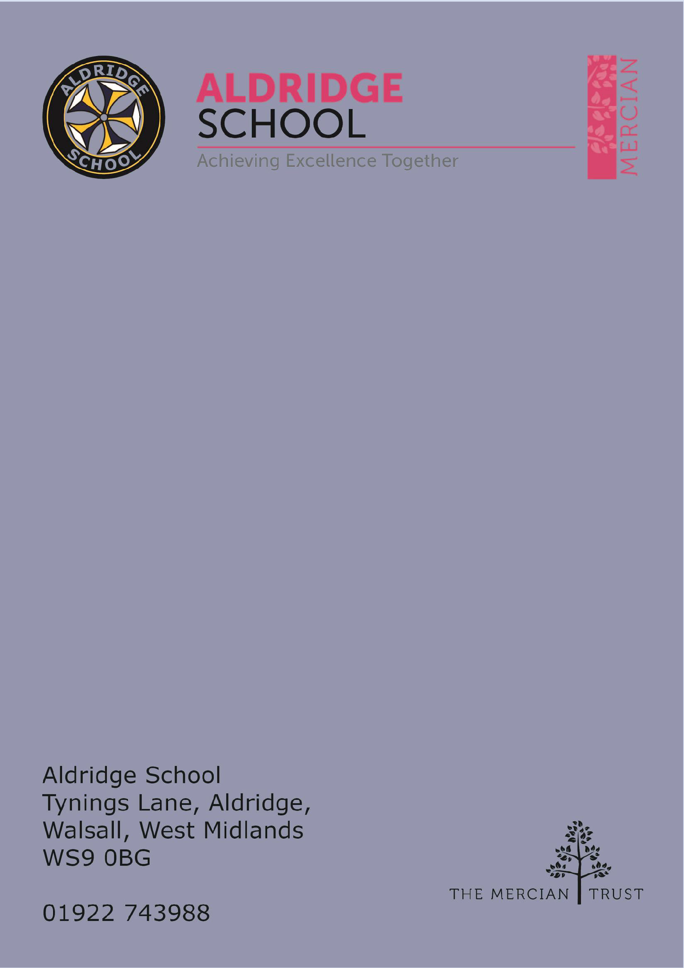

Application Pack

Pastoral Support – Sixth Form



About Aldridge School – a Founder Academy of the Mercian Trust

About The Mercian Trust

Job Description & Person Specification

Job Advert

How to Apply

# About Aldridge School

Thank you for taking the time to find out more about Aldridge School. This pack is intended to give you information about this role and our school's broader vision and ethos. Further background information is available in our Prospectus and Sixth Form Prospectus on our website.

We are a comprehensive school of over 1600 students situated near the centre of Aldridge village. We believe that it is our responsibility to work to meet the needs of every individual student, challenging them to achieve their best, supporting them to become responsible young adults and preparing them for their next steps into the world of work or further education.

Aldridge School is a good school (Ofsted 2022). It is a school which is proud of its traditions and successes which have been achieved through hard work and high expectations.

Aldridge School has a dedicated, talented and conscientious team of staff who work together to provide a high standard of teaching, excellent pastoral care and professional support services. Our broad curriculum is designed to meet national expectations, be relevant and interesting, support our students in achieving the best possible standards in external examinations and to equip them with the skills they need to be successful in adult life.

At Aldridge School we have a popular and thriving Sixth Form. We are very proud of our students' success with over 80% securing places at some of the top Universities and on Higher Apprenticeships last year. We offer a very broad range of both academic and vocational courses at level 3, ensuring that Aldridge School Sixth Form is an option for a wide range of students.

We also enjoy strong links with surrounding primary schools, working with students in Years 5 and 6 including work in Science, Maths, English, Performing Arts and Enterprise. We are proud of our community and we work hard to promote this pride in all our partnerships, so that we can make sure that future students from these schools enjoy an easy, enjoyable transition to Aldridge School.

Students at Aldridge School are friendly, polite and respectful. Strong relationships between staff and students contribute significantly to ensuring that students are happy and feel safe.

If you would like to find out more, please contact us to arrange a visit to see our school at work. We look forward to meeting you.

# Benefits of Working at Aldridge School

* Everyone has the highest expectations of behaviour, with all staff reinforcing those expectations
* A clear system of sanctions which is applied consistently so staff don't have battles with students
* Senior Leadership are very visible
* Excellent pastoral support offered through Head of Year staff
* CPD tailored specifically to staff needs, based off their feedback
* Time for staff to put new things into action
* Non-hierarchical approach to professional development - there are things a senior leader can learn from an ECT and vice versa
* Regular Staff, Faculty and Pastoral briefings to support good communication
* Performance Management is tailored to faculty and individual needs. Data targets are not used punitively but aspirationally. We begin from the assumption that everyone will get the pay rise unless they haven't done all they can to improve student outcomes
* We are constantly streamlining all systems and processes so they take less time
* Open door Senior Leadership Team - no concern is ever too small
* Countless opportunities to get involved with the wider life of the school - Duke of Edinburgh, school performances, sports teams, music
* Contributions of staff recognised through 'Above and Beyond' draws each half term

**The Mercian Trust**

Aldridge School is an academy in The Mercian Trust.

The Mercian Trust brings together twelve very different and individual schools together as a single Multi-Academy Trust or MAT.

The twelve schools are unique in their identity and united by their ambition to offer the best possible future for their students.

**The twelve schools are:**

* Aldridge School
* Queen Mary’s Grammar School
* Queen Mary’s High School
* Shire Oak Academy
* The Ladder School
* Walsall Studio School
* Q3 Academy Great Barr
* Q3 Academy Langley
* Q3 Academy Tipton
* New Leaf
* Rushall Primary School
* Oakwood School

Each school has its own distinct ethos and approach, but we have this over-arching aim in common: we prepare all our students to enjoy life to the full by inspiring them to:

* Realise their potential as learners
* Thrive in the world of work
* Make a positive contribution to the local, national and international community

The Mercian Trust respects the autonomy of its member schools but, through collaboration, fosters strengths that are greater than the sum of its parts. Working together as a Multi-Academy Trust provides a framework for sharing expertise and enthusiasm, resources and ideas.



# Job Description

**Post: Pastoral Support – Sixth Form**

**Responsible to: Head of Sixth Form**

**Salary:** **Grade 5 (SCP 9-17) pro-rata**

**Contract:** This is a permanent position working 37 hours per week Monday – Friday (40 weeks - term time inclusive of inset days + 1week).

PURPOSE To offer assistance to the Head of Sixth form, provide support to other members of staff, students, parents and other agencies.

**PRINCIPAL DUTIES AND RESPONSIBILITIES**

**Administrative duties**

* Arrange parental meetings, as required.
* Liaise appropriately with the Sixth Form Tutor team regarding all relevant administrative issues relating to all students.
* Using SIMS, track and evaluate attendance and punctuality data for students, liaising with tutors and parents to improve these where needed. Identify patterns to inform appropriate action and report findings at Sixth Form meetings.
* To aid and support in the Sixth Form application process.
* To aid in the KS4-KS5 transition induction process.
* Assist in the preparation and administration of A-level and GCSE results.
* Promote work experience and facilitate and monitor the completion of necessary documentation via the work experience platforms used.
* Key support for educational programmes available to students, such as open learn.
* Monitoring the completion of activities that form part of the enrichment programme.
* Promote equality and enable the educational and social inclusion of all students.
* Help maintain the Further and Higher Education resources in the Sixth Form.
* To support the Head of Sixth Form with the delivery of providing next steps information for our students, to include UCAS support and apprenticeship applications
* Undertake any appropriate training and attend any staff meeting where relevant.
* Attend Sixth Form line management meetings and record minutes.
* Be responsible for the day to day supervision of the Sixth Form: students and facilities.
* Ensure all medical information is up to date.
* To undertake any reasonable task as directed by the Head of Sixth Form.

**Stakeholder facing duties**

* Provision of a first point of contact for students, parents, external agencies.
* Ensure the Sixth Form Code of Conduct is being adhered to.
* Implement the Schools rewards and sanction policy
* Receiving visitors, speakers and prospective students and showing visitors around the Sixth Form.
* Ensuring students and staff are made aware of timely information relating to Sixth Form.
* Support the MAT students, monitoring attendance, progress and transport requirements.
* Implement the school’s rewards and sanctions policy with in the Sixth Form Centre.
* Arrange student ambassadors for parental events.
* Attend parental events and other after school commitments as required.



**STANDARDS AND QUALITY ASSURANCE**

1. Support the aims and ethos of the school
2. Set a good example in terms of dress, punctuality and attendance
3. Attend team and staff meetings
4. Undertake professional duties that may be reasonably assigned by the Head Teacher
5. Be proactive in matters relating to Health and Safety
6. Be committed to safeguarding and promoting the welfare of children and young people

**Advert**

Do you have the right blend of passion, drive, boundless enthusiasm and

empathy to become a valued member of our talented team of dedicated

pastoral staff?

Do you understand how children learn and develop, and do you truly believe that education has the power to transform the lives of all young people?

Do you have what it takes to lead on student progress and wellbeing? Can you make a significant and sustained contribution to school improvement?

If so, the role of Pastoral support for Sixth Form could be for you.

37 Hours per week

40 weeks per year (Term Time inclusive of training days + 1week)

Salary Scale: Grade 5 (SCP 9-17)

## Closing Date

## 03rd November 2025

## Start Date

As soon as possible

Aldridge school is a successful oversubscribed Academy with good track record of results at both GCSE and A Level. Our most recent Ofsted inspection (2022) rated us as Good in all areas. This is an excellent opportunity for inspired, committed and enthusiastic people to join a thriving team in this popular and successful school.

## Aldridge School - An Academy is committed to safeguarding and promoting the welfare of children and young people and expect all staff and volunteers to share in this commitment. The post is subject to enhanced DBS and safeguarding checks.

## Application

## Please apply through the Mercian Trust portal.

For further information please go to our web site [www.aldridgeschool.org](http://www.aldridgeschool.org/) or contact 01922 743988 ext 2224.

