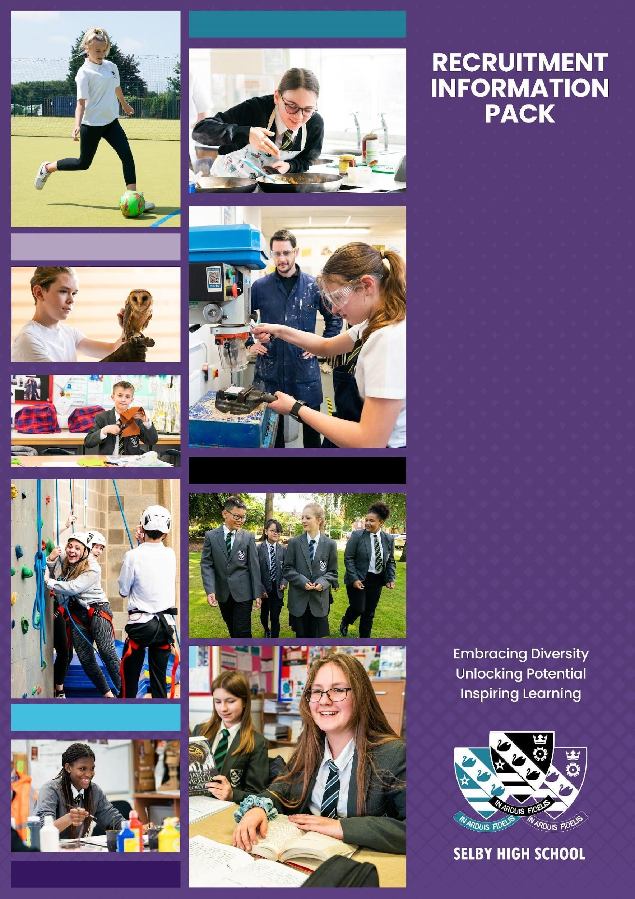

PE Teacher (maternity cover)
Starting
September, 2024

WELCOME
Dear Candidate,
Thank you for your interest in the post of teacher of Physical Education. We are looking for the right candidate for Selby High School, so whether you are an ECT or a more experienced candidate we’d love to hear from you. The role is a one year maternity cover from September 2024 until July 2025, and we are looking for somebody who will focus on girls PE, and who will be fully involved in the fixture programme.
Selby High School is an ambitious, forward looking, and successful 11-16 secondary school located in North Yorkshire and rated ‘good’ in our last inspection in September 2023. We are proud of our school and the opportunities it provides for both students and staff. Our ambition is success for everyone through encouragement, teamwork, and mutual respect, combined with an enjoyment of learning. We are a learning community who embrace opportunities for all our learners by securing high quality learning and teaching. We aim for all our students to achieve their full potential, both as students at Selby High School, and as considerate global citizens of the future. We always aim to be the best we can be; nothing less will do.
We are looking for a determined, enthusiastic professional, who wants to work with our young people, to ensure that, regardless of starting points or barriers to learning, they progress in the wider variety of physical activities available to the best of their ability. In return, we offer a comprehensive induction programme and continual professional development. As a teacher at Selby High School, we will provide you with excellent training opportunities, and encourage you to have high aspirations for your future career. If you are an ECT, we offer a high quality support programme to help you develop your skills in a supportive environment. Physical Education is held in high esteem at Selby High School, and you will work in partnership with the Director of Sport and the rest of the team to ensure an engaging curriculum and fantastic outcomes for the students.
Selby High School is a great place to work. Please, just take a little time to look at the whole school twitter feed https://twitter.com/SelbyHigh and the PE twitter feed https://twitter.com/SelbyHighPE to see some of the opportunities of the school. If you have a little longer to spend, our school website at https://www.selby-high.org.uk/ gives a real insight into the character of our school.
This information pack contains the Job Description and Person Specification, together with some background information about the faculty and the school. We hope this gives you a feel for Selby High School. If you wish to visit prior to putting in your application, then you would be most welcome. I look forward to receiving your application.
With all best wishes.
Yours faithfully
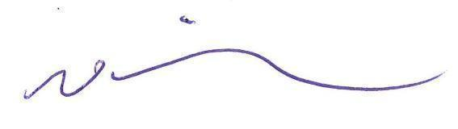
Nick Hinchliffe
Principal

About the role
We are looking for an outstanding teacher of Physical Education with the ability to teach at Key Stage 3 and 4, with a particular focus on teaching girls PE. You will be joining a committed and hardworking team. The successful candidate should be able to successfully teach across a range of traditional and more current sporting activities to both boys and girls. It is expected that the successful candidate will be able to teach across the age and ability range with the potential to deliver on the full range of our examination courses at Key Stage 4. A willingness to take a full and active role in our sporting extra-curricular programme is essential, with a priority on girls' fixtures and opportunities. We simply want the best teachers for our students, and that could be you!

The Physical Education Department
The Physical Education Department at Selby High School is a proud part of the whole school curriculum at Selby High School. Physical Education at Selby High School is built on the foundation of enjoyment, learning, participation and success. As a result, there is both breadth and depth to the curriculum, which incorporates increasing student choice from year 9 to 11. The curriculum is designed to challenge each student to the limit of his or her personal ability.
The Curriculum Area currently consists of seven members of staff who work cohesively as a team to ensure the quality of Physical Education, and the opportunities to take part, are continually growing.
At Selby High School, we believe that by creating a positive learning environment we build a culture where students and staff feel happy, safe, valued and motivated to achieve their best. Our passion is for all students to have enquiring minds, the confidence to seek a challenge, a lifelong desire to learn and a love of physical activity.

The Building and resources
The department is housed within its own new building with a dedicated theory classroom. A Sports Hall is equipped for basketball, netball, volleyball, high jump, badminton, 5 a-side football, tchoukball, handball and 3 cricket nets. We also have a 5 line indoor climbing wall and 10 sports wheelchairs alongside a Fitness Room with screen and sound system.
Also on site we are fortunate to have:
- A well-equipped gymnasium including 2 full size trampolines and high jump equipment.
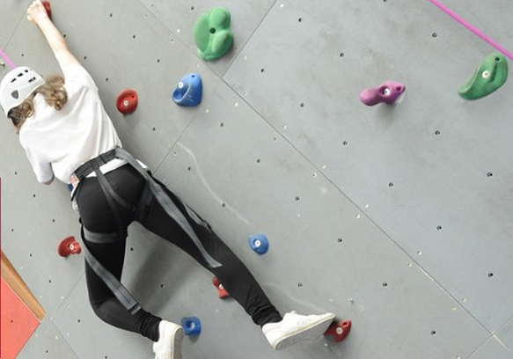
- The Main School hall – with 9 Table tennis tables and set of BoogieBounces
- Two drama and dance studios.
- A sand based all-weather pitch with 3 good sized 5 a side pitches which is also hockey and football marked.
- 2 football pitches with 9 a-side and 11 a-side wheeled goals
- Marked 5k route around the perimeter of the field
- 2 small lacrosse pitch and grid area.
- Newly created outside Handball, Basketball and Netball courts
- 400m grass athletics track and jumping pit.
- The grounds are also mapped for orienteering.
- Mountain Biking course
- Golf driving range

The department also has good access to ICT provision through the use of chrome books. The PE classroom and Sports Hall are both equipped with interactive touch screen TV’s. The department is extremely well equipped for all the activities undertaken. Resources are plentiful and of a good quality.
There are also good links with the local Selby Rugby Union Football Club, York City Knights, Selby Leisure Centre and College to extend the opportunities available to the students. The school competes in York & District, County and National competitions in a range of traditional sports. The advertised role would provide an opportunity to further develop the girl's extra-curricular experiences .

Staffing Structure
There are seven members of the PE team with a variety of roles in the department and school. We work collaboratively and share good practice regularly to develop teaching and learning strategies in our aim to become an outstanding school. We are a supportive, caring and enthusiastic team with the wellbeing and progress of our young people at the heart of everything we do.

Curriculum
All students in year 7-11 are timetabled for two hours of physical education each week. Students are taught in both mixed and single sexed groups throughout both Key Stage 3 and 4.

Year 7
All students in Year 7 follow a programme of Core athletics, gymnastics, OAA, Badminton, Fitness and the games of core skills, handball, rugby, netball, hockey, rounders, athletics and cross country.

Year 8 and 9
Year 8 and 9 students follow a programme of Athletics, Gymnastics including trampolining, OAA/Climbing, Volleyball and Paralympic sport and Year 9 theory. In addition to all the major games listed above students also participate in Lacrosse, Ultimate Frisbee and Tchoukball.

Year 10
During Year 10 students are given the opportunity to choose from a diverse range of sporting pathways that reflect the aims of the Key Stage 4 PE national curriculum. The sporting pathways promote their engagement and development within the wide range of activities covered in Key Stage 3 to promote their personal physical development.

Year 11
We encourage year 11 students to take responsibility for their own fitness and learning. They are able to choose from a variety of sporting activities run on site and at local facilities. The aim is for them to improve their own performances and to have an awareness of how they can take part in sport when they leave school.

PE Examination Courses
PE is a strong and popular choice for many of our students and its success is continuing to grow.
Students who elect to study Physical Education at examination level can opt from:
- Physical Education at GCSE level (OCR) as a 2 year course.
- OCR Cambridge National Sports Studies as a 1 year intensive course or as a 2 year course.

Through dance, students can choose to study the BTEC Performing Arts qualification as a 2 year course.

Extra-Curricular Activities
The Physical Education Department has an extensive range of extra-curricular activities available to the students. The school has a strong competitive reputation within the district in athletics and all the major games. A programme of weekly fixtures in the major games is run with teams from years 7-10 for both boys and girls. Other teams represent the school in show jumping, badminton, cross-country, indoor rowing, girl’s football, and rounders. The school has a highly successful enrichment programme which provides pupils with the opportunity to master skills within particular sports/activities. As part of this programme, the school works collaboratively with national governing body specialised sports coaches to further enhance pupils' sporting experiences. For example, pupils within year 9 also have access to cycling and opportunity to achieve their Sports Leaders level 1 award . Pupils in Year 7 & 8 are provided opportunities such as Rugby, Football and Basketball masterclasses.

ABOUT SELBY
Selby is a small market town situated 14 miles (22.5 km) south of the city of York, along the course of the River Ouse. It is dominated by the superb Abbey, founded in AD1069 by Benedict when he saw three swans on a lake in Selby which he interpreted as a sign of the Father, Son and Holy Ghost, resulting in the official crest of Selby Abbey, and subsequently, Selby High School.
Selby local government district has a population of 82,900. It is a fairly rural district with a population density well below the national average. Selby town, with a population of 24,680 is its only major settlement, with a population of more than 15,000.
Selby has a growing local economy with new housing and shops being built on the town's outskirts. The riverfront area is also being revamped with modern housing and flats. This is anticipated to bring population growth and enhanced demand for high quality educational places into the future. Selby is ideally located to a whole variety of places, facilities and activities for culture, leisure, commerce and learning. There is a wide range and variety of housing and prices are below the national average.
The district of Selby is contained within both the Leeds City Region and the York, North Yorkshire and East Riding Enterprise Partnerships. The Leeds E.P. Strategic Economic Plan (2016-2036) describes Selby as follows:  “The district of Selby sits on the eastern boundary of Leeds City Region within the county of North Yorkshire. Both the market town of Selby and the wider district are home to many highly skilled and paid employees, many of whom travel each day to Leeds, York and beyond. Its economy is characterised by manufacturing, distribution, construction and energy production; drawing its employees from the district’s market towns and villages, as well as neighbours including the East Riding, Wakefield and Doncaster.”  Looking ahead, the district has a key role to play in providing space for business growth in the Leeds City Region. The unemployment claimant count rate in Selby is around 1.3% (Sept 2016) which is well below the national average.  In terms of further education, Selby College is graded ‘good’ in all areas by Ofsted. It is a tertiary college providing the town`s sixth form as well as a small range of Higher Education courses, apprenticeship programmes and courses for adults. There is easy access to Leeds, Hull and York for Universities and it is to these centres that the majority of local, young HE entrants progress.  In short, Selby is a hidden gem, with both its own delights and very easy access to a diverse range of activities and experiences, for individuals and families of all ages. | 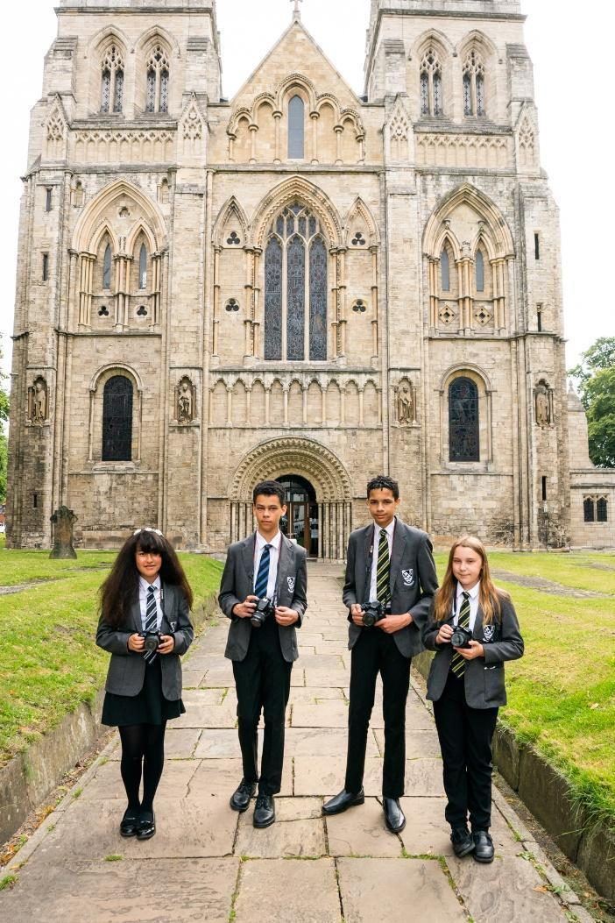  Selby Abbey has been at the heart of the community since 1069.

LIVING IN NORTH YORKSHIRE
North Yorkshire is England's largest county and one of the most rural. The area comprises the Yorkshire Dales and North York Moors, three Areas of Outstanding Natural Beauty, the Pennines and a stunning coastline around Scarborough and Whitby. The area hosted the phenomenal Tour de France in 2014, and due to its success has created the Tour de Yorkshire with global recognition. There are ruined castles and abbeys, serene gardens, unique breweries, thrilling rides and industrial heritage. Something for everyone!
Knaresborough
North Yorkshire has plenty to offer the outdoor enthusiast. From the hard gritstone of Almscliff and Brimham Rocks to the limestone of Malham, Gordale and Kilnsey, climbing venues are in abundance. The Yorkshire Dales is the premier area for caving and for mountain biking; there are the bridleways of the Dales and North York Moors as well as the renowned trail centre at Dalby Forest. The Sustrans trail centres are all easily accessible for days and weekends away, as is the Lake District and the fells, crags and coast of Northumberland. There are a small number of sailing clubs on reservoirs around the county and fantastic surf sport venues and sea kayaking on the east coast.
While the county is rightly known for its wide-open spaces, it also incorporates attractive market towns including Pickering and Helmsley, traditional seaside towns, the Spa town of Harrogate and the ancient city of York - the most visited city outside of London. There are a wide range of shopping, leisure and cultural facilities as well as excellent schools, universities, road and rail links; there really is everything to offer you and your family as a place to work, live and enjoy!
Travelling further afield we have convenient connectivity, with close proximity to metropolitan cities of Leeds and Newcastle, with little over two hours commute on the main train line to London. We border the Lake District, Lancashire, County Durham, and Yorkshire & Humber regions with all they have to offer.
Whitby

SELBY HIGH SCHOOL
Selby High School is a thriving, successful, and popular school. The ‘can do’ ethos at the school ensures the very best for each and every one of its students. Following our successful OfSTED inspection, everyone at the school is eager to move towards outstanding in every area. Selby, located in North Yorkshire, benefits from good commuter links with York and Leeds.

Selby High School is an equal opportunities employer. We have a robust child protection policy and are committed to safeguarding the welfare of our children and young people. It is our objective to ensure that job applicants and staff are treated solely on the basis of their merits, abilities and potential. We do not discriminate against any applicants on the basis of any protected characteristics, and welcome applications form all sections of the community.

As a school we work in a positive and supportive environment with learning and teaching at the heart of all that we do. We have committed and talented staff who aim to inspire everyone in our school community with a love of learning and, by doing so, maximising students’ life chances. We provide all our staff with a laptop computer and a full professional development and induction programme, both of which have been judged to be outstanding.

Please visit our Policies page for the most up to date policies including Safeguarding & Child Protection and the Equalities Scheme which are part of the interview process.
 | Community and Culture – Our school is a community, in which we provide help and support for one another, in line with our values. |  | Prioritising high quality planning – Effective  teaching and learning is underpinned by sensible, appropriate planning that is focused on the needs of all learners.
 | High quality recruitment, retention and  development – Our commitment to Career Pathways ensures that our staff team is always of the highest quality. |  | Developmental teaching and learning – We know that teaching time is like ‘gold dust’ and all staff need to be supported to deliver consistently good or better lessons.
 | Supportive staff appraisal – Aspirational targets that foster the improvement and development of all our colleagues, across the school. |  | Communication commitment – We strive to ensure that whole school communication is clear, timely, useful and manageable for all.
 | Streamlined data and report management – A  sensible approach that avoids duplication and leads to meaningful improvements for students. |  | Wellbeing – A welcoming place to work – We are an inclusive school community, committed to equality and diversity and a place where staff are happy in their work.
 | Marking that is manageable and meaningful – Time invested in marking and feedback should be proportional to the impact on student progress. |  | Managing workload – We believe that time well  spent is that which has the highest impact on raising standards, rejecting things that create unnecessary burden for little gain.

STAFF BENEFITS
Vivup is a provider of employee benefits in partnership with North Yorkshire County Council

North Yorkshire County Council recognise there is more to pay than just salary and they offer access to a wide range of competitive benefits.

The Vivup website provides colleagues with access to a host of voluntary benefits including discounts on goods and services such as your day to day shopping, days out, travel, electrical goods, leisure activities as well as links to salary sacrifice schemes.
Lifestyle Savings

Explore a huge range of discounts to help you save money across hundreds of the UK’s favourite high-street and online retailers.

Support & Wellbeing

Access expert help and support for life’s ups and downs 24/7, 365 days a year. Make the most of the schemes available to help your money go further.

DISCLOSURE
All successful applicants are required to complete an enhanced DBS check and any offer of employment will be subject to satisfactory references and checks.
HOW TO APPLY
Visits can be organised by contacting the SLT PA, Caroline Airth on 01757 244833 or admin@selbyhigh.co.uk. If you decide to apply, and we do hope you will, please complete the application form. This should be returned by e-mail to Caroline Airth.
Closing date: 3pm on Friday 3rd May.

JOB DESCRIPTION

GRADE: MPS/UPS
RESPONSIBLE TO: Director of Sport
RESPONSIBLE FOR: Key Stage 3 & 4 Teacher of Physical Education
To secure and account for effective learning, appropriate achievement and educational, social and personal progress of all students in the assigned area of responsibility, consistent with the aims of the school and the unique needs of each individual learner.

Physical Education are an important aspect of the curriculum in Selby High School, simply, it develops a wide range of valuable skills, which will benefit children throughout their lives. The qualities we aim to teach and instil in our pupils include; teamwork, co-operation, social skills, communication, performance skills, appreciation of others, sportsmanship and fair play. As well as teaching pupils about the benefits of exercise and the importance of a healthy lifestyle.
Your commitment to these areas will enable pupils to achieve and progress across the wide range of activities that we offer.
Main Activities

- To deliver Physical Education from Year 7-11 using a range of teaching methods and the agreed subject area schemes of learning and contributing to the SMSC development of students through the specified curriculum.
- To take responsibility for developing sporting areas within the curriculum that will enhance opportunities for the students.
- To support the work of the subject area through extra-curricular activities and engagement activities. Show commitment to educational trips and visits.
- To take an active role in the school’s sporting extra-curricular programme.
- To plan, prepare and deliver lessons to a range of classes, ensuring a positive working environment in classrooms.
- To ensure progress is made against student targets
- To mark work, giving appropriate feedback and maintaining records of student progress and development.
- To maintain up-to-date subject knowledge and devise and write new curriculum materials when required.
- To select and use a range of different learning resources and equipment.
- To undertake pastoral duties, such as taking on the role of form tutor, and supporting pupils on an individual basis as required. Undertake duties as part of the published rota.
- To prepare pupils for qualifications including external examinations.
- To manage student behaviour in the classroom and on school premises, following school policies.
- To support the work of teaching assistants, trainee teachers and newly qualified teachers (NQTs) as required.
- To participate in parents', carers’ and guardians’ consultations including published evening events and whole school training events.
- To liaise with other professionals, such as the SENDL, Personal Support Team, Learning Mentors, Careers Advisers, Educational Psychologists and Education Welfare Officers.
- To participate in the school quality assurance (QA) processes.
- To participate in regular in-service training (INSET) as part of continuing professional development (CPD).

- To follow school policy and procedures consistently and meet both internal and external deadlines.

Safeguarding
- Be responsible for promoting and safeguarding the welfare of children and young people that you are responsible for and come into contact with.
- Have awareness and basic knowledge, where appropriate, of the most recent legislation.
- Be able to recognise when a child or young person is in danger or at risk of harm and take action to protect them.
- Make considered judgements about how to act to safeguard and promote a child or young person’s welfare.

Data Protection
Comply with the County Council’s policies and supporting documentation in relation to Information Governance this includes Data Protection, Information Security and Confidentiality.

Other
Duties may be varied to meet the changing demands of the school at the reasonable discretion of the Headteacher.

This job description does not form the contract of employment. It describes the way the post holder is expected and required to perform and complete the duties set out above.

To fulfil all of the requirements and duties set out in the current Pay and Conditions Documents relating to the conditions of employment of teachers.

To achieve any performance criteria or targets related to this leadership post arising from the School’s Performance Management arrangements

This job description will be reviewed annually.

Person Specification

 | Essential | Desirable | Criteria
Teaching Experience | Experience of KS3 and KS4 teaching  Experience within traditional and up and coming games activities  Involvement in extra-curricular activities. | Teaching across the ability range, including mixed ability teaching.  Ability to challenge the more able.  Ability to work with lower prior attaining students  Experience of teaching girls PE
Qualifications | Qualified teacher status and a recognised degree or equivalent appropriate to the subject.  Evidence of CPD – sporting qualifications. | Additional relevant qualifications and/or experience.
Skills & Knowledge | Effective and confident classroom teaching.  Knowledge of the major current education initiatives.  Command of formal written English.  Familiarity with, and enthusiasm for the specified subject area.  Awareness of the needs of students with different learning skills and abilities.  Good ICT skills.  React to data about students and respond through different teaching strategies.  Confident familiarity with Programmes of Study and examination specifications at both Key Stages.  Ability to make high quality reasoned decisions based on available information.  Clear expectations of student behaviour and discipline.  Resilience and the ability to deal with, at times, larger volumes of work | Evidence of keeping up to date with educational thinking and knowledge.  Willingness to do extra-curricular activities.  Involvement in extra-curricular activities related to this subject area or the wider school community.  A personal interest in and knowledge of some specialist area related to the effective teaching of the specified subject.  Some knowledge of OCR/Vocational Sports examination specifications.
Personal Qualities | Reliability and punctuality.  Initiative.  Ability to work consistently with the policies and procedures of the school.  Commitment to succeed and to see others succeed. Commitment to further development of self and others.  Ability to work well with colleagues.  An enthusiastic, positive, encouraging classroom presence. | Sense of humour, resilience and resourcefulness.  Imagination, innovation and initiative.
Health | Good general health.  Good attendance.

Application | Reference | Lesson | Interview

