
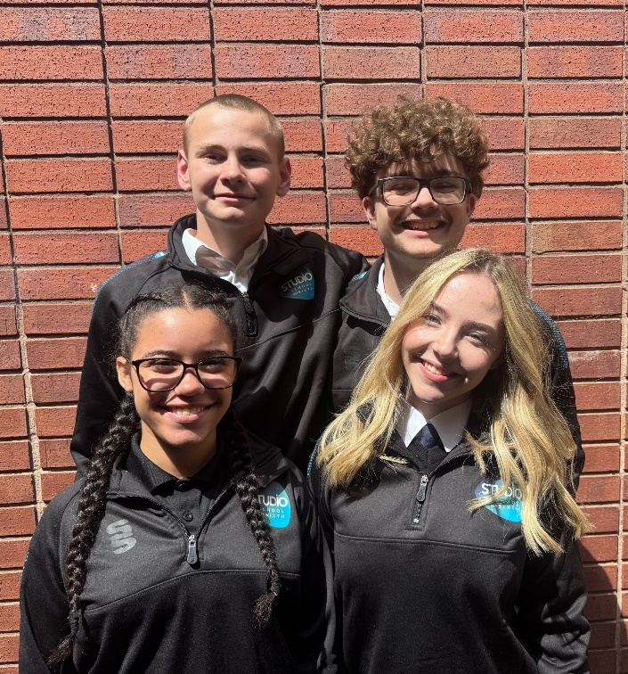
Peak Performance (Pastoral) Lead

Walsall Studio
School & Sixth

Required from April 2026

Permanent, Full-Time,
Term Time only

Competitive Salary
(Grade 7 £29,114 to £33,315)

Applicant
Pack

Deputy
Headteacher
Quality of Education and Operations
Walsall Studio
School & Sixth

Required for September 2025

Permanent, Full-Time.

Competitive Salary
(Leadership L14 to L18)

Candidate Pack



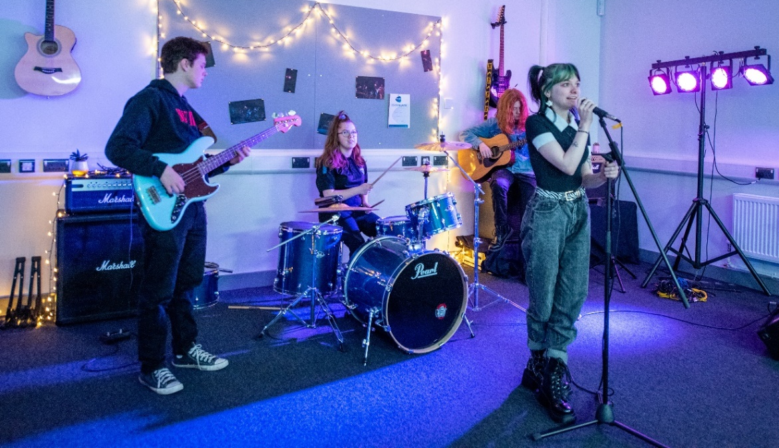

WELCOME TO WALSALL STUDIO SCHOOL & SIXTH


Dear Applicant,

Walsall Studio School and Sixth is a deliberately small, forward-thinking school serving young people aged 14 to 19 who are passionate about creative pathways in performance, music, and media. We offer a unique learning environment that looks and feels like a modern creative workplace rather than a traditional school, with flexible studio spaces and industry-standard facilities that reflect the real world our students are preparing to enter.

At the heart of our mission is a commitment to inclusion, aspiration, and professional standards. We believe in treating our students as young professionals, helping them to thrive both personally and creatively through high expectations, trauma-informed practice, and a deep understanding of the individual. Our culture is one where every student is known, seen, and supported.

As a founding member of The Mercian Trust, we are proud to be part of a family of schools that share our belief in partnership, collaboration, and community. We work closely with industry partners, creative professionals, and local organisations to ensure our students gain not just qualifications, but authentic experiences that prepare them for the world beyond education.

If you share our values and want to help shape the next generation of creative professionals, we would love to hear from you.

Yours sincerely,

Krissi Carter, Headteacher

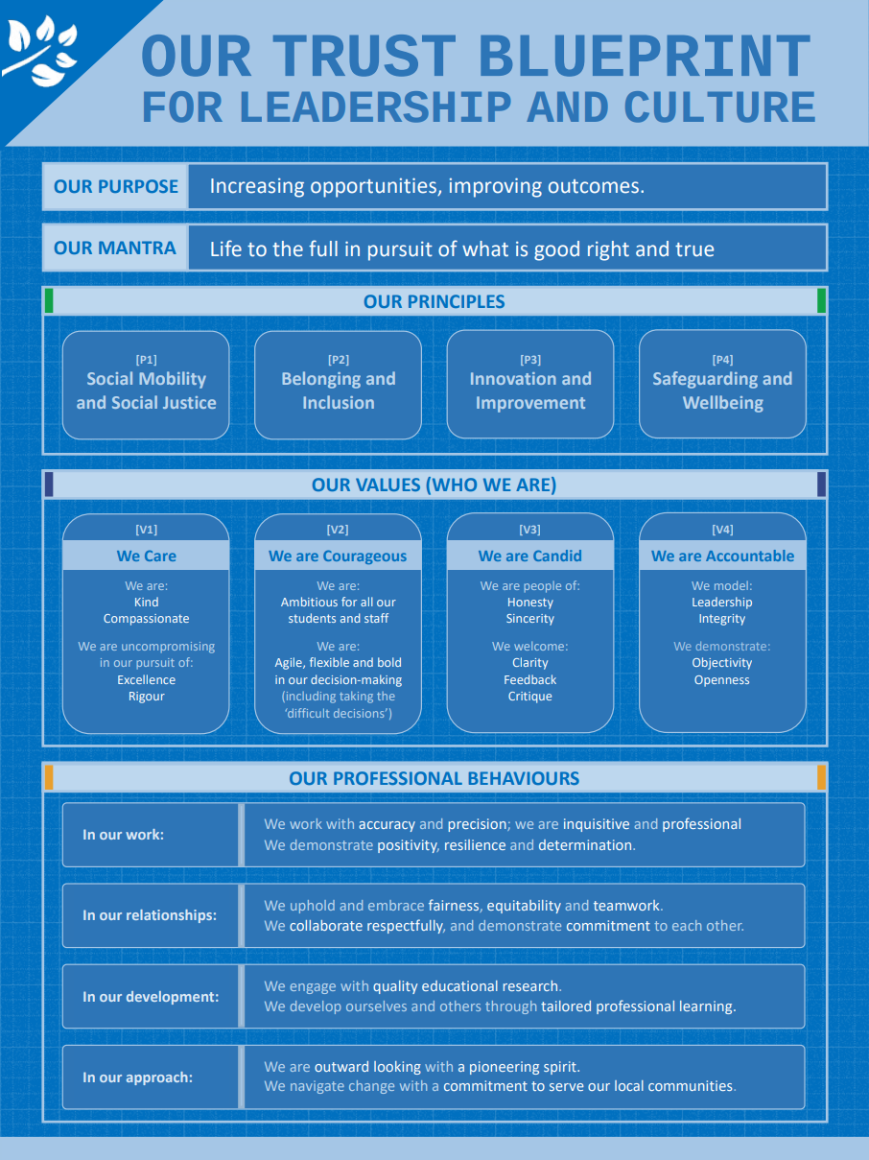

THE MERCIAN TRUST

The Mercian Trust is one of the largest regional Trusts in the West Midlands with 12 schools and more than 10,000 students. We are making strategic investments of time, focus, and resources into our people and organisational culture – and we are prioritising the development of leaders at all levels.

About The Mercian Trust
The Mercian Trust was incorporated in January 2018 and currently governs twelve secondary schools, comprising selective grammar schools, large comprehensive schools, two alternative provision schools, a primary school, a special education school and a 14-19 specialist studio school.

In 2021, the Regional Schools Commissioner approved the merger between The Mercian Trust and Q3 Academies Trust. The formal merger transfer was completed on 1st May 2022 when the academies of the two Trusts became part of the same family of schools governed by The Mercian Trust.

- Aldridge School (11-18)
- New Leaf School (Alternative Provision)
- Oakwood School (Special Education)
- Q3 Academy Great Barr (11-18)
- Q3 Academy Langley (11-16)
- Q3 Academy Tipton (11-18)
- Queen Mary’s High School (11-18, selective)
- Queen Mary’s Grammar School (11-18, selective)
- Rushall Primary School
- Shire Oak Academy (11-18)
- The Ladder School (Alternative Provision)
- Walsall Studio School & Sixth (14-19)
The Members of The Mercian Trust include The Vine Trust and the Queen Mary’s Foundation. Both are charitable organisations focused on improving the futures of local young people.

Plans for the future

- Leading students on a transformational journey empowering social mobility and delivering social justice.
- Develop and deliver an ambitious, relevant and responsive curriculum inside and outside the classroom (academic, vocational, cultural)
- Enhance aspirational, inspirational, evidence based teaching and experiential learning
- Support students’ physical safety, mental wellbeing and character development including student leadership in the community

- Establishing systems and structures to enable successful schools
- Develop effective MAT central teams and systems (finance/HR/Estates and more) to support schools with clear SLAs that demonstrate commitment and drive improvement
- Recruit, develop and maintain effective leadership and governance at all levels while succession planning for the future
- Strengthen leaders’ commitment to the students and staff in more than one school through collaboration and system leadership

- Driving the digital transformation
- Upskill teachers to become experts digital education (personalising high-quality content and interaction with students)
- Reduce staff workload and discover new efficiencies through collaboration, automated operations, innovation, and influence beyond one school
- Optimise evidence-based decision making through data analytics

- Becoming an employer of choice
- Further develop a well-trained, professionally skilled and motivated workforce (through opportunities and CPD beyond one school)
- Deliver consistent, harmonised pay and conditions of service as one employer committed to fairness across uniquely diverse schools
- Introduce staff rewards and recognition and increase retention and internal progression (promotion within the trust) for staff in all schools

- Growing the Trust in size and influence
- Demonstrate Trust capacity through improvements in existing schools (performance tables) and through securing good and better Ofsted judgements that are recognised by parents, external stakeholders, future partners and the DfE
- Increase student numbers from c5k to c10k through increasing PAN, recruitment/retention in post 16 and through additional schools joining the Trust
- Realise expansion projects and building programmes

Areas of focus for the Trust board at the moment include:

- Successful Growth
Having consolidated following our successful Trust merger, we are now preparing for our next period of growth in size and influence including new schools joining our Trust, increases in PAN, and increases in sixth form numbers. Ensuring this growth enables us to develop and refine our structures, systems and staff to be even more successful for our schools and the communities we serve. We are well-positioned to make a significant contribution to a Trust-led education sector.

- Equality, Diversity and Inclusion (EDI) - The Trust is passionate about its commitment to social mobility, social justice and inclusion in three significant areas.
- Students - Closing the gaps in opportunity, attainment and progress for disadvantaged students, students with SEND, vulnerable students and others with protected characteristics that may mean they are more likely to face discrimination and prejudice.
- Staff – Developing and nurturing opportunities for staff (including leadership development) particularly for those who are more likely to face discrimination and prejudice.
- Governance - Increasing numbers of non-executive leaders and governors from underrepresented groups.

- Digital Transformation
Delivering the digital transformation of how we teach, learn, lead and operate. The Trust is establishing a single consolidated digital ecosystem / infrastructure that facilitates ‘economies of scale’ and ‘network effect’ of being part of one charitable trust.

Trust ethos & values
Our name is rooted in history and expresses a geographical identity and ambition. The ancient kingdom of Mercia encompassed much of what we now recognise as the West Midlands – and crucially for us it included what we now call the Black Country. It was in Mercia that St Chad established an association of small monasteries which fostered unity through bonds of kinship.

Now, almost fifteen hundred years later, we look to demonstrate the same spirit in our approach. We are a family of schools committed to each other – diverse in nature, proud custodians of our history and success, but together, one charitable trust with a common purpose.

Our Trust exists to equip our students to:
- Realise their potential
- Thrive in the world of work
- Make a positive contribution to the local, national and international community.
Our mission is increasing opportunities and improving outcomes. Our mantra is Life to the full in pursuit of what is good, right and true.

Walsall Studio School
Student Peak Performance (Pastoral) Lead (KS4 and KS5)

Job Title: Student Peak Performance Lead (KS4 & KS5)
Salary: Grade 7 (22-27)
Responsible to: Headteacher / SLT
Responsible for: KS4/KS5 Tutor Teams, Whole School Pastoral Provision, Student Professional Conduct and Safeguarding Support, Progress and Destinations, PSHE, Bursary
Role Type: Middle Leadership Team (MLT)
Contract Type: Full-Time, Permanent

Job Purpose
The Student Peak Performance Lead will play a pivotal pastoral leadership role across Key Stages 4 and 5, working in partnership with a second Student Peak Performance Lead and Aspire Coach to ensure the highest standards of student welfare, engagement, personal development, and academic performance. This includes leading the tutor team, coordinating student support services, driving attendance and behaviour strategies, and overseeing the transition, enrichment and progress tracking of students. The postholder will lead one half of the school and contribute to whole-school student success.

Key Responsibilities
1. People and Relationships
- Lead a culture of high expectations, professionalism, and ambition among students and staff.
- Provide effective daily pastoral care to students, including support for personal, academic, vocational, and social development.
- Lead and manage a team of tutors, coordinating the delivery of tutor time, group sessions, and PSHE.
- Develop and deliver targeted 1:1 and small group coaching to students, particularly those with additional needs or facing barriers to success.
- Coordinate external partnership provision for students (e.g. The GAP, Base 25, MTMA), ensuring effective service delivery and impact.
- Establish and sustain positive relationships with parents/carers to support student attendance, conduct and progress.
- Liaise effectively with multi-agency professionals (e.g. health, social care, SEND teams) as part of the student support process.
- Support school behaviour policies, including interventions, celebrations, reintegration and exclusions.
- Act as a key pastoral worker for students at risk, providing frontline mental health and safeguarding support in partnership with DSLs/DDSLs.

2. Attendance and Safeguarding
- Monitor attendance and punctuality daily, implementing strategies to address concerns in coordination with the SLT PA/Office Manager and Aspire Coach.
- Ensure accurate, up-to-date records of attendance and interventions are maintained.
- Attend safeguarding meetings (e.g. Early Help, CIN, CP) under the direction of safeguarding leads.
- Create and disseminate medical care plans, safeguarding risk assessments and support plans for identified students.

3. School Efficiency and Effectiveness
- Oversee the smooth running of routines including morning check-ins, mobile phone collection, and transitions.
- Use school systems (e.g. MyConcern, SIMS) to log and monitor interventions and student support activities.
- Support key school events (e.g. academic reports, parents’ evenings, recruitment days, induction).
- Lead planning and delivery of communications and preparation for milestone assessments such as PPEs.
- Promote and organise student leadership, participation in charity and enrichment events, and wider school life.

4. Recruitment, Transition and Retention
- Support the induction of new students into Key Stage 4 and 5, including interviews and application processes.
- Plan and lead a coherent programme of transition activities, including induction days and early engagement opportunities.
- Ensure effective transition of Year 11 students into Year 12 through collaboration with leaders and curriculum teams.
- Ensure the effective transition of external students to year 10 and 12 in collaboration with leaders and curriculum teams.
- Monitor and support students entering via the Fair Access Protocol or alternative provision placements.
- Collate and disseminate key student information (medical, behavioural, academic) to appropriate staff.
- Promote and support the completion of relevant forms and policies, including Home-School Agreements and IT use policies.

5. Curriculum Development and Quality Assurance
- Lead the planning and delivery of a relevant and inclusive tutor time and PSHE curriculum.
- Oversee a coordinated and responsive pastoral programme, addressing local, national and global issues.
- Hold weekly tutor planning meetings and quality assure the delivery of pastoral sessions.
- Collaborate with subject leaders to enhance tutor time for Year 11 and 13 students in priority academic areas.
- Evaluate the impact of the pastoral curriculum through learning walks, student voice, and staff feedback.

6. Academic Support and Raising Attainment
- Work alongside the Assistant Headteacher (Teaching, Learning and Curriculum) to:
  - Track student progress and address academic underperformance.
  - Support the development and delivery of interventions to remove barriers to learning.
  - Ensure tutors fulfil their responsibilities for monitoring, mentoring, and celebrating student progress.
  - Facilitate targeted support strategies for individuals or groups of students.

7. Partnership and Collaboration
- Work collaboratively with the other Peak Performance Lead and Aspire Coach/Attendance Officer to ensure consistency across the whole school.
- Attend and contribute to key pastoral, safeguarding, SEND and attendance meetings with SLT and support teams.
- Liaise with external agencies to support student wellbeing, progress, and engagement in learning.
- Work with administrative and data teams to ensure student records, systems and communications are accurate and timely.

Leadership and Management
- Act as a visible and proactive pastoral leader, modelling professionalism, care, and high expectations.
- Contribute to whole-school development planning and evaluation as part of the wider pastoral leadership team.
- Support the performance management of allocated staff and the professional development of the tutor team.
- Promote inclusive, trauma-informed, and safeguarding-first practices across all areas of responsibility.
- Undertake any duties commensurate with the role as directed by the Headteacher or senior leadership team.

Safe Working Practices for Adults Working with Children
All staff at Walsall Studio School are expected to model and uphold the Trust’s ethos of safe, respectful, and professional conduct when working with students. The postholder must act in line with safeguarding principles and actively promote a culture of vigilance and care.


Safeguarding Statement
Walsall Studio School is committed to safeguarding and promoting the welfare of children. All appointments are subject to an enhanced DBS check, satisfactory references, and other relevant employment checks
Walsall Studio School
Peak Performance (Pastoral) Lead

Criteria | Essential | Desirable | Assessment
Qualifications | • GCSE English and Maths (Grade 4/C or above)  • Relevant qualification or substantial experience in pastoral support, youth work, education or related field  • Evidence of ongoing CPD in safeguarding, SEND, SEMH or mental health | • Further qualification in pastoral leadership, SEND, mental health, coaching or trauma-informed practice | AF
Experience | • Experience working with secondary-age students, including those with SEMH, anxiety, attendance or safeguarding needs  • Experience delivering 1:1 and small-group interventions or coaching  • Experience working with external agencies and multi-disciplinary teams  • Experience supporting students with EHCPs or additional needs  • Experience contributing to attendance, behaviour or pastoral systems | • Experience in a Studio School, alternative provision or specialist setting  • Experience leading or line managing staff  • Experience supporting post-16 students with progress, retention and destinations | AF, I, R
Skills and Abilities | • Strong interpersonal skills with high emotional intelligence  • Ability to build trust quickly with young people, families and colleagues  • Ability to model calm, consistent and professional conduct  • Strong organisational skills and ability to manage competing priorities  • Effective written and verbal communication skills  • Ability to analyse information and maintain accurate pastoral records  • Ability to lead, motivate and support a tutor team | • Coaching skills or training  • Ability to deliver or facilitate staff training or briefings  • Confident use of school systems (e.g. SIMS, Bromcom, MyConcern, CPOMs or similar) | AF, I
Knowledge and Understanding | • Strong understanding of safeguarding, child protection and safer working practices • Good understanding of inclusive education,  • Understanding of trauma-informed, attachment-aware and wellbeing-focused approaches  • Understanding of attendance, professional conduct and behaviour systems in secondary education | • Knowledge of PSHE curriculum design and delivery  • Understanding of post-16 pathways, bursary processes and destinations | AF, I
Leadership and Professional Practice | • Ability to act as a visible, proactive pastoral leader  • High expectations for student conduct, attendance and personal development  • Ability to work collaboratively as part of a wider pastoral leadership team  • Commitment to safeguarding-first and inclusion-led practice | • Experience contributing to whole-school improvement or development planning • Experience mentoring or developing colleagues | I, R
Personal Qualities | • Compassionate, resilient and emotionally literate  • Calm under pressure and able to manage emotionally demanding situations  • Reflective and open to feedback  • Values-driven, professional and solution-focused  • Flexible and adaptable in a fast-moving environment | • A sense of humour and genuine commitment to the ethos of Walsall Studio School | I, R
Other Requirements | • Undertake all enhanced DBS and all pre-employment checks  • Willingness to undertake further CPD as required (e.g. safeguarding, first aid, mental health first aid)  • Commitment to the school’s safeguarding ethos and professional standards |  | AF

OUR OFFER TO YOU
- A superb staff team committed to doing their absolute best for all in our school community.
- Support from our Trust central teams and other schools in our Trust to ensure you have the tools to deliver success (our schools are all located close to one another, and we work better when we are working together).
- A wealth of support for your ongoing continuing professional development, including a Trust-wide programme for support staff drawing on expertise from across the Mercian Trust.
- A comprehensive employee assistance and staff benefits package including Vivup (cash-back health plan and 24:7 video call and telephone access to GP and counselling), salary sacrifice schemes including our new Electric Car scheme, and discounts portal (ranging from gym membership to discount cards and vouchers for online and high street retailers).
- There will never be a dull moment; we never stand still, every day offers new challenges and opportunities within an ambitious, forward-thinking team.

SAFEGUARDING AND SAFER RECRUITMENT
- The Mercian Trust is committed to equal opportunities, safeguarding, and promoting the welfare of children and young adults. We expect all staff to share this commitment. As this post involves working in regulated activity unsupervised with children all post-holders are subject to satisfactory pre-employment checks including an online search check, Enhanced Disclosure and Barring Service check.

- You are required to uphold all relevant policies in respect of child protection and safeguarding, which are based on KCSIE (2024) and Working Together to Safeguard Children (2018).
- You are required to demonstrate and model the Nolan Principles (The Seven Principles of Public Life): Selflessness, Integrity, Objectivity, Accountability, Openness, Honesty, and Leadership. https://www.gov.uk/government/publications/the-7-principles-of-public-life
- You should demonstrate your commitment to our equality policy and all our related work to promote diversity, inclusion and belonging.

KEY INFORMATION – HOW TO APPLY

Post | Peak Performance (Pastoral) Lead
Responsible to | Headteacher / SLT
Contract and Salary | Full time, permanent, term time only  Grade 7 (£29,114 to £33,315)
Closing Date | Sunday 1st March 2026
Interview Dates | TBC
Start Date | April 2026
Informal Confidential Conversations and Visit of School | To speak to someone about the post, please contact Angela Lingard, SLT PA and Office Manager at a.lingard@studio.merciantrust.org.uk
How to apply | Please complete the Online Application Form via our Mercian website.

