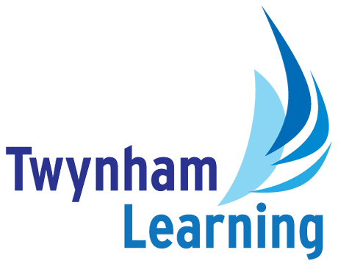**Job Description: Peripatetic BRASS Music Teacher**

|  |  |
| --- | --- |
| **Post Details** |  |
| **School/setting:** | Twynham and TGS |
| **Post type:** | Peripatetic Music Staff |
| **Grade/Pay Level:** | Casual |
| **Responsible to:** | Head of Extra Curricular Music |

|  |
| --- |
| **Main Purpose** |
| * Plan and teach engaging and effective lessons that motivate, inspire and improve pupil attainment. * Use regular assessments to monitor progress and set targets. * Maintain accurate pupil data that can be used to make teaching more effective. * Prepare and encourage students to take ABRSM, Trinity Examination and/or Rock School exams as appropriate. * Ensure that Music Scholarship students are showing adequate development and that their logbooks are completed regularly. |

|  |
| --- |
| **Duties and Responsibilities** |
| * Teaching brass from Year 7 up to and including Year 13. * Following the ABRSM, Trinity Examination and/or Rock School specifications as appropriate and preparing students fully for examinations. * Dovetailing teaching with the experience students have had over the course of the academic year. * Completing personal administration tasks to deadlines. * Completing two short reports a year to communicate with parents the students’ progress made on their chosen instrument. * Communicating with members of the Music Department and parents as appropriate. * Running an extra-curricular activity suitable for your role e.g. Brass ensemble * To undertake other reasonable tasks relevant to the needs of the school as the need arises. * Provide a nurturing environment that help students to develop as learners. * Demonstrate performance skills with competence. * Use the student Music Scholarship Logbook weekly to keep a record of attendance, to communicate with music staff/parents and to set work. * Prepare students for and attend any annual music concerts. * Attend and support other concerts during the year as agreed with the Head of Extra Curricular Music. * Help to establish / maintain discipline and good order in lessons. |

|  |
| --- |
| **Safeguarding Duties and Responsibilities** |
| * Promoting and safeguarding the welfare of children and young people in accordance with the school’s Safeguarding and Child Protection policies. |

|  |  |
| --- | --- |
| **Twynham Learning Attributes for all Staff** | |
| * Ambition for excellence * Professionalism * Humility * Championing change | * Inclusiveness * Positivity * Community-mindedness * Being collaborative |

|  |
| --- |
| **Knowledge, Skills and Attributes** |
| **Essential:**   * Grade 8 + standard performer * Highly accomplished and experienced instrumental teacher * A team player with a passion for collaborative music teaching   **Desirable:**   * The ability to accompany students * Any applicable teaching qualifications |

|  |
| --- |
| **Other Duties** |
| * All Twynham Learning staff may periodically be expected to carry out tasks and duties within their area of competence that are not listed herein, as directed, to meet the needs of the Trust. The particular duties and responsibilities may vary from time to time. |

|  |
| --- |
| **Notes** |
| * This job description may be amended at any time in consultation with the postholder. |

|  |  |
| --- | --- |
| **Key to Acronyms Used/Glossary of Terms Used in this Job Description** | |
| * TL = Twynham Learning | ABRSM = Associated Board of the Royal Schools of Music |