INFORMATION PACK
PERIPATETIC CELLO TEACHER
Approx. 5 hours per week
Self Employed
Required for September 2023

Overview of the Role

Altrincham Grammar School for Girls is looking for an inspiring and well-qualified musician to teach Cello. They would be expected to teach across a full and ability range of pupils aged 11-18 and contribute to the extra-curricular life of the school, for example liaising with our string orchestra director. The ability to play the piano well would be an advantage. The ideal candidate will be well-qualified with a BA or BMUS or equivalent in music and enthusiastic, with a desire to support the ethos and aims of the department. There are currently 6 hours of cello teaching available. These lessons are taught on a Monday though there may be some flexibility to change teaching day.

The full job description and person specification are at the end of this pack.

Contents of this pack
Bright Futures Educational Trust | Page 1-2
Altrincham Grammar School for Girls | Pages 3
Why work for us? Terms and conditions and how to apply | Page 4
Job Description | Pages 5-6
Person Specification | Pages 6

Bright Futures Educational Trust
Bright Futures Educational Trust (The Trust) is a multi-academy trust set up in 2011. The Trust is made up of a richly diverse group of schools in Greater Manchester and Blackpool. We are passionate about working together within and beyond the Trust to achieve our aspirational vision: the best for everyone, the best from everyone. We are an organisation that is underpinned by values of: community, integrity, and passion. In everything we do, we remember that we are accountable to the children, families, and communities that we serve.
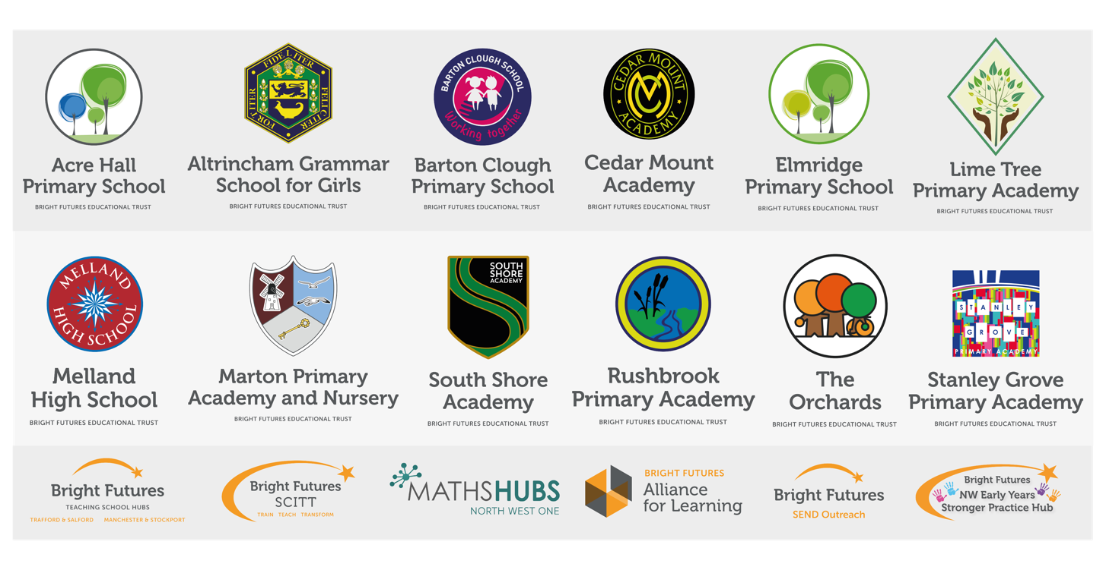
Our schools have their own identities, form one organisation and have one employer, Bright Futures Educational Trust. Bright Futures’ Board of Trustees maintains strategic oversight of the Trust and delegates some of its responsibilities to the Executive Team, Heads of School and local governing bodies. We place a high value on integrity and probity and take seriously our accountabilities for making the best use of public money. How decisions are made is described in our delegation framework. You can find out more about the Trustees and the Executive Team on our website: About Us - Bright Futures Educational Trust (bright-futures.co.uk)
The central team includes the Executive Team: John Stephens, CEO; Edward Vitalis, Chief Operating Officer; Gary Handforth, Director of Education; Lisa Fathers, Director of Development, Partnerships and Teaching School Hubs and Lynette Beckett, Director of People & Strategy. The focus of these roles is to work with schools, providing high quality and timely guidance, leadership, challenge, and support. In addition to the executive team, we have central operations for finance, communications and marketing, HR, educational psychology, and digital technologies. Please see our website brochure which explains our central operations: Why-Join-Bright-Futures

Bright Futures Professional Development Institute is an important part of the Trust. The Institute is the home of all professional development and school improvement resource in Bright Futures. The Institute is also where all of our outward facing work happens. Underneath this umbrella we have several hubs. The Alliance for Learning (AFL) which provides school improvement services and CPD to over 700 schools, a North West Maths’ Hub NW1 Maths Hub, providing mathematics training and coaching to 500 schools, and a SCITT (School Centred Initial Teacher Training) Bright Futures SCITT, which is the largest in the North West. Within the Institute, Bright Futures also has two Teaching School Hubs, serving Manchester, Stockport, Salford, and Trafford. Bright Futures Send Outreach is another service which we provide across the Northwest. We have also been designated as an Early Years Stronger Practice Hub under the name of Bright Futures North West Early Years Stronger Practice Hub providing guidance and support to settings across the region.

Collaboration and strong relationships form one of the ‘commitments’ in our Strategy and all components of the Bright Futures’ family work closely together. Our Strategy was developed collaboratively and can be found on our website: Our Strategy.

Altrincham Grammar School for Girls
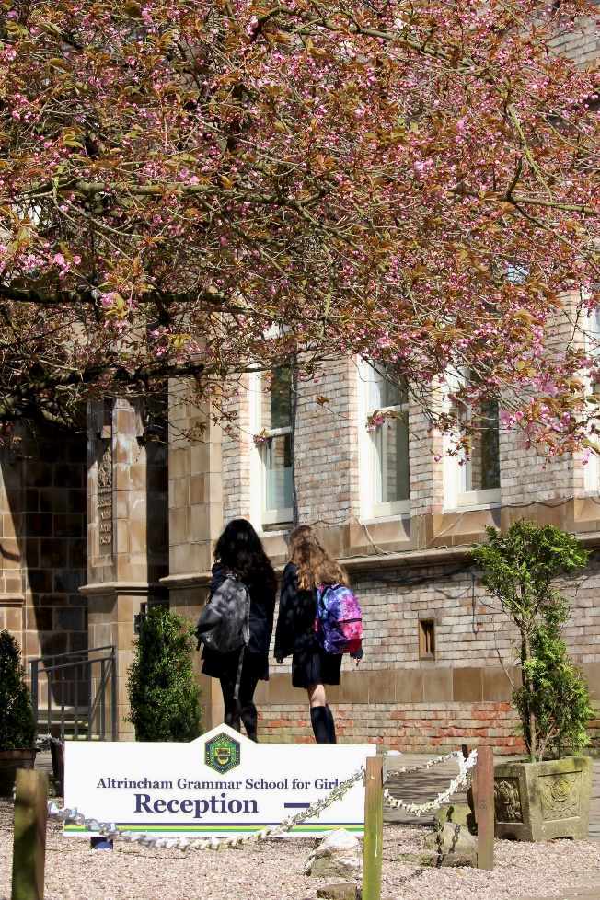
Altrincham Grammar School for Girls (AGGS) is a highly successful single sex 11 -18 academy in the South Trafford area. AGGS was in the first cohort of schools to be designated a national teaching school in 2011. AGGS is the lead school in ‘The Alliance for Learning’, which comprised schools of every type and phase, plus universities, throughout a wide geographical area. The impact of teaching school activities has been felt within the Trust and far beyond. We have a reputation for excellence regionally and nationally, of which we are very proud.

AGGS is committed to providing equal opportunity in recruitment and employment to all individuals. We will consider candidates without regard to race, ethnicity, gender, religion, sexual orientation and identity, national origin, age, military or veteran status, disability or any other legally protected status; and without discrimination based on socioeconomic, marital, parental or caregiving status, or any of the previously listed characteristics or statuses.

We value the diversity of our staff and reject any form of harassment, discrimination or victimisation. The Bright Futures Educational Trust vision is: ‘the best for everyone, the best from everyone’. To achieve this, we create and maintain a work environment and culture where people from different backgrounds, and with varying lifestyles, interests, opinions and responsibilities, treat each other with dignity and respect. It is a climate in which our staff feel safe and are inspired and motivated to be their best.

Our school is dedicated to sustaining and promoting diversity with respect to recruitment, promotion, training and general treatment during employment. We are actively seeking to extend the diversity of our staff. Furthermore, we welcome candidates who have not had previous experience of working in a grammar school.

We aim to ensure that our recruitment processes set up all candidates for success. At interview our aim is to provide a positive experience. We don’t want to catch anyone out, but rather to provide the opportunity for all candidates to be themselves and show us what they are capable of.

WHY WORK FOR US?

We offer a great opportunity to join an organisation which really lives its values. Our working environment is very inclusive and whilst you can expect to be challenged in your role, you will be supported through professional learning, treated fairly and with dignity and respect. Please see the Equality,
Diversity, an Inclusion statement on our website.

Terms and Conditions

Rate: £39 per hour on a self employed basis
Hours: Approximately 5 hours per week, dependent upon establishment requirement. Required on Mondays.
For a full explanation of our employment offer please see the booklet on our website:
Our-Employment-Terms-November-2022.pdf (bright-futures.co.uk)

How to Apply
We can only accept completed application forms, rather than CVs. This is because the regulatory guidelines of
Keeping Children Safe in Education (2021), require us to check various details of job applicants and an identical
application format for each candidate enables us to do this. We use a process that does not identify personal
characteristics to the shortlisting panel. This is part of our commitment to equalities and diversity.
NO AGENCIES PLEASE.

Our application form is available online, along with the disclosure of criminal background form. The portal link is HERE. Alternatively, you can click Apply Now on this role via the current vacancies page of our website. Please upload the forms by 9am Monday 26 June 2023.

The selection will take place on Thursday 29 June 2023. You will be notified after the closing date whether you have been shortlisted.

Keeping Children Safe in Education
Bright Futures Educational Trust is committed to safeguarding and promoting the welfare of children and young people and we expect all staff and volunteers to share this commitment. This post is exempt from the Rehabilitation of Offenders Act 1974; pre-employment checks will be carried out and references will be sought for shortlisted candidates and successful candidates will be subject to an enhanced DBS check and other relevant checks with statutory bodies.

Data Privacy
You can read the details of how we use the personal data that you provide us with in our Job Applicants’ privacy notice on our website: Applicant Privacy Notice

JOB DESCRIPTION
Peripatetic Cello Teacher

JOB SUMMARY
Music has a high profile at the school and there is an extensive programme of fifteen extra-curricular activities including several orchestras, choirs, bands and ensembles. Concerts are given regularly, both in school and as outreach opportunities. Choirs and instrumental groups have toured abroad in Europe and Asia. Exciting joint projects with the Northern Chamber Orchestra and the Hallé have taken place and, recently, in conjunction with the Drama and Dance departments, the musical ‘Matilda’ was successfully staged.

All pupils in Years 7 and 8 study music for three periods per 10-day cycle at key stage three and for two periods per cycle in Year 9, after which, it becomes an option at GCSE and A level. Currently there are 19 pupils studying GCSE and 4 students at A level. In the most recent set of examinations, our A level music students all achieved at least a grade A and all of our GCSE students achieved grades 8 to 9.

The department is well resourced with two teaching rooms, both of which are equipped with 15 Casio keyboards. One of these rooms is also equipped with 15 computers and both Sibelius and Cubase software is installed. In addition there are five practice/teaching rooms where the 14 visiting music staff give individual instrumental lessons. There are currently two other music teachers in addition to the Head of Music.

PERSON SPECIFICATION
Category | Essential | Desirable | Method of assessment
Qualifications, Education, training | - Good honours degree in music. | - Diplomas in teaching /QTS  - BA or BMUS in Music or equivalent or studying towards one | - Application form  - Interview  - Certificates
Relevant Experience | - Successful experience of teaching Cello | - Good pianist and accompanist. | - Application form  - Interview  - Task
Knowledge, skills, and abilities | - Outstanding oral and written communication skills.  - Ability to exercise effective behaviour management and encourage good behaviour.  - Ability to generate enthusiasm for the subject and for learning in general.  - Ability to work as part of a team.  - Good ICT skills (emails, working with PDFs)  - Up to date subject knowledge and of current resources for music teaching.  - Ability to plan, organise, review and adapt. |  | - Application form  - Interview  - Task
Personal Qualities/Other | - Commitment to the aims and ethos of the school.  - Willingness to be involved in extra-curricular activities.  - Commitment to pastoral care.  - A commitment to maintaining confidentiality and discretion inside and outside school.  - Flexibility and a willingness to be involved in change.  - Commitment to staff development.  - A positive approach to challenges, which seeks solutions to problems and addresses difficulties with cheerfulness and good humour. |  | - Application form  - Interview  - Task
Safeguarding | Commitment to demonstrating a responsibility for safeguarding and promoting the welfare of young people |  | - Application form  - Interview  - Task
Our Values | Community: Evidence of working together for a common purpose and encouraging diversity |  | - Interview  - Tasks
 | Integrity: Evidence of doing the right things for the right reason |  | - Interview  - Tasks
 | Passion: Evidence of taking personal responsibility, working hard and having high aspirations |  | - Interview  - Tasks

Bright Futures Educational Trust is committed to safeguarding and promoting the welfare of children and young people and we expect all staff and volunteers to share this commitment. This post is exempt from the Rehabilitation of Offenders Act 1974; pre-employment checks will be carried out and references will be sought for shortlisted candidates and successful candidates will be subject to an enhanced DBS check and other relevant checks with statutory bodies.

