Head Teacher: Mr Karl Caslin | Durrington CE Controlled Junior School  Bulford Road, Durrington, Salisbury,  Wiltshire SP4 8DL  Telephone 01980 652237  Facsimile 01980 654587  E-Mail kcaslin@durrington-jun.wilts.sch.uk  admin@durrington-jun.wilts.sch.uk  Website www.durrington-jun.wilts.sch.uk
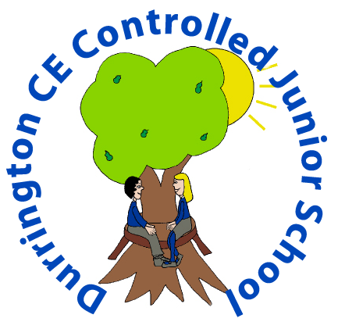

Thank you for your interest in the post.

Durrington CE VC Junior School is located in the large village of Durrington, on the southern edge of Salisbury Plain. The number on roll is currently 175. We serve mainly the local community, but a significant number of pupils come from surrounding towns or villages such as Amesbury, Bulford and Larkhill. Although about 17% of our pupils come from service backgrounds, we enjoy a stable school population.
The school is housed in a mixture of older and more modern buildings and is situated in attractive grounds. We have a strong musical and sporting tradition with lots of competition, creativity and performance.

We were confirmed as continuing to be a GOOD school by Ofsted in November 2023 and judged to be GOOD as a Church School in March 2023.

We are very proud of our well-behaved and hard-working children, and we aim to offer them a rich and challenging curriculum within a happy and secure environment. The school is well-regarded locally for its pastoral care while children’s spiritual development is another of our strengths. We are fortunate to have stable and experienced teaching staff and a terrific team of support staff and have many links with the local community through the Church, governors and friends of the school. We want staff to enjoy working here so we try hard to keep workload manageable and the staffroom a happy place. Please look at our website www.durrington-jun.wilts.sch.uk for much more about us! Alternatively, take a look at our School Facebook page https://www.facebook.com/DurringtonJuniorOfficialPage

Yours sincerely

Karl Caslin
Headteacher

