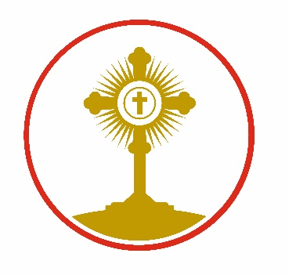

St Clare’s Catholic Primary School, A Voluntary Academy
‘I have come that they may have life and have it to the full.’
Fagley Road, Fagley, Bradford BD2 3JD
01274 637841
office@stclares.bradford.sch.uk
Headteacher: Mrs R d’Arcy

Dear Applicant

Thank you for your interest in joining St Clare’s Catholic Primary School.
St Clare’s is a thriving and successful school, supported by a dedicated, experienced, and highly effective staff team. Our pupils are happy, welcoming, and eager to learn, contributing to a warm and friendly school community. We pride ourselves on being a fully inclusive school, where every child is valued and supported to flourish. This is rooted in our mission statement, inspired by John 10:10: “I have come that they may have life, and have it to the full.”

We would be delighted to invite you to visit our school, where you can meet our team, explore the environment, and ask any questions you may have before submitting your application.

We look forward to meeting you and wish you success with your application.

Yours faithfully

Mrs. R d’Arcy
Headteacher

