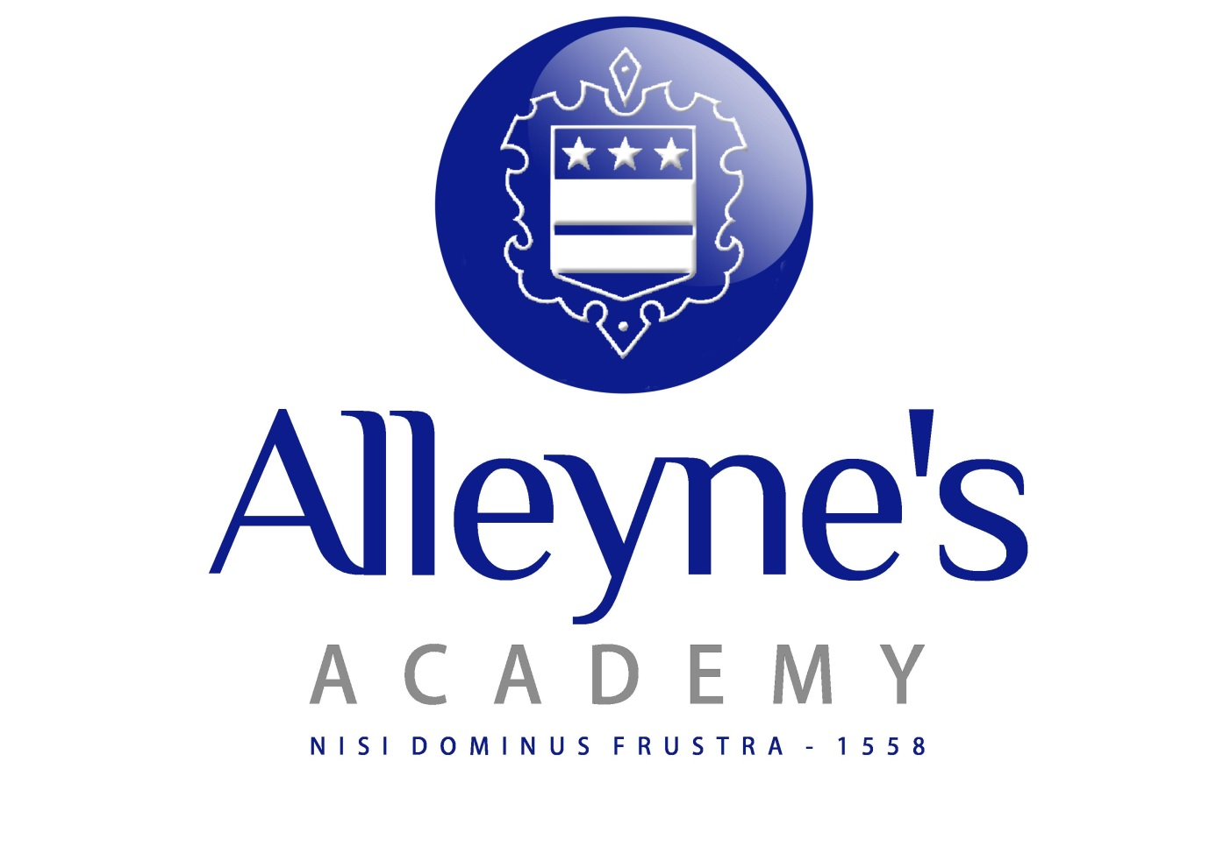

The English Faculty

The department has six full time and one part-time teachers who work closely as a team to deliver high quality teaching and experiences for our students. As a consequence, standards of achievement are consistently of a very pleasing standard.

When pupils arrive at Alleyne's in Year 9, they pursue a continuous programme of English Language and English Literature study through to the end of Year 11. Pupils are grouped according to their ability in Year 9 and, in order to provide continuity, for the most part remain in those groups in Years 10 and 11. All students sit both GCSE English Language and English Literature.

Students in Years 12 and 13 have the opportunity to study both English Language and English Literature to A Level and both subjects are immensely popular, with results at A2 consistently in line with or above the national average.

Students at all levels are encouraged to take part on extra-curricular activities such as theatre trips and poetry competitions.

This is a department that has enjoyed considerable success with both exam results and extra-curricular activities and is looking forward to building on this in the future.

