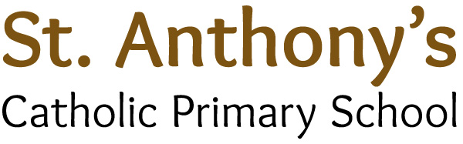

Address: Barkly Road, Beeston, Leeds, LS11 7JS
Head Teacher: Miss L S Leonard BA (HONS) QTS NPQH
Tel: (0113) 2776944
Fax: (0113) 2772633
Website: stanthonysleeds.co.uk
E-mail: l.leonard@stanthonyleeds.org.uk

“Growing together on a journey with Jesus”

Permanent Teaching Assistant

Salary: (Level 1 TA Scale point 1-6) , Term time only (27.5 hours weekly)

Start Date: 24th February 2025
Would you like to share your gifts and talents in an outstanding Catholic school that strives for excellence in all areas?

St Anthony’s Catholic Primary School is a thriving and inclusive school at the very heart of the community and parish it serves. As a recently inspected Ofsted ‘outstanding’ school (2024), we permanently look to develop teaching assistants to make a real impact on the lives of our children. Consequently, we are seeking to appoint an inspirational and innovative teaching assistant who possesses the skills and passion to ensure every child ‘grows on their journey with Jesus’.
We are looking for someone who is:
- A practicing Catholic or committed to sustaining the strong Catholic Ethos of the school.
- Able to demonstrate high levels of English and Maths skills to support our pupils in EYFS/KS1 or KS2.
- Creative and highly motivated, with passion and patience for providing quality learning experiences, including supporting pupils with special educational needs.
- Emotionally intelligent, placing immense value on developing the whole child.
- Able to communicate effectively with children, parents, colleagues and governors.
- Be able to work effectively as part of a team.

We can offer you:
- Enthusiastic, highly motivated and cherished children who take great pride in attending St Anthony’s.
- A fantastic team of dedicated and supportive staff who strive to have an impact on children’s lives.
- A perfect balance of care and support with high expectations.
- An attractive, stimulating and well-organised learning environment.
- Supportive and committed parents and governors.
- A leadership team dedicated to attainment, achievement and enjoyment.
- The opportunity to forge a career pathway through effective and supportive CPLD, as well as guidance from an innovative and experienced team.

All applicants who can demonstrate strong skills and experience will be welcomed.

‘This school inspires faith, hope and excellence.’
(S48)

Interested? If so, we would like to meet you. Prospective candidates are encouraged to visit the school prior to application; visits can be arranged (and are positively welcomed) by contacting the school on 0113 2776944 or by emailing the headteacher, Miss Lisa Leonard on l.leonard@stanthonysleeds.org.uk.
Application packs are available to download from our school website. Please use the CES application form. Only electronically completed application forms will be considered.

Closing date: Friday 17th January 2025
Shortlisting: Friday 17th January 2025
Interview dates: Wednesday 22nd January 2025

St Anthony’s Catholic Primary School is committed to safeguarding and promoting the welfare of children and expects all staff and volunteers to share this commitment. Our GDPR guidelines and policies are adhered to and displayed on our school website.
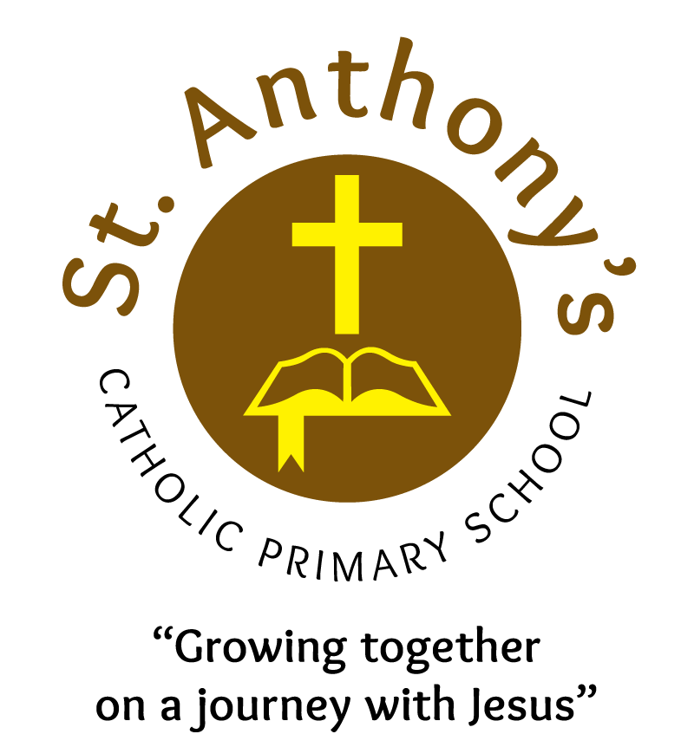
The successful candidate will be subject to an enhanced DBS disclosure and must be prepared to apply for ISA registration if required. Shortlisted candidates will be subject to a google online search.
We promote diversity and desire a workforce that reflects the population of Leeds.

