

Email: hr@stcatherines.worcs.sch.uk

Permanent, variable (15 – 30hrs) Grade 2 Teaching Assistant (Term-time only)

Thursday 11th June 2026
Dear Colleague,

Thank you for your interest in the position of Permanent, Variable Hours Grade 2 Teaching Assistant at St Catherine’s CE Primary School. We are delighted to provide you with the enclosed application pack and hope that it gives you a flavour of our school community and inspires you to submit an application.

St Catherine’s is a school with much to celebrate. Alongside strong outcomes for our children, we pride ourselves on the positive relationships that exist between pupils, staff, parents, governors and the wider community. We believe that when talented people work together with a shared sense of purpose, children thrive.

As a school, we are committed to continual improvement. We work hard to provide the very best educational experiences for our pupils while always keeping our focus on what matters most – ensuring every decision we make benefits the children in our care.

We are seeking an enthusiastic and dedicated Teaching Assistant who shares our commitment to nurturing, inspiring and supporting every child to achieve their potential. In return, we offer high-quality professional development and opportunities to grow your skills and expertise within a supportive and collaborative team. You will work alongside experienced colleagues who are passionate about learning and always willing to share ideas and embrace new approaches.

If you have a genuine passion for supporting children and want to make a positive difference in a caring and ambitious school community, we would be delighted to hear from you.

Should you wish to discuss the role further, please contact our HR Manager, Julie Cook, by email at hr@stcatherines.worcs.sch.uk or by telephone on 01562 823614.

We look forward to receiving your application.

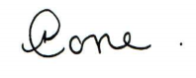
Yours sincerely,

Amanda Cope
Headteacher
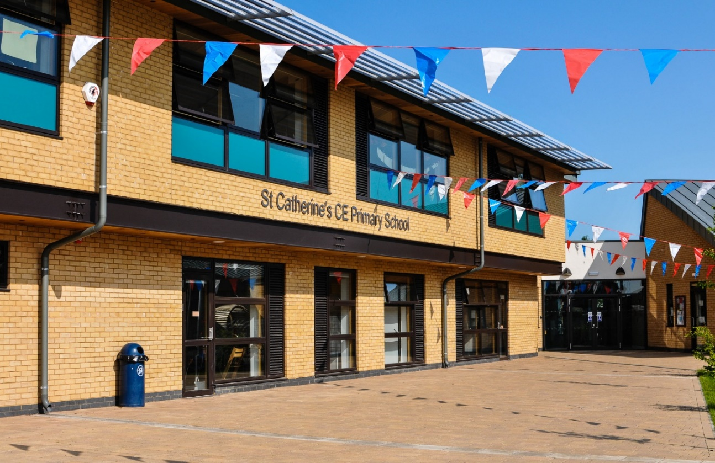

Appointment Schedule:

Permanent, variable (15-30hrs) Grade 2 Teaching Assistant (Term-time only)

Mon – Fri, 8:40am – 3:10pm/3:15pm (dependant on which Key Stage you are working in)
plus 1 x afterschool club session (45mins – 60mins)
Start Date – 1st September 2026

Closing date for all applications: Friday 26th June 2026

Short listing – Friday 26th June 2026

All candidates will be contacted on the afternoon/evening of Friday 26th June, to inform you whether you have been shortlisted for the next stage of the recruitment process.

Formal interviews will take place on Friday 3rd July 2026

Applications must be made using the electronic Worcestershire Local Authority application form which is attached to the application pack. All sections of the form MUST be completed. If you have no information to include in any section, please write ‘nil’ so that the short-listing panel know you have not simply omitted to complete the form. Please make sure that you include a current email address for your referees.

Safeguarding Commitment
St Catherine’s CE Primary School is committed to safeguarding and promoting the welfare of children. This post is subject to an enhanced Disclosure and Barring Service (DBS) check including a check against the Children’s’ Barred List, satisfactory references being obtained including one from the previous employer and an online search being carried out in accordance with latest version of Keeping Children Safe in Education.
The successful candidate will share this commitment and ensure the highest standards of care and protection for all pupils.
Applications may be emailed to the school (all emailed applications will be acknowledged by a return message). Please send your application to hr@stcatherines.worcs.sch.uk

Job Description

Teaching Assistant – Grade 2

To work under the guidance of teaching staff and senior leaders to support pupils in accessing learning, making good progress, and achieving their full potential. The postholder will promote pupils’ wellbeing, independence and positive behaviour, and contribute to a safe, inclusive and nurturing learning environment.

The role includes supporting individuals and groups of pupils and, where appropriate, supervising groups or occasionally whole classes for a lesson or session in the classroom or other learning environments.

Main Responsibilities
Support for Pupils
- Deliver planned learning activities to individuals and groups under the direction of the class teacher, including implementing Individual Learning Plans (ILPs) and targeted interventions.
- Provide effective support for all pupils, including those with additional needs, ensuring their safety, wellbeing and full participation in learning.
- Observe, monitor and record pupils’ progress, providing timely and accurate feedback to teachers.
- Attend to pupils’ pastoral, social, emotional and personal care needs, including health, hygiene, welfare and basic first aid where appropriate.
- Build positive, respectful relationships with pupils and model high expectations for behaviour, attitudes and learning.
- Promote inclusion, equality and acceptance, ensuring every child feels valued and supported.
- Encourage pupils to develop confidence, resilience and independence.
- Occasionally supervise whole classes or groups during short-term teacher absence, where directed and appropriate to the role.

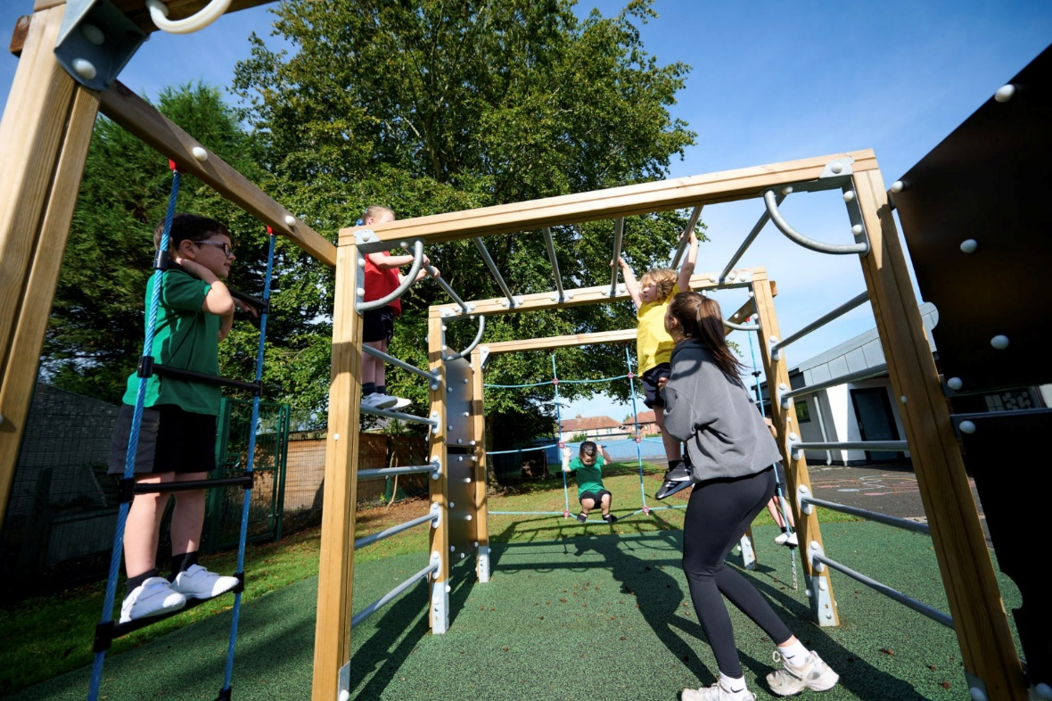
Support for Teaching and Learning
- Prepare classrooms, resources and equipment for learning activities and assist with clearing away afterwards.
- Provide administrative and clerical support, including photocopying, filing and maintaining classroom records.
- Maintain accurate pupil records and contribute to reports or assessments as requested.
- Support the implementation of behaviour management strategies in line with school policy.
- Build constructive relationships with parents and carers, passing relevant information to teaching staff where appropriate.
- Monitor pupils’ engagement and responses to learning activities and record progress accurately.
- Contribute to planning discussions and assist with the preparation, adaptation and organisation of learning resources.
- Support pupils in the effective and safe use of technology to enhance learning and develop independence.

Support for the Curriculum
- Deliver structured learning programmes and interventions under teacher direction, adapting activities to meet pupils’ needs and providing feedback on outcomes.
- Support the implementation of local and national curriculum initiatives and school priorities.
- Assist with assessment activities and contribute evidence of pupil achievement and progress.

Support for the School
- Uphold and actively promote the school’s safeguarding responsibilities, reporting concerns promptly in accordance with statutory guidance and school procedures.
- Comply with all health and safety, security, confidentiality and data protection requirements.
- Work collaboratively as part of a professional team, maintaining positive relationships with colleagues and other stakeholders.
- Supervise pupils safely during classroom activities, educational visits, playtimes or other designated times as required.
- Support the school’s Christian vision and values, contributing positively to its ethos and mission.
- Champion inclusion and equality of opportunity for all pupils.
- Attend staff meetings, training events and professional development opportunities as required.
- Engage positively in appraisal and continuing professional development to enhance knowledge and practice.

Additional Information
The Headteacher will ensure that the postholder has the appropriate qualifications, skills, experience and training necessary to undertake any specified work assigned to them.

A Grade 2 Teaching Assistant may occasionally provide cover supervision for groups or whole classes for a lesson or session. This may include contributing to planning, preparation, assessment and reporting, under the direction of qualified teaching staff and in accordance with school policies.

The postholder is expected to carry out all duties in accordance with the policies and procedures of the Governing Body and St Catherine’s CE Primary School, demonstrating professionalism, integrity and a commitment to securing the best possible outcomes for every child.

Person Specification

Teaching Assistant

Listed below are the minimum requirements considered necessary for the post. In your application, please address each of the essential areas (Experience, Qualifications and Training, Skills and Abilities and personal qualities) and any relevant desirable qualities, giving details of your experience together with examples of how you have undertaken tasks which illustrate clearly that you have the relevant experience, abilities, skills, knowledge and commitment for the post.

Person Specification – Grade 2 Teaching Assistant
Attributes | Essential Criteria | Desirable Criteria | Assessment Method
Experience | A minimum of two years’ successful experience working with primary-aged children in a primary, first school or EYFS setting. | Experience of working within the Early Years Foundation Stage (EYFS). | Application Form, References, Interview
Experience | Experience of planning and leading learning activities for small groups of pupils. | Experience of supporting pupils with additional educational needs and disabilities (SEND). | Application Form, References, Interview
Experience | Experience of providing effective one-to-one support to pupils to enable progress and participation. | Experience of undertaking cover supervision for classes or groups. | Application Form, References, Interview
Experience | Knowledge and understanding of how to support pupils’ learning in line with curriculum objectives and individual next steps. | Experience of delivering targeted intervention programmes. | Application Form, References, Interview
Qualifications and Training | A recognised Level 2 Teaching Assistant qualification (or equivalent). | Relevant additional training in areas such as SEND, behaviour support or safeguarding. | Application Form, Certificates
Qualifications and Training | Willingness to undertake further professional development and training to enhance effectiveness in the role. |  | Application Form, Interview
Skills and Abilities | Demonstrable ability to make a positive contribution to high-quality learning and teaching. |  | Application Form, References, Interview
Skills and Abilities | Excellent written and verbal communication skills. |  | Application Form, References, Interview
Skills and Abilities | Knowledge and understanding of supporting pupils with additional needs, including areas such as autism spectrum condition (ASC), speech, language and communication needs (SLCN), or similar. | Additional qualifications for supporting children with additional needs. | Application Form, References, Interview
Skills and Abilities | Good digital literacy and confidence in using IT and educational software to support learning. | Experience of using interactive classroom technologies and online learning platforms. | Typed Application Form, References, Interview
Personal Qualities | Self-motivated, organised and conscientious, with a strong commitment to supporting children’s learning and wellbeing. |  | References, Interview
Personal Qualities | Reliable, honest, approachable and able to maintain confidentiality and professionalism. |  | References
Personal Qualities | Able to build positive working relationships with pupils, parents, colleagues and external professionals, working effectively as part of a team. |  | Application Form, References, Interview
Personal Qualities | A commitment to supporting and promoting the Christian vision, values and ethos of the school. |  | Application Form, Interview
Personal Qualities | Flexible, resilient and willing to embrace new initiatives and continuous professional development. |  | Application Form, Interview

