job description
personal tutor.
reports to: Director of Student Development
hours: Permanent full time role, term time only
salary: SP 15-18 £29,346-£32,259 (pro rata to term time only £25,090-£27,581)
start date: As soon as possible

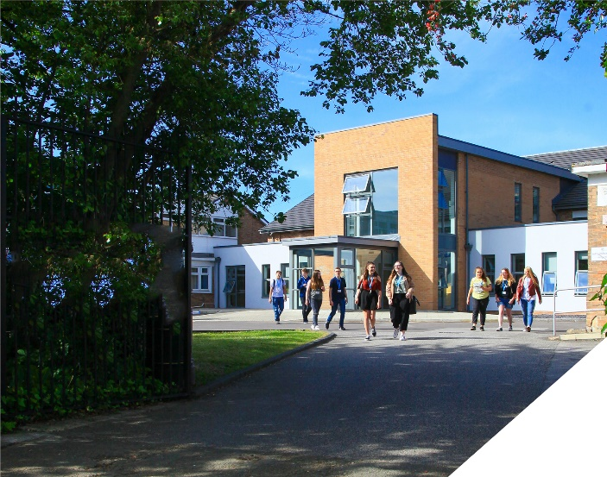
about the role.
The Student Development team is an outstanding part of an ambitious College, with highly dedicated and hardworking tutors. We are looking to appoint someone who will become an integral part of this proactive and skilled team and who will contribute to the excellent student experience. All students are allocated a personal tutor at the College. The team consists of eleven tutors and a co-ordinator – all of whom bring a broad skill-set and an enthusiasm for developing young peoples’ aspirations. There is a strong team ethos within the department and you will be fully supported by both other personal tutors and also by your line manager. This role is ideal for anyone who has the desire to make a positive impact on the lives of young people.
The Student Development team at the College are a team of dedicated and highly skilled tutors that ensure students make rapid progress whilst at the same time enjoying their studies. This therefore means the role of the tutor is very varied as students will present a wide array of differing needs and problems. You will therefore need to be able to quickly adapt to different situations and use a range of strategies to ensure students meet our expectations at College. The role entails the following: delivering weekly informative and highly relevant tutorials to each tutor group; offering advice, guidance and support to enable students to navigate College life effectively; monitoring and managing attendance and behaviour issues; liaising with parents/guardians where necessary; and preparing students for their next steps (including overseeing UCAS applications for all students). Tutors also form an integral part of the Admissions team and are responsible for interviewing prospective students at interview evenings and attending liaison activities at partner high schools (including some evenings).
about the College.
This is an exciting opportunity to join a highly successful and innovative sixth form College. The College was awarded the UK Sixth Form College of the Year by the TES in 2018 and this followed being graded outstanding in all areas by OFSTED in December 2016. All staff play a vital role in the experience that students have with us and ultimately their success.

The College currently has a 16 to 19-year-old student population of 1400 and is oversubscribed.

The College is committed to its core values of Positivity, Ambition, Resilience and Thoughtfulness, and these values shape everything we do. Our ethos is centred on the scientific evidence that tells us that everyone can achieve success through purposeful hard work as opposed to the talent myth, and as such, the College is in itself an engine for social mobility.

person specification.
Qualifications | essential | desirable
Degree or equivalent qualification | 
Careers/Advice & Guidance qualification |  | 
Experience
Minimum 12 months experience in educational (or similar) setting | 
Student guidance experience or similar | 
Effective liaison with external agencies |  | 
Knowledge / Skills / Abilities
Knowledge of progression routes for students | 
Knowledge of careers information, advice and guidance | 
Knowledge of HE | 
Excellent multi-tasking skills | 
Good organisational, administrative and presentation skills | 
Good level of IT skills, including use of: Word, Excel, Access, PowerPoint with an ability to input data accurately | 
Ability to work in fast-paced, demanding environment | 
Ability to communicate clearly and effectively | 
Ability to work with groups of young people | 
Ability to set clear targets and evaluate outcomes | 
Ability to work cooperatively with a range of people | 
Ability to work under pressure and maintain a sense of humour and perspective | 
Ability to seek positive solutions | 
Ability to work in a flexible, proactive manner and as part of a team | 
Ability to demand high standards from oneself and others | 
To demonstrate a commitment to
The Colleges values of Positivity, Ambition, Resilience & Thoughtfulness | 
Personal development and training | 
Safeguarding & promoting the welfare of students | 
Equality & diversity | 
how to apply.
If you are ambitious and determined to make a meaningful difference in one of the country’s leading sixth form Colleges then we would be thrilled to have you join our team.

- Please complete the Support Staff Application Form which is available on the College website: www.bsfc.ac.uk
- Write a Letter of Application of no more than two sides of A4 explaining how your qualifications and experience match the requirements of the Person Specification detailed above.

Please email these to: hrdept@bsfc.ac.uk

closing date: 12 noon, Friday 12th April 2024
Anticipated Interview date: Wednesday, 17th April 2024
Previous applicants need not apply

Application Form can be downloaded from the College website: www.bsfc.ac.uk

General Information
Birkenhead Sixth Form College has a commitment to safeguarding and promoting the welfare of students and expects all staff and volunteers to share this commitment. If you are invited for interview, your suitability to work with children will be explored as well as your suitability for the post.
All posts are subject to Enhanced Disclosure Clearance through the Disclosure & Barring Service.
The College is an Equal Opportunities employer and all members of the College have a personal responsibility to implement the policy, to carry out their responsibilities in accordance with it and to maintain an equality of opportunity for all.
The Governors and staff of the College take their duties under the Disability Discrimination Act (as amended by the Special Educational Needs Act 2001) very seriously. They will ensure that all reasonable adjustments are made to ensure that disabled people are treated fairly and that they are not placed at any substantial disadvantage. The College is committed to interview all applicants with a disability who meet the minimum criteria for the post and to consider them on their abilities.

Reference Checking
On the application form, you are asked to provide details of two employment referees (preferably your line manager from your current and previous or most recent employer/s), who can comment on your suitability for the post. References from relatives or individuals writing in the capacity of friends will not be accepted.

The College will seek references on short-listed applicants before interview, and will approach previous employers for information to verify suitability for the post, dates of employment, particular experience or qualifications, attendance / punctuality history and details of any disciplinary offences.

In addition, if you are currently working with children or young people, on either a paid or voluntary basis, your current employer will be asked about your suitability to work with children and any disciplinary offences relating to children or young people. This will include any offences for which the penalty is time expired (that is where a warning could no longer be taken into account in any new disciplinary hearing for example) and whether you have been the subject of any child protection concerns, and if so, the outcome of any enquiry or disciplinary procedures. If you are not currently working with children but have done so in the past, that previous employer will be asked about those issues. Please note providing false information is an offence and could result in your application being rejected, or dismissal without notice if you have been appointed and possible referral to the police.

