PHASE LEADER APPLICATION PACK
Recruiting for September 2021
Closing date: 14th May 2021

Dear Applicant,

Thank you for replying to our advertisement for the position of a phase leader at Orchard, Southwold & Hoxton Garden Primary Schools. I hope that you will find this information pack helpful. If you would like to learn more about our schools’ partnership we would be delighted to answer any questions you may have. Our contact details are on page four. We offer tours of all three school sites so you can see firsthand what we do and how we work.

Orchard, Southwold and Hoxton Garden Schools are all based in the vibrant and diverse communities of Hackney. With a joint pupil roll of nearly 1300 pupils we are a dynamic and fast moving organisation with a passion for making a difference and not accepting excuses for low standards. All three schools have their own leadership teams who work together with the common aim of giving children the very best. We have set an ambitious vision for the future and have very high standards for what can be achieved with the benefits of a shared expertise. Children at all three schools now attain above national averages and we are constantly striving to go beyond outstanding.

We have a very skilled team of highly committed and professional teachers and leaders who work incredibly hard and there is always much to do. We are now looking to recruit phase leaders with experience and ambition who want to further develop their leadership skills and talents. First and foremost we are looking for dynamic and confident teachers and leaders who have the energy and skill to make a difference as well as the flexibility to work in a large organisation. This post offers the possibility of working in any of our three schools and future opportunities to experience working on different school sites.

We take our role in raising the aspirations of our children and meeting the ambitions of our staff very seriously. Staff from all three schools meet regularly to share expertise with common systems and a shared curriculum. Subject and phase leaders work together to make sure that all of our pupils have excellent opportunities to learn.

If you are hardworking, reflective, resilient, and an outstanding classroom practitioner, looking to further develop your skills as a teacher and leader then we would love to hear from you.

Kind regards, Rachel Davie (Executive Headteacher)

Orchard, Southwold and Hoxton Garden have been working in a very successful partnership for over 5 years. We have a joint Governing Body and strong links to our Local Authority, Hackney Education. Each school has its own leadership team who work together with the common aim of giving children the very best. We have very high standards for what can be achieved with the benefits of a shared expertise. Although many of our pupils come from disadvantaged backgrounds or speaking a language other than English, we do not use this as an excuse for under achievement and have the same ambition for all pupils regardless of circumstances. Disadvantaged pupils at our school achieve significantly better than those nationally because of this belief, ambition and hard work.

We are looking to appoint a skilled individual who wants to make a difference to the life opportunities of our children and families and who is able to effectively support our inclusion team.

In particular we are looking for someone who:

- Has previous experience of working in a primary school
- Has high expectations of what can be achieved
- Is passionate about how children learn best and never gives up on them
- Is flexible with a good sense of humour and an understanding of the ‘bigger picture’
- Hard working, creative and has a good sense of fun
- Tough enough to cope with the daily challenges that working in fast paced inner city schools can bring
- Is an excellent communicator who is able to earn the trust and respect of others
- Is able to work to their own initiative as well as part of a team
- Puts children and their right to an excellent education first
- Has experience of planning provision for vulnerable children and hard to reach families

We can offer you:

- A genuine opportunity to make a difference
- Opportunities to work across partner school sites
- High quality support and CPD to ensure that you are successful
- An exciting, well organised and vibrant environment in which to work.
- A fantastic community of parents and children who deserve the best
- A supportive and highly experienced leadership team

If you would like to learn more about us and what we do there is more information on our school websites including an outline of our curriculum and our aims in more detail. We would also be delighted to give you a tour and answer any questions that you may have and this can be arranged by calling Beverley Shore (School Manager) on 0208 985 7785. Alternatively email us at: recruitment@vs.hackney.sch.uk.

Yours sincerely, Rachel Davie (Executive Headteacher)

Contents
Welcome Letter
Why work with us?
Who are we looking for?
How to apply
Job Description
Personal Specification

Why work with us?

This post offers a genuine opportunity to lead and will require you to work in partnership with the senior team, taking our schools to the next level and raising standards in teaching & learning. We offer an ambitious, exciting place to work, a genuine opportunity to make a difference, a great team of staff and a three school community who deserve the very best.
Our staff have access to:
- Opportunities to work across partner school sites
- High quality support and CPD to ensure that you are successful
- An exciting and well organised environment in which to work
- A supportive and highly experienced leadership team

Who are we looking for?

We are looking to appoint skilled and ambitious teacher to lead our EYFS, KS1 or KS2 provision and take responsibility for a whole school curriculum area.

In particular we are looking for someone who:

- Is an outstanding teacher with very high expectations of what can be achieved and proven track record of raising pupil attainment
- Understands how children learn best and never gives up on them
- Is determined, resilient with high expectations of themselves and others, leading by example
- Understands what high standards look like and how to attain them
- Is flexible with a good sense of humour and an understanding of the ‘bigger picture’
- Can effectively coach and mentor others with genuine impact
- Can effectively lead a team to the benefit of children
- An innovator who can take risks to make a school improvement project their own
- Have a clear idea of what outstanding learning & teaching should look like

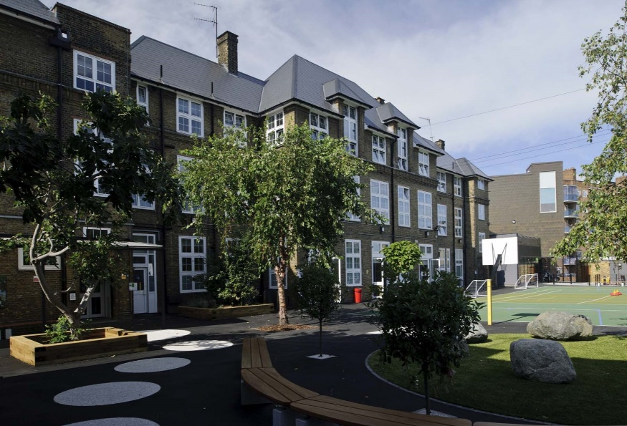

HOW TO APPLY
- Read the job description and person specification carefully.
- Complete the application form either electronically or print it off and hand write it.
- Ensure your supporting statement relates to the competencies outlined in the person specification.
- Email your competed application to Ms Beverley Shore at
recruitment@vs.hackney.sch.uk

or send by post:

Recruitment
c/o Southwold Primary School Detmold Road
London E5 9NL

Our schools are committed to safeguarding and promoting the welfare of children and young people and expects all staff and volunteers to share this commitment. Successful candidates will be required to complete an enhanced DBS disclosure.

We welcome applications from all sections of the community, regardless of gender, race, religion, disability, sexual orientation or age.

Should you like to arrange to visit our schools please contact Ms Beverley Shore on: 0208 806 5201 or email: recruitment@vs.hackney.sch.uk

We look forward to receiving your application!

Closing date: 14th May 2021

Phase Leader
JOB DESCRIPTION
(Grade: MPS/UPS/LP ~ Salary Range £32,157 - £50,935
+ TLR2C £6,771)

Main Purpose
In addition to the expectations detailed in the Teachers Pay & Conditions Document (as a class teacher), the post holder should play a major role under the overall direction of the school supporting the Senior Leadership Team in:
- Formulating the aims and objectives of the school
- Establishing the policies through which they should be achieved
- Managing staff and resources
- Monitoring progress towards achievement
- Leading across the school in a curriculum area

Essential Qualifications
- Educated to degree level
- Qualified teacher status
- At least 2 years full time classroom teaching experience
- Experience of leading a subject /phase or team

Person Specification

Experience
- Will have had some experience of teaching in a multicultural inner city environment, ideally in more than one year group.
- An outstanding classroom practitioner.
- Experience of leading a subject area.
- Experience of leading a whole school initiative.

Practical Skills
- Excellent classroom teacher.
- Excellent interpersonal skills.
- Secure people management skills.
- Highly competent in use of IT.
- Ability to think creatively and be solution focussed.
- Understanding of teaching strategies and teaching styles.

Main Activities:

Leadership
- Be a member of the extended leadership team.
- Support and implement the vision and ethos of the school
- Contribute to, implement and evaluate the success of School Development Plan relevant to your teaching across the phase.
- Ensure policies are translated into practice by the team, be an effective role model for your team in teaching, behaviour and classroom environment.
- Line manage teachers and TAs within the phase.
- Implement and support the performance management process as a reviewer.
- Lead weekly phase meetings with impact focus direction.
- Lead phase assemblies upholding the school vision and values to children.

Curriculum
- Lead, develop and enhance the teaching practise of others in the phase through coaching, mentoring and leading by example as an outstanding practitioner.
- To review planning and teaching within the phase in order to meet individual pupils needs, including SEND, most able, disadvantaged and children with English as an Additional Language.

Assessment
- Closely monitor the progress of the phase ensuring that progress is made.
- Ensure that the target setting process is robust and is linked to standards and measurable to enable impact.
- Use data and children’s work to monitor progress and implement changes where necessary.

Liaison
- Liaise with other phase leaders to ensure effective transition for pupils from one year to another.
- Work with other phase leaders to ensure effective communication across the school.
- To lead staff training to share practice and school standards.
- To provide curriculum information for parents such as letters and booklets, in line with school policy and in consultation with the Deputy Headteacher.
- To lead parents meetings/workshops, in consultation with the Deputy Headteacher.
- To organise special assemblies, performances, school trips and other events.
- To promote the image of the school within the local community.

General
- Provide support to the Headteacher in the management of all aspects of the day to day running of the school, ensuring that the aims, policies and values are upheld.
- Be mindful of Health and Safety regulations.

Pastoral
- Actively encourage and support all staff, providing advice, praise and support.
- To provide for the pastoral, educational, social, moral, spiritual and cultural development across the phase.

