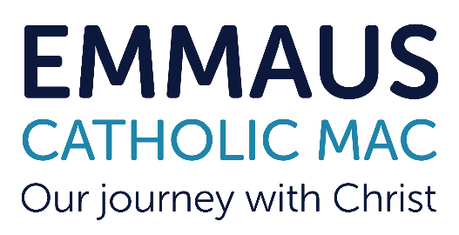

Emmaus Catholic MAC is committed to safeguarding and promoting the welfare of children and young people.This position is subject to an Enhanced Disclosure check under the Rehabilitation of Offenders Act 1974.
All applicants must be able to provide documentation to prove their right to work in the UK.
St Marys Catholic Primary School is looking to appoint a level 6 Unqualified Teacher (UQTS) / Early Years Teacher (EYTS) / Early Years Professional (EYPS) to support the EYFS lead in leading the pre-school. The successful candidate will be dynamic, enthusiastic and an inspirational EYFS professional with a clear vision on how to build on the current Ofsted ‘Good’. They will continue to raise standards and further enhance the curriculum so that it enriches the lives of our children, make learning engaging and fun, and ensures every child’s talents are developed to the full. Promoting the school ethos and supporting the children with the transition from preschool to reception is key.
St Mary’s Catholic Primary School, Brierley Hill, is an innovative and outward looking school with happy, motivated and well-behaved children, an excellent staff team committed to raising standards, a supportive and enthusiastic Local Governing Body and strong links with our local Parish.
Under the leadership of the Principal, the successful candidate will play a full part in the development of a quality preschool that nurtures and develops our children.
This is a fantastic opportunity to join a forward thinking and growing
School, committed to an exciting vision of providing “excellent education
for all in the heart of our communities: nourishing faith, nurturing
talent, fostering aspiration.”

We are recruiting for a Pre School Manager
Required for September start
Salary £21,731 - £33,902 Grade UQTS Level 6

Contact Us
A full application pack is available from Mrs J Bate in the school office.
E-Mail- enquiry_stmarys@emmausmac.com
Phone – 01384985005
Online - St Mary's RC Primary School Brierley Hill - Home
We warmly welcome visits to the school. For specific questions about the role and/or to request a visit, please contact Mrs J Bate using the above details.

