

**Job Application Pack**

**Cherry Tree Hill Primary School**

**Premises Assistant**

**10 hours per week (4.30pm – 6.30pm)**

**Contract Type: Permanent (Term Time only)**

**Salary: Grade D, Point 7-9**

**Start Date: 1st September 2025 (earlier start could be negotiated)**

**Closing Date: Friday 30th May 2025**

**Interview Date: Wednesday 4th June 2025**



**Welcome letter from Paul Appleton, Head Teacher of Cherry Tree Hill Primary**

Dear Candidate,

Thank you for showing an interest in the role of Premises Assistant at our school. An exciting opportunity has arisen for a strong candidate to make a difference to our pupils at Cherry Tree Hill in Derby. We are looking for a candidate who will strengthen the team, who has good communication skills and will have our children’s best interests at heart.

Our school is a large primary, set in spacious grounds two miles from Derby City Centre. Visitors to our school comment positively on our facilities and the stimulating environment. They describe our atmosphere as respectful and nurturing, and you know what? It is!

Being the Headteacher of Cherry Tree Hill Primary School continues to give me great pleasure. I am fully committed to the community of Cherry Tree Hill Primary School and strive to ensure that the school serves our local children and their families well. I am proud to welcome you to our school and I look forward to welcoming you to our community.

Our school is part of the Odyssey Collaborative Trust. Our Trust is committed to supporting and delivering education of the highest quality across the trust. Here at Odyssey, we share one vision; ‘Our Children Thrive - Our Colleagues Thrive - Our community Thrives.’

This is a tremendous opportunity to make a difference and to be part of a dynamic and innovative staff team.

We look forward to receiving your application and working with you on your own professional journey to excellence.

Best regards,

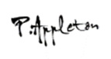

Mr Paul Appleton

Headteacher

Cherry Tree Hill Primary School





**About the school**

At Cherry Tree Hill, we endeavour to create a happy, secure, relaxed atmosphere whilst, at the same time, insist on high standards of both work and behaviour. Together we strive for the fulfilment of every child’s potential. Children are encouraged to be independent and self-reliant. They are taught to have respect for property, themselves and each other.

Parents are seen as important partners in their child’s learning, and are actively encouraged to get involved in the life of the school. Parents are always made welcome in school, and staff endeavour to find time to listen to their concerns.

We develop positive learning relationships with our children and recognise the importance of this. We are proud of our children, staff and school.

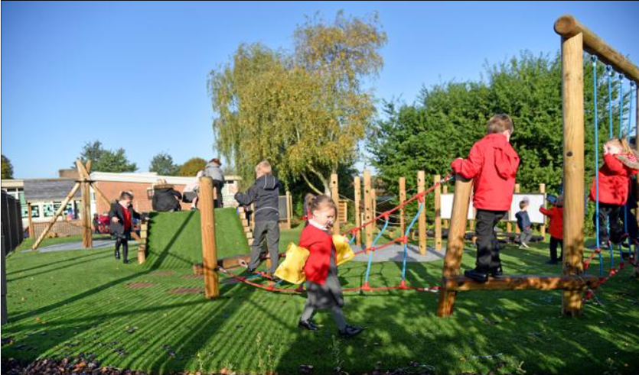

**Job Description – Premises Assistant**

**Application Details**

We are looking for an enthusiastic Premises Assistant to join our team here at Cherry Tree Hill Primary School. We need ambitious and driven candidates with a passion for helping children learn effectively. Everyone who visits our school comments on the calm atmosphere, the enthusiasm our children have for learning and the great sense of team amongst staff and children alike.

At Cherry Tree Hill we value every individual and put our children at the heart of everything we do. If you think this sounds like you then come and visit us to see for yourself. Visits are positively encouraged. Please phone or email to arrange a mutually convenient appointment. Find out if we’re right for you! Contact Holly Hassall on 01332 347275 or email [h.hassall@odysseyct.org.uk](mailto:h.hassall@odysseyct.org.uk).

Odyssey Collaborative Trust is committed to safeguarding and promoting the welfare of children. We follow safer recruitment procedures and will require an enhanced DBS clearance and references from current and past employers. Further details of this post, the school and the Trust are included in this pack and details of how to apply can be found below.

**How to Apply**

Should you wish to apply for the post, please complete and return an application form along with a covering letter addressed to Cherry Tree Hill Primary School which clearly demonstrates your suitability for this role. Applications can be submitted via email to h.hassall@odysseyct.org.uk, or by post, for the attention of Holly Hassall, to the following address: Cherry Tree Hill Primary School, Lime Grove, Chaddesden, Derby, DE21 6WL.

Wherever possible, please provide work email addresses for your referees.

**Closing Date**

Please ensure your application form arrives by Friday 30th May 2025 at 9am

Interviews for the role will be held Wednesday 4th June 2025

Our privacy notice can be found at <https://www.odysseyct.org.uk/gdpr/>

*Cherry Tree Hill is committed to safeguarding and promoting the welfare of children and young people, and expects all staff and volunteers to share this commitment. As this post is regulated activity, successful appointments are subject to an enhanced Disclosure and Barring Service check and relevant recruitment checks that comply with guidance in the most recent version of Keeping Children Safe in Education.*

*We are committed to equality of opportunity in employment and services*

*Cherry Tree Hill is part of the Odyssey Collaborative Trust*

All members of staff will receive training in line with our Safeguarding and Child Protection Policy.

**Equal Opportunities**

Odyssey Collaborative Trust welcomes applications from everyone and values diversity in our workplace. A commitment to promoting diversity and developing a workplace environment where all staff are treated with dignity and respect is central to our recruitment process.

**KEY PURPOSE OF THE JOB**

• To be responsible for the maintenance and security of the school premises and site, ensuring a safe environment.

**MAIN ACTIVITIES**

* Have a ‘hands on, can do’ approach.

• Security - undertake the locking up of the school site and opening as required.

• Undertake minor maintenance and DIY, including grounds maintenance if required (e.g. removal of leaves, litter picking and gritting).

• To operate the heating, lighting etc.

• To complete various safety checks, COSHH across the whole school in the absence of the Site Manager.

• To report major items for repair to senior staff in the absence of the Site Manager.

• To oversee some contractors and deliveries on site in the absence of the Site Manager.

• Cover in the absence of the Site Manager (up to 6 weeks a year).

• Work with the site manager on collaborative maintenance during school closure periods (as and when required).

**PRINCIPAL ACCOUNTABILITIES**

1. Ensure that buildings and the site are secure, including during out of school hours and take remedial action if required.

2. Act as a designated key holder for the school premises.

3. Operate systems such as heating, cooling, lighting and alarms.

4. Undertake minor repairs (i.e. not requiring qualified craftsperson) and maintenance of the buildings and site.

5. Undertake general porter duties, including moving furniture and equipment within the school.

6. Receive deliveries to the school site in and out of school hours.

7. Perform duties in line with health and safety and COSHH regulations and take action where hazards are identified, and report serious hazards to line manager immediately. Coming into contact with cleaning materials provided by the Cleaning Company.

8. Undertake any other appropriate duties as assigned by senior staff.

9. Collect and assemble waste for collection and other materials if required and liaise with office staff to ensure replenishment. When needed under the instruction of Senior Leadership team in the absence of the Site Manager.

10. Provide access to premises and arrange emergency repairs out of school hours.

11. Work in conditions that may be unpleasant, including cleaning toilets and occasionally other human waste, and deadline with minor hazards and waste.

**KEY ORGANISATIONAL OBJECTIVES**

The Post holder will contribute to the school’s objectives in service delivery by:

• Enactment of Health and Safety requirements and initiatives as directed

• Ensuring compliance with Data Protection legislation

• At all times operating within the school’s Equal Opportunities framework

• Contributing to the maintenance of a caring and stimulating environment for pupils

**SPECIAL CONDITIONS OF SERVICE**

Because of the nature of the post, candidates are not entitled to withhold information regarding convictions by virtue of the Rehabilitation of Offenders Act 1974 (Exemptions) Order 1975 as amended. Candidates are required to give details of any convictions on their application form and are expected to disclose such information at the appointed interview. Because this post allows substantial access to children, candidates are required to comply with departmental procedures in relation to Police checks.

If candidates are successful in their application, prior to taking up post, they will be required to give written permission to the Department to ascertain details from the Police regarding any convictions against them and, as appropriate the nature of such convictions. Equal Opportunity The post holder will be expected to carry out all duties in the context of and in compliance with the Council’s Equal Opportunities Policies.

These above-mentioned duties are neither exclusive nor exhaustive, the post-holder maybe required to carry out other duties as required by the Trust.

**As this job is designated as a ‘regulated activity’ an enhanced DBS with Barred list check is essential.**

**Person Specification**

**Post Title:** Premises Assistant

**Hours:** 10 hours per week (4.30pm – 6.30pm)

**Salary:** Point 7-9

|  |  |  |
| --- | --- | --- |
| **Person Specification Premises Assistant** | **Essential** | **Desirable** |
| **Qualifications & Experience** |  |  |
| Experience of Successful Caretaking Role | X |  |
| Evidence of Appropriate Professional Development |  | X |
| Accredited Health and Safety Training |  | X |
| **Knowledge & Skills** |  |  |
| Knowledge of Health and Safety Principles and Procedures within the Health and Safety at Work Act and COSHH Regulations, or willingness to attend relevant training | X |  |
| Able to Safely Operate Heating, Plant, Intruder and Fire Alarms, Door Controls and CCTV Systems | X |  |
| Ability to Undertake Minor Repairs and Maintenance of the Buildings and Site | X |  |
| Ability to Operate Manual, Electrical, Domestic and/or Industrial Equipment | X |  |
| Able to Work to Deadlines, without Supervision | X |  |
| Ability to Demonstrate Basic Use of a ICT |  | X |
| To be able to operate independently, with occasional lone working such as when opening and locking the school | X |  |
| Experience of Monitoring Stock and Supplies |  | X |
| Experience of Liaising with Onsite Maintenance Contractors, Checking Work is Completed to Required Standards and within Required Timescales |  | X |
| Experience of Handling Small Amounts of Cash for the Purchase of Materials |  | X |
| Ability to respond appropriately to unusual circumstances, emergencies, especially when on 24 hour call out | X |  |
| Plan and Deliver regular term time routines and for different routines during school holidays/big cleans |  | X |
| **Effective Relationships and Networks** |  |  |
| Form positive, professional and effective relationships with a range of personnel within the school e.g. Headteacher, Staff, Pupils, Parents, Contractors and Governors | X |  |
| Indirectly responsible for cleaning staff, their health and safety and welfare and for all users of the premises who are entitled to a safe and secure environment. |  | X |
| Willing to Facilitate Lettings and Carry Out associated tasks, in line with local agreements, with possible out of hours working |  | X |
| **Equalities, Inclusion and Safeguarding** |  |  |
| Knowledge and Aware of the Equality Act 2010 and How it Applies to this Job | X |  |
| Ensure that Equality Issues are Identified, Promoted and Managed in all areas of your work. | X |  |
| Evident of a good understanding and commitment to safeguarding, child protection and Health and Safety Procedures | X |  |
| **Personal Qualities** |  |  |
| Positive, Proactive, Tidy and Well Organised | X |  |
| Demonstrate the ability to work independently, using own initiative | X |  |
| Good communication and planning skills | X |  |
| Well-developed team working skills | X |  |