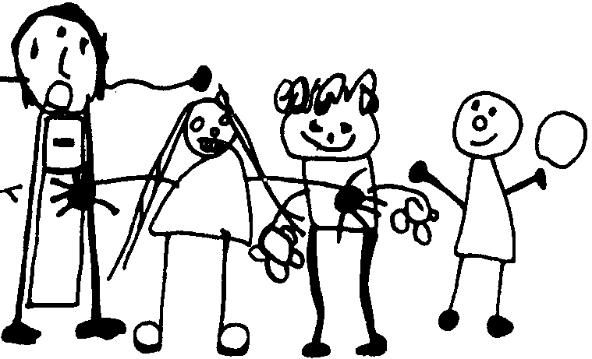Rachel McMillan Nursery School and Children’s Centre
Website: www.rachelmcmillannursery.co.uk
Email: admin@rachelmcmillan.greenwich.sch.uk

Post: Premises Assistant
Hours of work: 30 hours per week, Monday- Friday – 8.00am – 3.00pm
1 hour lunch unpaid . All year round
Grade and Scale: Grade 4 Scale 7-10 £27,030.00 - £29,139.00 full time equivalent
Actual Salary: 7-10 £23,875.71 – £24,976.29 pro rota, depending on experience

You must have GCSE level or equivalent, spoken and written English.

Permanent contract – (subject to probationary period)
Start date: October 2024.

This is an exciting opportunity to be joining Rachel McMillan Nursery School as a Premises Assistant. We are looking for an enthusiastic and positive individual who is passionate about offering children the safest learning and playing environment to join our premises management team.
You must be a clear communicator who takes pride in providing excellent services for children. Responsible to the Premises Manager, School Business Manager and Headteacher for the security of the building and the safety of staff and children. We are particularly interested in candidates who have very practical maintenance or D.I.Y experience that can uphold and preserve our characterful school site. When on duty, the daily hours of this post are to be agreed with the successful candidate. This could be blocked working hours OR a split shift. Occasionally you will be required to cover afternoon/evening shifts at the school during term time. Annual leave is to be taken during term time.
You will need to be reliable and self-sufficient with an ability to prioritise your work and use your initiative to undertake a variety of practical tasks including security of the building and grounds, maintenance of equipment and consumables. You will have some previous experience of working in a school with emphasis on health and safety practice and ensuring the wellbeing and safety of all the children and staff.
The post of Premises Assistant is fundamental to the school’s ongoing operation – including Health & Safety, security, the school environment and site buildings.

Rachel McMillan Nursery School is an equal opportunities employer. Committed to safeguarding and promoting the welfare of all children and expects all staff to share this commitment. All appointments will be conditional to a satisfactory Enhanced Disclosure being obtained via the Disclosure and Barring Service.

In line with KCSIE guidance, as part of the shortlisting process, we reserve the right to conduct an online search on shortlisted candidates as part of our due diligence and to share any pertinent information found concerning a candidate's suitability to work with children with the panel to be discussed at interview stage.

Closing Date: Midday 6th September 2024

Interviews: 19th September 2024

The successful candidate must meet the requirements of the
Person Specification to be offered the post. No C.V.s will be accepted.

If you are interested in visiting the school, please telephone
0208 692 4041 to book a time.

Please apply for this post via the ‘Application Form’ link.
You will not be short-listed unless you name two people to provide a reference – references will be requested before the interview.

