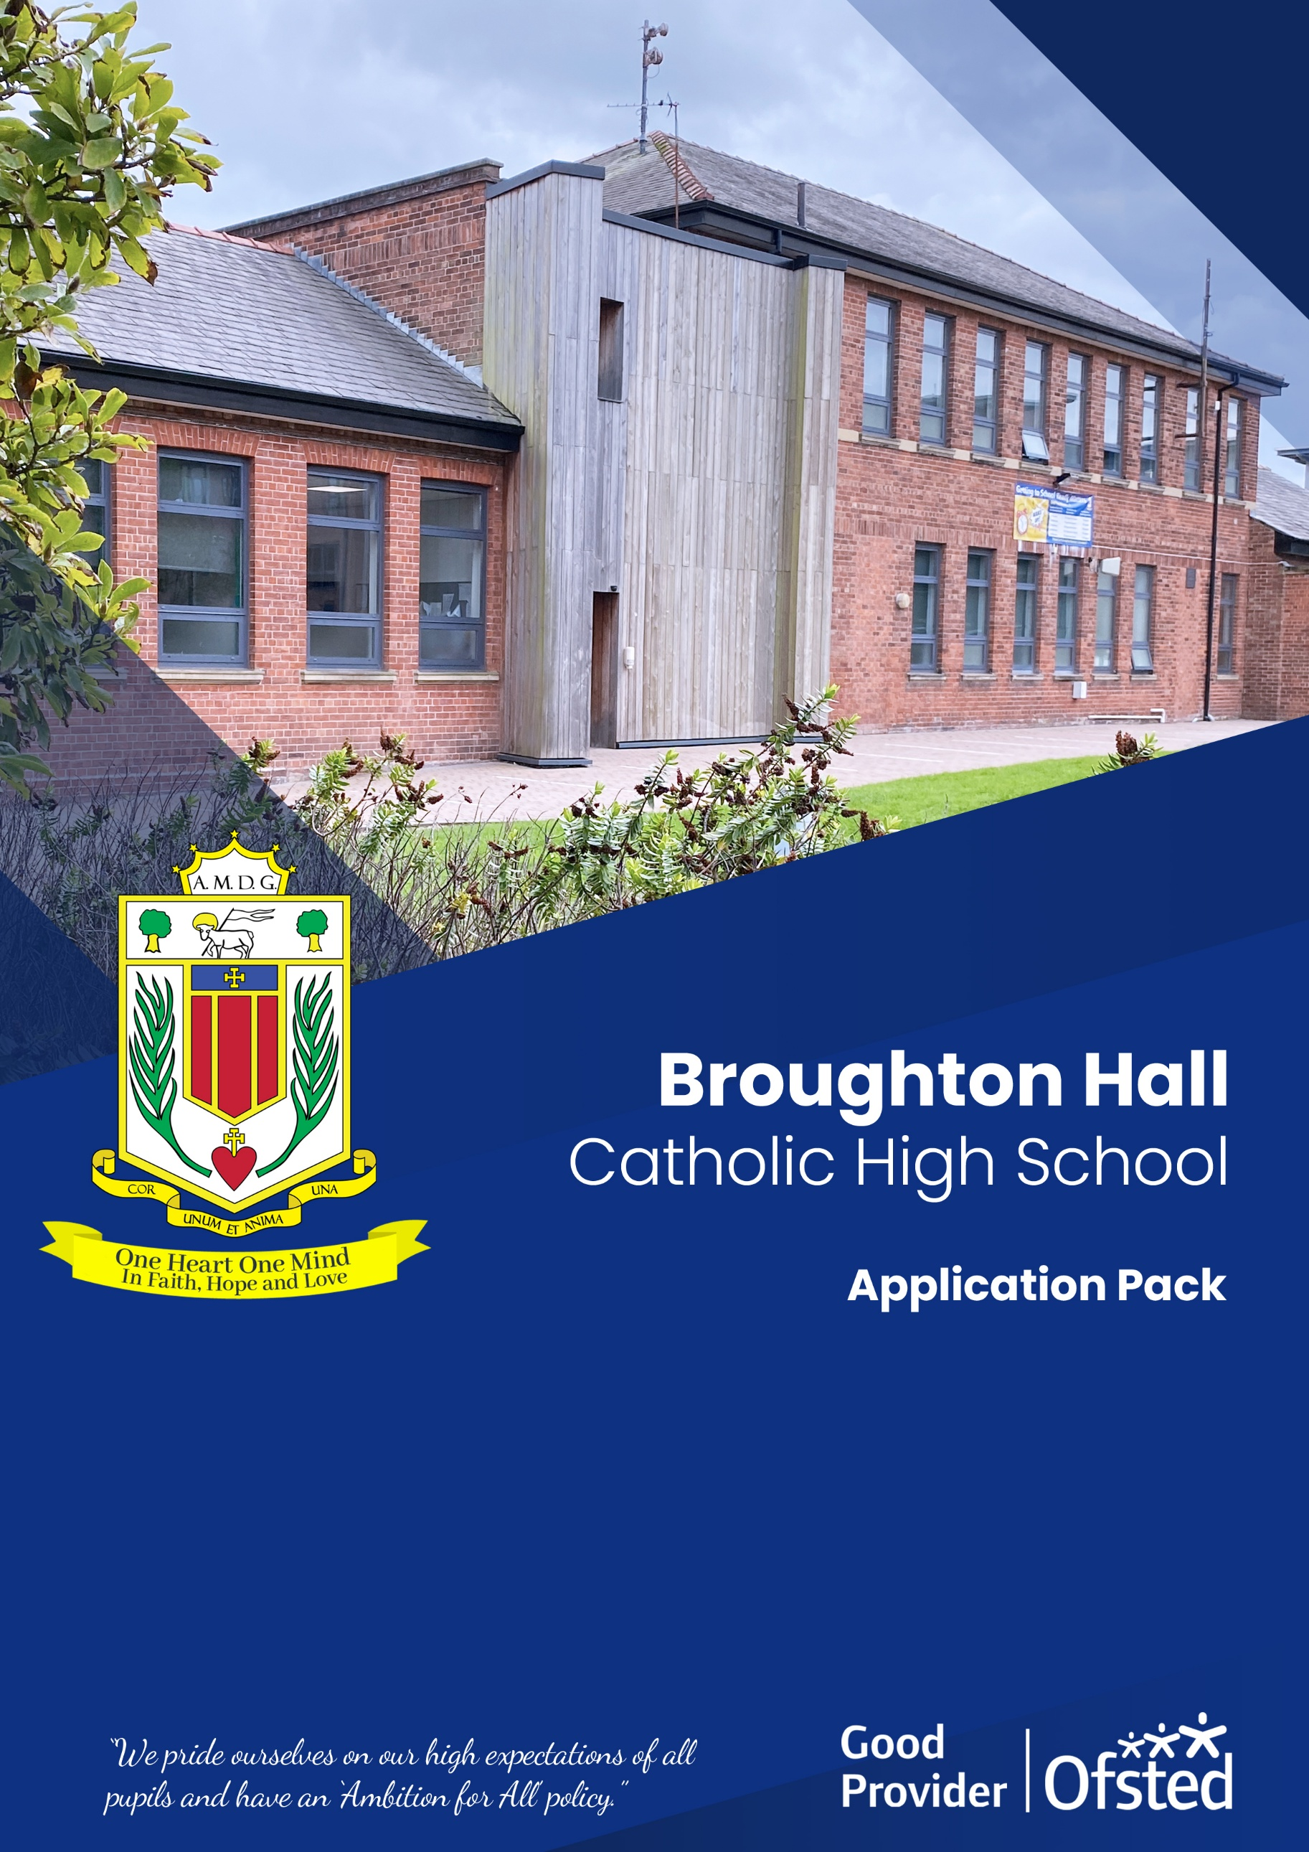
ROLE: Premises Manager
Full Time - 35 hours per week – 52 weeks contract

START DATE: As soon as possible
CLOSING DATE: 5th March 2025
INTERVIEW DATE: To be confirmed
SALARY SCALE: NJC SCP 26 – 29 £34,834 to £37,336
CONTRACT TERM: Permanent

Broughton Hall Catholic High School
Founded in 1928 under the trusteeship of the Sisters of Mercy, Broughton Hall Catholic High School, an all-girls Catholic secondary school in Liverpool, provides the very best in modern education based on the Gospel values of mutual respect and care.

The central aim of our school is to provide excellent educational opportunities enabling each pupil to develop their God given talents, to grow in confidence and self-esteem and to fulfil their potential.

As a Catholic school Broughton Hall centres its mission on the person of Jesus Christ, and promotes the Gospel values throughout the school community and in all aspects of school life: spiritual, academic, pastoral, and personal. By proclaiming and living out the faith of the Catholic Church, we support each other in shared experiences of teaching and learning, prayer, worship and charity. Our mercy values permeate throughout our community.

Broughton Hall is Ofsted rated as a “Good” provider (November 2022).

Our facilities are bright, spacious, high tech and designed to meet the needs of all our pupils. We have a separate 6th Form facility, which is shared with our neighbouring boys school Cardinal Heenan Catholic High School. A full range of extra-curricular activities are provided to further the creative, sporting and academic talents of each pupil and offer Outward Bound and Duke of Edinburgh Award schemes as well as the opportunity to attend educational visits and residential trips.

We pride ourselves on our high expectations of all pupils and have an ‘Ambition for All’ policy. Whatever your role within the school, you will share these values and be able to encourage and motivate pupils with your passion, presence and personality.

Our school motto ‘Cor Unum et Anima Una’ - One Heart and One Mind, reflects the strong sense of community amongst pupils, staff, parents and Governors.

School has a weekly Newsletter – please click here to view our latest edition. https://www.broughtonhall.com/newsletter/

Welcome

Thank you for your interest in the position of Premises Manager.

This pack has been designed to help you should you choose to submit an application form, which we sincerely hope you do. We hope it answers your initial questions, but if not, please do not hesitate to contact us and we will endeavour to help you through your application process.

Broughton Hall Catholic High School is the largest all-girls school in Liverpool and serves many different areas making us a vibrant a diverse school. Our aim is to be a good school in all areas and we are seeking staff to apply to work with to be of that journey. Ofsted rated the school as “Good” in November 2022.

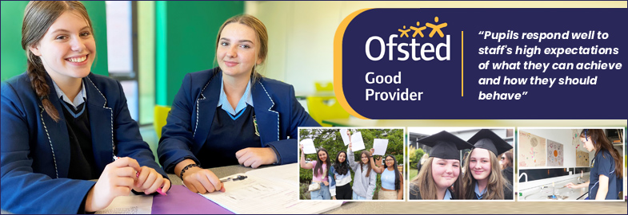

We work hard to ensure Broughton Hall Catholic High School remains a friendly and welcoming environment for all those who work, study or visit here and hope that you are the person we are looking for to bring creativity and innovation to the role.

The school actively supports the training of middle leaders through well-respected Teaching Leaders’ programme. Opportunities for promotion exist for suitable candidates. Our staff are passionate about teaching and are committed to develop exciting and stimulating lessons that not only engage students.

We look forward to hearing from you.

Sarah O’Rourke
Head Teacher

We Offer

- Pensions Scheme – Teacher Pension Scheme for teaching staff or Merseyside Pension Fund for support staff
- Regular training and development programme
- An enhanced Occupational Health & Well-Being App (Smart Clinic) with access to a wide variety of services e.g.
- Virtual GP
- 24 hour employee assistance line
- Physiotherapy
- Mental Health Services
- Self-support and guidance tools
- Cycle2Work Scheme
- Tax Free Childcare Vouchers
- Supportive work environment where all staff are valued
- Continuous professional development for all staff and follow a whole school approach to staff performance and development

And that’s not all, we place the outcomes of the children in our school at the heart of everything we do, so you’ll wake every day in the knowledge that your role will have a significant positive impact on the lives of others.

Equal Opportunities

Broughton Hall Catholic High school is an equal opportunities employer.

We welcome applicants from all backgrounds and value everyone as an individual. We are committed to organisational practices, which promote diversity and inclusion for all employees and volunteers regardless of age, gender reassignment, marriage or civil partnership status, pregnancy and maternity status, disability, race (including colour, nationality, ethnic or national origin), religion or belief, sex, or sexual orientation. Connecting these differences creates a productive environment in which everyone feels valued.

Monitoring information in relation to job applicants will be to assist us in equality monitoring. The recruitment panel will not have access to job applicant’s monitoring information.

To assist us in monitoring the operation of equal opportunities policy, and for no other reason, please ensure you complete and submit the Equal Opportunities Monitoring Form with your application form.

Safeguarding & Enhanced DBS Checks

Broughton Hall Catholic High School is committed to safeguarding and promoting the welfare of young people and expect all pupils, staff, volunteers and visitors to share this commitment

All posts are subject to an enhanced DBS check and full pre-employment checks to comply with the current Keeping Children Safe in Education statutory guidance for schools.

All staff will be expected to follow Broughton Hall Catholic High School’s child protection policies, code of conducts and managing allegations against staff procedures.

All roles in school, including this post, are exempt from the Rehabilitation of Offenders Act (ROA) 1974. The Ministry of Justice’s guidance on Rehabilitation of Offenders Act 1974 and the Exceptions Order 1975 provides information about which convictions must be declared during job applications and can be accessed here.

All applicants must therefore declare all previous convictions and cautions, including those which would normally be considered ‘spent’ except those received for an offence committed in the United Kingdom if it has been filtered in accordance with the DBS filtering rules. Information about filtering offences can be found in the DBC Filtering Guide, which can be accessed here.

By engaging in this recruitment process, shortlisted candidates consent to an online search in line with the Keeping Children Safe in Education Statutory Guidance 2022.

A copy of our Child Protection Policy and Procedures can be access at https://www.broughtonhall.com/documents/BroughtonHall_CP_Policy.pdf

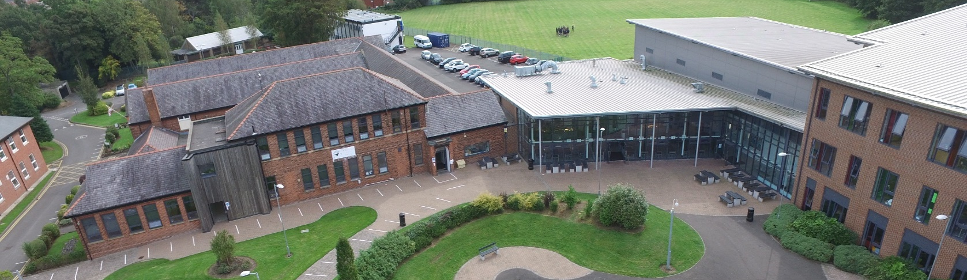

Advert
PREMISES MANAGER
FULL TIME – 35 HOURS PER WEEK (52 WEEKS CONTRACT)

SALARY: NJC SCP 26 to 29 - £34,834 - £37,336
CONTRACT TYPE: Permanent/Full-time
HOURS: 35 hours per week (some flexibility will be required)
CLOSING DATE: 5th March 2025
INTERVIEWS TO BE HELD: To be confirmed
START DATE: As soon as possible

The Governing Body of Broughton Hall Catholic High School wish to appoint a Premises Manager
to take an active part in site development and facilities. The successful candidate will need to be able to provide a site management service for the school, which includes responsibility for the cleanliness and tidiness of the premises to approved standards, health and safety compliance for the whole school, security and day-to-day maintenance of the school site.
Duties to include:-
- Project manage minor works and carry out school inspections to actively identify maintenance and security requirements, taking prompt action to deal with immediate actions required
- Maintaining an up-to-date knowledge of all relevant Health & Safety legislation and requirements and to serve as the school’s Health & Safety Officer
- Effectively line manage the premises staff team and be a key team player
- Manage the premises and building maintenance budgets and complete purchase orders to request works or services to be carried out
- Drive the school minibus with passengers when required
- To play a full part in the life of the school community, to support and contribute to its Catholic mission and ethos

Induction, support and training will be offered to the successful candidate.
Our Trustees are the Sisters of Mercy.

How to Apply:- Please complete the school’s Application Pack and email to smithg@broughtonhall.com

Tour of the school: This can be arranged for shortlisted candidates please email smithg@broughtonhall.com to arrange.

Broughton Hall Catholic High School is committed to safeguarding and promoting the welfare of children and we expect all staff and volunteers to share this commitment to keeping children safe. Any offer of employment will be subject to statutory pre-employment checks including satisfactory references and Enhanced DBS and Barred List checks. This post is exempt from the provisions of the Rehabilitation of Offenders Act - accessed here - and shortlisted candidates will be required to disclose any relevant criminal history prior to interview.

Job Description
PREMISES MANAGER

Reporting to: | Head Teacher, Governors and Senior Leadership Team as appropriate.
Responsible for: | Premises Staff
Purpose: | To provide a site management service for the school, which include responsibility for the cleanliness and tidiness of the premises to approved standards, health and safety compliance for the whole school, security and day-to-day maintenance of the school site and management of premises resources.  To take an active part in site development and facilities.
Areas of Responsibility:

Health & Safety | - Maintaining an up-to-date knowledge of all relevant Health & Safety legislation and requirements  - To serve as the school’s Health & Safety Officer, which includes setting agendas and attending appropriate governor meetings  - Produce an annual Health and Safety Action Plan  - Plan and monitor a rigorous health & safety inspection programme  - Informing the Head Teacher and other key staff of health & safety concerns, recommending actions where necessary  - To complete risk assessments to ensure compliance with all relevant legislation  - To carry out, or oversee as appropriate, all necessary testing procedures in line with health and safety regulations and statutory legislation, e.g. Legionella testing, water temperature, asbestos check, etc.  - To ensure the safety and security of all staff, pupils and visitors at all times  - Organise fire drills/ lock down practices in conjunction with the Senior Leadership Team
Site Supervision | - To be a registered key holder, reporting all alarm incidents and attending site if necessary  - Carry out the locking and un-locking school buildings  - Effectively dealing with emergencies which occur outside of normal working hours  - Ensure that alarm systems are checked regularly and appropriate records of tests are kept  - Understanding alarm system, CCTV and fire alarms
Safety of Site: | - To initiate and oversee repairs and maintenance to the school premises, liaising with contractors as required  - To negotiate and manage premises and safety related contracts, including insurance and grounds maintenance, monitor the cleaning operation of the school, ensuring that standards meet the required specification
Manage School Lettings: | - Manage and supervise school and lettings facilities  - Open facilities and provide (non-specialist) support for users of the site  - To work flexibly to maintain the smooth operation of all events at the school whether inside or outside of normal school hours
Staff Management: | - Involvement in the appointment of school staff responsible for the security and maintenance of the buildings and of external contractors involved in such activities  - Effectively line manage the premises staff team,  - Devise and implement schedules of work monitoring the quality of work undertaken and taking appropriate action in the event of unsatisfactory performance  - Liaise with contractors undertaking work on site and monitoring the quality of work and to ensure they satisfy Health and Safety requirements e.g. asbestos/ COSHH/ PPE etc.  - Ensure adequate premises staff cover at all times including when staff are absent for work for any reason  - Oversee the standard of cleaning throughout the building, liaising with the contract provider as necessary
Maintenance: | - Project manage minor works  - Maintain a premises manual which includes an annual scheme of work to ensure a high standard of maintenance in school buildings  - Carry out school inspections to actively identify maintenance and security requirements, taking prompt action to deal with immediate actions required  - Maximise the number of minor repairs in house  - Ensure effective porterage around the school  - Practical hands-on involvement in security, maintenance and refurbishment when this is necessary or offers the most cost effective solution
Budget Management: | - Manage the premises and building maintenance budgets  - Complete purchase orders to request works or services to be carried out  - Ensuring work is completed and sign off before requesting invoice be processed by the Finance Team
Facilities Management Oversight: | - Monitor of energy consumption and efficiency of utilities  - Devise, maintain and monitor an energy plan for the school in accordance with guidance and legislation  - Act as a point of contact with the schools Facilities  - Management contractors, using systems and portals to log and monitor work requests  - Report compliance to governors at the appropriate committee meetings
Educational Visits  Coordinator (EVC) | - Act as the Educational Visits Coordinator for the school  - Responsible for the coordination of school trips and activities to ensure they are organised in line with school policy and uploading relevant trips to the LA Evolve system for their approval.
School Support: | - Drive the school minibus with passengers when required  - To play a full part in the life of the school community, to support and contribute to its Catholic mission and ethos  - To attend relevant in-service training  - Actively promote, comply and adhere to all school policies  - Demonstrate willingness to support new initiatives within the school  - Participate fully in training, learning development and the school’s performance management system for support staff
Supervision: | - To work under the supervision of the Head Teacher.  - Able to work on own without direction.
Working Time: | 35 hours per week, full time.  Flexibility will be required as some additional hours may need to be worked to support events taking place outside of school.
Salary/Grade: | SCP 26 to 29  £34,834 to £37,336
Disclosure level: | Enhanced
Whilst every effort has been made to explain the main duties and responsibilities of the post, each individual task undertaken may not be identified.

The post holder will be expected to comply with any reasonable request from senior staff to undertake a similar level of work not specified within this job description.
This job description is current at the date shown, but in consultation with you, may be changed by the headteacher to reflect or anticipate changes in the job commensurate with the grade and job title.

Person Specification
Qualifications | Essential | Desirable
Excellent numeracy and literacy skills equivalent to Level 2 in English and Maths
Hold IOSH (Institute of Occupational Safety & Health) or equivalent or be willing to train for the qualification
Hold a First Aid certificate or be prepared to train for a qualification
Full driving licence
Minibus Driver Awareness Scheme (MIDAS) certified qualification
Experience | Essential | Desirable
Significant facilities or site management experience
Working in a school or educational environment
Working as part of a productive team to raise standards
Managing staff
Experience in working in the building trades or associated industry
Knowledge & Skills | Essential | Desirable
Good communication skills to liaise effectively with a range of colleagues, internally and externally
Knowledge of Health & Safety legislation and procedures within the workplace
Ability to lead and manage people, delegating where appropriate
Ability to organise work and prioritise effectively
Demonstrate a commitment to raising standards
Possess good working knowledge of general building maintenance
An ability to undertake a wide range of maintenance activities to a high standard of workmanship
Organised and self-motivated, with a proven record for meeting targets and deadlines
An understanding of safeguarding procedures within an educational environment
Personal Qualities | Essential | Desirable
Works well as a member of a team, sharing knowledge
Ability to develop good relationships with pupils and staff
Flexible and adaptable
Patient, positive, approachable and friendly
Proactive nature
High level of accuracy and attention to detail
Maintains confidentiality
Display commitment to protection and safeguarding of children and young people
Ability to perform physical tasks required by the post including bending, lifting, safe use of ladders and carrying of equipment
Show initiative/work independently

