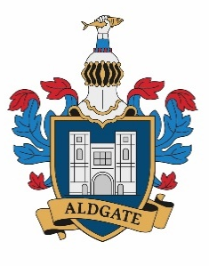
The Aldgate School
Headteacher: Ms A Allan

Premises Manager (permanent)
Scale 6 Spine point range from 18 to 20
Salary range £35,520 to £36,585

Hours: 35 per week, all year round.
Site hours 10am to 6pm
Late August/early September start

The Aldgate School is looking to appoint a full time, permanent Premises Manager to join our friendly and welcoming team.

Located on the edge of the square mile the school delivers high-quality childcare and education to babies and children from 9 months to 11 years. We have a rich and diverse community of local children whom we have served for many years.

We provide a broad and balanced curriculum at this ‘outstanding’ school. We believe in equal opportunities for every pupil in this unique environment.

The successful candidate will enjoy working in a setting which has a diverse community and strong transport links.

We welcome applications from candidates with experience of working in premises management, with a good understanding and knowledge of health and safety in schools.
You will be organised and methodical, ensuring a safe learning environment for children, staff, parents and visitors.

Visits to the school are welcome. Please email lwebb@thealdgateschool.org
Deadline for applications: 9am on 10th July 2026
Interviews will take place on 15th July 2026

