Fox Federation is a passionate community of four schools working collaboratively to ensure equal access to consistent, excellent education for all pupils. Our schools are nurturing places to work, committed to innovation and have high academic standards. Staff who join our team are supported to grow and develop outstanding practice through exceptional CPD and support from a warm, passionate team of dedicated teachers and leaders. 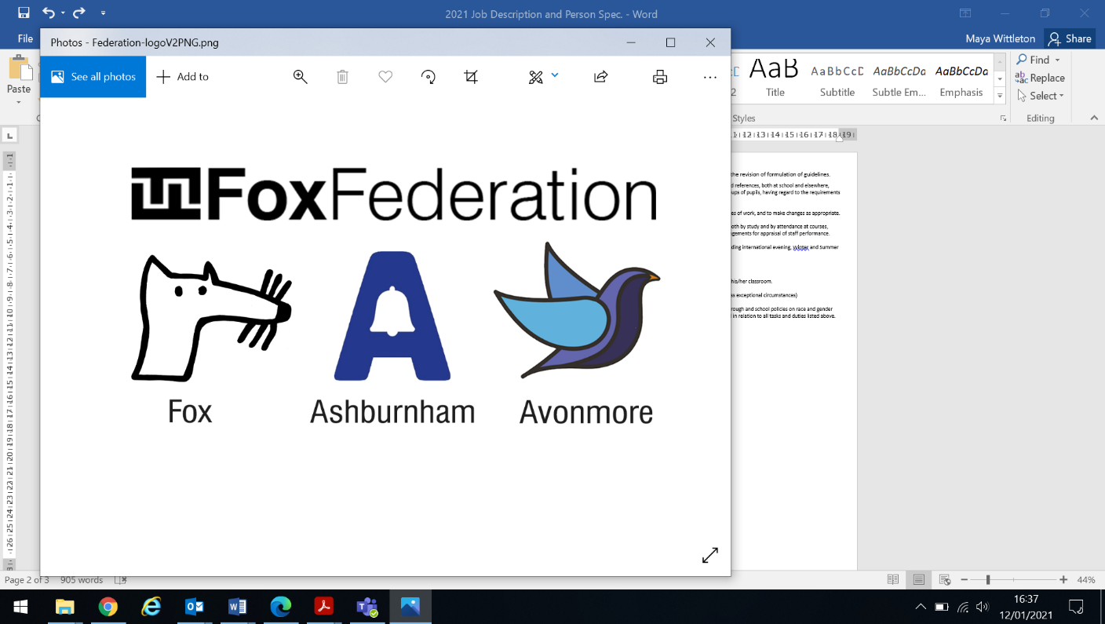

**Job Description**

**Post: Federation School Premises Officer**

**Responsible to: Headteachers and Executive Head**

**Scale: Salary: £29,364 – £33,510 depending on experience**

Our community of schools

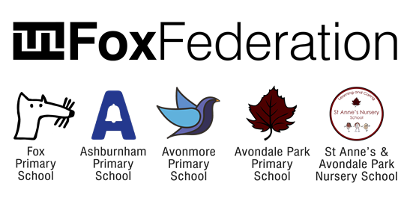

Main Purpose of the Job

Assist in ensuring the school site is in a clean, tidy and presentable condition at all times and that it provides a safe and secure environment for pupils, staff, parents and visitors. Liaise closely with the school staff and provide assistance as problems arise. The basic requirements of the role are:

* Contributing to the overall/ethos/work/aims of the organisation
* Assisting the management of site staff and site contractors (including cleaners)
* Supporting the general maintenance and upkeep of the site and buildings
* Completing and managing building/repair works in liaison with the Line manager and the Governors’ Premises Committee, keeping appropriate logs, records and reports
* Taking necessary steps for the security of the site from the start to the end of the school day
* Upholding a commitment to Health and Safety
* Managing resources and energy to reduce carbon footprint and enhance sustainable practices
* Supporting equality, diversity and individual rights in the workplace

Main Responsibilities

**Organisational Effectiveness**

Working to support the school and its mission and comply with all legal requirements (FM301):

* Understanding and supporting the culture, ethos, policies and aims of the federation
* Understanding and adhering to safeguarding principles and practices in the school and identifying the named person leading on Child Protection
* Conducting yourself in your work to reflect the mission statement of the school and its commitment to achieving good outcomes for all of the pupils/staff/parents
* Complying with systems, policies, procedures and resource constraints
* Working to ensure that the site is managed lawfully, ethically and morally

**Building and Site Maintenance**

Work to ensure the school is a clean, safe and secure environment to work in by:

* Maintaining a maintenance request log (using the federation’s chosen logging method – currently Every Premises) to ensure completion of requests and to track any follow up as necessary
* Completing building and maintenance works where necessary
* Liaison with external contractors for the purpose of essential maintenance in the schools and on site
* Maintenance of playground(s) and keeping drains and gutters free from obstruction
* Ensuring the maintenance of boundaries, footpaths and car parks on the school site
* Monitoring projects and contracts according to plans agreed with line manager
* Assessing risks and taking all reasonable steps to restrict access to potential hazard
* Identifying and implementing actions for improvement that meet the organisation’s needs
* Check building for routine maintenance matters, reporting and taking appropriate action when necessary.
* Undertake day-to-day maintenance duties, reporting to Site Manager any faults requiring specialist attention and carrying out minor maintenance and repairs where experience and qualifications allow

**Health, Safety and Security**Helping the organisation meet the required standards for Health, Safety and Security and participating in robust monitoring to secure the highest standards and seek continuous improvement by:

* When carrying out work to be guided by relevant people in the organisation with regard to the responsibilities and liabilities for meeting legal, regulatory and internal requirements for health and safety, environmental impact and quality
* Recognising any pollution or disruption and taking necessary action
* Disposing of hazardous and non hazardous waste safely and following relevant approved procedures and practices
* Demonstrating that your own actions reinforce the messages in the organisation’s health and safety and environmental policy statements
* Collaborating with staff to ensure that all work areas are kept clear of obstruction, particularly those associated with fire escape routes
* Monitoring adequate security of the building and premises at all times
* Carry out security procedures for grounds, premises and their contents. The routine and non-routine opening and closing of premises.
* Key holder responsibilities providing access to the premises in the event of fire, flood, breaking and entering, snow and other emergency situations.
* Carry out required duties in connection with approved lettings of premises and after school activities outside of term time.

**Professional Relationships**

Developing productive relationships with others when managing the site by:

* Liaising and communicating effectively with stakeholders in the school (including children, relevant colleagues, line manager, parents and Governors)
* Managing conflicts, misunderstandings and disagreements to ensure that the school’s needs are met
* Seeking line manager support where necessary and appropriate
* Reflecting on the effectiveness of professional relationships and identifying where improvements can be made

**Manage resources efficiently**

Adopt effective procedures for energy and resource management that reduce the organisation’s carbon footprint and encourage the efficient use of natural resources by:

* Supporting line manager and other stakeholders in the long-term implementation of making improvements to energy efficiency of buildings and facilities
* Promoting energy efficiency and environmental impact when assessing the viability and sustainability of new and existing facilities
* Minimising demands on natural resources such as water and energy
* Employing practices that minimise the environmental impact of site management, such as on pollution and carbon footprint
* Making the most efficient use of materials, equipment and consumables
* Encouraging and facilitating recycling across the organisation
* Requesting suppliers and contractors to adopt sustainable practices wherever possible
* Contributing to the development, implementation and revision of sustainability policies and practices
* Adopting an approach to site management that impacts positively on the local and wider community

**Other**

* Undertake such other duties as the Headteacher will direct
* This is a description of the main duties and responsibilities of the post at the date of production. The duties may change over time as requirements and circumstances change

**As part of our commitment to fairer recruitment, all applications will be assessed with names and any protected characteristics redacted.**

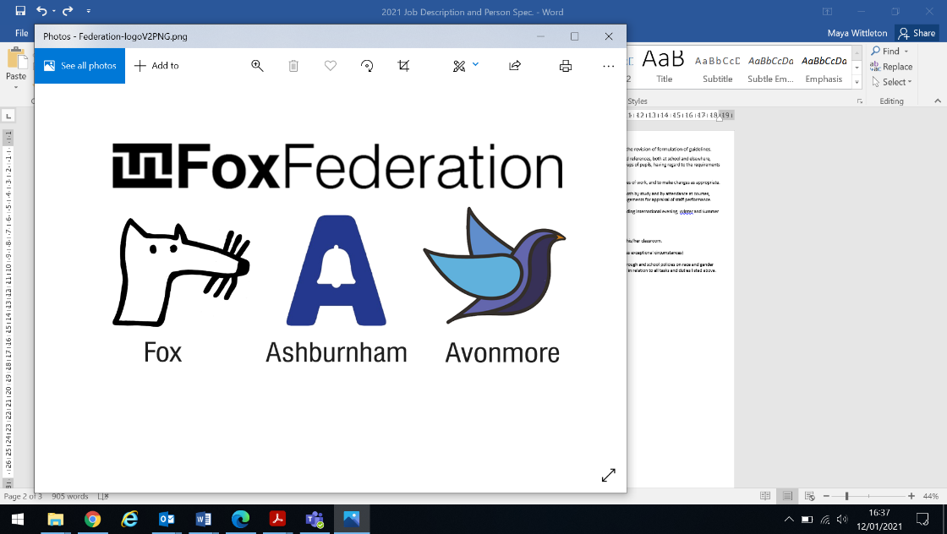

**We are committed to building a diverse team and strongly encourage applications from underrepresented groups such as people from minority ethnic backgrounds, LGBTQ+ people and people with disabilities.**

**Person Specification**

|  |  |
| --- | --- |
| Essential | Desirable |
| Experience:   * Experience in a similar role, preferably in a school environment * Experience of DIY, building and maintenance projects, preferably in a school environment. | * Experience of DIY, building and maintenance projects, preferably in a school environment. * Have knowledge of C.O.S.H.H (Control of Substances Hazardous to Health 1998) |
| Qualifications:   * Accredited Health and Safety Training | * First Aid Certificate * GCSEs or equivalent in English in Maths |
| Skills and Competencies:   * Have strong oral and written communication skills * Willingness to undertake induction training * Willingness to participate in ongoing training relating to the role * Knowledge and use of moving and handling procedures including for heavy objects * Ability to work as part of a team. * Ability to work in accordance with the school’s health and safety policies and standard safe working practice for premises staff * Ability to work to deadlines * Ability to work on own initiative * Ability to undertake general building maintenance * Ability to demonstrate a practical approach to problem solving * Ability to communicate well with adults and students * Ability to respond calmly to emergencies * Flexibility and proactive attitude |  |
| Safeguarding:   * Enhanced DBS clearance   An Enhanced DBS and satisfactory references would be obtained prior to commencement of employment. |  |