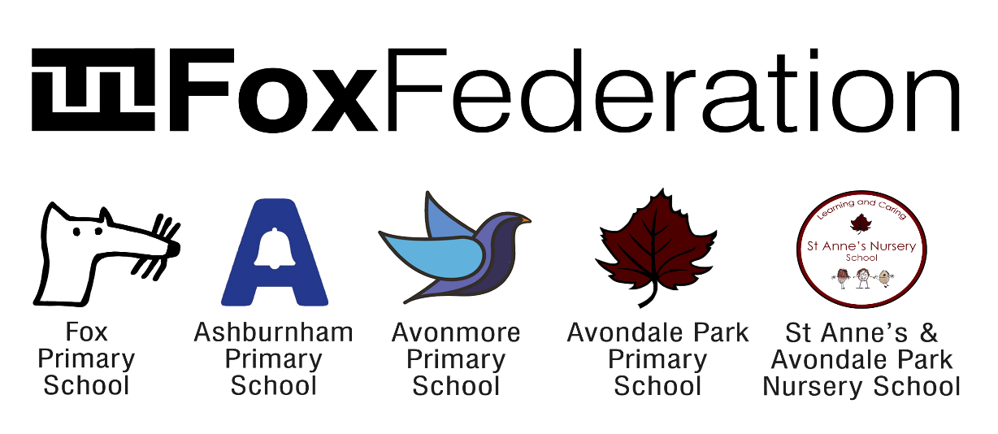

Respect. Resilience. Collaboration. Curiosity. Inclusion

Position: Federation School Premises Officer at Fox Federation Schools – Avonmore Primary School W14 and Ashburnham Community School SW10

Grade: Scale 5 – 6, Spine Point 12 to 20
Salary: £29,364 – £33,510 depending on experience

Hours and Service terms: 36 hours a week, Monday to Friday with 37 days annual leave (including Bank Holidays)

Required from: For immediate start or September 2023 start

Closing Date: Friday 30th June (applications to be sent to hr@avonmoreprimary.co.uk)

Interview Date: Week commencing Monday 3rd July

We are committed to building a diverse team and strongly encourage applications from underrepresented groups such as people from minority ethnic backgrounds, LGBTQ+ people and people with disabilities.

We are looking for a committed, capable and proactive federation site manager/caretaker to join the Fox Federation premises team. The position would suit a team player who wants to work as part of our current site team to ensure that our sites are compliant, safe and looking their absolute best.
If you are ambitious and determined to make a difference, we would like to meet you.

The Fox Federation is a passionate community of four schools working collaboratively to ensure equal access to consistent, excellent education for all pupils. Our schools are Fox Primary School in Notting Hill, Ashburnham Community School in Chelsea, Avondale Park Primary and St Anne’s & Avondale Nursery in North Kensington; and Avonmore Primary School in Kensington Olympia.

What the school staff say about Fox Federation:
‘Fantastic schools. Great staff. Supportive leadership team. Amazing children.’
‘A genuine educational family, providing a community beyond our gates. A network of schools, committed to providing the best education for children whilst creating a safe a happy place for them.’
‘It is incredible to be surrounded by so many competent, hard-working, passionate people - so committed to delivering fantastic education opportunities to our pupils.’
‘Management are always available to speak with, unbelievably approachable and create time to listen and come up with solutions.’
‘It is run in an extremely compassionate, supportive and nurturing manner for both staff and pupils, and I really do feel that the wellbeing of the whole community is at the heart of the school's ethos.’
‘A place of supportive colleagues who are constantly striving to improve what we do for our children and families.’
‘A shared vision of always going the extra mile to support and care for the families in our community.’
‘It is somewhere that has nurtured my career, but also a place where I have met friends that I know will be friends for life.’
‘The Fox Federation is an incredible support network of teachers and staff working together to ensure children's education is kept at the highest possible standard.’

Our ideal candidates would:
· Be hard working and proactive
· Be flexible in a busy school environment
· Be friendly and want to be part of a team, who embodies our schools’ values and vision for excellence.
· Have strong communication skills

What else do we offer?
· An experienced Leadership Team with a shared vision working in partnership across the Federation.
· Hard-working leaders who strive to ensure that both pupils and staff enjoy coming to school.
· We are passionate about supporting staff in their career development and success through care and guidance.
· A working environment that values wellbeing and supports work-life balance through working in partnership across schools.
· Vibrant, multicultural and inclusive city schools that have positive, diverse communities and a determination that all children will succeed.
· Exceptionally well-behaved children who love to learn.
· A relaxed and fun working environment where all adults are equally valued and supported.

The schools and the local authorities are committed to safeguarding and promoting the welfare of children and young people and expect to share this commitment. An enhanced Criminal Records Bureau Certificate is required for this post prior to commencement

Applications are assessed with names and protected characteristics removed.
To make an application or further information, please download our application pack or contact Emily Bishop Emily.bishop@avonmoreprimary.co.uk/emily.bishop@ashprimary.co.uk

