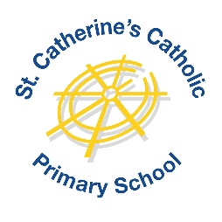

**Primary French Teacher**

**Part Time, 3 days per week (Tuesdays, Wednesdays & Thursdays)**

**From September 2025**

**MPS / UPS**

St Catherine’s Catholic Primary School is looking for an amazing French Teacher to join our team from September.

We would like to hear from teachers who have high expectations of pupils, both in their learning and their behaviour, and who will challenge and motivate them in creative ways. We also want people who are fun and dynamic and not afraid to try something new! You should be willing to participate in the Catholic life of our school but do not need to be Catholic yourself.

Key responsibilities:

* Deliver engaging and stimulating French lessons from nursery to year 6
* Foster a love of the French language and culture
* Participate in extracurricular activities related to French

Successful candidates will:

* Hold QTS and have experience teaching French at primary and if possible also nursery level
* Demonstrate a strong command of the French language
* Show strong communication and behaviour management skills
* Be keen to promote cultural awareness through language

St Catherine’s School is a successful, warm and friendly two form entry Barnet primary and nursery school, with a strong caring ethos. We have fantastic children who deserve the very best learning opportunities. Our children’s behaviour is exemplary and they are keen and motivated to learn. Our school is bright, modern and well-resourced, set in beautiful grounds with access to ample outdoors space. Our staff team are supportive and caring, wellbeing is a focus and we have a strong commitment to innovative professional development.

If you are eager to inspire young learners and contribute to our dynamic school community, please arrange a visit by telephoning the school office on 020 8440 4946 to make an appointment.

**Closing date for applications is** **Monday 30th June at 9am.**

**Interviews will take place as applications are received.**

**Completed applications should be returned via email to** [**office@stcatherines.barnetmail.net**](mailto:office@stcatherines.barnetmail.net)**. Alternatively please apply directly through Eteach on the following link:**

**https://www.eteach.com/job/teacher-of-primary-french-1491864**

We reserve the right to interview and appoint prior to the deadline so please do not delay in submitting your application.

*St Catherine’s Catholic Primary School is committed to promoting and safeguarding the welfare of children. This post is exempt from the Rehabilitation of Offenders Act and as such all candidates will be subject to an enhanced DBS check*.