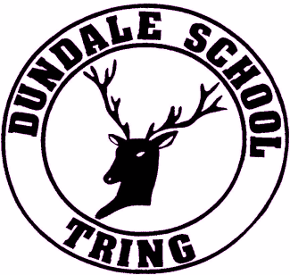
Dundale Primary School & Nursery
Silk Mill Way,
Tring,
Hertfordshire, HP23 5DJ.
Learning, exploring, reaching for success.

Dear Applicant,

Thank you for showing your interest in becoming the Headteacher at our school. I hope that you find the information pack useful in providing an introduction to Dundale School and I am delighted that you see our school as one whereby you could make an impact.

This position became vacant following the departure of our Head teacher at the end of the Autumn term 2020 and our Assistant Head has been Acting Headteacher since this time. Our last OFSTED Inspection was in September 2015 where the school was graded Good. Although results declined since this time, we are making great strides with our school improvement plans and are confident and excited for the future.

Dundale Primary School & Nursery is a single form entry community school in Tring, Hertfordshire serving a diverse and vibrant local community. Supporting individuals and their families is an integral part of the way we work at Dundale and an ethos we are proud to foster. We are also proud within school that each child is seen as unique with individual needs which are understood and met.

It is anticipated that we will be joining the Ridgeway Learning Partnership from September 2021. Being part of the Ridgeway Learning Partnership will not only give our new Head teacher the opportunity to develop their career but the necessary local support and expertise to raise both standards of teaching and learning and pupil attainment which will be the ongoing challenge for our new Headteacher.
In recruiting a new Headteacher we are seeking someone who has the experience, enthusiasm, drive, and energy to move our school forward to the next stage of its development working in partnership with the RLP as we endeavour to move on to the next stage of our journey. This is a unique opportunity for someone who is passionate about making a real difference.

The closing date for applications is the 28th April 2021. Shortlisting will be taking place on 10th May 2021. If you wish to discuss the role, please contact me at bhamilton@dundale.herts.sch.uk to arrange a suitable time. To arrange a visit to the school, please contact our Office Manager at officemanager@dundale.herts.sch.uk.
Thank you for your interest and if you feel you meet the requirements of the post, I, together with my colleagues, look forward to meeting and interviewing motivated candidates interested in taking on this important and exciting challenge. Good luck with your application and I look forward to meeting you.
Yours faithfully,
Barbara M Hamilton
Chair of Governors
Dundale Primary School & Nursery

