SOUTHERLY POINT CO-OPERATIVE
MULTI-ACADEMY TRUST

CANDIDATE RECRUITMENT PACK
HEADTEACHER
PARC EGLOS SCHOOL

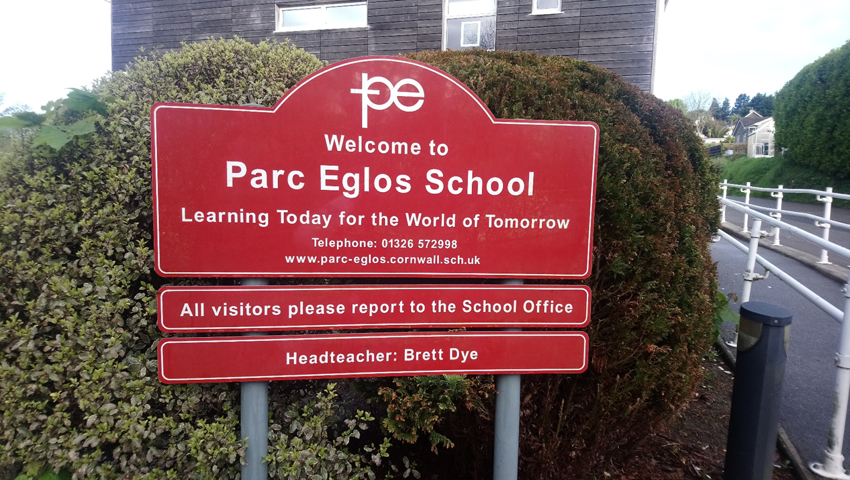

Self Help Self Responsibility Equity Equality Democracy
Solidarity Social Responsibility Honesty Openness Caring for Others

CONTENTS PAGE NUMBER
Letter from the Chair of Governors and 3
Chair of the Trust
Background Information 4
Parc Eglos School 5
Job Description 6
Person Specification 8
Senior Leadership Team Organisational Chart 11
Information for Candidates/How to Apply 12

Message from the Chair of Governors and Chair of the Trust

Dear Applicant

Thank you for showing an interest in the position of Headteacher at Parc Eglos School. This vacancy arises due to the retirement of the current post holder. This is a tremendous opportunity for the successful candidate to lead a popular 2-11 Primary School, within a supportive Multi-Academy Trust in the stunning West Cornwall area, recognised for its outstanding natural beauty and award winning beaches.

Parc Eglos School is part of the Southerly Point Co-operative Multi-Academy Trust, which was established on 1st June 2017, and is one of 19 schools situated around Helston and the Lizard – the most southerly part of Cornwall. We believe in working together so that everyone benefits. Our work is underpinned by the co-operative values: self-help, self-responsibility, equity, equality, democracy, solidarity, social responsibility, openness, honest and caring for others.

The Trust works to improve and enhance opportunities for all young people in the local community. We are committed to delivering high academic standards in our schools, combined with a view of education that is child-centred and holistic. Our schools have a strong commitment to personal development and extra-curricular activities are strongly promoted. Teachers collaborate in cross-phase groups through a range of curriculum networks, including Literacy, Mathematics, Science, History and Geography. There is also a very effective DSL network group, which provides both challenge and support across the Trust schools.

Parc Eglos School is fully inclusive, and has a strong track record of academic success for all students. The school was last inspected in 2011 and judged as ‘Outstanding’.

We were most recently inspected by Marcia Headon, one of Her Majesty’s Inspectors, on 30th November 2015 and judged to continue to be an Outstanding school.

There is a wealth of information about the school and the Trust available online, and we recommend that you review what is available via the school website: www.parc-eglos.cornwall.sch.uk

Informal visits to the school are welcomed. Please contact Lucy Ufton, School Secretary on 01326 572998 or email awilliams@parc-eglos.cornwall.sch.uk should you wish to speak to someone about the role or to arrange a visit.

If this all excites you, please apply!

Best wishes

Keith Warham Karen Harris
Chair of Governors Chair of Trustees

Southerly Point Co-operative Multi Academy Trust
BACKGROUND INFORMATION
OUR TRUST

Southerly Point Co-operative Multi-Academy Trust has one simple objective: to enable excellence together.

The schools in the Trust have a long history of working together – those living and working in the area may well remember SKILL – the South Kerrier Initiative for Linking Learning. Through this, schools worked together to provide sporting opportunities and joint curriculum initiatives.

In 2012, the schools joined together to form the Helston and Lizard Peninsula Education Trust, a Co-operative Foundation Trust. This work led to an even closer working relationship with some shared procurement via a Trust Business Manager, shared data, school-to-school reviews and training events. The next step for us was to ensure the longevity of this relationship and to deepen its effectiveness.

Summary of the Trust Strategic Plan
The key foci of the Strategic Plan are:
- Excellence in Teaching and Learning;
- A culture of high expectations and aspirations, continuous improvement and commitment to learning;
- Resilient people who show respect for others and contribute as active citizens to their communities;
- Outstanding leaders at all levels through the schools and Trust who are confident, proactive and effective;
- Excellent support services enable and support a sustainable educational model for the community, optimising depth and breadth in the capability and capacity of the Trust.
Our Trust Schools:

Breage C of E Primary School | Manaccan Primary School
Coverack Primary School | Mullion Primary School
Crowan Primary School | Mullion Secondary School
Cury C of E Primary School
Garras Primary School | Porthleven Primary School
Godolphin Primary School | Sithney Primary School
Grade Ruan C of E Primary School | St Keverne Primary School
Halwin Primary School  Helston Community College | Trannack Primary School
Landewednack Primary School | Wendron C of E Primary School

Parc Eglos School
At Parc Eglos School we learn together to achieve success for all, based on high expectations and equality of access for all. We nurture the growth of the whole child- academically, socially, emotionally, morally and physically – whole heartedly celebrating all achievement in a safe, caring and creative environment. The whole team works together to bring learning ‘alive’ and extend pupils’ experiences so that they are well prepared for the next steps in their education.
Parc Eglos is a vibrant school where children are enthusiastic and motivated to achieve and they are truly at the heart of every decision we make.
We believe a happy child will be a successful child and work to ensure every child enjoys school and achieves success. We do this by providing the best teaching and learning experiences that we can through an exciting and engaging curriculum.
.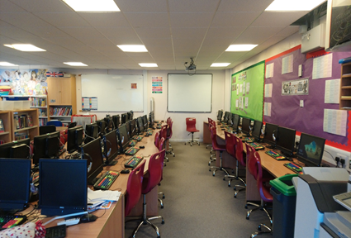 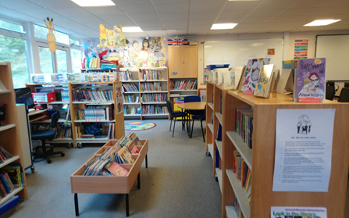
We have a very dedicated and hard-working staff who will go that extra mile - as only the best will do for the children in our care. We work in a very close partnership with parents so that every child is fully supported. We know the importance that parents play in their child’s education and so welcome their involvement in their child’s education and in the life of our school.
At Parc Eglos we pride ourselves on being a warm, welcoming school. We work together with parents, grandparents and the wider community to ensure the best possible education for all our children.
The School has been rated Outstanding by OFSTED since September 2011. We were most recently inspected by Marcia Headon, one of Her Majesty’s Inspectors, on 30th November 2015 and judged to continue to be an Outstanding school.
Informal visits are welcomed and can be arranged by contacting Lucy Ufton, school secretary on 01326 572998 or awilliams@parc-eglos.cornwall.sch.uk
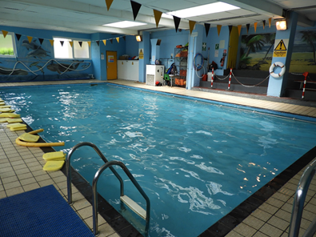
About the Role

Post Title: Headteacher
Responsible to: Executive Leader of the Trust
Grade: Leadership Spine L16 – L22
Contract: Full Time and Permanent
Start Date: September 2022

Ideally, you will be a Senior Leader who wants to make a difference in a large school or an experienced senior leader able to demonstrate significant and successful school improvement. You should place students first in every decision you make, and have the confidence and capacity to drive an ambitious education agenda which has school improvement at its core.
An experienced professional, you will possess a vision for success, have drive, determination and believe that every young person deserves the very best education. Parc Eglos School needs an exceptional, highly aspirational, passionate and strong leader who is able to demonstrate strategic leadership, coupled with excellent people management skills who will build on what is currently outstanding, and ensure the school continues to improve by embracing opportunities and challenges. A proven track record of achieving success and raising standards as a leader with a commitment to the highest quality of education, strength to hold staff to account, and an attitude that will engage students, staff and the wider community are all essential.

In return, you will receive on-going professional development and strong, consistent support from dedicated staff, loyal parents and students, together with a committed Central Trust team, Governors and Trustees. You will also have an opportunity to work with Trust Headteachers, the Central team, and impact on how the Trust develops over the coming years, as it looks to grow and mature.

JOB DESCRIPTION
The core purpose of the Headteacher is to provide professional leadership and management for the school, which will promote a secure foundation from which to achieve high standards in all areas of the school’s work. This should be viewed alongside national standards for Headteachers.

SPECIFIC RESPONISIBILITIES
- Be an outstanding teacher and inspirational leader for all employees;
- Establishing a strongly aspirant culture with responsibility for day to day standards: behaviour for learning, uniform, engagement, attendance etc;
- Developing teaching and learning at the school, including leading on teaching and learning development, action-based research and practice;
- Developing the curriculum – to ensure clear intent, implementation and evidence of impact across all subjects and classrooms;
- Ensure that student outcomes are at least ‘above average’ in progress measures.
- Devise and implement the School Development Plan, sitting alongside the Trust Strategic Plans;
- Writing, reviewing and developing the school’s Self-Evaluation Form (SEF); based on a strong and secure evidence base;
- Leading, through line management, the departmental quality assurance and improvement planning cycle;
- To foster strong professional relationships and use intelligent Quality Assurance processes to monitor and continually improve student achievement;
- Producing, presenting and reviewing all appropriate school policies; presenting these to the LGB as appropriate;
- Ensuring website compliance;
- Line manage the Senior Leadership Team;
- Formulate and propose annual budgets with the CFO for agreement with the Executive Leader and Trust Board;
- Monitor, manage and adjust the school expenditure to meet the annual budget set by the Trust;
- Build and maintain strong partnerships with other schools and the community;
- Developing teaching and learning at the school, including leading on teaching and learning development, action-based research and practice; developing the curriculum – to ensure clear intent, implementation and evidence of impact;
- Harvest research informed practice to enhance the students experience;
- Developing and managing whole school appraisal and performance management procedures linking them to CPD, school and/or Trust priorities and making appropriate recommendations relating to pay recommendations and staff capability;
- Ensure that the curriculum, teaching and learning and wider provision are appropriate for the needs of all students, having regard to their academic and personal development and social needs;
- Reporting progress of all ages and groups of students to the Executive Leader and Governors as required, using robust and quality assured data;
- Maintain excellent standards of pastoral care;
- Ensure that all students can achieve, and maintain a strong commitment to inclusion, through providing an equitable education;
- Making recommendations to the Executive Leader and CFO for recruitment within budget to ensure high quality curriculum and pastoral provision;
- Developing effective data tracking and MIS systems, including reviewing existing provision;
- Developing reporting that is meaningful and informative to students and parents and that are progress focussed and lead to action and impact;
- Responsibility for the effective marketing of the school;
- Responsible for the employment of high quality teachers, pastoral and support staff, and for their training, development and motivation in order to maintain the highest professional standards.
SAFEGUARDING RESPONSIBILITIES
To ensure that safeguarding practices secure the safety and welfare of all students; ensuring that the designated safeguarding leads have sufficient time and resources to discharge their duties effectively. This includes the personal professional duty to report welfare and safeguarding concerns to the local children’s services, as appropriate, and engage with the Trust’s safeguarding processes and professional development.

ADDITIONAL INFORMATION
Whilst every effort has been made to explain the main duties and responsibilities of the post, each individual task undertaken may not be identified.

Staff will be expected to comply with any reasonable request to undertake work of a similar level that is not specified in this job description.

The school will endeavour to make any necessary, reasonable adjustments to the job and the working environment to enable access to employment opportunities for disabled job applicants or continued employment for any employee who develops a disabling condition.

This job description is current at the date shown, but in consultation with you, may be changed by the Executive Leader to reflect or anticipate changes in the job, commensurate with the grade and job title.

PERSON SPECIFICATION

This person specification is related to the requirements of the post as determined by the job description. Shortlisting is carried out on the basis of how you meet the requirements of the person specification. You should refer to these requirements

Attributes | Essential | Desirable | Recruiting Method
Relevant Experience | - Senior Leadership Experience at Deputy or Headteacher level with significant evidence of impact in current role  - Demonstrable evidence of innovating and adapting curriculum to engage students and enable them to perform highly  - Experience of school improvement planning, including planning student interventions and maximising achievement  - Experience of work across the 2-11 age range.  - Experience of managing a key school budget area and understanding of school financial planning  - Experience of the strategic overview of pupil progress and the ability to translate this into strategic plans with specific, measurable targets  - Experience and understanding of successful transition from/to each stage of education  - Experience of leading rigorous Quality Assurance Procedures  - Experience of successful work in partnership with parents and the wider community. | Currently a Headteacher or Head of School/Academy  Experience of managing complex HR and staffing issues | Application Form  References  Interview
Education and Training | - Qualified teacher status or recognised qualification  - A degree level qualification  - Current and recent professional development. | Qualified to Master’s level or NPQH | Application Form
Knowledge and Skills | - Considerable and wide ranging up to date knowledge of curriculum, including structure, content, pedagogy and assessment  - Working knowledge of KCSIE 2021 and other legal frameworks  - Ability to lead teaching and learning underpinned by a knowledge of what works best  - Excellent communication and interpersonal skills  - Strong written skills, with attention to detail  - Able to manage own time and workload and to work under pressure to meet deadlines  - Ability to handle complex issues and solve problems, independently or collaboratively  - Ability to delegate effectively  - Ability to effectively evaluate and plan for improvement  - Ability to develop effective relationships and teams  - Ability to prioritise, meet deadlines and work under pressure  - Ability to engage senior leaders in the process of self-evaluation; holding them to account for their areas of responsibility  - Ability to foster a positive, inclusive culture that is focused on high quality education so that all students can flourish  - Self-awareness and the ability to reflect on own performance |  | Application Form  References  Selection Tasks  Interview
Any Additional Factors | - Passionate about education and educational issues  - Strongly committed to the moral purpose of education, including educational inclusion and belief in achievement for all  - Ambition and a highly professional approach to their work  - A real drive to make things happen and a passionate desire to make a difference  - Complete reliability for maintaining confidentiality  - Exceptional personal integrity and character  - Great energy, enthusiasm and hope and the ability to inspire the best in others  - A warm, open and optimistic disposition, loyalty, determination and persistence  - Demonstrate a commitment to:  - Co-operative values;  - promoting the school and the Trust’s vision and ethos;  - high quality, stimulating learning environment;  - relating positively to and showing respect for all members of the school and wider community;  - ongoing relevant professional self-development;  - Safeguarding and child protection. |  | Interview  Selection Tasks  References

Senior Leadership Team
Organisation Chart

INFORMATION FOR CANDIDATES

Terms and Conditions
This post is offered on a full-time, permanent basis and is based at Parc Eglos School.

Remuneration
Competitive – on the leadership spine, appropriate to the seniority of the role and the skills and experience of the post holder.

Pre-Employment Checks
All applicants must be prepared to undergo several compliance checks to confirm their suitability to work with children and young people in line with ‘Keeping Children Safe in Education’.

The Trust reserves the right to withdraw offers of employment where checks or references are deemed to be unsatisfactory.

HOW TO APPLY
Complete an online application form via our website – www.parc-eglos.cornwall.sch.uk or download an application form and send to the email address below
Closing Date: | Sunday 27th February 2022
Shortlisting Date: | During week commencing 28th February 2022
Interview Date: | During week commencing 14th March 2022

Visits to the school: | Please contact Lucy Ufton, school secretary on 01326 572998 or awilliams@parc-eglos.cornwall.sch.uk
Parc Eglos School Website: | www.parc-eglos.cornwall.sch.uk
Trust Website: | www.southerlypoint.co.uk
Send your completed application to: | awilliams@parc-eglos.cornwall.sch.uk

Southerly Point Co-operative Multi-Academy Trust is committed to safeguarding and promoting the welfare of children and expects all staff and visitors to share this commitment. Appointment to this post is subject to an enhanced Disclosure and Barring Service check (DBS) as well as other pre-appointment checks outlined in Keeping Children Safe in Education (September 2021).

Southerly Point Co-operative Multi Academy Trust is also committed to promoting equality, challenging discrimination and developing community cohesion. We welcome applications from all sections of the community.

Applicants are expected to familiarise themselves with our Safeguarding and Child Protection Policy, which can be found via the following link:
http://www.parc-eglos.cornwall.sch.uk/website/policies/327015

