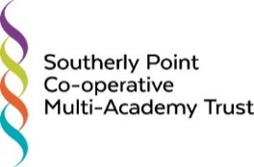
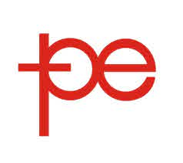

Tel: 01326 572998 E-mail: awilliams@parc-eglos.cornwall.sch.uk
Website: www.parc-eglos.cornwall.sch.uk

Headteacher Parc Eglos School, Helston, Cornwall
Start Date: September 2022
Salary: L16 - L22
Contract: Full-Time and Permanent

Due to the retirement of our highly respected current headteacher, we are seeking a passionate, dynamic, inspirational and child-centred leader to take Parc Eglos School into the future. Parc Eglos is a remarkably friendly and welcoming school which has a fantastic reputation, locally and beyond. Staff are highly skilled, and they know pupils exceptionally well.
Parc Eglos Primary School is a 2-11 school with almost 500 children on roll. We are one of the family of schools who together are Southerly Point Co-operative Multi-Academy Trust. We genuinely support each other and work closely together to achieve our aim of 'enabling excellence for all': our children, our staff and our communities. Our work is underpinned by the co-operative values and these inform everything we do.

Ideally, you will be a current Headteacher or Head of School who wants to make a difference in a large Primary School - or an experienced senior leader able to demonstrate significant and successful school improvement. You will be someone who has the ambition and drive to lead and support a successful and highly motivated team, and can sustain and develop high quality teaching across the school to continue to improve outcomes.
We are looking for an inspirational and multi-talented professional who is dedicated to making a lasting and positive difference to the lives of our pupils and their families. You will:
- Have strong leadership and communication skills
- Have a deep understanding of the wider curriculum and pedagogy
- Be enthusiastic, inspirational, empathic, and resilient
- Have a vision for, and a commitment to, the whole school community

We are committed to Enabling Excellence Together within a values-driven ethos.

For more details, please log on to the school website or contact awilliams@parc-eglos.cornwall.sch.uk
Please note we do not accept CVs and only applications submitted on an application form will be considered.

Closing date: Sunday 27th February 2022
Interviews: During the week commencing 14th March 2022

Southerly Point Co-operative Multi-Academy Trust is committed to safeguarding and promoting the welfare of children and young people. DBS disclosure will be required at the enhanced level for all appointments.

Southerly Point Co-operative Multi Academy Trust is also committed to having a workforce that promotes equality and celebrates diversity.

Applicants are expected to familiarise themselves with our Safeguarding and Child Protection policy, which can be found via the following link:
http:www.parc-eglos.cornwall.sch.uk/website/policies/327015

