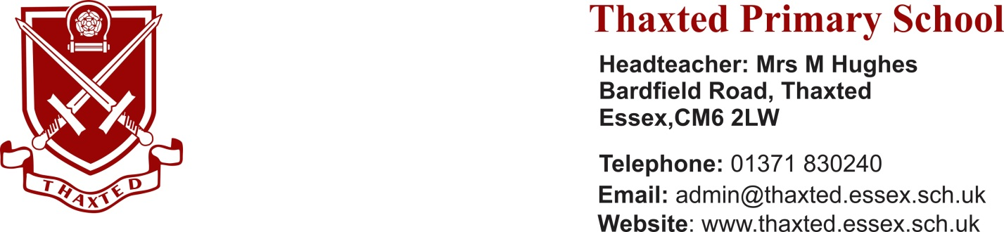

Welcome from the Chair of Governors

Dear Candidate
Thank you for your interest in the post of Headteacher at Thaxted Primary School.
The Governing Board is seeking to appoint a highly motivated leader with a passion for learning, who will inspire pupils and staff always to give of their best.
The Governing Board is ambitious for the school in wanting to build further on the existing high standards to move the school from its current ‘Good’ status to ‘Outstanding’. Alongside this ambition, and of equal importance to us, is that our children are happy and safe and that they enjoy their learning and coming to school. One of the features of Thaxted Primary is its focus on an extensive and broad programme of additional activities. These bring the curriculum to life; supporting, consolidating and extending learning – as well as being thoroughly enjoyable and enriching for our pupils. There is a rigorous focus across the school on the curriculum and on the progress and achievement of all pupils.
Our headteacher, Michelle Hughes, has built a very effective and committed staff team, recognised in the most recent Essex Teaching Awards for its success in ensuring that the disruption to our pupils’ learning during the repeated lockdowns was as limited as possible. Our parents were particularly appreciative of the support they received from the school during these times.
The governing board places a great deal of emphasis on staff well-being and our staff surveys confirm that staff feel supported and valued and that they would strongly recommend the school as a place to work.
Pre-application, pre-arranged visits to the school are welcomed, indeed encouraged, and I look forward to meeting you then. Visits to the school will, of course, be conducted under current DfE Covid guidance.

I should point out that the school prospectus included in this recruitment pack was published in September 2019. It will be updated this Autumn term.
Anne Hopkins
(Chair of Governors)

