Cleeve Prior Primary School
‘Where Every Child Shines’

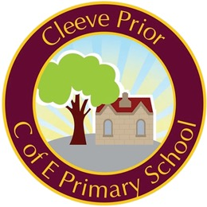

Mixed-age Class Teacher Vacancy
Commencing September 2021

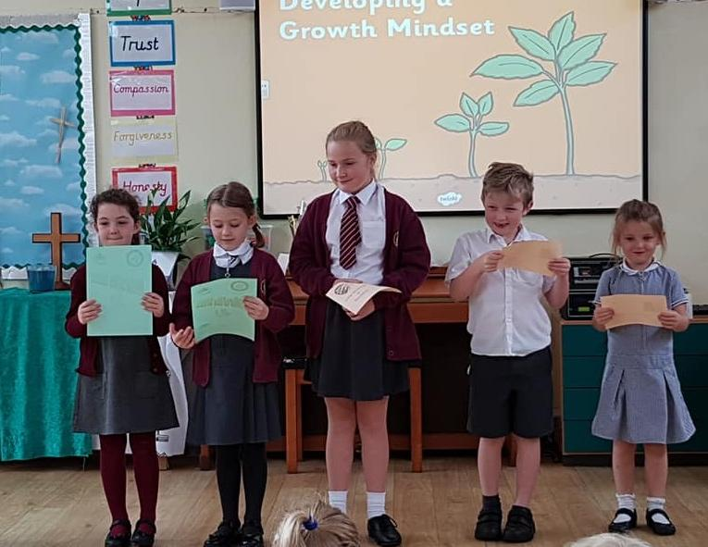

Information for Candidates

Cleeve Prior Primary School

Main Street, Cleeve Prior, Evesham, WR11 8LG

Telephone: 01789 772 276
Email: office@cleeveprior.worcs.sch.uk
Web Page: www.cleevepriorprimaryschool.com

Class Teacher – Mixed Age Class
Note this could be Early Years/ Key Stage One or Key Stage One/ Lower Key Stage Two depending on cohort sizes moving through the school.

Salary: Main Scale

Full time, permanent contract - teacher required from September 2021
You are invited to join this very welcoming school where we are committed to giving the best to our pupils. We are a friendly local school which is well-regarded within the local community and we pride ourselves on our commitment to providing a high-quality education and encouraging children to achieve the best that they can. The post has arisen following a current restructure of classes as part of ongoing school development and growth plans.

We are seeking to employ an enthusiastic and committed teacher to join our small but very friendly team at Cleeve Prior Primary School. We are looking for a candidate to teach in a small, mixed-age class, working very closely with our preschool to maximise the use of available facilities and resources. The post would suit flexible, experienced teachers with an Early Years and Key Stage One or Lower Key Stage Two background who are able to demonstrate inclusive, high quality teaching with the ability to meet the individual learning needs of every child in a small, varying mixed-age class.

In your letter of application, please state your curriculum strengths and any particular talents and abilities you could offer to the school.

Cleeve Prior Primary School is committed to safeguarding children and promoting the welfare of all children and young people and expect all staff to share this commitment. All successful candidates will be subject to a Disclosure and Barring Service (DBS) enhanced check.

We would encourage you to look at our website, www.cleevepriorprimaryschool.com to find out more about our school, download our application form and find out further details.

No Closing Date: This is a rolling recruitment process, which will remain open until the post is filled. Please apply as soon as possible to ensure that your application is included.
Shortlisting: All applications will be individually reviewed, shortlisted and responded to on receipt.
Interviews: Successful applicants will be contacted and offered an individual interview date.

We would be happy to discuss the role and answer any questions potential candidates might have. Please contact us via office@cleeveprior.worcs.sch.uk for further information.

A Message from the Chair of Governors

Thank you for the interest you have shown in the above vacancy that has arisen within our school. I hope that, after reading this information pack, you will feel able to apply for the post. Please visit our web page and social media platforms as it gives additional information about our school and the context of our supportive, friendly local community.

This is an exciting time for Cleeve Prior Primary School as we look forward to new leadership, collaborating with another school and welcoming a new class teacher to achieve the best outcomes for our pupils, within our dedicated and highly motivated staff team.

We look forward to receiving your application.

Yours sincerely
Jonathan Marshall
Chair of Governors

About Cleeve Prior Primary School
Our school is located at the heart of the beautiful village of Cleeve Prior on the outskirts of Evesham. A vibrant and thriving local community supports our school and we use our surroundings in one of the most picturesque areas between the Warwickshire and Worcestershire borders, to support the children’s learning whenever possible. Our curriculum gives the children a breadth of experience that recognises the traditions and heritage of the local area, whilst encouraging curiosity and excitement in the wider world.

About the children
There are approximately 35 pupils aged between 4 and 11 years old at the school who come mainly from the village. We also offer a pre-school for 2-4 year olds within the school setting which is popular and growing.

Children at Cleeve Prior are enthusiastic, hard-working and well behaved. They are treated with respect and valued for their unique contribution to our school. Parents of children attending our school say that they enjoy coming to Cleeve Prior Primary and value the nurturing environment and learning opportunities that we provide.
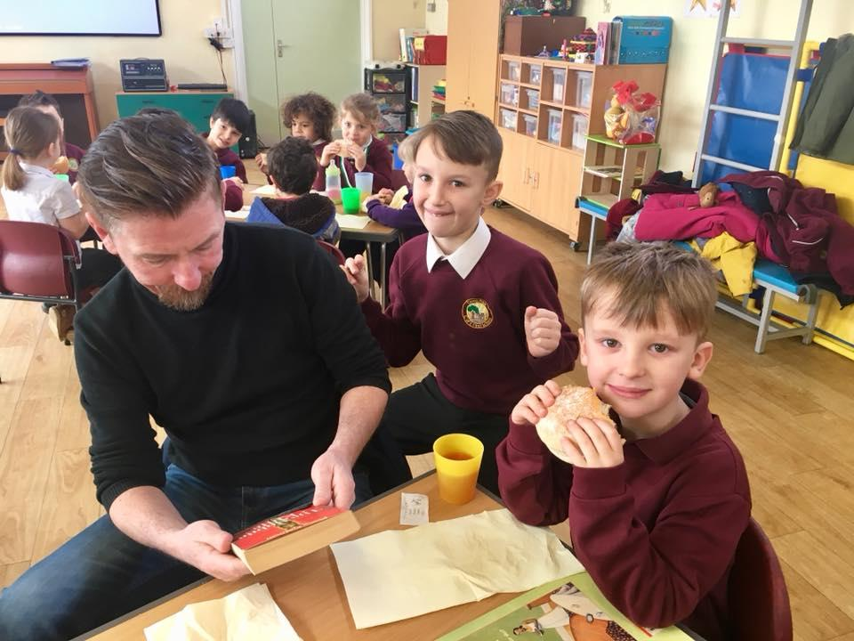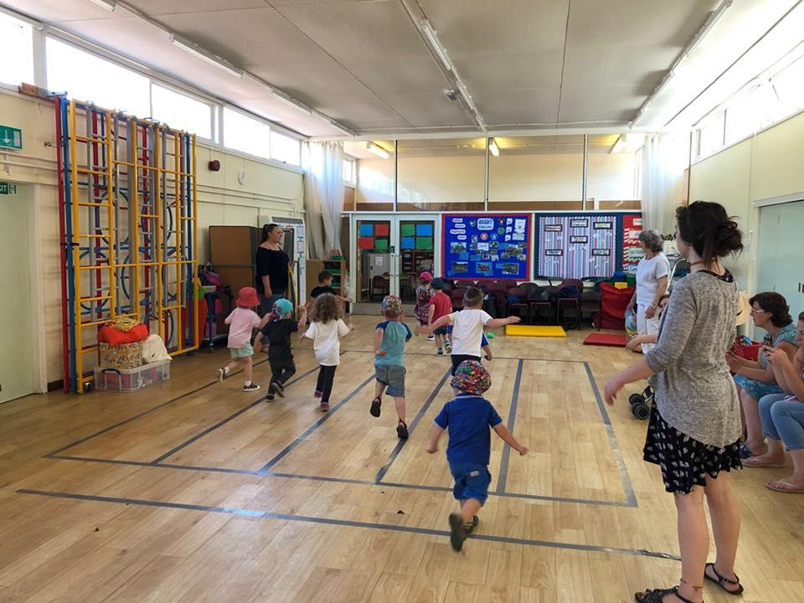

About the Staff team
There will be two full-time teachers at Cleeve Prior, including the Head of School, supported by a team of experienced Teaching Assistants. Governors will be collaborating through a federated arrangement with another local school, providing an Executive Headteacher to oversee both schools. Additionally, we have our team of midday supervisors and office staff. All Staff are friendly, hardworking and committed to providing the best educational experience possible for all children.

About the Post
The position is for a permanent, full-time, experienced class teacher based at Cleeve Prior Primary School. We are looking for a teacher who can demonstrate high quality teaching and meet the wide-ranging educational and pastoral needs of all pupils, supporting the Christian values and ethos of the school. All teachers at our school will have access to professional development opportunities in line with our school development priorities.

In your letter of application, please state your curriculum strengths and any particular talents and abilities you could offer our school.

About the teacher we are looking for:
The Governors are seeking to appoint a committed, energetic and forward-looking teacher who is prepared to go that extra mile in the pursuit of excellence and to maximise each individual child’s learning opportunities.

We are looking for a teacher to join our team who:
· Is an excellent classroom practitioner with an inclusive approach to teaching
· Is well organised and can manage additional adults effectively
· Is able to foster an effective partnership with parents and the wider community
· Has the personal qualities of enthusiasm, flexibility, creativity, passion and commitment
· Is ambitious in their aspirations for pupils and themselves

In return we offer:
· Small class sizes, allowing for strong relationships with delightful, well-motivated children
· A caring, warm and friendly environment
· Staff who are supportive and enjoy working as part of a team
· Exciting professional development opportunities within the school and through partnerships
· A school embarking on an exciting journey of growth and improvement

What to do next
We would encourage you to visit our website to get a flavour of the school. Questions about the school or post are welcomed, please contact office@cleeveprior.worcs.sch.uk with any queries. Please remember to include a contact telephone number and email in your correspondence.

Send a completed application form with a letter of application to the school email above or by post. There is no fixed closing date - please apply as soon as possible. The recruitment process will conclude on appointment of the right candidate.

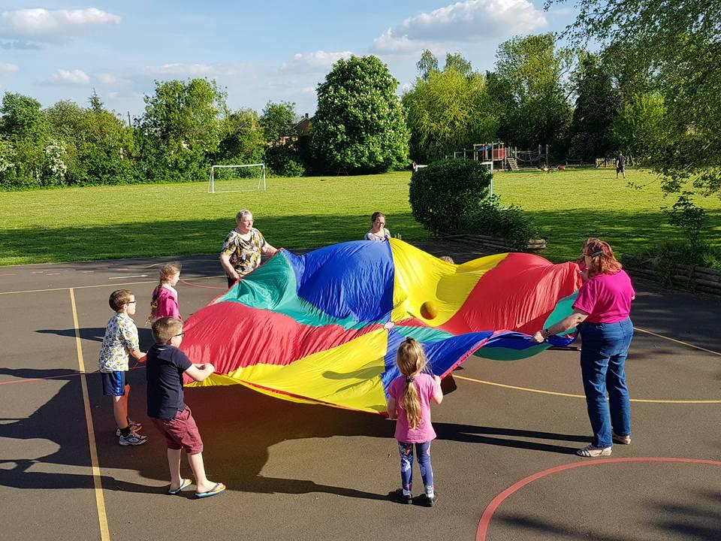

Person Specification

Attributes | Essential | Desirable
Relevant experience | - Teaching experience in Key Stage One or Lower Key Stage Two  - Creating and implementing individual education and pastoral plans for pupils with SEND.  - Experience of positive behaviour management strategies.  - Experience of assessment to inform teaching and learning. | - Experience in more than one Key Stage  - At least two years teaching experience in a mixed age setting  - Ability to offer extra- curricular activities in Reception, KS 1 or 2
Education and training | - Qualified teacher status.  - Evidence of relevant training.  - English and maths training in the relevant  Curriculum.  - Evidence of continuous commitment to further professional development. | - Evidence of creative and innovative teaching  - Experience in Early Years
Knowledge and understanding | Up to date knowledge and understanding of;  - current educational developments in  teaching and learning and accelerated  ways of learning.  - providing effectively for the individual needs of all children, including disadvantaged children, children with special educational needs and those who are more able, gifted or talented.  - the statutory National Curriculum requirements  - monitoring, assessment, recording and reporting of pupils’ progress  - positive links necessary within school and the importance of community cohesion  - Child Protection / Safeguarding procedures | - A clear understanding of differentiation in tasks  - Knowledge and understanding of developing links between schools
Skills | - An excellent classroom practitioner with work planned to a high standard and regular assessment and record keeping to promote and support high quality teaching and learning.  - Insistence on high standards and expectations of attitudes and behaviour.  - Well-organised and managed classroom where children are independent.  - A creative and exciting learning environment, where children’s work is celebrated and well displayed. | - Evidence of involvement in the wider school community
Personal characteristics | - Ability to work as part of an effective team with colleagues, parents and the wider community.  - Creative ideas and support for the future development of the school.  - An ability to inspire children with innovative and exciting learning opportunities to encourage learning from mistakes.  - Flexible and adaptable – with a willingness to take a whole school perspective, support colleagues within the ethos of the whole school family and cope positively with change.  - Good interpersonal and communication skills.  - Willingness to be involved in extracurricular activities and events and engage in all aspects of school life.  - Supportive of the Christian ethos of a Church School, evidenced by the demonstration of the school’s Christian values. | - To have career aspirations beyond classroom teaching.

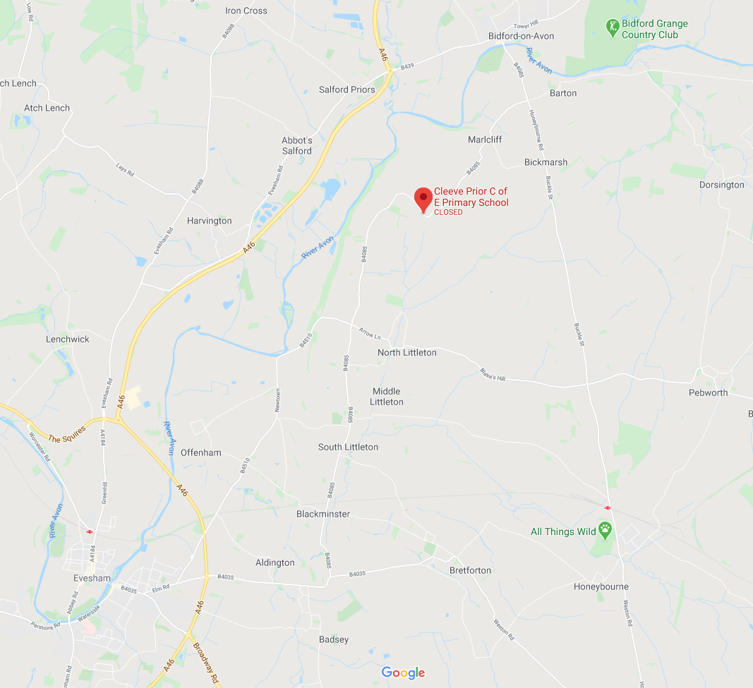
Where to find us…
KS1 Base
KS2 Base

