


JOB DESCRIPTION
Post Held: Primary Special Educational Needs Teacher MPR/UPR plus 1 or 2 SEN Points
Employment Duties:
The current School Teachers’ Pay and Conditions document describes duties which are required to be undertaken by teachers in the course of their employment. In addition, certain duties are reasonably required to be exercised and completed in a satisfactory manner. It is the contractual duty of the post holder to ensure that his/her professional duties are discharged effectively.

Exercise of general professional duties
All teachers will be expected to carry out the professional duties of a teacher as outlined in the School Teachers’ Pay and Conditions Document 2025, or any subsequent legislation.

Purpose of Job:
To teach autistic pupils and to carry out such other associated duties as are reasonably assigned by the Headteacher. To act within the statutory framework set out in the Teachers Standards.

Special Responsibility:

- To teach a range of subjects to assigned groups.
- To act as a Form Tutor monitoring the pastoral and special educational needs of the students in your form
- To have a clear understanding of the needs of pupils that arises from autism and be able to apply distinctive teaching approaches to engage and support them.

Reports to: Headteacher

Teaching and Learning

- To implement school policies and schemes of work according to the individual needs of students, having high expectations and setting outcomes as part of the annual review cycle of the Educational Health and Care Plan (EHCP)
- To implement the curriculum in accordance with the school’s philosophy and policies
- Contributing to the whole school ethos by taking a leading role in creating an autism specific environment.
- To organise personalised learning activities and experiences which are differentiated to meet the individual needs and levels of achievement and motivation of each pupil.
- To ensure teaching programmes are supported by clear aims and objectives with appropriate links to recognised specialist approaches used within school underpinned by SCERTS, using principles of Intensive Interaction rooted in social relational models of child development.
- To promote the use of Literacy, Numeracy and ICT within your subjects
- Promoting the inclusion of all students within the classroom using a working knowledge of how to personalise learning.
- Assessing work and providing feedback to students and parents in line with school policy and practice.
- Contributing to the preparation and development of programmes of study, schemes of work, teaching materials, teaching programmes, methods of teaching and assessment and pastoral arrangements throughout the school, including school trips, assemblies, performances and special events
- To be responsible for planning, tracking, evaluating, assessing and reporting the teaching and learning of pupils, including completing assessment systems including Evidence for Learning.
- Generating and updating Personal Snapshots and individual learning plans on a termly basis and preparing advice in accordance with the schools’ practices and policies.
- To lead on specific areas of teaching and learning within school as designated by Headteacher.
- To have pastoral responsibility for a group of pupils and undertake administrative tasks in respect of those pupils
- To be responsible for safeguarding the health and welfare of pupils using appropriate risk assessments and incident /accident recording and reporting as required by the school
- To ensure in all teaching situations the collaborative nature of working between non-teaching staff, support services and parents.
- To maintain an inclusive and orderly learning environment through the effective management of resources, lesson planning

Form Tutor
- To mark the register twice per day, at the commencement of the morning session and during afternoon form time
- To monitor the pastoral, social and academic progress of the students in your form through regular review of Personalised Learning Plans and maintenance of individual progress monitoring outcomes set within EHCP’s and SCERTS
- To organise the collection of written reports from all who teach the students when required by the Head Teacher or her representative and to include a form tutors’ perspective for each student
- To foster and maintain positive links with the parents and carers of the students in your form
- To bring to the attention of the Head Teacher or any other Designated Safeguarding Lead any worries concerning Child Protection Issues
- To promote equal opportunity of access to the Windmill Curriculum for each individual student and to liaise with other colleagues to achieve this.
- To create and maintain a secure classroom environment reflecting and acknowledging the students’ gender, disability and ethnicity.
- To represent the students’ interests and to respond to their concerns.
- To facilitate and actively promote pupil voice in all learning and social activities and throughout the review of the EHCP
- To work with parents producing and maintaining home/school programmes where mutually agreed and to follow agreed procedure for home/school liaison.
- To attend meetings to discuss the pastoral, social and academic progress of students in your class

Other Activities
- To safeguard every student’s health, safety and well-being in line with school policies, particularly those relating to child protection, equal opportunities, racial equality, health, safety and security, confidentiality, behaviour and data protection, reporting concerns to the designated person
- To promote the celebration of diversity and difference
- Communicate and co-operate with other agencies to support the educational, development, progress and well-being of individual students, participating in meetings arranged for any purposes described above, keeping records and making reports on the personal and social needs of students
- To communicate and consult with parents of students
- To participate in staff meetings as requested by the Head Teacher
- To supervise students throughout the school during play and at any other unstructured free time or break and lunch as requested by the Head Teacher

Training and Development
- Participate in training and development activities in school or at other providers in order to improve professional skills and knowledge
- To participate in appraisal reviews in line with school policy
- Review and evaluate teaching methods and schemes of work

This job description is subject to amendment from time to time within the terms of the conditions of employment, as the needs of the school may require - but only to an extent consistent with those conditions of employment following consultation by all parties.
The agreed Grievance Procedure may be invoked in any dispute arising from this job description, or subsequent amendment, in which case teachers are advised to consult their professional association.

Values and Ethos:
‘Celebrating Uniqueness’
The Windmill School (TWS) will enable its pupils to access a full but relevant and meaningful curriculum that will allow them to achieve their potential in the least restrictive environment, informed by the latest approaches in the field of autism and education.
Our aim is to develop academic potential and prevent regression. Throughout planning, expectations will be high but realistic and based on thorough assessment of individual needs that arise out of the analysis of the individual’s sensory sensitivities, strengths and special interests. Personalised pathways of learning that build on this type of analysis will develop pupils’ self-esteem.
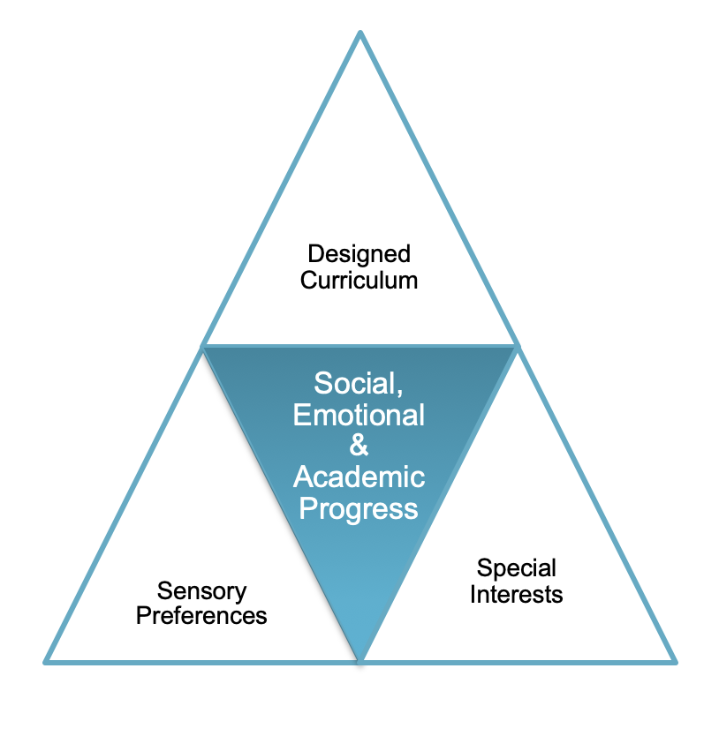
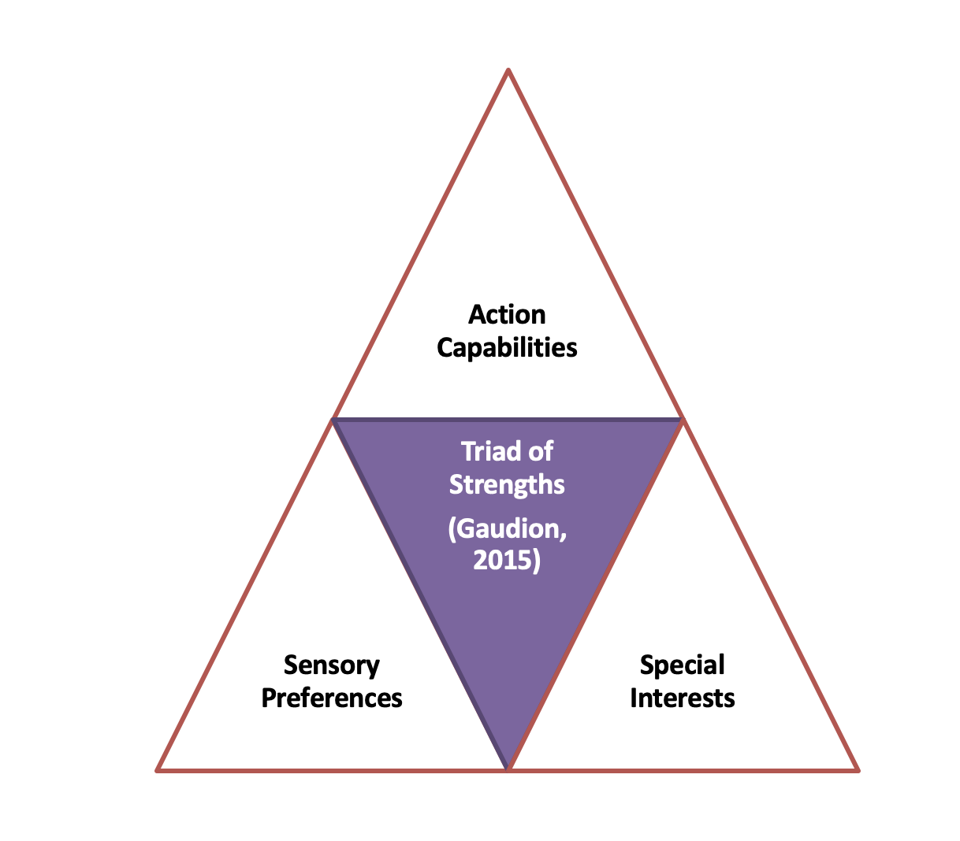
Personalised programmes are designed on a model described as a triad of strengths rather than one of impairment.

The Windmill School will develop and conduct applied research to identify the best ways to directly improve the outcomes of its pupils and their families, and to ensure their wellbeing throughout their schooling and beyond by committing to the following within all provision planning:
- Autistic pupils need specialist, evidence-informed approaches in quality-first teaching practice to remove barriers and allow them to learn effectively inside and outside the classroom.
- Educating autistic pupils benefits from a whole-child approach, recognising that attention to pupils’ mental health and emotional well-being is just as important as their autism.
- Innovative and individualised methods of adapting the curriculum, utilising pupils’ strengths and interests, are essential for ensuring that it is accessible, effective and motivating for pupils.
- Close working relationships with parents, recognising their key role, expertise and joint decision making, as well as their need for support, is essential for ensuring that learning continues outside the school.
- Autistic pupils who are engaged in their learning, and who are active participants in decisions about their learning, are more likely to be confident learners.
Person Specification
 | Essential | Desirable
Qualifications | Qualified Teacher Status | Evidence of continuous INSET and commitment to further professional development  SEN qualification or evidence of specialist training in autism that may include SCERTS Intensive Interaction TEACCH
Experience | Teaching in KS1/early years or primary age range  Experience of teaching autistic pupils  Working in partnership with parents. | Successful multi-agency collaboration  Teaching of PE
Knowledge and understanding | Working knowledge and understanding of the KS1 National Curriculum  Working knowledge of formative and summative assessment for SEN pupils including autism  The monitoring, assessment, recording and reporting of pupils’ progress  The theory and practice and pedagogy suitable for teaching autistic pupils that includes all teaching and learning approaches and approaches to understanding emotional regulation  The statutory requirements of legislation concerning Safeguarding, Equal Opportunities, Health & Safety, Prevent, SEN (EHCP & Annual Reviews)  The positive links necessary within school and with all its stakeholders; | SCERTS framework  B –Squared/ Evisense  Evidence for Learning
Skills | Promote the school’s aims positively, and use effective strategies to monitor motivation and morale;  Develop good personal relationships within a team & effective management of Teaching Assistants.  Establish and develop close relationships with parents, governor, Trustees and the community;  Communicate effectively (both orally and in writing) to a variety of audiences;  Create a positive, happy and purposeful learning environment.  Ability to manage time effectively to ensure the submission of reports on time.  Competent IT user | Develop strategies for creating community links.
Personal characteristics | Empathetic  Committed  Enthusiastic  Organised  Patient  Resourceful  Sociable  Resilient  Curious

