

**PRIMARY TEACHER**

# Contents

Headteacher’s Welcome. 4

The Recruitment Process. 5

Advertisement. 6

Department Information. 10

Job Description. 11

Person Specification. 15

Our Ethos and Strategic Direction. 17

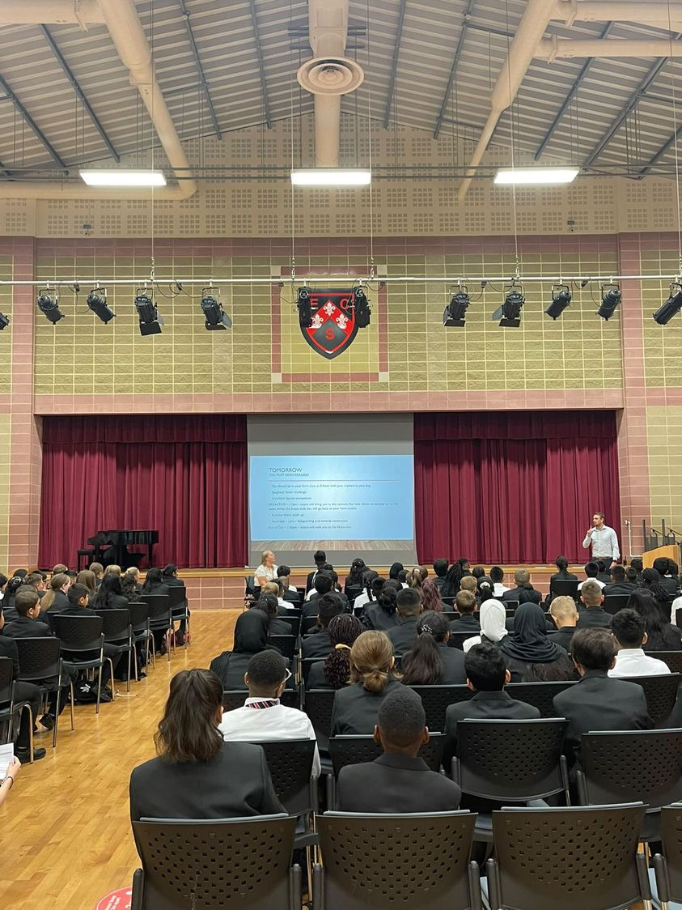

## Headteacher’s Welcome

Welcome to Eastbury Community School, and thank you for expressing an interest in applying for the position of Primary Teacher.

For me, our school is where our young people are given the opportunities to allow them to realise their potential, and that potential can and does manifest itself in a range of ways.

Our young people need to see that success comes in a range of different forms, and ECS is where they can explore where and how they can and will be successful. Our pupils get some of the best progress results in GCSEs in the local area, our 6th Form- judged outstanding (March 2024) achieves some of the best results in the Barking and Dagenham, and over half of these young people go on to attend Russell Group universities.

Our young people need to have a voice in the school, the local community and the wider world. As part of our commitment to this belief we are a Rights Respecting School – Silver award at the moment, but we are confident that within the next year we will achieve Gold – one of the only 3-19 schools in London to do so.

Sir Tim Brighouse said “If a teacher makes the weather the school creates the climate.” and I firmly believe this. It is our role as a leadership team to create the best possible learning environment for our teachers to teach in. In return we expect the best possible teaching from them and our results show this over time. We have created systems and structures that support high quality learning, whilst minimising workload and maximising impact.

**Our recent Ofsted report – March 2024 stated:**

“*Pupils are proud to be part of this inclusive community where people respect and care for each other. They appreciate the support they receive from staff if they have a concern” .*

*“Leaders are ambitious for all pupils to achieve well”*

*“The school takes effective steps to address behaviour that does not meet its high expectations. Pupils conduct themselves well and enjoy their time at school. Low level disruption in lessons is rare”*

*“Staff, including early career teachers, said that leaders have carefully considered their workload and well-being. They value the many opportunities to improve their professional practice.”*

If you share our ethos and values and absolutely believe in the potential of all young people then we can offer you the chance to make a difference and change our community for the better, and look forward to receiving your application form and welcoming you to our school.

 **Sharon Gladman – Executive Headteacher**

**The Recruitment Process**

The interview process will be organised to provide a range of assessment tasks and opportunities for candidates to find out more about the school and demonstrate their ability to fulfil the role.

**Key Dates**

**Closing Date for Applications 24 February 2025**

**Interviews w/c 3 March 2025**

Please note all dates are subject to change.

Completed applications should be sent to: [kdunnell@eastbury.bardaglea.org.uk](mailto:kdunnell@eastbury.bardaglea.org.uk)

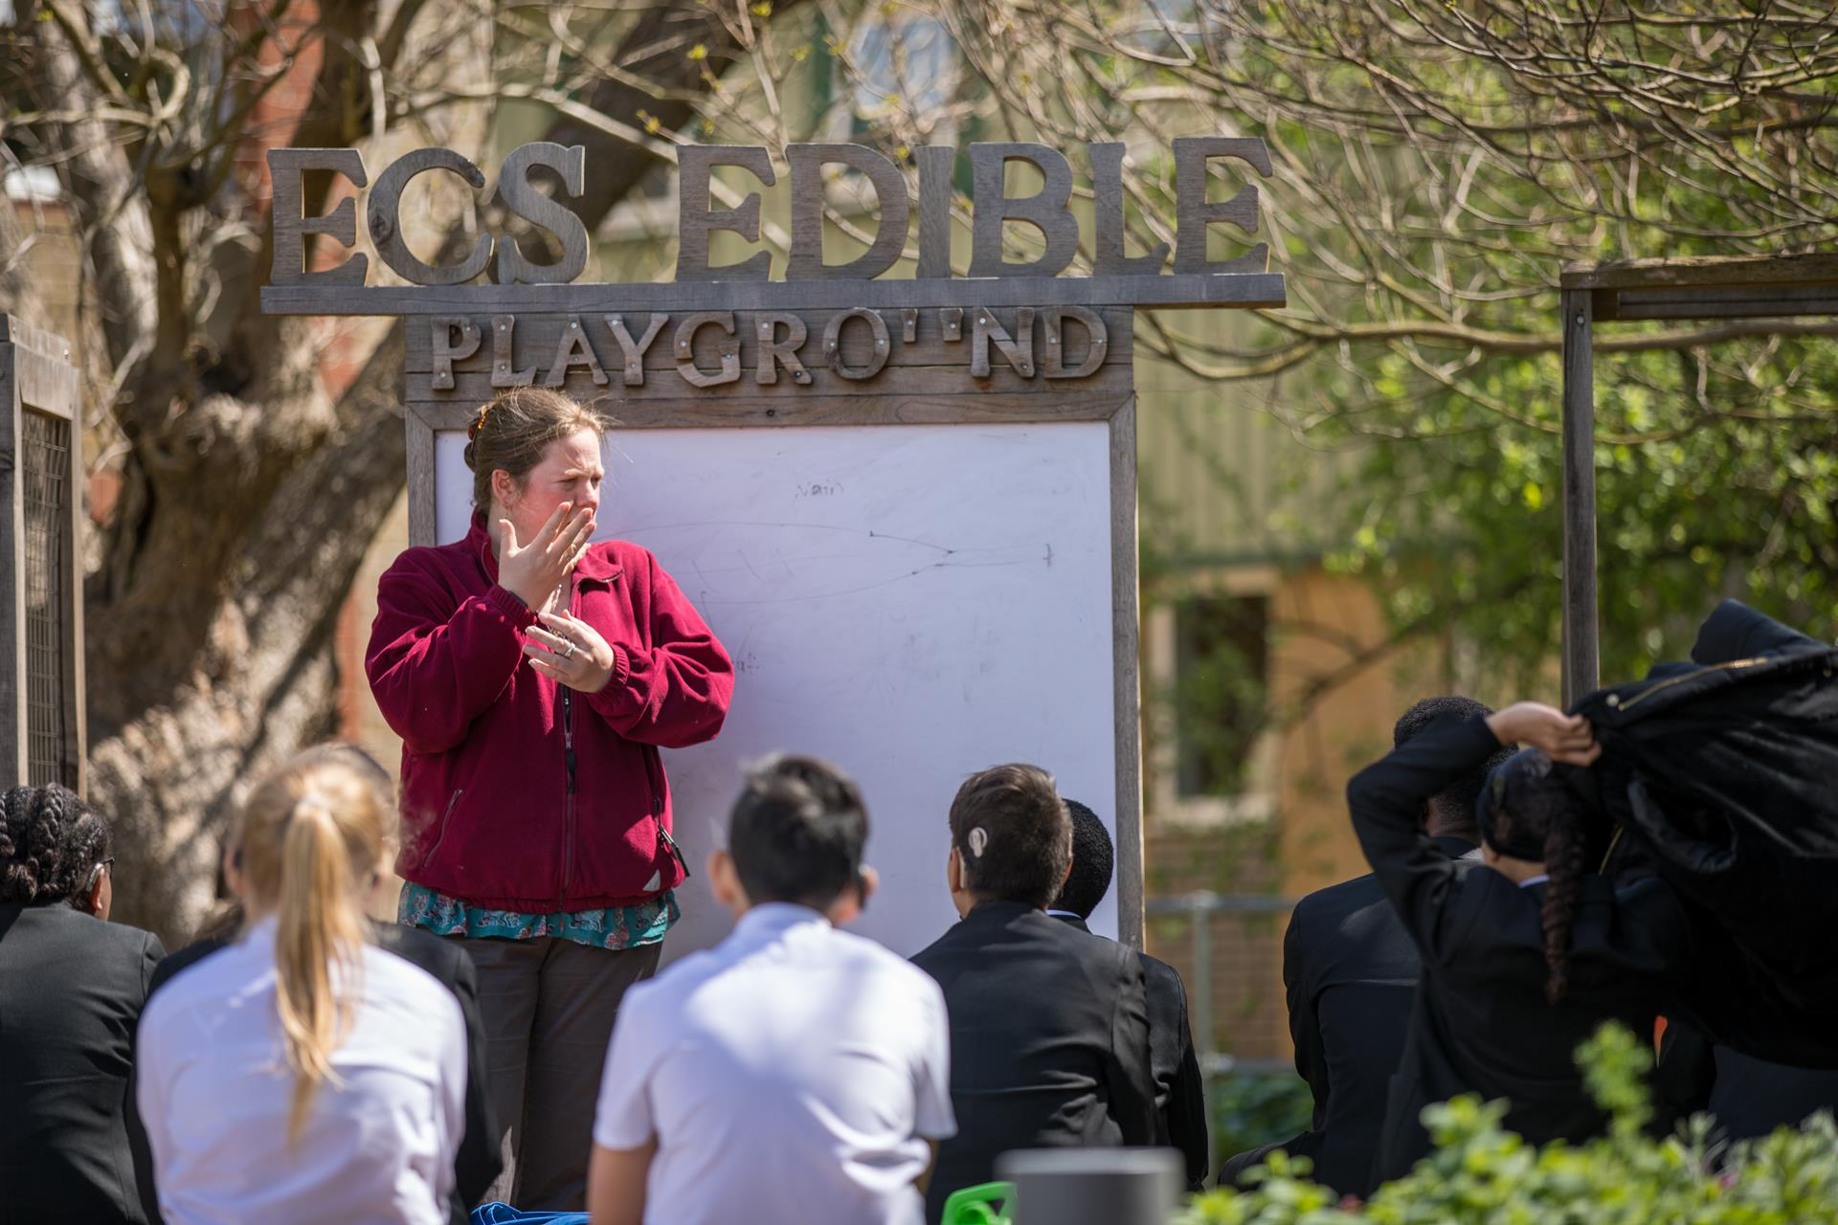

**Advertisement**

**Advertisement**

**JOB ROLE PRIMARY TEACHER**

**CONTRACT Full time**

**START DATE: September 2025**

**SALARY SCALE: MPS/UPS £38, 766 - £60,092**

**About Our School:**

This is an excellent opportunity for a committed and innovative individual to join a successful, forward thinking and inclusive 3-19 all through school.  We are at the heart of an ethnically diverse community in East London, an area undergoing significant regeneration and building affordable homes.  We are a successful school, where academic outcomes and character development are at the heart of everything we do. We believe our students can achieve and give them the opportunities to realise their potential.   Our children perform significantly above National Average in all Key Stages and make accelerated progress throughout their time in the school.  We foster a collaborative culture where talented individuals are empowered to produce their best work in a purpose-built accommodation.

**Find out more about a career at ECS here:** [**Join Our Community**](https://www.eastbury.bardaglea.org.uk/Work-for-Us/index.asp)

**About The Role:**

We are seeking to appoint enthusiastic professional who:

We are seeking a well-qualified and ambitious professional who is motivated to make a difference to the life chances of children and help the school to move to overall outstanding. The post would suit a team player who is committed to the happiness, well-being, self-esteem and progress of everyone at the school.

* Set high expectations which inspire motivate and challenge pupils
* Promote good progress and outcomes by pupils
* Demonstrate good subject and curriculum knowledge
* Plan and teach well-structured lessons
* Adapt teaching to respond to the strengths and needs of all pupils
* Make accurate and productive use of assessment
* Manage behaviour effectively to ensure a good and safe learning environment
* Fulfil wider professional responsibilities

ECS celebrates its diversity, and we positively welcome applications from all sections of the

community. If you are interested in making a difference in young people’s lives, whatever your background or history please apply.

In return we can offer:

* A pupil centred, progress focused ethos.
* A welcoming and supportive community.
* The opportunity to work with a passionate, hardworking and supportive staff.
* A commitment to develop your skills through continued professional development.
* A supportive and committed Leadership Team and Governing Body.
* A cohort of pupils with high aspirations and a willingness to learn.
* A school which understands the importance of staff well-being and workload management

*“Pupils value the opportunities that they have to work with leaders to further improve the*

*school, for example through the school council. Older pupils, and students in the sixth*

*form, help pupils in the primary phase with their reading. Pupils benefit from a range of*

*extra-curricular clubs, both at lunchtime and after school.” (Ofsted March 2024)*

Please click here to find out more information about what it is like to work at ECS:

<https://www.eastbury.bardaglea.org.uk/>

The school is located less than 10 minutes’ walk from Upney tube and 15 minutes from Barking mainline station.

To find out more about how teachers can secure rented accommodation at a discounted rate of 20% please contact: [**info@bdsip.co.uk**](mailto:info@bdsip.co.uk)

ECS is committed to safeguarding and promoting the welfare of children and is an Equal Opportunities Employer.

This post is exempt from the Rehabilitation of Offenders Act 1974 and a comprehensive screening process, including Disclosure check, will be undertaken on all successful applicants.

**How To Apply:**

For full details of the post and an application form, please visit the school website [www.eastbury.bardaglea.org.uk](http://www.eastbury.bardaglea.org.uk) and return the application form to the Headteacher’s PA, Karen Dunnell [kdunnell@eastbury.bardaglea.org.uk](mailto:kdunnell@eastbury.bardaglea.org.uk). The closing date for applications is 24 February 2025 and interviews will be held w/c 3 March 2025.

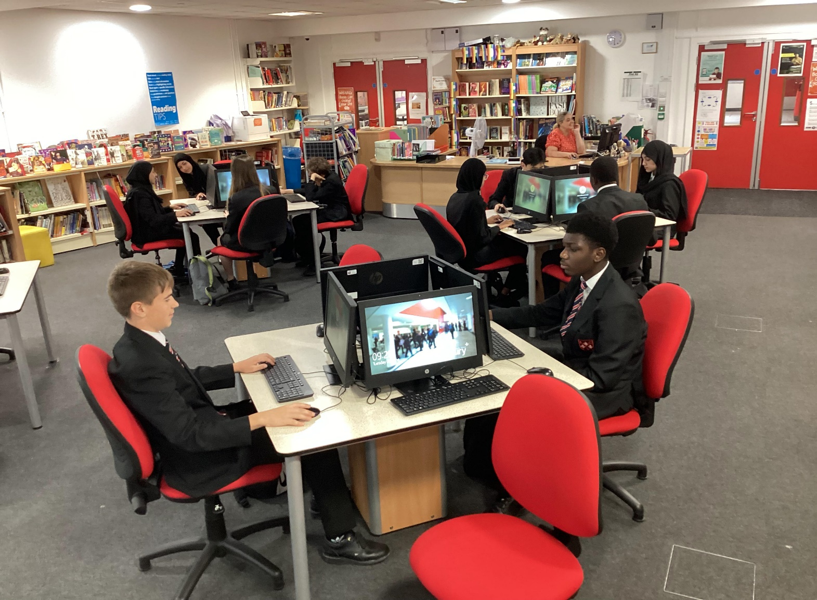





**Department Information**

**Job Description**

**Primary Phase Overview:**

The successful candidate will be joining a dedicated, collaborative and supportive team who build confidence and trust in their staff through autonomy. The Primary is a 2 form entry oversubscribed school. We foster a love of reading for all children. Children learn to read through Sounds Write Phonics Program and reading is taught through Daily Supported Reading and Destination Reader. We have embedded the Talk for Writing Program which is an engaging teaching framework that raises progress and boosts standards. Maths is taught through Maths No Problem. This scheme is based on the evidence-based approach developed in Singapore, it has been recommended by the DfE for schools on the Teaching for Mastery Programme. Every child in the Primary Phase learns to play a musical instrument from Violins to Clarinets with experts in the field. This has been noted as an area of excellence within the school and we have been accredited with the Music Mark Award. The PE curriculum is delivered by an experienced Sports Coach and children have access to a wide range of extra-curricular sporting activities. Spanish is delivered by a Native Speaking Spanish Teacher and children have the option to learn Spanish from EYFS.

The Primary School has a Forest School where the children learn how to grow their own fruits and vegetables and this is a space where many lessons are brought to life.  We are a Silver Rights Respecting School. Children are able to articulate the rights of a child and this is embedded within our school life. Our Eco Warriors work on improving the sustainability of the environment. We have been awarded with The Green Flag Award. The Science curriculum across the school has been implemented well and as a result we have been awarded our Primary Science Quality Mark.

**Job Description**

**Job Description**

|  |  |
| --- | --- |
| **Post Title:** | Class Teacher – Main Professional Grade/UPS + (Inner London) |
|  |  |
| **Purpose:** | * In cooperation with the Head of Primary , to implement and deliver an appropriately broad, balanced, relevant and differentiated curriculum for pupils and to support the Primary curriculum areas as appropriate; in accordance with the aims of the school and the curricular policies determined by the Governing Body, Head of Primary and Executive Head of the school. * To monitor and support the overall progress and development of pupils as a class teacher * To facilitate and encourage learning experiences which provide pupils with the opportunity to achieve their individual potential and academic growth. * To become an increasingly effective practitioner, leading to improved and sustained standards of teaching and learners’ attainment. * To be responsible for the continuing review and development of their professional practice, providing evidence of their improving skills and the ability to work with colleagues, and of their potential capacity to meet the performance threshold/ senior teacher standards. * To work as directed by the Head of Primary, KS Leaders meeting School standards. * To personalise learning for the pupils under your care so that achievement is accessible to all. * To be accountable for the progress of the pupils in your class. * To share good practice with colleagues and be willing to undergo INSET to develop and enhance your own good practice. * To contribute to keeping the school informed of the characteristics of high quality teaching and learning, and the main strategies for improving and sustaining high standards of teaching, learning and achievement for all students with particular reference to the area of responsibility. * To use comparative data, together with information about students’ prior attainment to establish benchmarks and set targets for student improvement within your class. * To act as an advocate for a subject area both outside and inside school * To contribute to developing systems for behaviour for learning and thus contribute to whole school strategies. * In cooperation with the Head of Primary and KS Leaders ,ensure the monitoring of teaching and learning in the Primary * To liaise with other teachers to meet individual and thus whole school targets. * With the Head of Primary, to provide and analyse current data as required regarding the performance of your class. |
|  |  |
| **Reporting to:** | Head of Primary and Phase Leader |
|  |  |
| **Responsible for:** | The provision of a full learning experience and support for pupils in your class. |
|  |  |
| **Liaising with:** | Executive Head, KS Leaders, Head of Primary, teaching/support staff, LEA representatives, external agencies and parents. |
|  |  |
| **Working Time:** | 195 days per year. Full-time/Part-time |
|  |  |
| **Salary/Grade:** | Main Professional Grade |
|  |  |
| **Disclosure level** | Enhanced |
| **MAIN (CORE) DUTIES** | |
| **Operational/ Strategic Planning** | Be responsible for the learning and achievement of all pupils in the class, ensuring equality of opportunity throughout • Be responsible and accountable for achieving the highest possible standards in work and conduct • Treat all pupils with dignity, building relationships rooted in mutual respect, at all times observing proper boundaries appropriate to a teacher’s professional position • Work proactively and effectively in collaboration and partnership with learners, parents/carers, governors, other staff and external agencies in the best interests of pupils • Act within the statutory framework, which sets out professional duties and responsibilities as outlined in the current School Teachers Pay and Conditions Document and Teacher Standards (2013) • Take responsibility for promoting and safeguarding the welfare of children within the school • Demonstrate outstanding practice in all areas |
|  |  |
| **Curriculum Provision:** | To assist the Head of Primary and KS Leaders in order to ensure that the curriculum provides a range of teaching which compliments the school’s strategic objectives. |
|  |  |
| **Curriculum Development:** | To assist in the process of the curriculum development and change so as to ensure the continued relevance to the needs of students, DfE and the school’s Mission and Strategic Objectives. |
|  |  |
| **Staffing**  **Staff Development:**  **Recruitment/ Deployment of Staff** | * To take part in the school’s staff development programme by participating in arrangements for further training and professional development. * To continue personal development in the relevant areas including subject knowledge and teaching methods. * To engage actively in the Performance Management Review process. * To ensure the effective/efficient deployment of classroom support * To work as a member of a designated team and to contribute positively to effective working relations within the school. |
|  |  |
| **Quality Assurance:** | * To help to implement school quality procedures and to adhere to those. * To contribute to the process of monitoring and evaluation of the curriculum in line with agreed school procedures, including evaluation against quality standards and performance criteria. To seek/implement modification and improvement where required. * To review from time to time methods of teaching. * To take part, as may be required, in the review, development and management of activities relating to the curriculum, organisation and pastoral functions of the Primary school. |
|  |  |
| **Management Information:** | * To maintain appropriate records and to provide relevant accurate and up-to-date information for MIS, registers, etc. * To complete the relevant documentation to assist in the tracking of pupils. * To track pupil progress and use information to inform teaching and learning. |
|  |  |
| **Communications:** | * To communicate effectively with the parents of pupils as appropriate. * Where appropriate, to communicate and co-operate with persons or bodies outside the school. * To follow agreed policies for communications in the school. |
|  |  |
| **Marketing and Liaison:** | * To take part in Open Evenings, Parents Evenings, Review days and liaison events with partner schools. * To contribute to the development of effective subject links with external agencies. |
|  |  |
| **Management of Resources:** | * To contribute to the process of the ordering and allocation of equipment and materials. * To assist the KS Leaders to identify resource needs and to contribute to the efficient/effective use of physical resources. * To co-operate with other staff to ensure a sharing and effective usage of resources to the benefit of the School, department and the pupils. |
|  |  |
| **Pastoral System:** | * Establish a safe, purposeful and stimulating environment for pupils, rooted in mutual respect, and to establish a framework for discipline with a range of strategies, using praise, sanctions and rewards consistently and fairly. • Manage the class effectively, using approaches which are appropriate to pupils’ needs in order to inspire, motivate and challenge. • Maintain a good relationship with pupils, exercise appropriate authority, and act decisively when necessary. • Be a positive role model and demonstrate consistently the positive behaviour, attitude and values which are expected of pupils. • Have high expectations of behaviour, promoting self-control and independence of all learners. • Carry out playground and other duties as directed by Senior Management. • To ensure that educational needs of all pupils in your class are fully met and liaise with the SENCO where necessary to support children with special needs. • To inform the SENCO of any concerns relating to the development of a child. • To inform the Designated Safeguarding Lead or Family Support Worker of any concerns relating to the safety or well-being of a child. |
|  |  |
| **Primary**  **Teaching Duties:** | * To teach pupils according to their educational needs, assessing and marking pupil work. * To assess record and report on the attendance, progress, development and attainment of pupils and to keep such records as are required. * To provide, or contribute to, oral and written assessments, reports and references relating to individual students and groups of students. * To ensure that ICT and the Primary Areas of learning are reflected in the teaching/learning experience of students * To undertake a designated programme of teaching for the Primary. * To ensure high quality learning experiences for pupils which meet internal and external quality standards. * To prepare and update subject materials. * To use a variety of delivery methods which will stimulate learning appropriate to pupil needs and demands of the Primary Phase. * To maintain discipline in accordance with the school’s procedures, and to encourage good practice with regard to punctuality, behaviour, standards of work and homework. * To undertake assessment of pupils as requested by external examination bodies, departmental and school procedures. * To assess pupil learning and give written/verbal and diagnostic feedback as required. |
|  |  |
| **Proposed Other Specific Duties**: | |
| * Attend Meetings * To play a full part in the life of the school community, to support its distinctive mission and ethos and to encourage staff and students to follow this example. * To promote actively the school’s policies. * To continue personal development as agreed. * To comply with the school’s Health and Safety policy and undertake risk assessments as appropriate. * To undertake any other duty as specified by STPCB not mentioned in the above. * Employees will be expected to comply with any reasonable request from a manager to undertake work of a similar level that is not specified in this job description. * Employees are expected to be courteous to colleagues and provide a welcoming environment to visitors and telephone callers. * The school will endeavour to make any necessary reasonable adjustments to the job and the working environment to enable access to employment opportunities for disabled job applicants or continued employment for any employee who develops a disabling condition.   Whilst every effort has been made to explain the main duties and responsibilities of the post, each individual task undertaken may not be identified. | |
|  | |
| This job description is current at the date shown, but following consultation with you, may be changed by Management to reflect or anticipate changes in the job which are commensurate with the salary and job title. | |

Head of Primary : …………………………………………………

Teacher: ………………………………………………………

Date issued: ………………………………………………….

**Person Specification**

**Person Specification**

**Eastbury Community School - Primary Phase**

**Job Specification – Class Teacher + MPG + Inner London Allowance**

|  |
| --- |
| **Qualifications**   * QTS * Current DBS in place by start of post |
| **Experience + Training**   * Experience of Teaching in a Primary School or as part of initial teacher training programme * Primary Teaching experience in a multi-cultural urban area |
| **Knowledge, Understanding and Skills**   * A good knowledge and understanding of the National Curriculum * The ability to create a happy, challenging and effective learning environment. * Good communication skills – able to talk effectively to children, parents and colleagues. * The ability to manage pupil’s behaviour in an effective manner following the school’s positive behaviour policy. |
| **Personal Qualities**   * A calm and positive person who is well organised. * An effective team member with a flexible approach and the ability to respond to changes in circumstances. * Has high standards for self and others. * Able to show a high level of written and oral communication skills. * Committed to developing as a teacher and to taking responsibility for their own professional development. |
| **General**   * A commitment to working with all the stakeholders in the school and wider community. * Able to demonstrate an understanding and commitment to equal opportunities and diversity. |



**Our Ethos and Strategic Direction**

**Our Ethos and Strategic Direction**

