
PRIMARY TEACHER

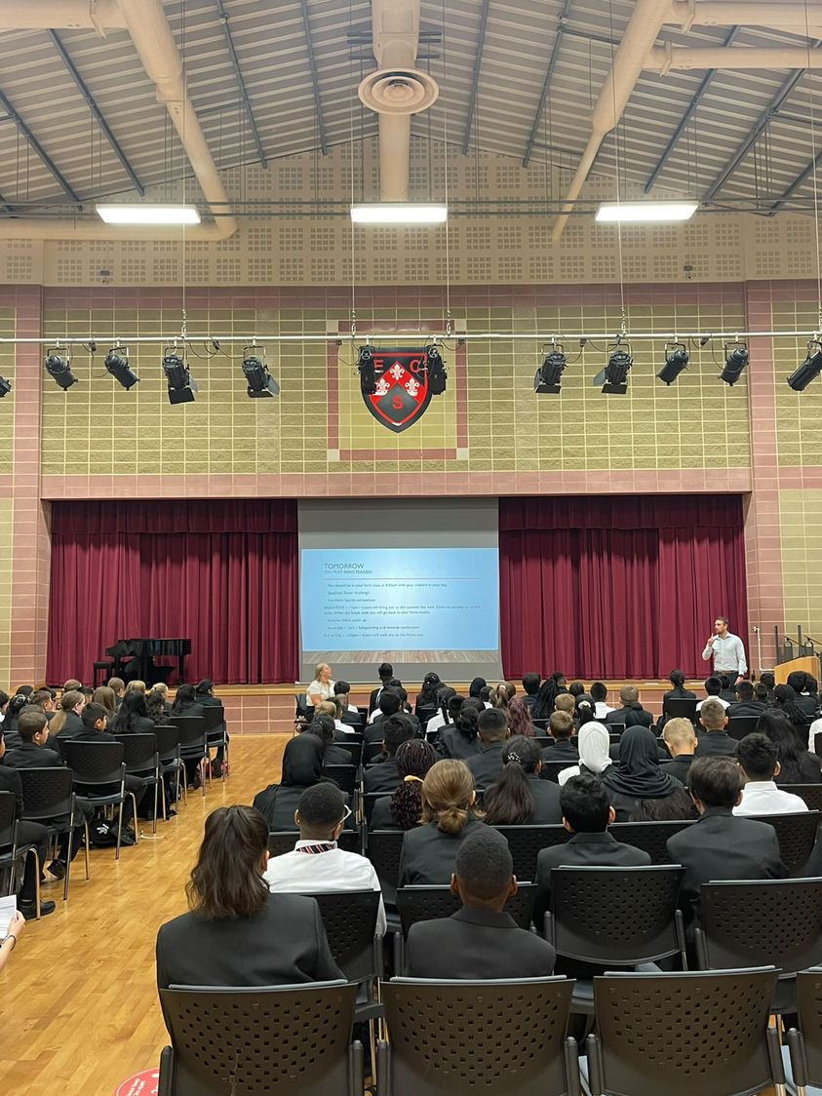

Contents
Headteacher’s Welcome. 3
The Recruitment Process. 4
Advertisement. 5
Department Information. 9
Job Description. 10
Person Specification. 14
Our Ethos and Strategic Direction. 17

Headteacher’s Welcome
Welcome to Eastbury Community School, and thank you for your interest in applying for the position of Primary Teacher.
At ECS, we believe that every child should have the opportunity to realise their potential. That potential takes many different forms, and our role as educators is to create the conditions where each child can discover how they can be successful.
In our Primary phase, children achieve outstanding outcomes, giving them the strongest possible start to their educational journey. Our Secondary phase continues to build on this foundation, with pupils achieving well at both GCSE and A Level. Our Sixth Form, judged Outstanding by Ofsted in March 2024, sees a significant proportion of students progress to Russell Group universities.
We are proud to be a Rights Respecting School, accredited at Gold level. This reflects our commitment to ensuring that pupils understand their rights, their responsibilities, and how to advocate for themselves and others—within school, in the community, and in the wider world.
Sir Tim Brighouse said: “If a teacher makes the weather, the school creates the climate.” I believe this wholeheartedly. As a leadership team, we are committed to creating the best possible environment for teachers to thrive. In return, we expect the very best teaching, because we know that high expectations from staff translate directly into high outcomes for pupils. We have built systems and structures that support high-quality learning while minimising workload and maximising impact.
Our Ofsted report (March 2024) reflects our ethos and approach:
- “Pupils are proud to be part of this inclusive community where people respect and care for each other. They appreciate the support they receive from staff if they have a concern.”
- “Leaders are ambitious for all pupils to achieve well.”
- “The school takes effective steps to address behaviour that does not meet its high expectations. Pupils conduct themselves well and enjoy their time at school. Low-level disruption in lessons is rare.”
- “Staff, including early career teachers, said that leaders have carefully considered their workload and well-being. They value the many opportunities to improve their professional practice.”
If you share our ethos and values, and if you believe absolutely in the potential of every young person, we would love to hear from you. This is your opportunity to make a real difference—not only to children’s lives but also to our community.
We look forward to receiving your application.


Sharon Gladman – Executive Headteacher

The Recruitment Process

The interview process will be organised to provide a range of assessment tasks and opportunities for candidates to find out more about the school and demonstrate their ability to fulfil the role.

Key Dates
Closing Date for Applications 22 September 2025
Interviews 30 September 2025
Please note all dates are subject to change.
Completed applications should be sent to: kdunnell@eastbury.bardaglea.org.uk
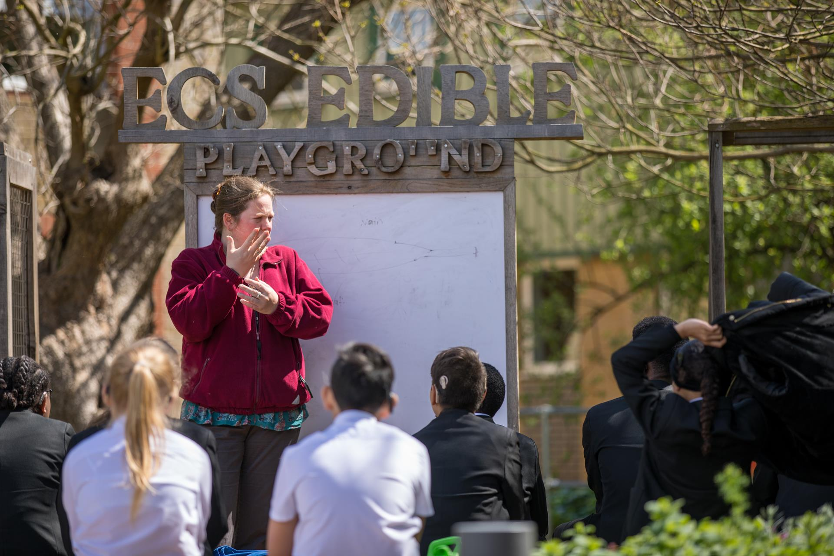
Advertisement

Advertisement

JOB ROLE PRIMARY TEACHERS

CONTRACT Maternity Cover (one year in the first instance)

START DATE: September 2025/January 2026

SALARY SCALE: MPS/UPS £38, 766 - £60,092

Eastbury Community School is a vibrant, oversubscribed 3–19 all-through school, located in the heart of East London. With a roll of 470 in our Primary Phase, we are proud to serve a wonderfully diverse community that reflects the rich culture and heritage of the area. Our school is more than just a place of learning – it is a community where every child is known, valued and inspired to achieve their very best.
We are committed to the belief that every child can succeed. This underpins everything we do, from academic achievement to personal growth and character development. Our vision is to equip children not only with the knowledge and skills they need for their next stage of education, but also with the values and resilience to thrive in life.
Our Primary Phase has quickly gained a reputation for innovation, creativity and excellence in teaching and learning. We are proud to offer:
- A rich, broad and balanced curriculum, designed to engage and challenge every learner.
- A strong focus on early reading and writing, with Sounds Write Phonics, Daily Supported Reading, Destination Reader, and Talk for Writing embedded across the school.
- A mastery approach to mathematics through Maths No Problem, ensuring depth of understanding and success for all pupils.
- A thriving music programme, where every child learns a musical instrument, recognised through the Music Mark Award.
- A high-quality PE and sports curriculum, delivered by a specialist coach and enriched with a wide range of extra-curricular clubs.
- Spanish taught by a native speaker, giving pupils the opportunity to become confident young linguists.
- A dedicated Forest School and Eco Curriculum, which fosters a love for the natural world, sustainability, and pupil leadership – recently recognised with the Eco Schools Green Flag Award.
- Excellence in Science teaching, acknowledged by the Primary Science Quality Mark.
When you join Eastbury, you become part of a dynamic, forward-thinking and supportive team who are committed to making a real difference. We are ambitious for our pupils, ambitious for our staff, and ambitious for the community we serve.
This is an exciting time to join us as we continue on our journey towards excellence. If you are looking for a school where you can truly inspire, innovate and make an impact, Eastbury Community School could be the perfect place for you.

Find out more about a career at ECS here: Join Our Community

About The Role:

We are seeking a well-qualified and ambitious professional who is motivated to make a difference to the life chances of children and help the school to move to overall outstanding. The post would suit a team player who is committed to the happiness, well-being, self-esteem and progress of everyone at the school and can

- Set high expectations which inspire motivate and challenge pupils
- Promote good progress and outcomes by pupils
- Demonstrate good subject and curriculum knowledge
- Plan and teach well-structured lessons
- Adapt teaching to respond to the strengths and needs of all pupils
- Make accurate and productive use of assessment
- Manage behaviour effectively to ensure a good and safe learning environment
- Fulfil wider professional responsibilities

How To Apply:

For full details of the post and an application form, please visit the school website www.eastbury.bardaglea.org.uk and return the application form to the Headteacher’s PA, Karen Dunnell kdunnell@eastbury.bardaglea.org.uk. The closing date for applications is 22 September 2025 and interviews will be held on 30 September 2025.

Eastbury School is committed to safeguarding and promoting the welfare of children and young people. We are committed to and promote equalities in our practice. We expect all staff to share this commitment and to undergo appropriate checks including enhanced DBS checks. CVs are not accepted and will not be considered.

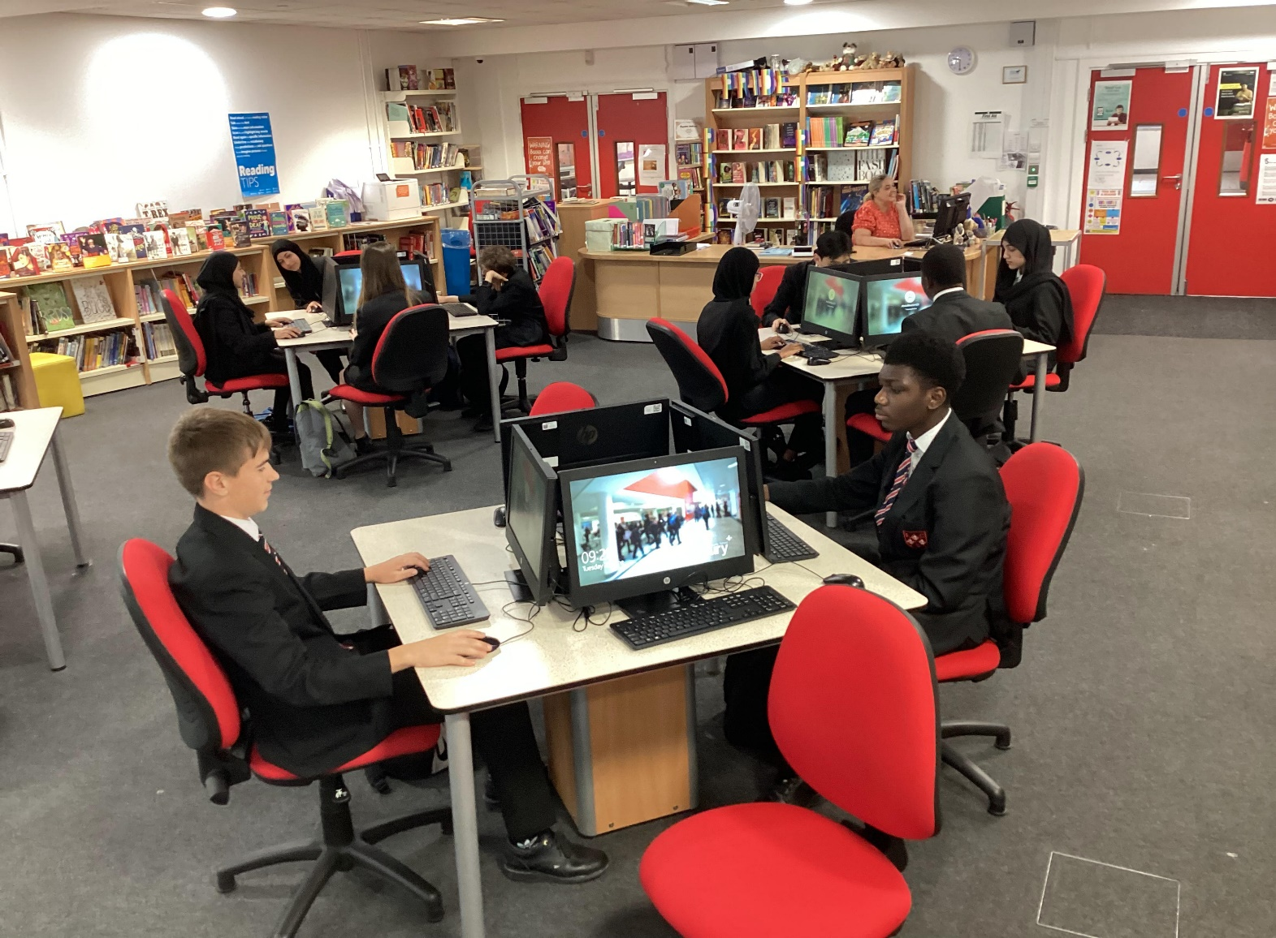




Department Information

Job Description

Primary Phase Overview:

The successful candidate will be joining a dedicated, collaborative and supportive team who build confidence and trust in their staff through autonomy. The Primary is a 2 form entry oversubscribed school. We foster a love of reading for all children. Children learn to read through Sounds Write Phonics Program and reading is taught through Daily Supported Reading and Destination Reader. We have embedded the Talk for Writing Program which is an engaging teaching framework that raises progress and boosts standards. Maths is taught through Maths No Problem. This scheme is based on the evidence-based approach developed in Singapore, it has been recommended by the DfE for schools on the Teaching for Mastery Programme. Every child in the Primary Phase learns to play a musical instrument from Violins to Clarinets with experts in the field. This has been noted as an area of excellence within the school and we have been accredited with the Music Mark Award. The PE curriculum is delivered by an experienced Sports Coach and children have access to a wide range of extra-curricular sporting activities. Spanish is delivered by a Native Speaking Spanish Teacher and children have the option to learn Spanish from EYFS.

The Primary School has a Forest School where the children learn how to grow their own fruits and vegetables and this is a space where many lessons are brought to life. Children are able to articulate the rights of a child and this is embedded within our school life. Our Eco Warriors work on improving the sustainability of the environment. We have been awarded with The Green Flag Award. The Science curriculum across the school has been implemented well and as a result we have been awarded our Primary Science Quality Mark.

We are especially proud that our EYFS has been recognised nationally as an “Area of Excellence” by Challenge Partners. Our innovative early years curriculum and practice have been shared with schools across the country, and leaders from other settings regularly visit Eastbury to learn from our approach.
We also place a strong emphasis on student leadership. From Eco Warriors to School Councillors, our pupils are encouraged to take responsibility, champion change and develop their voice. This builds confidence, independence, and the skills to become active citizens both now and in the future.
Beyond the curriculum, we are passionate about developing the whole child. We are a Gold Rights Respecting School, where children understand and live by the principles of respect, equality and kindness. Our pastoral care is strong, and our staff are committed to nurturing pupils’ well-being, self-esteem, and personal development alongside academic progress.
Eastbury is a school that invests in its staff as much as in its pupils. We believe in collaboration, professional growth and autonomy. Teachers are trusted and supported to innovate in their classrooms, and professional development opportunities are plentiful, from in-house CPD to partnership work with leading educational organisations.
When you join Eastbury, you become part of a dynamic, forward-thinking and supportive team who are committed to making a real difference. We are ambitious for our pupils, ambitious for our staff, and ambitious for the community we serve.
This is an exciting time to join us as we continue on our journey towards excellence. If you are looking for a school where you can truly inspire, innovate and make an impact, Eastbury Community School could be the perfect place for you.
Job Description

Job Description

Post Title: | Class Teacher – Main Professional Grade/UPS + (Inner London)
Purpose: | - In cooperation with the Head of Primary , to implement and deliver an appropriately broad, balanced, relevant and differentiated curriculum for pupils and to support the Primary curriculum areas as appropriate; in accordance with the aims of the school and the curricular policies determined by the Governing Body, Head of Primary and Executive Head of the school.  - To monitor and support the overall progress and development of pupils as a class teacher  - To facilitate and encourage learning experiences which provide pupils with the opportunity to achieve their individual potential and academic growth.  - To become an increasingly effective practitioner, leading to improved and sustained standards of teaching and learners’ attainment.  - To be responsible for the continuing review and development of their professional practice, providing evidence of their improving skills and the ability to work with colleagues, and of their potential capacity to meet the performance threshold/ senior teacher standards.  - To work as directed by the Head of Primary, KS Leaders meeting School standards.  - To personalise learning for the pupils under your care so that achievement is accessible to all.  - To be accountable for the progress of the pupils in your class.  - To share good practice with colleagues and be willing to undergo INSET to develop and enhance your own good practice.  - To contribute to keeping the school informed of the characteristics of high quality teaching and learning, and the main strategies for improving and sustaining high standards of teaching, learning and achievement for all students with particular reference to the area of responsibility.  - To use comparative data, together with information about students’ prior attainment to establish benchmarks and set targets for student improvement within your class.  - To act as an advocate for a subject area both outside and inside school  - To contribute to developing systems for behaviour for learning and thus contribute to whole school strategies.  - In cooperation with the Head of Primary and KS Leaders ,ensure the monitoring of teaching and learning in the Primary  - To liaise with other teachers to meet individual and thus whole school targets.  - With the Head of Primary, to provide and analyse current data as required regarding the performance of your class.
Reporting to: | Head of Primary and Phase Leader
Responsible for: | The provision of a full learning experience and support for pupils in your class.
Liaising with: | Executive Head, KS Leaders, Head of Primary, teaching/support staff, LEA representatives, external agencies and parents.
Working Time: | 195 days per year. Full-time/Part-time
Salary/Grade: | Main Professional Grade
Disclosure level | Enhanced
MAIN (CORE) DUTIES
Operational/ Strategic Planning | Be responsible for the learning and achievement of all pupils in the class, ensuring equality of opportunity throughout  • Be responsible and accountable for achieving the highest possible standards in work and conduct  • Treat all pupils with dignity, building relationships rooted in mutual respect, at all times observing proper boundaries appropriate to a teacher’s professional position  • Work proactively and effectively in collaboration and partnership with learners, parents/carers, governors, other staff and external agencies in the best interests of pupils  • Act within the statutory framework, which sets out professional duties and responsibilities as outlined in the current School Teachers Pay and Conditions Document and Teacher Standards (2013)  • Take responsibility for promoting and safeguarding the welfare of children within the school  • Demonstrate outstanding practice in all areas
Curriculum Provision: | To assist the Head of Primary and KS Leaders in order to ensure that the curriculum provides a range of teaching which compliments the school’s strategic objectives.
Curriculum Development: | To assist in the process of the curriculum development and change so as to ensure the continued relevance to the needs of students, DfE and the school’s Mission and Strategic Objectives.
Staffing  Staff Development:  Recruitment/ Deployment of Staff | - To take part in the school’s staff development programme by participating in arrangements for further training and professional development.  - To continue personal development in the relevant areas including subject knowledge and teaching methods.  - To engage actively in the Performance Management Review process.  - To ensure the effective/efficient deployment of classroom support  - To work as a member of a designated team and to contribute positively to effective working relations within the school.
Quality Assurance: | - To help to implement school quality procedures and to adhere to those.  - To contribute to the process of monitoring and evaluation of the curriculum in line with agreed school procedures, including evaluation against quality standards and performance criteria. To seek/implement modification and improvement where required.  - To review from time to time methods of teaching.  - To take part, as may be required, in the review, development and management of activities relating to the curriculum, organisation and pastoral functions of the Primary school.
Management Information: | - To maintain appropriate records and to provide relevant accurate and up-to-date information for MIS, registers, etc.  - To complete the relevant documentation to assist in the tracking of pupils.  - To track pupil progress and use information to inform teaching and learning.
Communications: | - To communicate effectively with the parents of pupils as appropriate.  - Where appropriate, to communicate and co-operate with persons or bodies outside the school.  - To follow agreed policies for communications in the school.
Marketing and Liaison: | - To take part in Open Evenings, Parents Evenings, Review days and liaison events with partner schools.  - To contribute to the development of effective subject links with external agencies.
Management of Resources: | - To contribute to the process of the ordering and allocation of equipment and materials.  - To assist the KS Leaders to identify resource needs and to contribute to the efficient/effective use of physical resources.  - To co-operate with other staff to ensure a sharing and effective usage of resources to the benefit of the School, department and the pupils.
Pastoral System: | - Establish a safe, purposeful and stimulating environment for pupils, rooted in mutual respect, and to establish a framework for discipline with a range of strategies, using praise, sanctions and rewards consistently and fairly.  • Manage the class effectively, using approaches which are appropriate to pupils’ needs in order to inspire, motivate and challenge.  • Maintain a good relationship with pupils, exercise appropriate authority, and act decisively when necessary.  • Be a positive role model and demonstrate consistently the positive behaviour, attitude and values which are expected of pupils.  • Have high expectations of behaviour, promoting self-control and independence of all learners.  • Carry out playground and other duties as directed by Senior Management.  • To ensure that educational needs of all pupils in your class are fully met and liaise with the SENCO where necessary to support children with special needs.  • To inform the SENCO of any concerns relating to the development of a child.  • To inform the Designated Safeguarding Lead or Family Support Worker of any concerns relating to the safety or well-being of a child.
Primary  Teaching Duties: | - To teach pupils according to their educational needs, assessing and marking pupil work.  - To assess record and report on the attendance, progress, development and attainment of pupils and to keep such records as are required.  - To provide, or contribute to, oral and written assessments, reports and references relating to individual students and groups of students.  - To ensure that ICT and the Primary Areas of learning are reflected in the teaching/learning experience of students  - To undertake a designated programme of teaching for the Primary.  - To ensure high quality learning experiences for pupils which meet internal and external quality standards.  - To prepare and update subject materials.  - To use a variety of delivery methods which will stimulate learning appropriate to pupil needs and demands of the Primary Phase.  - To maintain discipline in accordance with the school’s procedures, and to encourage good practice with regard to punctuality, behaviour, standards of work and homework.  - To undertake assessment of pupils as requested by external examination bodies, departmental and school procedures.  - To assess pupil learning and give written/verbal and diagnostic feedback as required.
Proposed Other Specific Duties:
- Attend Meetings
- To play a full part in the life of the school community, to support its distinctive mission and ethos and to encourage staff and students to follow this example.
- To promote actively the school’s policies.
- To continue personal development as agreed.
- To comply with the school’s Health and Safety policy and undertake risk assessments as appropriate.
- To undertake any other duty as specified by STPCB not mentioned in the above.
- Employees will be expected to comply with any reasonable request from a manager to undertake work of a similar level that is not specified in this job description.
- Employees are expected to be courteous to colleagues and provide a welcoming environment to visitors and telephone callers.
- The school will endeavour to make any necessary reasonable adjustments to the job and the working environment to enable access to employment opportunities for disabled job applicants or continued employment for any employee who develops a disabling condition.

Whilst every effort has been made to explain the main duties and responsibilities of the post, each individual task undertaken may not be identified.
This job description is current at the date shown, but following consultation with you, may be changed by Management to reflect or anticipate changes in the job which are commensurate with the salary and job title.

Head of Primary : …………………………………………………

Teacher: ………………………………………………………

Date issued: ………………………………………………….

Person Specification

Person Specification

Eastbury Community School - Primary Phase

Job Specification – Class Teacher + MPG + Inner London Allowance
Qualifications
- QTS
- Current DBS in place by start of post

Experience + Training
- Experience of Teaching in a Primary School or as part of initial teacher training programme

- Primary Teaching experience in a multi-cultural urban area

Knowledge, Understanding and Skills

- A good knowledge and understanding of the National Curriculum

- The ability to create a happy, challenging and effective learning environment.
- Good communication skills – able to talk effectively to children, parents and colleagues.
- The ability to manage pupil’s behaviour in an effective manner following the school’s positive behaviour policy.

Personal Qualities

- A calm and positive person who is well organised.
- An effective team member with a flexible approach and the ability to respond to changes in circumstances.
- Has high standards for self and others.
- Able to show a high level of written and oral communication skills.
- Committed to developing as a teacher and to taking responsibility for their own professional development.

General
- A commitment to working with all the stakeholders in the school and wider community.
- Able to demonstrate an understanding and commitment to equal opportunities and diversity.



Our Ethos and Strategic Direction

Our Ethos and Strategic Direction

