

Appointment Information Pack




4.

Vacancy | Teacher
Location | Deeplish Primary Academy
Start date | 1st September 2026
Closing date & time Interview and assessment | - Closing date for applications Friday 1st May at Midday  - Shortlisting: Friday 1st May  - Observations: week beginning Monday 4th May  - Interview: Friday 15th May 2026
Salary | Main Pay Scale and Upper Pay Spine
Contract | Permanent
Return application / Apply | Please return letter of application to Ruth Minton via email by midday on Friday 1st May.  Letter describing how you meet the enclosed job description. No more than 2 sides of A4.

Welcome from Ewan McPherson, Principal, Deeplish Primary Academy

Dear applicant,
‘Growing great learners’
‘Growing great learners’

Thank you for your interest in the post of Teacher at Deeplish Primary Academy. I am extremely proud to be the Principal of such a warm and friendly school as Deeplish.

Whatever the needs of our children we aim to ensure they thrive at Deeplish, feeling safe, having fun and enjoying success. We want our pupils’ time in our school to be memorable, build on what they know and can do and help them become lifelong learners.

We value highly the partnership between home and school and encourage all parents to take an active part in the education of their children. The partnership between school staff, parents, governors and other stakeholders is an essential one. Children are at the heart of all we do and their social and emotional well-being, as well as their academic achievements are very important.

We are looking for:
- A resilient, team player capable of working within dynamic high performing teams.
- Someone who is passionate about high quality teaching and learning.
- Someone who is committed to their own professional development and raising the standards of those around them.

Closing date for applications Friday 1st May at Midday
Shortlisting: Friday 1st May
Observations: week beginning Monday 4th May
Interview: Friday 15th May 2026
Post to commence – 1st September 2026

Academy details

Address | Derby St, Rochdale, Lancs. OL11 1LT
Telephone | 01706 392480
Email | deeplish@focus-trust.co.uk
Website | www.deeplishprimaryacademy.co.uk

Welcome from David Roberts, Chair of Governors

Dear applicant,

Thank you for taking the time to consider applying for the role of Teacher at Deeplish Primary Academy. As Chair of the Governing Board, I would like to take this opportunity to tell you a little bit about the context of our school.

Deeplish is an academy right at the heart of the Deeplish community and we work really hard to do everything that we can to support our children and families. We joined Focus Trust in December 2014 and have not stopped improving.

When you visit us, you will find a very inclusive culture where everyone is valued and listened to. Our children and staff are fantastic and have a real love for learning. We have a reputation for being a friendly, caring and successful school, something that I know you will see if you come to visit us.

I hope I have given you a flavour of Deeplish and I have every confidence that we will successfully recruit a teacher who can work with us in order to develop school further. We will offer you a very supportive governing body with high expectations for our children and staff. I hope that you feel encouraged to apply for the post.

Job description

Job title | Teacher
Grade | Main Pay Scale and Upper Pay Spine
Accountable to | Principal, Vice Principal
The responsibilities and professional duties of the post are to be performed in accordance with the provisions of the most recent version of the Teachers’ Standards.

Teachers make the education of their pupils their first concern, and are accountable for achieving the highest possible standards in work and conduct. Teachers act with honesty and integrity; have strong subject knowledge, keep their knowledge and skills as teachers up-to-date and are self-critical; forge positive professional relationships; and work with parents, colleagues and external agencies in the best interests of their pupils.

Purpose of the role
To ensure all pupils achieve high standards of learning and well-being.

Main duties
Set high expectations which inspire, motivate and challenge pupils
- Establish a safe and stimulating environment for pupils, rooted in mutual respect
- Set goals that stretch and challenge pupils of all backgrounds, abilities and dispositions
- Lead by example and demonstrate consistently the positive attitudes, values and behaviour which are expected of pupils

Promote good progress and outcomes by pupils
- Be accountable for pupils’ attainment, progress and outcomes.
- Plan teaching to build on pupils' capabilities and prior knowledge.
- Guide pupils to reflect on the progress they have made and their emerging needs.
- Demonstrate knowledge and understanding of how pupils learn and how this impacts on teaching.
- Encourage pupils to take a responsible and conscientious attitude to their own work and study.

Demonstrate good subject and curriculum knowledge
- Have a secure knowledge of all curriculum areas, foster and maintain pupils’ interest in the subject, and address misunderstandings.
- Demonstrate a critical understanding of developments in curriculum areas, and promote the value of learning and scholarship.
- Demonstrate an understanding of and take responsibility for promoting high standards of literacy, articulacy and the correct use of Standard English, whatever the teacher’s specialist subject.
- Demonstrate a clear understanding of the teaching of systematic synthetic phonics, reading and the teaching and application of basic skills.
- Demonstrate a clear understanding of the teaching of mathematics and the application of basic skills.

Plan and teach well-structured lessons
- Impart knowledge and develop skills and understanding through effective use of lesson time.
- Promote a love of learning and children’s intellectual curiosity.
- Set and assess homework and plan other out-of-class and enrichment activities to consolidate and extend the knowledge and understanding pupils have acquired.
- Reflect systematically on the effectiveness of lessons and approaches to teaching.
- Contribute to the review, design and provision of an engaging curriculum.

Adapt teaching to respond to the strengths and needs of all pupils
- Know when and how to differentiate appropriately, using approaches which enable pupils to be taught effectively.
- Have a secure understanding of how a range of factors can inhibit pupils’ ability to learn, and how best to overcome these.
- Demonstrate an awareness of the physical, social and intellectual development of children, and know how to adapt teaching to support pupils’ education at different stages of development.
- Make effective use of resources (including other adults) to impact on pupil learning and progress.
- Have a clear understanding of the needs of all pupils, including those with special educational needs; those of high ability; those with English as an additional language; those with disabilities; and be able to use and evaluate distinctive teaching approaches to engage and support them.

Make accurate and productive use of assessment
- Undertake formative, summative and statutory assessments in line with the Academy’s policy and assessment calendar.
- Make use of formative and summative assessment to plan for and secure pupils’ progress.
- Use data to monitor progress, set targets, and plan subsequent lessons.
- Give pupils regular and timely feedback, both orally and through accurate marking, and encourage pupils to respond to the feedback.
- Prepare and present written and verbal reports for parents and carers.

Manage behaviour and resources effectively to ensure a good and safe learning environment
- Have clear rules and routines for behaviour in classrooms, and take responsibility for promoting good and courteous behaviour both in classrooms, around the academy and when learning off-site, in accordance with the Academy’s behaviour policy.
- Have high expectations of behaviour, and establish a framework for discipline with a range of strategies, using praise, sanctions and rewards consistently and fairly.
- Manage classes effectively, using approaches which are appropriate to pupils’ needs in order to involve and motivate them.
- Maintain good relationships with pupils, exercise appropriate authority, and act decisively when necessary.
- Ensure the learning environment is kept well ordered, tidy and free from hazards.

Fulfil wider professional responsibilities
- Make a positive contribution to the wider life and ethos of the Academy and the Trust.
- Develop effective professional relationships with colleagues, knowing how and when to draw on advice and specialist support.
- Deploy support staff and other adults in a support role effectively.
- Liaise with external agencies with regard to pupil progress, safety and welfare.
- Take responsibility for improving teaching through appropriate professional development, responding to advice and feedback from colleagues and external advisers.
- Work with other staff across the Trust and in other maintained schools.
- Communicate effectively with parents with regard to pupils’ achievements and well-being.
- Lead an area or strand of school improvement (excl. NQT).

Personal and professional conduct
A teacher is expected to demonstrate consistently high standards of personal and professional conduct. The following statements define the behaviour and attitudes which set the required standard for conduct throughout a teacher’s career.

- Teachers uphold public trust in the profession and maintain high standards of ethics and behaviour, within and outside the Academy, by:
- treating pupils with dignity, building relationships rooted in mutual respect, and at all times observing proper boundaries appropriate to a teacher’s professional position;
- having regard for the need to safeguard pupils’ well-being, in accordance with statutory provisions;
- showing tolerance of and respect for the rights of others;
- not undermining fundamental British values, including democracy, the rule of law, individual liberty and mutual respect, and tolerance of those with different faiths and beliefs; and
- ensuring that personal beliefs are not expressed in ways which exploit pupils’ vulnerability or might lead them to break the law.
- Teachers must have proper and professional regard for the ethos, policies and practices of the Academy and the Trust, and maintain high standards in their own attendance and punctuality.
- Teachers must have an understanding of, and always act within, the statutory frameworks which set out their professional duties and responsibilities; and within the policies, handbooks and guidelines of the Academy and of the Focus-Trust.

General
The post holder will:
- Be expected to actively support work and values of the Focus-Trust;
- Be expected to undertake such additional duties as may reasonably be requested by the Principal or their representative.
- Respect confidentiality of staff, pupils, families and visitors and not breach this trust. Any breaches of confidentiality must be reported to the Principal immediately.
- Comply with the requirements of all policies, procedures & handbooks of the Focus-Trust and individual academy.
- Participate in arrangements for appraisal and in the identification of areas in which s/he would benefit from training and undergo such training.
- Proactively keep abreast of developments in relation to the post, and whenever possible and appropriate, attend professional development opportunities.
- Comply with and support all requirements related to equal opportunities and safeguarding children.

This job description is neither exhaustive nor exclusive, and it may, after consultation with the post holder be subject to modification and amendment in accordance with the needs of the academy.

Teacher
Personnel specification
Key;
App - application form
Ref- Reference
SP - Selection process. This could include a range of exercise, including an interview

Knowledge, experience and skills
 | Essential/  Desirable | How identified
Experience | E/D | App/sp
Ability of raising attainment of all pupils | E | App/sp
Ability to reflect on practice and improve teaching methods to increase pupils achievements | E | App/sp
Ability to continually improve teaching and learning through schemes of work, assessment and extra curriculum activities etc. | E | App/sp
Knowledge
Up to date knowledge in the primary curriculum | E | App/sp
Ability to use strategies needed to establish consistently high aspirations and standards of results and behaviour | E | App/sp
Skills
Able to play a full and active role in a team | E | App/sp
Clear understanding of expectations, accountabilities and consistency | E | App/sp
Aligned with the Trust’s values | E | App/sp
Motivated to continually improve standards and achieve excellence | E | App/sp
Commitment to the safeguarding and welfare of all pupils | E | App/sp
Excellent classroom practitioner | E | App/sp
Effective and systematic behaviour management, with clear boundaries, sanctions, praise and reward | E | App/sp
Excellent communication, planning and organisational skills | E | App/sp
Fulfil wider professional responsibilities
Understand when and how to seek advice and support. | E | App/sp
Able to develop and maintain good relationships with staff, parents, pupils, governors and the community | E | App/sp
Committed to own development as a professional. | E | App/sp
Able to reflect on own practice and identify areas for improvement | E | App/sp
Qualifications and training
Qualified Teacher Status or other educational qualification | E | App
Qualified to degree level and above | E | App
Evidence of further professional development. | E | App/sp
Personal qualities and attributes
Moral purpose (Equality, children and adults treated with respect) | SP
Excellent communicator (Listening, putting a message across) | SP
Child centred | SP
Resilient | SP
Integrity | SP
Self-motivated and able to motivate others | SP
Enjoys challenge | SP
Works to deadlines | SP
Enthusiastic and optimistic | SP

About our Academy

Academy vision, ethos and values
Our vision is ‘Growing Great Learners’.

At Deeplish we aim to create a quality environment where everyone involved with the school has respect for themselves, for others and for their community.

By constantly encouraging and emphasising positive aspects of work and behaviour we seek to promote the high standards we strive to achieve.

We believe that the goals and targets we set should be high but realistic so every child has equal opportunity to achieve their maximum potential.

We actively promote healthy life-styles and give children the knowledge and understanding they need to make informed decisions about their health, safety and well-being as they grow.

Everyone at Deeplish, be they child or adult, has a role to play and a contribution to make to the life of the school and its place in the community.

We believe that the teaching/learning environment we provide should reflect the fact that everyone’s contribution will be recognised and their views will be listened to.

We aim to have a school which provides stimulating, enriching and fulfilling experiences - a place which people enjoy coming to.

Our children are our future. At Deeplish we work together to give children the academic and life skills they will need for a happy and successful future.

Our pupils

The children at Deeplish are a real strength of the school. Pupils’ behaviour, their relationships with all people and their eagerness to learn makes the school a great place to be. Pupils get on well together and their relationships with each other and their teachers are characterised by warmth and mutual respect. We have a very active School Council who play a key role in how school runs and how we will take the school forward in the future.

Our staff

The staff at Deeplish are committed to providing the best possible education for all children. They work extremely hard to nurture and develop children so they achieve their full potential in a supportive environment.

Our facilities

Deeplish is a modern school (completed in December 2011) and is a two-form entry. The classrooms are light and spacious and well equipped to ensure the children have a learning environment conducive to the 21st century. We are extremely fortunate to have large grounds which have been designed and developed to support childrens’ learning.

Our school organisation

Our pupil admission number is 60 and there are two classes for each year group, from Reception to Year 6. In addition to class teachers, learning is supported in classes by teaching assistants – the number of these depends on needs within classes and year groups.

Our curriculum

We offer a broad and balanced curriculum which gives the children a wide range of experiences to develop the whole child. Our curriculum is geared to giving children a firm grounding in the necessary knowledge and skills to succeed in an ever-changing world as well as providing them with the solid foundations of reading, writing and maths.

Our extra-curricular activities

A range of extra-curricular activities usually operates in the autumn and summer terms, during which staff generally run an after-school club once a week. Examples of clubs offered include basketball, choir and debating.

School Quick Facts

Type of school | Primary
Age range | 3 - 11
Location/LA | Rochdale
Number of children | 457
Number of teaching staff | 20
Number of support staff | 27
% FSM | 34%
% SEN | 26%
% EAL | 75%

Our geographical area

Deeplish Primary Academy is right at the heart of the community it serves. The school is situated in the middle of Deeplish, very close to Rochdale train station.

In addition to our partner academies within Focus-Trust, we work collaboratively with schools in our local partnership and with a range of secondary schools in the Rochdale area to which our pupils transfer at the end of Year 6.
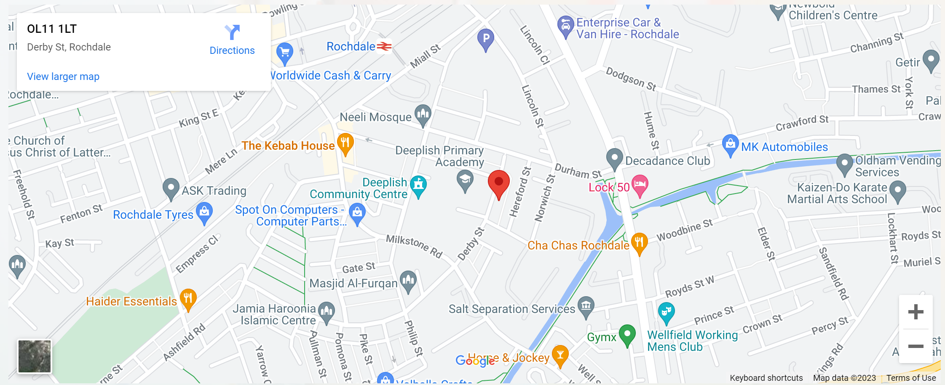

Background to the Trust
Focus-Trust was incorporated in May 2012 as a primary trust. The Trust has links with the sponsor, Focus Education, but is an entirely separate legal entity. As with all academy trusts, the Trust is a company limited by guarantee and an exempt charity. The Trust’s offices are situated in a newly converted historic mill conversion in Chadderton, Oldham with excellent motorway networks to access our schools.

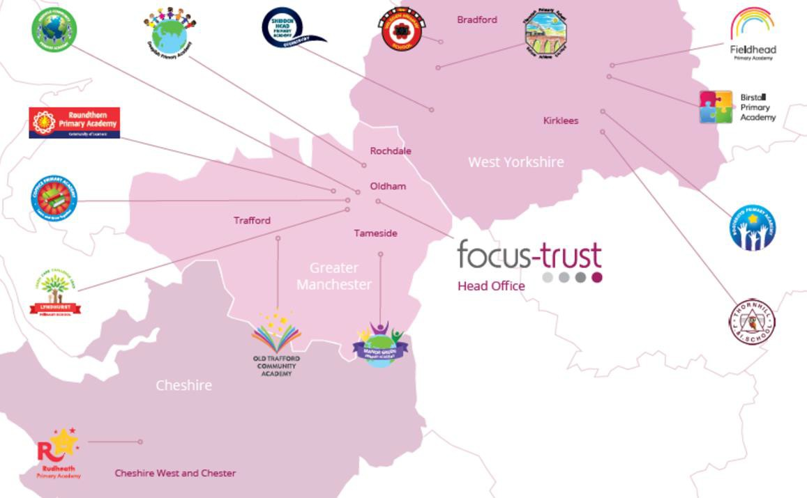

The defining feature of Focus-Trust is that it is a specialist primary phase trust. This means that the work of the Trust is driven by the distinctive needs of primary schools. Whilst the Trust has robust systems for accountability, each school has their own distinctive identity, ethos and culture, and this is a commitment to every school when they convert and join the Trust.

Focus-Trust currently has a small centrally employed team. The members of the team are highly skilled and committed to the vision, culture and values of the Trust.

All the schools within the Trust are willing partners who have actively chosen to join Focus-Trust and there is a very high degree of consensus, cooperation and commitment from within the group.

The Trust has robust policies and systems in place to govern and guide its work. These have been gradually implemented as the Trust has grown. The Trust has well-established productive relationships with trade unions and meets half termly with a group of national trade union representatives to discuss policy development. This has enabled us to introduce and change a range of policies in a streamlined and cooperative way.

Our Vision
‘Great schools at the heart of our communities’ - with our Community Champions and colleagues, we strive to ensure we are being civic leaders making a difference in the local and national communities and the community is supporting us.

Focus-Trust Mission
‘Learning together, making the difference’

Collective Efficacy
We have a well-developed and securely embedded culture of Collective Efficacy. By this we mean we have, ‘A shared commitment to work together on the things that matter to improve outcomes for all.’

The Focus-Trust Values
Professional honesty is at the heart of everything we do. The Trust knows the schools well because of the strong working partnership between academy leaders and the Trust Central Team. It is only by being honest and transparent with a balance of credible challenge and effective support, that we can move forward and get the best for all children and staff. Our work is underpinned by our values:

Care for children, adults and the learning environment
Dare to do things differently and have a go
Be fair, honest and inclusive – demonstrating integrity
Share concerns, expertise and best practice for the benefit of all learners

Our Moral Purpose

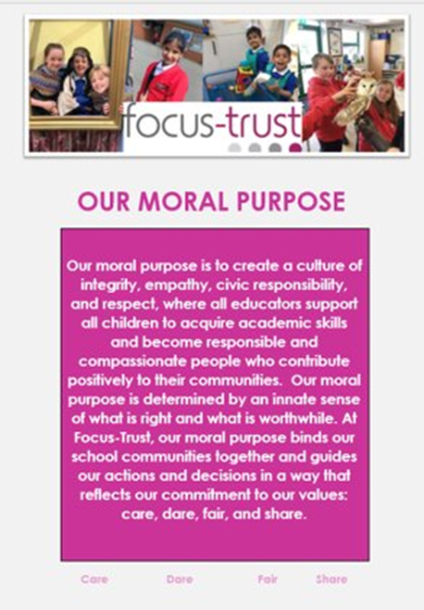

Our People Strategy

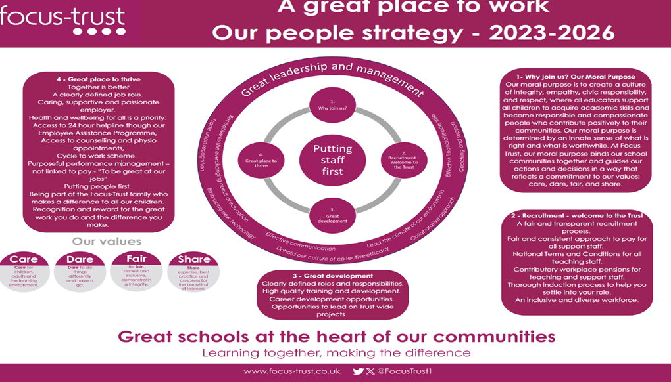

What you might want to know about Focus Trust

Pensions
Focus-Trust contributes to Teachers’ Pensions and Local Government pensions in the same way and with the same level of contribution as local authorities.

Employer Relations
Focus-Trust has a Trade Union agreement which recognises the teacher and support staff unions. This is further supported by an ongoing and productive relationship with key trade union officials.

Equality of opportunity
Focus-Trust is an equal opportunity employer, dedicated to a policy of non-discrimination in employment on any basis including age, gender, race, colour, nationality, ethnic origin, disability, gender, religion, age, marital status, sexual orientation and/or medical condition.

Safeguarding
Focus-Trust is committed to safeguarding and promoting the welfare of all children and young people. There is an explicit expectation that all employees share this commitment and adhere to all safeguarding policies and procedures. Applicants should be aware that the recruitment process will include an assessment of your suitability to work with children.

Dress code
We expect all staff to dress professionally and appropriately for the roles undertaken. We pride ourselves on the high standards of dress of both our pupils and staff; these standards are led by our staff who we expect to set an example.

Policies
Focus-Trust and the schools have a range of policies and handbooks that help to make clear our expectations and ways of working. These are always shared openly with staff and are accessible to everyone. There are several policies that prospective employees should be aware of when making an application. These can be found on the Trust website
www.focus-trust.co.uk and school websites. All members of staff will be asked to sign a declaration as part of the induction process to acknowledge that they have read and understand the Code of Conduct and some of the key policies, e.g. Safeguarding and Child Protection, Health and Safety, Acceptable use of IT.

Right to work in the UK
Under the Asylum and Immigration Act 1996, it is a criminal offence to employ anyone who is not entitled to live or work in the United Kingdom. Applicants can expect us to ask for proof of this at interview stage, where you will be asked to provide some original documentation to confirm that you are eligible to work within the UK. Photographic proof of identity will also be required.

Validation of qualifications and identity
All shortlisted candidates will be asked to bring original certificates or relevant qualifications and identity documents to interview. These will be photocopied and kept on file and, if appropriate, may be confirmed as genuine with the relevant awarding bodies. The copies of the successful candidate will be retained on their personnel file. The copies of unsuccessful candidates will be treated as confidential waste and disposed of appropriately.

References and Social Media Checks
If you are shortlisted, we will take up references before the interview date. One of your referees must be your current or most recent employer. Two satisfactory references must be received before we can confirm any offer of an appointment. The information we request will relate to salary, length of service, skills and abilities, suitability for the job, disciplinary record and suitability to work with children. Copies of references or open references will not be accepted. On receipt of references, your referees may be contacted to verify any discrepancies, anomalies or relevant issues as part of the recruitment verification process.

In line with our safer recruitment policy, social media checks will be undertaken if you are shortlisted. This social media check is designed to complement the range of standard recruitment checks and allows us to identify a candidate’s online presence which potentially could damage the organisation’s reputation.

Knowledge and skills profile
This is an important part of your application and is your opportunity to explain how you meet the person specification for the post. You should demonstrate your skills, knowledge and experience and give short examples. Describe how you match the requirement of the job; include experience gained from previous jobs, community or voluntary work. Ensure that the information you give is well organised, relevant and brief. You may find it helpful to use sub-headings in order to keep your statement well focused. If you do not submit this profile, you will not be considered for short listing.

Disability
To comply with the Equality Act 2010, we are legally required to consider making reasonable adjustments to ensure that disabled people are not disadvantaged in the recruitment and selection process. We are therefore committed to meeting, wherever possible, any needs you specify on the application form. Please contact Natalie Harris if you need to discuss this in any detail. We will consider any reasonable adjustment under the terms of the Act to enable an applicant with a disability (as defined under the Act) to meet the requirements of the post.

Disclosure of a criminal record
Employment in this role is subject to an enhanced check with the Disclosure and Barring Service (DBS). Checks will also be made against the lists showing people barred from working with children. All checks must be satisfactory before any offer of employment can be confirmed and before commencement of work can take place.

Please apply via My New Term by midday on Friday1st May 2026

Using this link: https://mynewterm.com/jobs/141365/EDV-2026-DPA-34930

We do not accept applications or CVs submitted by any other method.

Thank you for taking the time to read this information pack. We wish you every success in any application you may make.

