 | Teacher in Primary Department
MPS + SEN + ToD | £34,983 - £54,729
pa (depending on qualifications and experience)

About our school  Royal School for the Deaf Derby is a unique provider of day and residential placements for deaf children and young people aged 3 – 19. We are a speaking and signing community with a qualified, competent and confident staff team working together to ensure all children and young people leave with the know-what and know-how to make the most of life beyond school. | 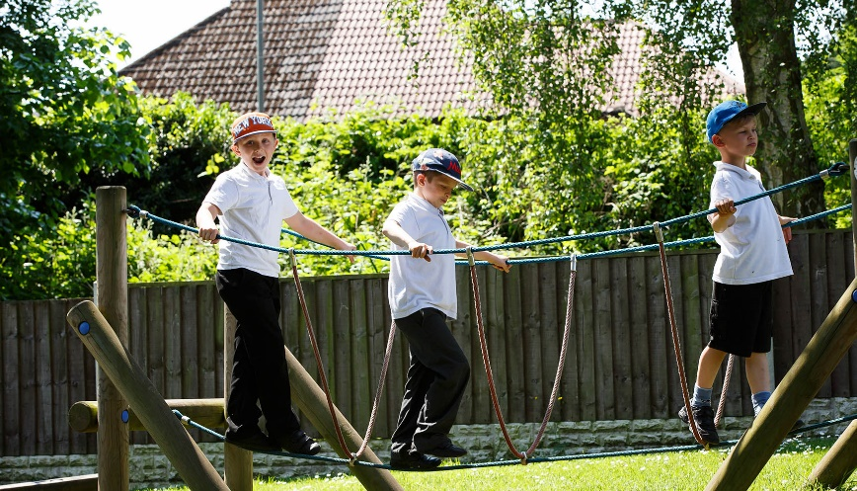
Find out what we’ve been up to on our Facebook pages at www.facebook.com/RSDDOfficial and/or why not come and see for yourself?
Contact us on 07500 878565 or via enquiries@rsdd.org.uk to visit in person or book
an informal chat about the role
Closing date: Friday 7th November Interview date: Thursday 13th November

Primary Department The experiences, progress and attainment of children is at the heart of our everyday practice. Primary enjoy playing and learning outdoors on their leafy green campus in their very own forest school cabin. Class sizes are small with good pupil to staff ratios. All teaching and learning is supported by an in-house team of multi-disciplinary experts including highly specialist speech and language therapy, Teachers of the Deaf and qualified, competent Education Assistants.  Our Primary colleagues should have the ability and flexibility to teach across Key Stages 1 and 2 if required.  “Throughout the school, staff and pupils have warm and strong relationships. Pupils feel safe and happy in school. They trust adults will help them if they need it. Pupils’ behaviour is exemplary in class and around the school” Ofsted December 2024 |  | The person We are looking for an excellent classroom practitioner with the ability to deliver creative and innovative lessons to join our busy Primary Department. Proficiency in British Sign Language (BSL) or the willingness to start working towards Level 3 BSL as soon as practicable upon appointment is essential.  We want the very best outcomes for our pupils and so seek the very best staff for them.  We want teachers who have the highest ambitions for our amazing pupils, and who can set and achieve the highest expectations for them. The successful applicant will benefit from a personalised CPD plan including a rolling programme of full sponsorship to achieve professional status as a Teacher of the Deaf with the option of continuing to achieve an MA.
Applications from Early Careers Teachers are welcome.

