Recruitment Pack
Primary Teachers

JOB REFERENCE NUMBER: SCH-AIAT-0039

A Message from the Chief Executive Academies Trust

Dear Applicant,

Thank you for downloading this application pack and for your interest in becoming a Primary Teacher for The Discovery Academy, part of The Alpha Academies Trust in Stoke-on-Trent.

Our Trust currently consists of five academies:

The Discovery Academy - Age 11 –16;
The Excel Academy - Age 11 –16;
Eaton Park Academy-Age 3- 11;
Maple Court Academy - Age 4 – 11;
Sneyd Academy – Age 4 – 11.

Alpha Academies Trust has a clear purpose to deliver a first-class education for every child and overcome inequality. We intend to achieve this purpose by investing heavily in staff development and developing a quality all through curriculum from birth to post 16. We are committed to work with other stakeholders and Trusts to create a joined-up momentum, that will bring about transformational change in Stoke on Trent. We have a rigorous approach to the evaluation of impact through a research and development culture. This ensures we identify the approaches that have the greatest impact on children and supports the well-being and workload of our staff. We take seriously our responsibilities to the community and future agendas, such as environmental sustainability and digital transformation, are very much in our line of sight.

Parents and stakeholders are at the heart of our learning partnerships. Our Governors are challenging and supportive and all our staff are committed and dedicated to providing first class education for all children and young people in our academies.

We are looking for dedicated and enthusiastic professionals to join our highly skilled staff and help deliver outstanding educational experiences for the young people of Stoke-on-Trent.

I look forward to receiving your application and meeting you soon.

Yours faithfully,

Mr S French
Chief Executive Officer

The Context

The City of Stoke-on-Trent is in the West Midlands and has a population of 249,000, which is predominately white British along side a significant minority ethnic community. Ambitious plans are underway to transform and renew the City through major investment in health, housing, economic development, and education. The ‘Potteries’, as Stoke-on-Trent is affectionately called, is renowned for its world class ceramics industry and industrial heritage.

The City is benefitting from recent investment which is driving economic growth and renewed prosperity. It is well connected with transport links to the capital and is within one hour of travel to Birmingham or Manchester. The City is one of the fastest for economic growth in the country.

Our Trust Purpose

Our Trust Strategy & Aims

- High Performing - to use Trust resources, ensuring we deliver first class education for every child.

- Collaborative - to grow more effective partnerships within and beyond the Trust, that impact on children and are mutually supportive.

- Finance and Infrastructure - to have strong and sustainable finances with a highly effective infrastructure.

- People - to attract, develop and retain excellent people who are valued, supported and encouraged to innovate.

- Leadership - to develop expert leaders and governors with a range of skills, that make a difference to children’s life chances.

In an Academy:
- Children and young people develop strong literacy, numeracy and employability skills;
- Children and young people enjoy innovative learning experiences, including sport and the arts which lead to high levels of success;
- Children and young people’s progress is always tracked and monitored and no one falls behind;
- Children and young people understand the pathways open to them. Through our Academies the gates to next steps and phases are opened;
- Children and young people, parents and staff feel valued, safe, supported and have a voice;
- Children and young people have the best staff and Academy leaders as their role models;
- Children and young people enjoy inspirational learning environments which are safe, well maintained and constantly improved;
- Children and young people enjoy the best catering and nutrition;
- Staff have an entitlement to first class training, coaching and support;
- Staff have opportunities to progress from the start of their career onwards;
- Employer partners contribute to curriculum design;
- Governance is strong, challenging and supportive;
- Parents are partners in their children’s education;
- Children develop skills for the modern workplace;
- Children receive extensive information, advice, and guidance to become well rounded adults, who contribute to society as highly employable responsible citizens.

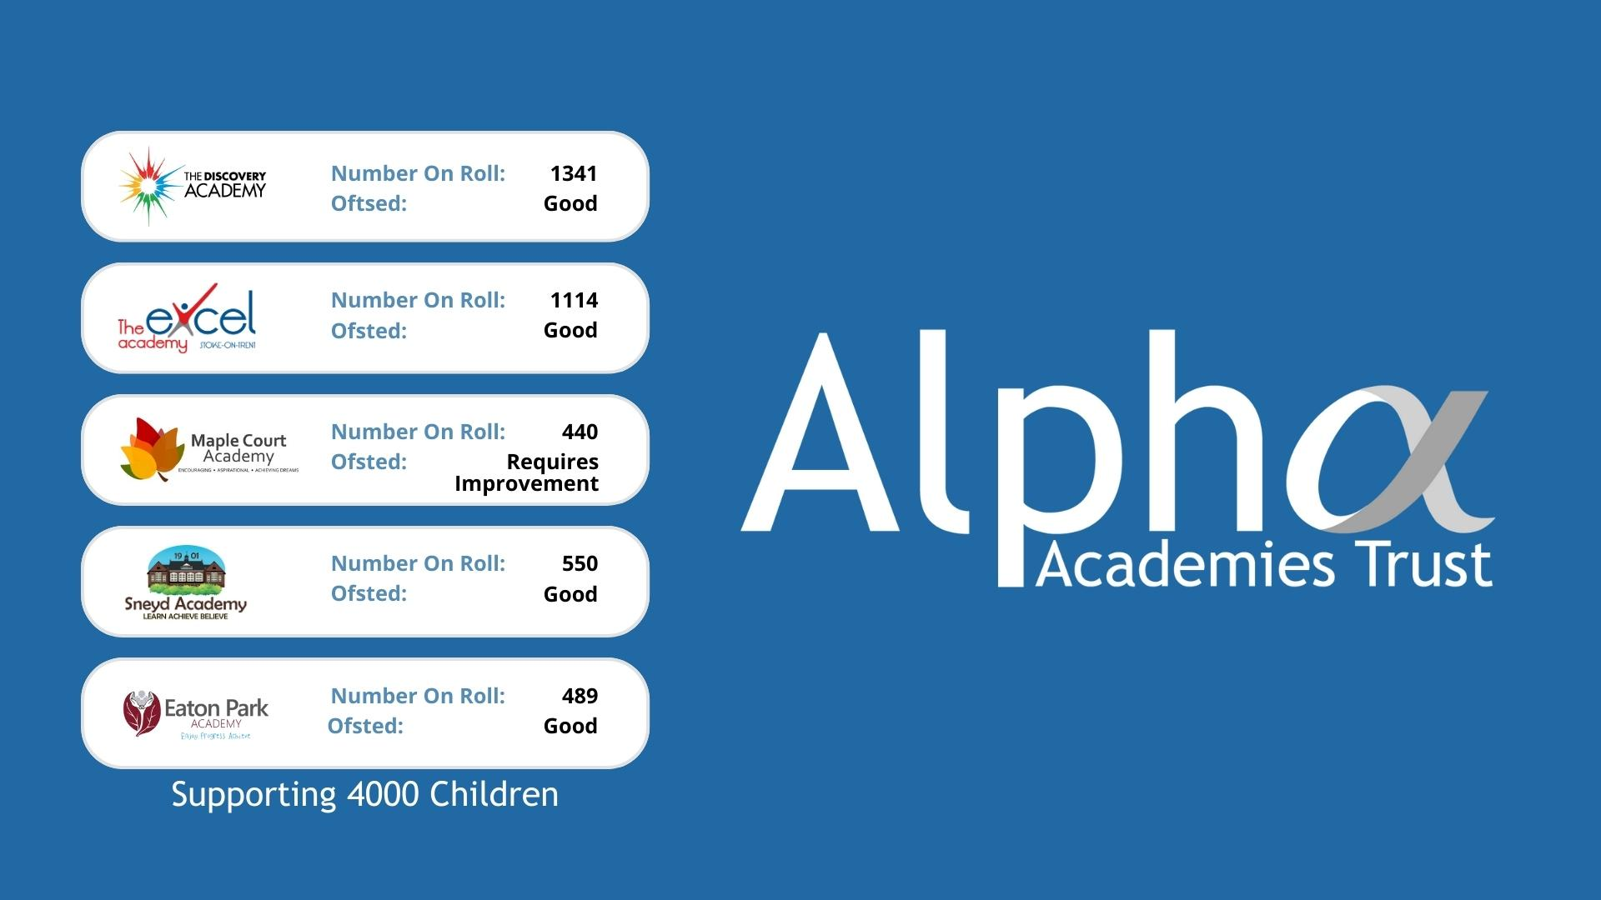
Our Academies
The Discovery Academy
The Discovery Academy is one of the largest academies in the area, boasting a £21 million building with world class facilities and, belonging to a forward-thinking Trust, encompassing a number of successful local schools. Our promise is to deliver ambitious, high-quality teaching and learning every lesson, every day, overcoming inequality and allowing every student to achieve success. As an academy, we have created a culture around our core values of Pride, Respect and Commitment to ensure high expectations, positive relationships and support for all our students. I believe having high expectations of behaviour and attitudes enables teachers to teach, and students to develop, in a caring, supportive environment.

The Discovery Academy Purpose
“Achieve outstanding academic success for every child, whilst developing the ASPIRE skills and values to lead fulfilling lives”

Comments from Ofsted Report of 2019 include;

“Leaders know the school well. They identify weaknesses by carefully analysing the available evidence. Consequently, their strategies to address weaknesses are thoughtful, considered and effective.”

“All staff are very committed to seeing the school improve further. They form a united and hard-working team.”

“A strong culture of care and support exists throughout the school. Consequently, pupils feel safe and are safe in school.”

The Excel Academy
The Excel Academy Purpose
“To provide a first-class education to enable all students to excel”

The Excel Academy has consistently been one of the highest performing academies in Stoke-on-Trent. Student numbers have increased rapidly due to the success of the Academy and it is now oversubscribed in all years. It is the school of choice in the north of the city and is housed in a new build and refurbished buildings.

The Academy was inspected by Ofsted in November 2021 and maintained a ‘Good’ judgement and is now focused on becoming an outstanding provision.

Comments from Ofsted Report of 2021 include;
“Leaders, including governors and trustees, are ambitious for all pupils…. there is a strong sense of community within this school….Staff and pupils talk positively about the ‘Excel way’”
“Relationships between pupils and teachers are very strong and based on mutual respect…..Pupils are proud of their school…. They are happy and safe…. pupils behave in a calm and mature manner….they study a wide range of subjects and achieve well”
Eaton Park Academy

Eaton Park has consistently been one of the highest performing academies in Stoke-on-Trent for the last few years.

Eaton Park are one of the highest performing primary schools in Stoke on Trent and, for the last two years, Eaton Park have been in the top 3% of schools nationally for pupil progress. Student numbers are consistently increasing due to the successes of the Academy and its popularity locally. Eaton Park Academy has around 500 pupils and is one of the larger primaries in Stoke-on-Trent, offering places from Nursery through to Year 6.

The Academy was inspected by Ofsted in March 2019 and maintained a ‘Good’ judgement; we are now focused on becoming an outstanding provision.

Eaton Park Academy Purpose
“Carving pathways to success for all, regardless of social and academic background.”

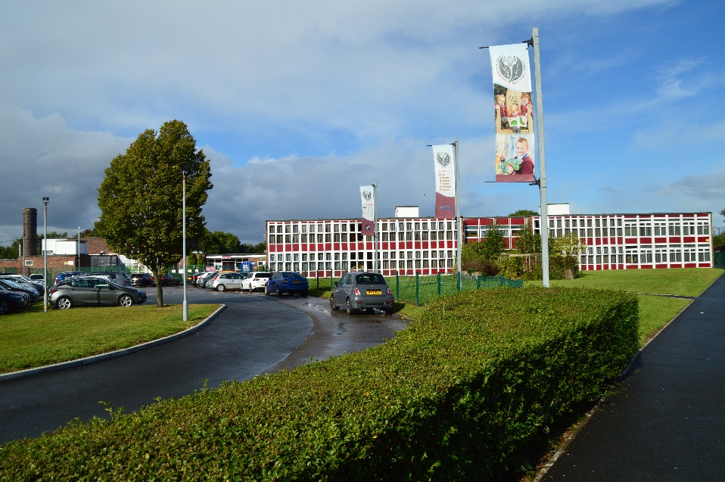

Comments from Ofsted Report of 2019 include;
“The leadership team has maintained the good quality of education in the school since the last inspection. You and your team of committed senior leaders have created a motivating and inspiring learning environment in which pupils thrive.”

“Pupils are proud to attend Eaton Park. They enjoy school and are enthusiastic about their learning. In lessons, pupils work hard and cooperate well with their peers.”

Maple Court Academy
Maple Court is a large primary academy with almost 500 pupils located in the Bentilee area of Stoke-on-Trent.

Every member of staff in the Academy is fully committed to ensuring that all children work hard, are well supported and make good progress across the curriculum.

Maple Court offers enrichment opportunities through its
extra-curricular programme and the many academy visits that it offers. Life skills and confidence continue to grow through its student character development, raising aspiration and ambition by opening up the world to its students.

Maple Court Academy Purpose
“To encourage and nurture the aspirations of all pupils to achieve their dreams”

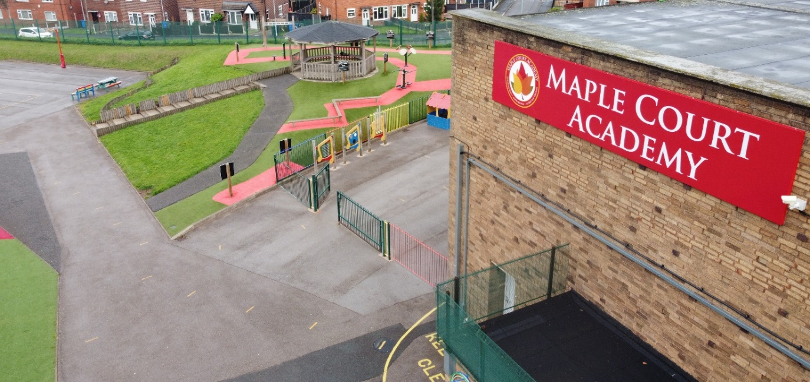

Comments from Ofsted Report of 2021 include;

“The quality of learning is on the up and standards are beginning to rise. Lessons are purposeful, classrooms are calm places in which to learn and staff treat pupils fairly”

“Ambitious leadership from Trust and school leaders is making its mark. Since the previous inspection, leaders have made expectations clear and lifted everyone’s aspirations. They have injected new purpose to the school through a mix of challenge and support.”

Sneyd Academy
Sneyd Academy is a large and diverse primary academy with happy children and staff and an exciting curriculum housing almost 600 pupils. Sneyd Academy is one of the largest primary academies in Stoke-on-Trent. It is located in the centre of the city with good access to local facilities such as Central Forest Park and Festival Park. The Academy serves a diverse population from the Sneyd Green, Cobridge and Burslem areas and is very much a school at the heart of its community.

Sneyd Academy Purpose
“Inspiring children to achieve excellence and be their best”

Comments from our recent inspection June 2023;

“Pupils enjoy their learning and spending time together in school. They speak with pride of the many varied opportunities they take part in. Pupils embody leaders’ ambitions to learn, achieve and believe in all they do and say.”

“Leaders recent improvements to the curriculum are helping to strengthen pupils learning across subjects.” “Leaders identify pupils’ additional needs swiftly and accurately.”

“Leaders promote successfully a calm and inclusive culture around school. Pupils know themselves and their peers well. Pupils are mature and respectful.”

“Pupils speak of the family feeling within and across the school. They recognise that this extends to the Alpha Academies Trust too.”
In total, over 4,000 students, aged 3-16 years, are currently on roll and supported in our academies. In addition, we employ approximately 525 staff across the Trust.

Job Description

Purpose of the Post
Main Purpose of the Post
- To maintain and/or raise standards of student attainment and achievement within their taught classes and other learning activities and to monitor and support student progress.
- To be accountable for student progress and development within their taught classes.
- To develop and enhance their own teaching practice to achieve high standards.
- To ensure a high-quality delivery of an appropriately broad, balanced, relevant and differentiated curriculum for all students studying in their classes, in accordance with the aims of the Academy and the curricular policies.
- To effectively manage and deploy support staff, financial and physical resources to support the designated curriculum portfolio.
- To monitor and support the overall progress and development of students as an academic progress tutor.
- Responsibility for the provision of a full learning experience and support for students within subject area, liaising with the Principal, Senior Leadership Team, Head of Faculty and other Subject Leaders, Achievement Leaders, SENDCO, and relevant staff with Academy responsibilities, relevant support staff, LA representatives, link governor, external agencies, and parents/carers.
Core Responsibilities, Tasks and Duties
- Key Roles
- Through effective teaching secure successful outcomes for learners such that they enjoy and achieve when compared to indicators used by the Academy and external bodies.
- Use challenging targets to raise standards for all learners and eliminate low attainment among particular groups and individuals.
- Support the drive to develop, implement, review, and improve teaching and learning to ensure that each student thrives, exhibits outstanding learning behaviours, and achieves positive progression.
- High Standards of Teaching and Learning
Teachers are accountable for the setting of targets for improvement and delivering effective teaching and learning that secures high standards of students’ achievements. The following identify aspects and prompts that will enable teachers to carry out their role:
- Role model
- Implementation of national strategy (e.g. Pedagogy/methodology)
- Self-evaluation
- Ambience/climate for learning
- High expectations
- Learning styles and thinking skills
- Use of data analysis
- Marking and assessment
- Reporting
- Planning, schemes of work
- Meet the needs of all students (including management of behaviour and its impact on learning)
- Intervention strategies (e.g. booster classes, use of National Strategy resources)
- Educational enhancement (e.g. trips/visits)
- Student Outcomes
- Key Stage 2
- Key Stage 3
- Behavioural standards
- Extra-curricular activities
- Examinations/ accreditations
- Attendance and punctuality
- Duties as an Academic Tutor
- Maintain discipline and acceptable standards of conduct.
- Establish a positive rapport with students to develop their social and academic potential and be a main source of reference for students.
- Mark the Tutor Group register, ensuring absences and lateness are accounted for and appropriate actions taken to ensure high attendance and punctuality.
- Compile reports, profiles and references on students as required.
- Monitor students’ home study, the teaching of tutor group periods, escorting the tutor group to assemblies and attending tutor meetings called by the Team Leader.
- Track students’ academic progress and maintain close contact with parents and other agencies.
- Other Professional Requirements
- Establish and maintain effective working relationships within the team and also other colleagues and clients/ partners of the Academy.
- Be responsible for own professional development and proactive in their own performance management.
- Participate as required in meetings with colleagues in respect of their post, duties and responsibilities.
- Any other duties and responsibilities within the range of the salary grade.
- General
- The duties and responsibilities of the post will be subject to those detailed in the Academy contract issued to all teachers.
- This Job Description does not define in detail all the duties/responsibilities of the post. It will be reviewed at least once a year as part of the performance management process and may be subject to modification or amendment after consultation and agreement with the post holder
- Staffs’ individual priorities for each academic year will be identified through team plans. It is the responsibility of each individual member of staff to meet the agreed targets within the context of the Academy’s improvement plan.
- Team priorities for each academic year will be identified through the Academy’s improvement plan. It is the responsibility of the Head of Faculty to ensure team plans are implemented, monitored, and reviewed and for individual team members to meet the targets set.
- Health and Safety
- Ensure a work environment that protects people’s health and safety and that promotes welfare, and which is in accordance with the Trust Health and Safety policy.
- Professional Accountability
- The post holder is required to be aware of and comply with policies and procedures relating to child protection, health, safety and security, confidentiality, and data protection, reporting all concerns to an appropriate person. In addition, they are to contribute to the achievement of the school’s objectives.
- Safeguarding
- Promote and safeguard the welfare of children and young persons you are responsible for or come into contact with.
- Equalities
- Ensure that all work is completed with a commitment to equality and anti-discriminatory practice, as a minimum to standards required by legislation.

Declaration
The Alpha Academies Trust is committed to safeguarding and promoting the welfare of children and young people.

Signed _________________________________ Dated______________________

Print name_______________________________

PERSON SPECIFICATION

APPOINTMENT OF: TEACHER AND ACADEMIC TUTOR (KS2/3)

DEPARTMENT: TEACHING AND LEARNING

Minimum Requirements | Measured by:  A) Application  B) Test/Exercise  C) Interview
QUALIFICATIONS/TRAINING  It is essential that the post holder has:  - Qualified Teacher Status.  - Graduate status.  - A balanced programme of relevant courses undertaken. | A
EXPERIENCE/KNOWLEDGE:  It is essential that the post holder has:  - Training and experience across the primary/secondary phase in specialised subject area.  - Experience of successful management of change.  - Proven effectiveness as a teacher.  - Experience in the practical application of learning. | A & C
SKILLS AND ABILITIES:  It is essential that the post holder has:  - Ability to support teaching across the Academy.  - Ability in understanding of good assessment and its implications for planning and teaching.  - Evidence of successfully implementing strategies for raising standards.  - Knowledge of assessment across vocational and G.C.S. E. Specialist subject(s).  - Ability to communicate effectively both orally and in writing. | C
It is desirable that the post holder is/has:  - A self-starter with vision and imagination.  - Ability to take risks.  - Strong awareness of Health and Safety issues. | A & C
ADDITIONAL FACTORS:  It is essential that the post holder has:  - Ability to lead and motivate staff and students.  - High expectations personally for students and staff.  - Commitment to equal opportunities policies.  - Good organisational skills.  - Ability to work to agreed targets and deadlines.  - Ability to work under pressure and be flexible.  - Integrity, loyalty, sensitivity, and a good sense of humour.  - A willingness to undertake appropriate training.  - Awareness and sensitivity with regard to equal opportunities and race equality.  - An ability to fulfil all spoken aspects of the role with confidence through the medium of English. | C

How to Apply
If you feel that the position is of an interest, you have the right experience and skills and are ready for fresh challenges, then we would love to hear from you. To apply, visit our website's vacancies page at https://alphaacademiestrust.co.uk/vacancies/. Click on 'Explore Available Opportunities,' find the vacancy you wish to apply for, and simply click on the 'Apply Now' button at the top of the page, which will direct you to the Alpha Academies Trust vacancy portal. If you're already registered, please log in to submit your application. New users can register using the sign-up option and proceed to submit their application. Should you need any further information regarding your application please contact our Recruitment Team by email at recruitment@alphaacademiestrust.co.uk

Visits to our Academy are warmly welcomed, please contact the Academy to arrange a mutually convenient appointment.

If Successfully Shortlisted
The Alpha Academies Trust is committed to safeguarding and promoting the welfare of children and we expect all staff to share this commitment. We comply with the Disclosure & Barring Service (DBS) code of practice, and if successfully shortlisted, you will be required to declare any relevant convictions, adult cautions or other matters which may affect your suitability to work with children. As a result of amendments to the Rehabilitation of Offenders Act 1974 (exceptions order 1975) in 2013 and 2020, some minor offences are now protected (filtered). You will also need to complete and return a DBS self-disclosure declaration prior to interview.
In addition, you will need to bring to your interview, your passport and/or original birth certificate along with a document giving your permanent National Insurance number and name i.e. a P45, P60, NI card or a letter from a government agency as proof of identification. If, unfortunately, you are not offered the post, please be assured that the details taken regarding your personal documentation will be destroyed.
Please note, references will be sought for all shortlisted candidates prior to interview.
Please note, it is the policy of The Alpha Academies Trust to contact shortlisted candidates only.

Academy Location

Discovery Academy: Discovery Drive, Stoke-on-Trent, ST2 0GA

Excel Academy: Milton Road, Sneyd Green, Stoke-on-Trent, ST1 6LG

Eaton Park Academy: Arbourfield Drive, Bucknall, Stoke on Trent ST2 9PF.

Maple Court: Beverley Drive, Bentilee, Stoke-on-Trent, ST2 0QD

Sneyd Academy: Sneyd Street, Burslem, Stoke-on-Trent, ST6 2NS

Equality & Diversity
Alpha Academies Trust is committed to promoting equality and diversity opportunities among our community of staff and students. Ensuring best practice in our recruitment processes is essential to this commitment. We will seek to ensure that all job applicants and staff are treated fairly, with respect and without bias. No applicant or member of staff will be treated less favourably than another because of their age, disability, ethnic origin, gender, gender identity, sexual orientation, marital status, caring or parental responsibilities, racial group, religious or philosophical beliefs.

Advertising
Alpha Academies Trust will advertise posts outlining the relevant skills, qualifications, knowledge and experience necessary for the job in order to attract the best applicants. Careful consideration will be given to the wording used in job adverts, job descriptions and person specifications to ensure that they are not written in a way that stereotypes or encourages people to believe that the position is only suitable for certain groups of people. The Recruitment Team will ensure all published job advertisements, job descriptions and person specifications comply with current equality legislation. Consideration should also be given to which media is used for advertising in order to ensure that applications from some sections of the community are not excluded or limited.

Selection
Completion of the Safer Recruitment training is mandatory before anyone may be directly involved in the selection process including long and short listing, interviews and assessments. Any staff who are still directly involved in the recruitment and selection of staff must attend refresher training every three years, which ensures that they are all aware of changes in legislation and practice.
Long and short-listing should be fair and consistent, comparing applications against the objective criteria set out in the job description and person specification. Records of decisions must be made and retained. The short-list of job applicants must, from the evidence available, appear to have the necessary skills and abilities in relation to criteria stipulated in the job description and person specification. Human Resources will monitor job applications, short-listing and appointment decisions, for both permanent and temporary positions, with regards to age, ethnic origin, disability, and gender. If monitoring reveals evidence of any form of discrimination, remedial action will be taken to redress it.

If anyone has any queries with regard to fair and best practice, please contact recruitment@alphaacademiestrust.co.uk

Additional Information
Please note it is an offence to apply for the role if you are barred from engaging in regulated activity relevant to children. All employees of the Alpha Academies Trust will be required to undertake an enhanced DBS disclosure check if successfully appointed (unless already registered with the DBS update service) and every 5 years following this.
The suitability for employment of a person with a positive DBS disclosure will vary, depending on the nature of the job and the details and circumstances of the cautions/convictions/bindovers. If a positive DBS is received then the Trust will decide whether the individual can be cleared for appointment or whether further investigations are needed.
Ofsted Reports: www.ofsted.gov.uk
Information about Stoke City council: www.stoke.gov.uk
A copy of the most recent inspection report and copies of the Safeguarding Policy can be found on the Academy website.

