Job Description – Teaching Assistant
Job title: | Teaching Assistant
Responsible to: | Head of School
Liaising with: | Teachers, other TA’s
Pay range: | SCP 3-7
Contract terms: | 37hrs per week term time only

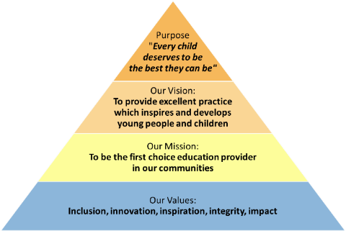

All staff should be committed to the school and East Midlands Academy Trust’s purpose to provide a relentless focus on great leadership and management and outstanding teaching. East Midlands Academy Trust is committed to support the school leaders, teachers and support staff to be the best they can be.

Teaching Assistant job summary
Our school is in need of a Teaching Assistant to help with the general supervision and management of students. You will work under the direction of the classroom teacher and be expected to assist with the implementation of instructional plans. The successful candidate will be ready to work with all students to promote educational, social and emotional development. The ideal applicant will be caring, patient and understanding. The Teaching Assistant must be attentive to the unique needs of each student and be able to identify proper solutions when students encounter issues. You should have strong interpersonal skills, as you’ll be collaborating with other teachers, working with students and talking to families. We’re committed to building brighter futures, and we’re hoping you’re excited to be part of that experience.
Teaching Assistant responsibilities
Assist with classroom instruction and provide support and guidance to students
Maintain a supportive, safe and clean classroom environment
Design and implement a classroom system to track student progress, and take steps to ensure academic progress is where it should be
Supervise students during non-classroom time and arrange recreational activities
Work closely with the head teacher to identify issues students are having and develop appropriate solutions
Attend teacher meetings and training sessions, as well as parent-teacher conferences
Teaching Assistant skills
Experience working in a school or educational setting
Excellent verbal and written communication skills
Great collaboration and teamwork skills
Basic computer skills
A positive, empathetic and loving attitude

Additional duties
Whilst every effort has been made to explain the main duties and responsibilities please note that this is illustrative of the general nature and level of responsibility of the work to be undertaken, commensurate with the grade. It is not a comprehensive list of all tasks that the post holder will carry out.
Employees will be expected to comply with any reasonable request from a manager to undertake work of a similar level that is not specified in this job description.
N.B. The post holder will carry out his/her responsibilities in accordance with the Trust’s equal opportunities policy.
This job description is provided to assist the post holder to know what his/her duties are. It may be amended from time to time without change to the level of responsibility appropriate to the grade of the post.
Health and Safety
So far as is reasonably practical, the post holder must ensure that safe working practices are adopted by employees, and in premises/work areas for which the post holder is responsible, to maintain a safe working environment for employees and students.
Safeguarding
EMAT is committed to the safeguarding of its young persons and expects all staff, volunteers and adults to work within the parameters of the policies and procedures as agreed by the Board of Trustees to ensure the safety of all young persons within its care.
Equal Opportunities

It is the policy of EMAT to provide equal opportunities for all individuals; to prohibit discrimination in employment on any basis protected by applicable law, including but not limited to race, colour, religious creed, marital status, sex, sexual orientation, ancestry, national origin, age, medical condition or disability. EMAT promotes equal employment opportunities in all aspects of employment through positive employment policies and practice.

If any special requirements are needed to attend an interview, please inform the trust.

Compiled by: HR | Revision Number: v1
Approved by Headteacher: | Revision Date ___/___/___
Approved by HRBP:

East Midlands Academy Trust is committed to safeguarding and promoting the welfare of children and young people and expects all staff and volunteers to share this commitment.
All appointments are subject to safer recruitment requirements.
This post is subject to an Enhanced DBS Disclosure

Person Specification
 | Essential | Desirable
Education and Qualifications
Experience of working with children |  | ✓
Level 2 Teaching Assistant Qualification |  | ✓
First Aid training |  | ✓
Experience
Working in a similar environment | ✓
Working and communicating with students and staff |  | ✓
Knowledge and understanding
Demonstrate successful behaviour management | ✓
Safeguarding policies and procedures | ✓
Knowledge of child development and social interaction |  | ✓
Skills and Attributes
Talk to both children and adults in a calm manner | ✓
Be able to encourage high standards of behaviour at all times | ✓
Undertake appropriate training as required | ✓
Ability to lone work or as part of a team | ✓
Personal Qualities
Well organised |  | ✓
Reliability and punctuality | ✓
tolerant |  | ✓
Tactful and understands confidentiality | ✓
Further requirements
Willingness to work flexible hours on occasion | ✓
Willingness to maintain confidentiality on school matters | ✓
Willingness to be involved in internal and external meetings | ✓
Supportive of the ethos of the trust and school | ✓

