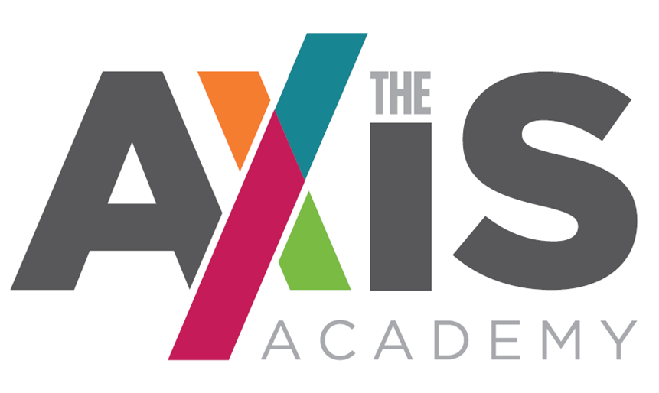

A specialist provision for students with Social, Emotional and Mental Health needs, with specific focus on mental health difficulties.

PRIMARY TEACHING ASSISTANT RECRUITMENT PACK

Pay Scale: £17,340 - £18,360 (Pro rata)
Working Hours – Monday to Friday
8.00am –4:00pm
Term Time Only (39 weeks per year)

The Axis Academy
Lodgefields Drive
Crewe
Cheshire
CW2 8TU
CONTENTS

- Letter from Head teacher
- Application + Selection process and schedule
- The Axis Academy story and vision
- Primary Teaching Assistant Role and Job Description
- Primary Teaching Assistant Specification and assessment criteria
- Safer Recruitment and Selection Policy Statement
- School holidays

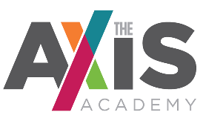

Dear Applicant

Thank you for your interest in our Primary Teaching Assistant vacancy.

This vacancy at The Axis Academy is an outstanding and unique opportunity for the right person to become fully functional, multiskilled member of a highly inclusive and collaborative team that strives to change the lives of children with Social, Emotional and Mental Health needs (SEMH) through all that we do.

We pride ourselves on being a versatile, empathetic, and intuitive team which develops bespoke, personalised programmes of study to meet the needs of all of our students to provide them with the opportunity to maximise their potential, whatever that potential may be. As a specialist school this is a rare opportunity that will give you the chance to help develop an education system that truly focuses on the individual.

The Axis Academy is fast becoming a beacon of outstanding practice in SEMH specialist provision. You will have the opportunity to grow with the school and truly make a difference to the most vulnerable young people in society.

We are looking for individuals who can inspire a love of learning, foster curiosity and creativity both within and outside of lessons.

If you feel that The Axis Academy may be the right place for you, I hope you will consider applying for the post.

I will be more than happy to have an informal conversation if you have any further questions please do not hesitate to get in touch.

I look forward to hearing from you.

Yours sincerely

Helen Phillips
Head teacher (Director of Education)
The Axis Academy Primary Teaching Assistant Recruitment and Selection Process

- You are asked to complete The Axis Academy Application Form which is attached.

- You are asked to include as part of or separate from the Application Form, a Letter of Application that addresses the items listed under desirable criteria on the attached Teaching Assistant Person Specification & Assessment Criteria. Please keep this letter as brief and to the point as possible (no more than 2 sides).

- You are asked to return your Application Form & Letter of Application by email to;

admin@theaxisacademy.org

The deadline for applications is: Midday on Friday 1st October 2021

Interviews will be held: Friday 8th October 2021

Start Date: As soon as possible

If you would like further information please contact admin@theaxisacademy.org or alternatively telephone: 01270 304 074

The Axis Academy Educational Vision

Our Mission and Vision.

It is our mission to provide children with a wealth of education which doesn’t just focus on academic achievements. It is our drive to implement a holistic approach to supporting children in order for them to feel safe, develop self-worth, be happy and have true informed perspective, through quality education.
We will offer a wide and varied curriculum which will inspire and excite them so that children feel ambitious and empowered to succeed. Ultimately we want to unlock every child’s potential, reaching out to every possibility within them, making sure we have the most impact for their future.
Through a diverse and carefully tailored curriculum, and positive, understanding and empathetic staff students’ anxieties will reduce and their emotional well-being will improve and students will become confident and functioning members of society.
We want to motivate children, to inspire their minds and encourage them to think outside of the box. We want children to believe in their dreams, to believe that it is possible for them to accomplish anything they want and make it a reality, giving children a purpose in life and the confidence to believe in themselves. This is not just an aim but a devout commitment.

To work collaboratively with the class teacher in order to Support outstanding lessons and support students emotional health and wellbeing. As an Academy our key focuses will be:

Re-engagement, raising aspiration and motivating
  - A whole education, recognising that essential pre-cursors to academic success are personal and emotional development, independent living and decision-making skills and discovering meaningful interests and goals.
  - A personalised curriculum including specific engagement activities based on the interests of each individual learner.
  - Positive and trusted adult role models in the form of Teaching Assistants and qualified teachers recruited for their enthusiasm for working with disconnected young people and their ability to understand and adapt, in order to meet the needs of the students.
  - Opportunities to support social and emotional needs through individualised programmes and a varied curriculum.

Unlocking every child’s potential
- The curriculum will determine the knowledge and skills students will learn at each stage. It is planned efficiently to Support exceptional lessons where students make outstanding progress, and are able to relate their learning to the wider world.
- Individualised learning programmes, based on the interests and skills of the students and which draw upon the diverse range of pastoral, vocational, engagement and personal and social development activities.
- Small groups of students (max 1:8) with capability to offer 1 to 1 student support.
- Practical application of English and Maths to develop skills that prepare for accreditation and work towards independence and social integration.

Recognising and celebrating achievement
- Positive learning environments with praise for success and recognition of achievement.
- Regular liaison with parents and carers to involve them fully in the education of their children including weekly progress telephone calls.
- Celebration of success through: weekly celebrations with students and staff; rewards for targeted elements; and high profile annual celebration events.
- Relevant vocational learning that broadens the curriculum offer to students providing the opportunity to support their classroom learning by gaining practical skills in the workplace and ultimately allowing them to achieve recognised qualifications.

Primary Teaching Assistant Job Description

Key Priorities;

- Support the vision and direction of the school

- Support teachers and Learning Mentors to deliver an engaging specialist curriculum within the academy

- Support effective learning and teaching throughout school

- Deploy and create resources efficiently and effectively to meet specific objectives in line with your specialist area strategic plans.

- Ensure effective pastoral care and behaviour support throughout the school

Teaching and Learning;

As a Teaching Assistant of The Axis Academy you will support teaching staff to ensure effective teaching and learning throughout the Academy, monitor and evaluate the progress made in your specialist area and present students’ achievement effectively, using benchmarks to track set targets for improvements. He/she will:

- Support teaching staff to ensure high quality teaching is delivered to students. This will be in your subject area as well as other subjects as and when required

- Support teaching staff to provide and maintain an environment and a code of behaviour and discipline which promotes and secures good teaching, effective learning and high standards of achievement

- To support the curriculum and its assessment; work with the teachers and Learning Mentors to monitor and evaluate it in order to identify areas for improvement

- To support students with their emotional health and wellbeing

- To develop key relationships with students and parents and carers

- To engage in outreach to ensure all our students needs are met

- Ensure that the relevant interventions are delivered to support improvements in literacy, numeracy and emotional wellbeing.

Partnership Working;

- Seek opportunities to invite parents and carers, into The Axis Academy to enrich student experience and to promote The Axis Academy’s value to the wider community

- Collaborate with staff, to actively promote the British values, academic, spiritual, moral, social, emotional and cultural well-being of students and their families

Health and Safety / Child Protection;

- To help ensure that health and safety standards meet statutory requirements, monitoring health and safety matters within the school, particularly ensuring that all members of the staff take reasonable care for the health and safety of themselves and others

- To help ensure that Child Protection and Safeguarding procedures and Department of Health assessments of Children in Need are rigorously complied with, and that the welfare and health and safety of students are of prime consideration

- To promote the safety and well-being of students and staff

- To ensure good order and discipline of students and staff

Extra CPD Opportunities

- Engage with CPD opportunities in order to effectively fulfil your role and achieve the best possible outcomes for our students.

Primary Teaching Assistant
The Axis Academy

Accountable to: School Senior Leadership Team
PERSON SPECIFICATION

Criteria | Essential | Desirable | Evidence
Qualifications/  Education | - GCSEs or equivalent | - Recognised behaviour / curriculum / SEMH qualification | - Application  - Interview  - Certificate
Educating Experience | Proven ability to :  - Set high expectation which inspire, motivate and challenge  - Promote good progress and outcomes  - Demonstrate subject and curriculum knowledge  - Support in the delivery of well-structured lessons  - Manage behaviour effectively to ensure a good and safe learning environment  - Communicate and work effectively  - Ability to motivate and inspire  - Experience working with primary aged children. | - Demonstration of high expectations  - Delivering phonics interventions  - Success in educational settings  - Work with disconnected students  - Able to support the differentiation of teaching to respond to the strengths and needs of all students  - Understanding the commitment to the schools wider focus on student attainment | - Application  - Interview  - References
Professional /Personal Skills | Proven ability to:  - Generate enthusiasm for new ideas  - Inspire others with confidence  - Communicate effectively to groups and individuals, orally and in writing  - Resolve conflict through active listening and negotiation  - Demonstrate a flexible approach and a willingness to listen to others  - Good organisational skills  - Provide advice and guidance to parents and carers in a positive and clear manner  - Remain calm when working under pressure.  - Ability to show patience and empathy | - Evidence of coaching and/or mentoring  - Able to effectively resolve personnel issues  - Training and understanding of child protection  - Training and experience of working with students with a variety of mental health needs | - Application  - Interview  - References
Curriculum & Personal Management | - Evidence of successful experience in managing change  - Ability to analyse situations, prioritise and help to implement realistic solutions  - Ability to establish and develop good relationships with all involved in the school.  - Commitment to the school’s wider community.  - Ability to inspire all in a love of learning  - Ability to support students emotional, personal and social development. | - Experience of supporting staff. | - Application  - Interview  - References
Knowledge and understanding | - Demonstrate a good level and understanding of ICT  - Knowledge of how to deal with safeguarding issues in school.  - Behaviour management techniques for groups and individuals.  - Know how to develop effective rapport with students, this being based on high expectations and establish a purposeful learning environment. | - Knowledge and experience of current good practice and development in special education provision.  - Knowledge of successful practice and strategies in teaching hard to reach students.  - Knowledge of how to promote independence for young people with complex needs.  - Knowledge of Mental Health needs.  - Behaviour Management training | - Application  - Interview  - References
Shaping the Future /Philosophy | - Expectation of high achievement of all students  - Evidence and understanding and commitment to equality of opportunity  - Respect for students’ individual difference  - Commitment to parental partnership in education and developing links between school, home and the community. |  | - Application  - Interview
Developing Self and Working with Others | - Excellent interpersonal skills  - Commitment to one’s own continuing professional development  - Ability to work as part of a team  - Ability to make decisions and take direction and set priorities  - Able to gain and maintain the confidence and respect of colleagues, students, parents and multi professionals.  - Commitment  - Have energy and perseverance.  - Be confident and enthusiastic.  - Be reliable and have integrity. |  | - Application  - Interview  - References
Other Requirements | - Positive recommendation from present employer  - Satisfactory attendance record |  | - Letter  - Reference

The successful candidate would be expected to maintain a well-organised, creative, safe and friendly environment for living and learning and hence enhance the ethos of the school. Candidates are asked to address as many of the person specifications as possible in their application.

Note re: Free School holidays

Before applying, please be aware that The Axis Academy will adopt a different holiday calendar to other schools. Each half term will be approximately six weeks in duration with two week breaks in between. This will mean that summer break will be approximately 4 weeks in duration. For further clarification please contact admin@theaxisacademy.org

