Ash Field Academy
Principal Recruitment Information
October 2022
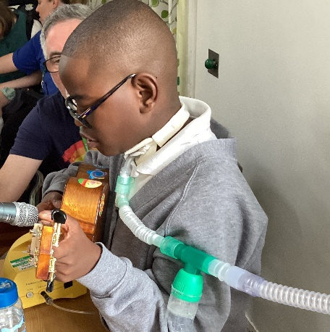
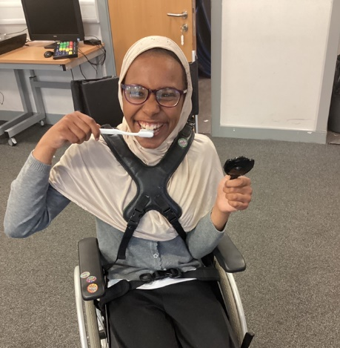
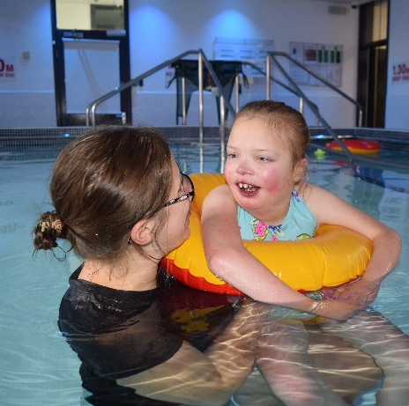

‘Reach for Success’
Closing Date: 23rd October 2022 at 12.00 midnight
Interviews: 14th and 15th November 2022

Dear Candidate

On behalf of the Board of Trustees I would like to thank you for expressing an interest in the post of Principal at Ash Field Academy.
We hope this information will give you a sense of the school and an understanding of the role and our expectations. We would encourage you to look at our website to find out more.
The Trustees are seeking to appoint a Principal who is dynamic, inspirational and highly motivated and who will bring strong leadership skills, and a commitment to pupils, their families and the dedicated staff team to build further upon our progress and success to date.
Ash Field Academy which is a single academy trust has an excellent national reputation and both the day school and weekly residential are rated as outstanding by Ofsted. The school learning environment is warm and welcoming and is carefully looked after and respected. Our Inclusion and SEND Hub has a proven track record as an outward facing centre of excellence.
Pupils here want to learn and make progress and we have a moral obligation to make sure that each day at Ash Field is as good as it can be. Our pupils never fail to astound us with their determination, positive approach to learning, kindness and exemplary behaviour.
We are proud of our inclusive and positive school ethos. Our dedicated team of senior leaders, teachers, support staff and families ensure that all pupils benefit from a personalised approach to their education. Staff go the extra mile to support all pupils to reach their full potential.
I hope that when you have read the enclosed literature that you will be excited at the prospect of joining us at Ash Field Academy. We anticipate that you will want to visit the school; please contact Linda Newman on 0116 273 7151 to make an appointment, and please contact the same number to arrange an informal discussion with the Principal. Please note that Ash Field Academy will be closed from 17th – 21st October 2022 for the half-term break
We look forward to the future with confidence and continued high ambitions. If you have an unwavering commitment to making a difference then we very much look forward to receiving your application.

Kathy Inskip
Chair of Trustees

About Ash Field Academy

Ash Field Academy is a specialist school, including a residential provision, serving Leicester City, Leicestershire and Rutland and also admits pupils from other counties.

We have increased in size to a PAN of 160 pupils over several years, with pupils ranging in age from 4 to 19, all of whom have physical disabilities and often complex medical conditions associated with these. This is often combined with other needs, such as cognition and learning or communication. The school is proud of its pupils and of all their achievements.
“Ash Field is a happy, warm, nurturing and positive place. My son has thrived here. Thank you all.”
We are proud of our Inclusion and SEND Hub (iSENDHub) and have special and mainstream schools in our iSENDHub Network. We feel it is important to work with Teaching School Hubs, organisations and other schools to champion best practice and secure excellent achievement for all pupils. We lead an established Challenge Partners hub and value both the network opportunities this provides as well as the quality assurance work around our leadership, curriculum, teaching and learning. Our last Challenge Partners report in October 2021 graded us as a ‘leading’ school in all areas.

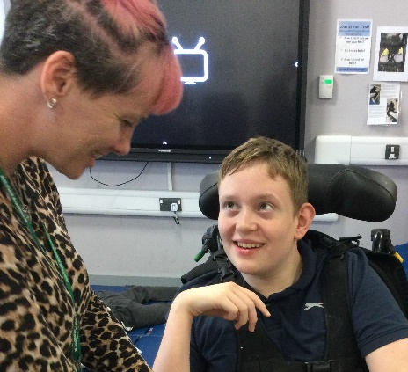
Ash Field has a multi-disciplinary team of Teachers, Teaching Assistants and other support staff including Health Service professionals who are integral to the school. Physiotherapists, Occupational Therapists and Speech and Language Therapists work closely with school staff to make the most efficient use of time for the maximum benefit of the pupils. We commission an Ash Field nurse and a team of healthcare assistants who are on site during the school day.

Curriculum and Learning
We have pupils of all abilities at Ash Field. In order to meet the needs of all of our pupils we have developed four different pathways. Every pupil’s individual learning needs are carefully considered to ensure they are placed on the appropriate pathway and even within the pathway, learning is carefully adapted to meet the individual pupils’ needs. Over the course of their education, some pupils may move between pathways. These pathways are described below:
Early Primary: this pathway is for pupils in the early years foundation stage (EYFS) and key stage 1. It is a mixed ability pathway, based on the Early Years Foundation Stage curriculum.
The Blue Pathway is primarily for pupils with profound and multiple learning difficulties (PMLD). It is very sensory-based and is a Challenge Partners ‘Area of Excellence’.
The Green Pathway, which is primarily for pupils with severe learning difficulties. This pathway takes on a semi-formal curriculum model.
The Yellow Pathway, which is primarily for pupils with moderate learning difficulties, follows a formal curriculum model, adapting the National Curriculum whilst ensuring it still meets the needs of the cohort.
Each pathway has a separate curriculum designed to meet the learning needs of the children.

To support our work in these key areas we have dedicated teams:
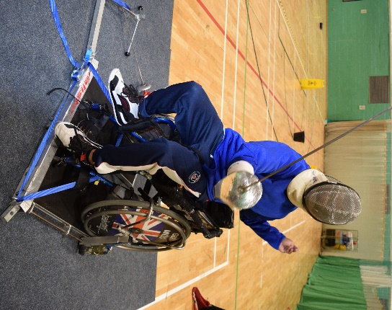
Movement Team – A specialist team of Ash Field staff who work
closely with physiotherapists and occupational therapists as well as
our yoga teacher to ensure that pupils are as comfortable as
possible so they can enjoy learning.

Communication Team - A specialist team of Ash Field staff who work
closely with speech and language therapists and our specialist music practitioners, to develop pupils’ communication skills through music, singing and assistive technology.

Well Being Team - A specialist team of Ash Field staff who work
closely with health professionals to ensure our pupils receive the care
they need, are happy and ready to learn as well as ensuring class teams have the right training, competence and confidence to carry out the medical procedures required.

There is a rich and varied Arts, Sports/Movement and Music offer which ensures pupils develop their talents and interests in school and in the community beyond and we enjoy excellent networks such as working closely with The City Classroom, The Open Orchestra, Noise Academy and SENsory Atelier, all of whom have shaped our work, and we theirs. We participate in sports competitions with other schools and have sports specialists in to share skills in Zumba, table top cricket and wheelchair basketball. Our playground and outdoor space has recently been updated to offer greater opportunity to enjoy being outside, including our new Edible Gardens plot.

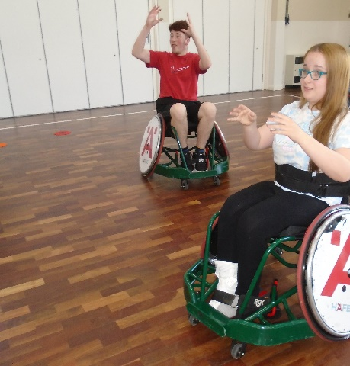
Residential Provision

The core aims of the weekly residential provision is to develop independence, social skills and emotional regulation and to enhance aspects of the school’s curriculum. The residential department is led by an experienced and highly competent Head of Residential Education and Care who has worked at the school for over 30 years, and who is ably supported by two deputies.
One of the main objectives is to continue the work done during the school day in developing independence and intellectual, emotional, spiritual and to the greatest extent possible, physical skills. There is a flat for older pupils' use.
“We are very much grateful and shall be grateful forever to school for providing all above to my daughter”
Pupils stay for one night per fortnight up to two nights per week. Older pupils may stay up to four nights on occasional weeks when they use the flat.
To ensure safety through the night - in addition to three night-waking members of staff, there are two members of staff who sleep on the premises and an ‘on call’ rota which always includes a member of the Senior Leadership Team or the Head of Residential Education and Care. The Principal has overall responsibility and accountability for the residential department.

Our Vision and Aspirations
Provide exceptional education and care so every pupil reaches his or her potential
To achieve this we aspire to:
- Ensure pupils are safe and feel safe, included and accepted.
- Provide great teaching so pupils make excellent progress.
- Offer a broad, balanced and exciting curriculum.
- Promote British values and encourage pupils to be resilient, confident and determined.
- Support pupils to be as emotionally and physically healthy as they can be.
- Develop independence and ensure pupils have as much autonomy over their lives as they can.
- Listen to pupils, however they communicate, and ensure their needs are met.
- Engage with parents, carers and other stakeholders, keeping pupils at the
heart of our thinking.
- Evaluate our work in a clear and honest way so we are held to account and continually strive to improve.
- Enhance and support the development of excellence for all pupils with special educational needs and disabilities in a local, national and international context.

Our strapline is ‘Reach for Success.’ This encapsulates our commitment to offer challenging learning experiences and celebrate each pupil’s achievements and progress.

Staffing Structure

Senior Leadership Team:
This includes the Principal, Deputy Principal and four Vice Principals (three of whom are part-time) as well as a Chief Financial Officer.
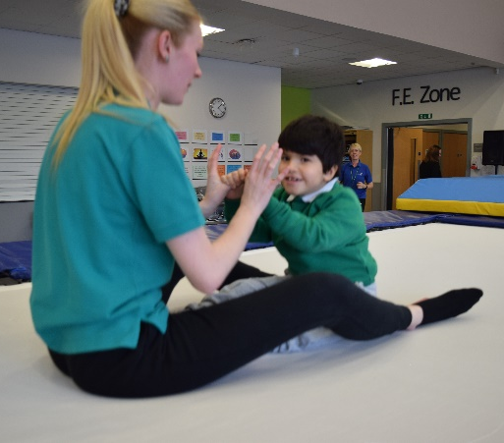
The Principal, takes overall responsibility for the strategic and operational leadership of the day and residential school and is the Designated Safeguarding Lead.

The Deputy Principal, Stephanie Chamberlain, oversees the pastoral elements of the school, including medical and health aspects, residential, attendance and behaviour and also has significant safeguarding responsibilities.

We have two part-time Vice Principals who are responsible for different phases within the school. Helen Jarvis is Head of Primary and Caroline Lindsay is Head of Secondary and FE. They have overall pastoral responsibility for their phase and line manage the teachers.

We have a further part-time Vice Principal who is responsible for Teaching and Learning, including Curriculum and Assessment, and a Vice Principal who is Director of the iSENDHub primarily and also takes responsibility for Continuous Professional Learning and Development within the school.

Wider Leadership Team:
We have eight middle leaders who form our Wider Leadership Team. This includes three Pathway Leaders each responsible for pupil progress within the Blue, Green and Yellow Pathways. The Early Primary Pathway is smaller and so the wider leader has a range of other responsibilities under the title of Personal Development. There are also curriculum leaders who are responsible for Healthy Lifestyles, Communication, Arts and Enrichment and Preparing for the Future.
“My daughter has had an amazing first year at school. She has come on in leaps and bounds and I am very proud of her. I would like to thank all staff across the school for being there for her. Best decision I made on sending her to Ash Field. An amazing school”

Parent quotes
‘My son has gained amazing progress this year. He really enjoys Ash Field. Thank you to all’
‘Thank you for everything you do. He has come on so well and we are so grateful for everything you do, thanks’
‘I would like to thank Ash Field Academy and the staff for their help and support in my child's learning and development.’
‘Very friendly and helpful team @ Ash Field, Thank you’
‘Thank you for great efforts during the very difficult time. A enjoys school! She loves to go to Ash Field.’
‘Really pleased with my son’s progress. He loves school and all the activities. He’s getting more and more vocal every day!’
‘We are so proud of how far our son has come. We love the school and all the staff – Brilliant’
‘We love the school and thank you for all your hard work’

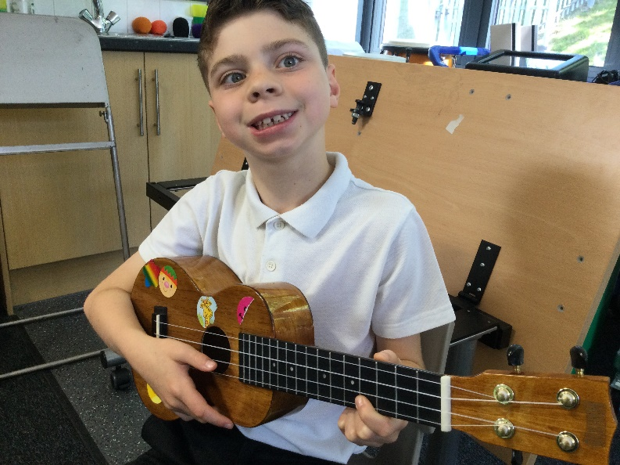
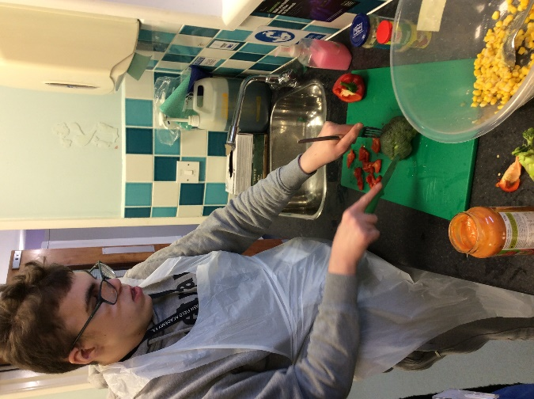

It may be helpful for you to look at some documents on our website including:
- Our vision and values:
https://www.ashfield.leicester.sch.uk/vision-and-values/
- All four Curriculum Handbooks:
http://www.ashfield.leicester.sch.uk/curriculum/
- Challenge Partners and Ofsted reports:
https://www.ashfield.leicester.sch.uk/external-education-reviews-including-ofsted-report/

