

JOB PROFILE
Job Title: | Principal | School/Department: | Crawshaw Academy
Salary Grade: | L28 – L32 | Working Hours: | Full Time
Contract Type: | Permanent | Location: | Pudsey, Leeds
Responsible to: Chair of Governors/ the Local Governing Body at Crawshaw Academy and the CEO of Red Kite Learning Trust.
Role summary:
- To provide vision, leadership and management, ensuring continual improvement and high-quality standards in all aspects of the Academy, being accountable for pupil, staff and financial performance.

- This is a non-teaching headship, leading a team of 156 staff, fulfilling all requirements of the National Standards of Excellence for Headteachers. We are committed to continuing to work with the School Teachers’ Pay & Conditions Document and associated conditions of service.
Red Kite Learning Trust is committed to safeguarding and promoting the welfare of students and expects all colleagues and volunteers to share this commitment.
Special conditions of service:
No smoking policy, including e-cigarettes.
1 / Key Responsibilities – Strategic Leadership of the Academy
- Create, develop, and effectively communicate a vision of excellence for the school, which involves continuously improving the quality of teaching and learning
- Work closely with the local governing body and others to ensure the school vision and strategic plan are effective and relevant to the school’s development
- Demonstrate, articulate and set expectations and targets so the vision is shared, understood and acted upon effectively by all
- Ensure Teaching & Learning is led in accordance with the school’s and Trust’s vision and values
- Ensure the strategic planning takes account of the diversity, values and experience of the school and its community
- Secure excellent teaching through an analytical understanding of how students learn and of the core features of successful classroom practice and curriculum design, leading to rich curriculum opportunities and students’ wellbeing throughout the school
- Use a range of evidence, including national data and own school’s performance data, to support, monitor and evaluate and improve aspects of school life, including challenging poor performance
- Ensure a culture and ethos of challenge and support where all students can achieve success and be engaged in their own learning
- Ensure that learning is at the centre of strategic planning and resource management
- Implement strategies that secure high standards of behaviour and attendance
- Monitor, evaluate and review classroom practice and promote improvement strategies
- Determine, organise and implement a diverse, flexible curriculum and implement an effective assessment framework
- Seek and share best practice within and between schools, drawing on and conducting relevant qualitative and quantitative data
- Take a strategic role in the development of new and emerging technologies to enhance and extend the learning experience of students.
2 / Key Responsibilities – Management of the School
- Arrange for a Deputy or other suitable person to assume responsibility at any time when absent from the school.
Curriculum
- Manage the curriculum – demand ambitious standards for all students and instil a strong sense of accountability in staff for the impact of their work on students’ outcomes
- Provide information, objective advice and support to the governing body to enable it to meet its responsibilities for securing effective teaching, learning and improved standards
- Build a school ethos and curriculum which takes account of the richness and diversity of the school’s community
- Ensure a consistent and continuous school-wide focus on students’ achievement, using data and appropriate benchmarks to monitor progress in every child’s learning
- Develop suitable quality assurance systems including school review, self-evaluation and performance management and present a coherent, understandable and accurate account of the school’s performance to a range of audiences including governors, trustees, parents and carers.
Staff
- Lead staff talent planning: forecast and also reactively manage talent succession moves and vacancies, and be the decision maker of staff employment offers aligned with school needs and financial ability
- Ensure staff are inducted appropriately so they are clear about the vision and aims of the school, understand their accountabilities, policies and procedures, and swiftly become integrated into school life
- Ensure individual staff accountabilities are clearly defined, understood and agreed and are subject to careful, fair and transparent review and performance evaluation in accordance with role expectations, performance management, appraisal and reward policy
- Articulate clearly the values and behaviour expectations of the school and the Trust and hold staff to account for their professional conduct
- Ensure effective planning, allocation, support and evaluation of work undertaken by teams and individuals, ensuring clear delegation of tasks
- Build and develop the team to work as effectively and efficiently as possible whilst also securing the highest levels of staff engagement
- Motivate, inspire, challenge, coach and support staff to maintain high expectations of behaviours, safeguarding and a positive school environment
- Treat people fairly, equitably and with dignity and respect to create and maintain a positive school culture
- Create a safe learning environment where colleagues feel able to share and contribute to ideas and practice; a supportive rather than “blame” culture
- Manage own workload and support others in doing the same, to provide for good levels of work/life balance
- Nurture a positive staff engagement: conducting and reviewing staff surveys, regularly gaining informal and formal feedback, collaborating on improvement areas, recognising staff strengths and opportunities, and celebrating individual and team achievements
- Be a good and consistent role model reflecting a high level of professional teaching standards and values aligned with the school and Trust’s vision
- Maximise the contribution of staff to improve the quality of education provided and standards achieved and ensure that constructive working relationships are formed between staff and students.

Finance
- Accountable for the financial performance of the school
- Work closely with the Business and Operations Manager and wider Trust Finance team to manage the school’s financial and human resources, ensuring effectiveness and efficiency in achieving the vision and goals of the school
- Knowledgeable of all school finances and continuously seeking opportunities for cost savings, sensible spending and investments, and revenue growth
- Encouraging an ethos of a cost-conscious school culture in which all can contribute ideas to aid revenue.
Operations
- Manage and organise the school environment efficiently and effectively to ensure it meets the needs of the curriculum and health and safety regulations
- Support and uphold the school and Trust policies
- Ensure creativity, innovation and the use of appropriate new technologies and initiatives to achieve excellence
- Ensure that the school’s systems and processes are well considered, efficient and fit for purpose, upholding the principles of transparency, integrity and probity
- Ensure there is Health and Safety compliance, conducting risk assessments where applicable and escalating to the Trust any non-conformance issues.
3 / Key Responsibilities – Stakeholder and Community Engagement
- Welcome strong governance and actively support the governing body to understand its role and deliver effectively
- Develop and secure trust amongst the community and all stakeholders
- Create a wholly inclusive environment
- Create and maintain an effective partnership with parents and carers, to support and improve students’ achievement and personal development
- Seek opportunities to invite parents, carers and community figures, business or other organisations into the school to enhance and enrich the school and its value in the wider community
- Build the reputation of the school with the outside community
- Ensure learning experiences and opportunities for students are integrated into the wider community (youth services, out of school activities)
- Work as a key partner within the Trust through the Executive Headteacher, Board and other Trust and Alliance wide activities.
4 / Key Responsibilities – Developing Self and Others
- Contribute to the development of the school-led, self-improving education system through the work of the Trust and Alliance
- Build a collaborative learning culture within the school and actively engage with other schools to build effective learning communities
- Regularly review own practice, set personal targets and take responsibility for personal development.
5 / Key Responsibilities – Child Protection and Safeguarding
- Ensure a culture of professional curiosity as a Designated Safeguarding Lead (DSL) and whole school adherence to all statutory requirements, currently provided through Keeping Children Safe in Education.
- Ensure that the child protection policies and procedures adopted by the governing body are implemented and followed by all stakeholders
- Ensure that resources and time are allocated to enable through this role and for other staff to discharge their child protection related responsibilities effectively and that colleagues involved in child protection and safeguarding responsibilities receive supervision
- Provide a safe, calm and well-ordered environment, focused on safeguarding students and developing their exemplary behaviour in school and in the wider society
- Collaborate with other agencies, particularly across the Trust, in providing for the wellbeing of students and their families and provide opportunities for all children, regardless of their capabilities, to be the best that they can be
- Be the Safeguarding Lead to support the work of the child protection and safeguarding team.
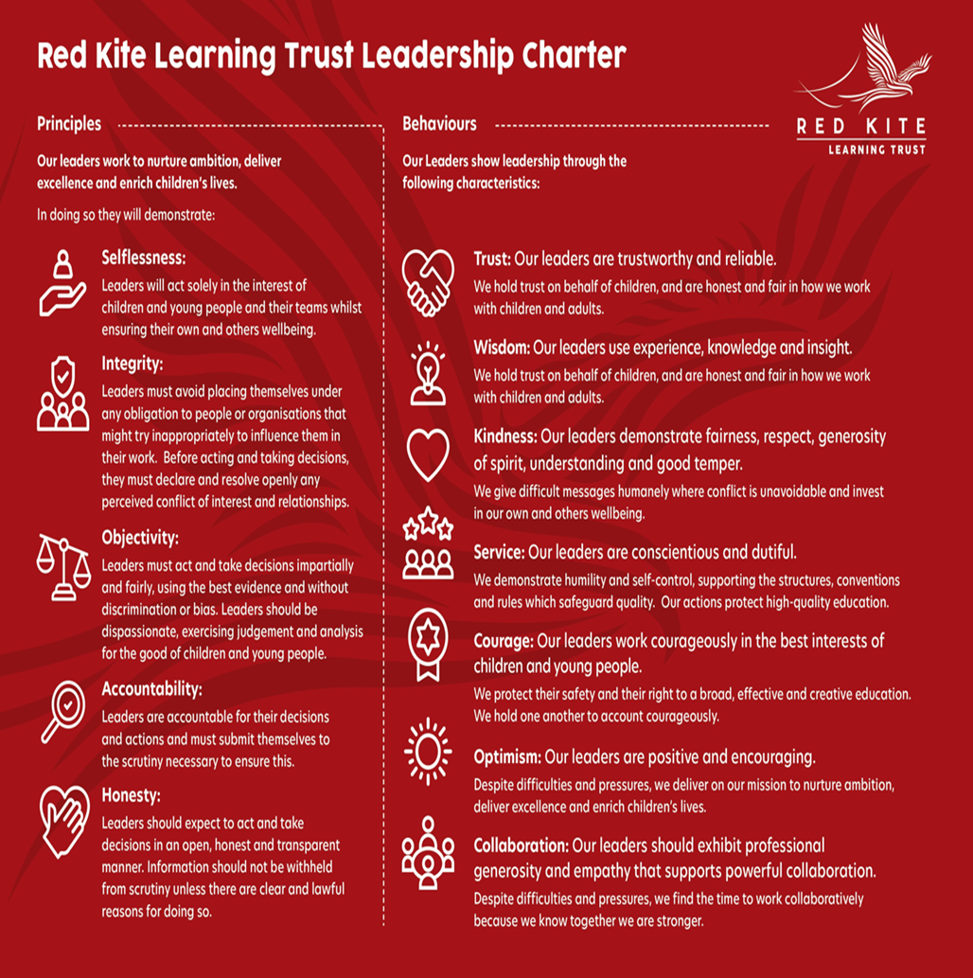
PEOPLE PROFILE
Aptitudes and Characteristics |  |  |  | Essential | Desirable
Able to collaborate and communicate with a wide range of audiences including parents, students, colleagues, governors, other schools and colleges |  |  |  | *
Ability to communicate a compelling vision, driving aligned activities, whilst maintaining effective working relationships |  |  |  | *
Able to challenge, influence, motivate and support others to attain high standards |  |  |  | *
Ability to monitor and evaluate the work of others; to offer support and intervention where necessary |  |  |  | *
Ability to give and receive effective feedback and act to improve personal performance |  |  |  | *
Ability to manage the school efficiently and effectively on a day-to-day basis including HR, Finance and Accommodation |  |  |  | *
Ability to ensure effective strategic financial planning and budgetary management to achieve best value |  |  |  | *
Ability to develop and sustain a safe, secure and healthy school environment, ensuring an understanding of the legal issues related to managing a school |  |  |  | *
Able to apply the principles and practice of quality assurance systems including school review, self-evaluation, performance management and stakeholder and community involvement |  |  |  | *
Resilient and demonstrates optimistic personal behaviour, a drive for excellence and a positive attitude towards all |  |  |  | *
An ethical leader who exercises confidentiality and a high level of emotional intelligence |  |  |  | *
Willingness to be flexible and work to meet the best interests of the school and our Trust |  |  |  | *
Qualifications, Knowledge and Experience |  |  |  | Essential | Desirable
Graduate with Qualified Teacher Status |  |  |  | *
Leadership training such as a Masters degree, NPQH |  |  |  | *
Proven successful experience in a leadership role, e.g. Headteacher/Principal, Interim Headteacher / Principal or Deputy Headteacher / Principal |  |  |  | *
Experience of leading, managing and co-ordinating staff through an effective team-based approach |  |  |  | *
Knowledge of what constitutes quality in educational provision, the characteristics of effective school development, and effective strategies for raising standards and the achievement of all students |  |  |  | *
Proven experience of developing good working relationships with all stakeholders |  |  |  | *
Experience in analysing data, developing strategic plans, setting targets and monitoring/evaluating progress to lead school improvement |  |  |  | *
Experience of whole school self-evaluation and improvement strategies |  |  |  | *
Understand strategies for performance management, including distributive leadership and building teams to share accountability for goals and standards |  |  |  | *
Understand team dynamics and ability to understand team and individual strengths and development opportunities |  |  |  | *
A thorough understanding of curriculum development |  |  |  | *
Up to date knowledge in subject, national policy, pedagogy, classroom management strategies, research/inspection findings and statutory requirements |  |  |  | *
Understand the characteristics of an effective learning environment and the key elements of successful behaviour and attendance management |  |  |  | *
An excellent classroom practitioner with the highest expectations for the welfare and progress of all students |  |  |  | *
Knowledge and experience of a range of successful teaching and learning strategies to meet the needs of all students |  |  |  | *
Proven experience of monitoring and improving the quality of teaching and learning |  |  |  | *
A secure understanding of assessment strategies and the use of assessment to inform the next stages of learning |  |  |  | *
Proven experience in the analysis of performance data for the purposes of target setting and evaluation |  |  |  | *
Experience of leading an inclusive school community |  |  |  | *
Proven experience of meeting the needs of all learners; raising standards |  |  |  | *
Proven commitment to excellent and respectful behaviour from the whole academy community |  |  |  | *
Knowledge of local and national educational trends |  |  |  | *
Safeguarding and Promoting the Welfare of Students |  |  |  | Essential | Desirable
An appropriate motivation to work with children and young people |  |  |  | *
Ability to maintain appropriate relationships and personal boundaries with children and young people |  |  |  | *
Emotional resilience in working with challenging behaviours and appropriate attitudes to the use of authority and maintaining discipline |  |  |  | *

