Contents
- About our school
- Advert for the Principal position
- Letter from Chair of Governors
- Key school information
- Our vision and ethos
- Principal job description
- Principal Person Specification
- Children and parent comments

About our School
Welcome to Monks Coppenhall Academy and Nursery. We are proud to be the founding school of the Alexandra Academy Trust.

Our school
We offer a friendly, vibrant and enriched learning environment where every child matters. Our inclusive ethos nurtures and celebrates the diversity across our school, built around a positive and engaging curriculum. Our educational vision is to be a place of excellence and enjoyment and we have very high aspirations for all our children.

At Monks Coppenhall Academy and Nursery, we have very high expectations of behaviour, where all learners are given equal opportunities and treated fairly. We aim for children to feel safe and secure; we place a particular emphasis on meeting the emotional needs of our children. We aim for children to leave our Academy confident, happy and well equipped for the next phase of their education. Our very skilled team know each child well and want the very best outcomes for them.
We want children to enjoy learning and develop a love of learning. Children are at the heart of everything we do. The Children’s Council plays an active part in decision making within the Academy.
Our Character-Building, Commando Joe curriculum focuses on achievement based around ‘RESPECT’, Resilience, Empathy, Self-awareness, Passion, Excellence, Communication and Teamwork.
We want every child to reach their full potential, measuring the impact of their resilience.
Our school has 21 large, well-equipped classrooms. Each of our classrooms has computers, an interactive whiteboard, internet connection and audio-visual equipment.

In Key Stage 2, we have created teaching pods which provide valuable working areas for small group work to extend or support the needs of learners.

The school has extensive, outdoor facilities, a large field enabling a wide variety of sporting activities to take place, a well-equipped outdoor fitness zone and a Multi-Use Games Area, which allows our children to participate in outdoor activities all year round.

We are dedicated to promoting a love of reading in our children. We are very fortunate to have a beautifully decorated and well-resourced ‘magical forest’ themed library. This area is much loved by our children, who enjoy accessing it on a regular basis. In 2020, we installed a Harry Potter themed outdoor library for our children to further explore and develop their love of reading.

We are very proud of our ‘Rainbow Room’, which is a relaxing room specially designed for Monks Coppenhall Academy. The Rainbow Room provides a beautiful, tranquil and relaxing space in which we can offer a personal development plan to support our children.

Our journey
Our school first opened in 1953 and converted to an Academy in June 2016. In 2017, we undertook a large expansion project to increase our Planned Admission Number from 60 to 90 and changed the age range from 4-11 to 2-11.

In 2018, Monks Coppenhall Nursery joined the Alexandra Academy Trust. Our well-resourced nursery provision has recently relocated into the main school. We currently have 73 children on roll aged between 2 and 4.

In September 2022, we opened a 7 place Resource Provision for children with Social, Emotional and Mental Health diagnoses. Our Resource Provision has a dedicated teacher and teaching assistant.

Monks Coppenhall Academy and Nursery Principal
Salary L19-L27
Start date: Preferably September 2023, however we would be prepared to wait until January 2024 for the right candidate.
The Trustees of the Alexandra Academy Trust and the Local Governing Board of Monks Coppenhall Academy and Nursery are offering a unique opportunity to a very special person to apply to become Principal at Monks Coppenhall Academy. This vacancy has arisen due to the current Principal’s role change, to solely focus on the CEO’s role within the Trust.
Monks Coppenhall Academy and Nursery is a growing 3 form entry Primary school with and age range of 2-11 which currently has 603 on roll (inclusive of nursery). The school serves a diverse catchment with the most delightful children. Visitors at the school always comment on the politeness, respectfulness and excellent behaviour of the children.
We are seeking to appoint a Principal who is an inspirational, ambitious and a resilient person to help to build on our strengths to ensure continued success. Our Academy is currently rated Outstanding
Our Academy is a place where we aim to establish high aspirations, excellence, enjoyment, where everyone feels valued and is supported to achieve the best they can in mind, body and spirit. Our ideal candidate will currently be a Senior Leader, or serving Head who is keen to join an excellent team and school community. We are looking to appoint a person who will have already played a central role in overall school improvement and has a proven track record at a senior level in a primary school, has knowledge and experience of working with EYFS, KS1, KS2 and is an outstanding classroom practitioner.
In return we offer a warm family and nurturing environment, within which our amazing children feel confident to express their individuality and their talents. They know that their efforts and achievements will be appreciated and celebrated. Our excellent team is very supportive and hardworking and the talented Governors and Trustees know the school well and are fully supportive of work life balance. Our excellent facilities and grounds provide a positive and safe learning environment for our community.
Visits to the school are warmly welcomed and should be arranged by contacting Mrs Zoe Holloway by e-mail Holloway@monkscoppenhall.cheshire.sch.uk

Completed applications should be returned by e-mail together with a supporting letter of no more than two sides of A4, font size 12, outlining your suitability for the role. to: Holloway@monkscoppenhall.cheshire.sch.uk

- Closing Date: Sunday 16th April at 5:00pm
- Short Listing: Monday 17th April
- Interviews: Tuesday 25th April and Wednesday 26th April
Our school is committed to safeguarding and promoting the welfare of children and requires all staff and volunteers to share this commitment. References will be taken up for all shortlisted candidates prior to the interview. The successful applicant will be required to undergo an enhanced DBS Disclosure.

Dear Applicant,
Thank you for your interest in the post of Principal at Monks Coppenhall Academy and Nursery.
I am very pleased that you are considering applying to lead our wonderful school. The vacancy has arisen following the current Principal moving to the CEO role within the Trust.
In the application pack we have provided you with a flavour of the school in order to give you more information about what the post offers. I hope that you find the information we have provided of sufficient interest that you decide to apply for the post. We want to employ somebody who is inspired to lead an outstanding school who will continue to build on the strengths and achievements of the current team as well as working closely with colleagues across the MAT to improve learning outcomes for all.
Our new Principal should be a strong, approachable, compassionate and supportive leader who is passionate and knowledgeable about continuing to improve teaching and learning in school and has a love of working with children. The person specification provides a more comprehensive list of the qualities we are looking for, but in essence, we wish to appoint somebody who is a personable and outstanding leader and has the relevant experience and confidence to take the school forward. Our new Principal will be someone who puts children at the heart of every decision made and values the importance of Continued Professional Development and work life balance within the team. The right person will be dedicated to partnership working across the Trust.
I warmly encourage you to visit the school and meet our amazing children and fabulous team.
Mr Gordon Fairbairn
Chair of Monks Coppenhall Academy and Nursery Local Governing Board

Monks Coppenhall Academy & Nursery (Alexandra Academy Trust)
Key School Information
Type of School:
- Primary School (Part of Alexandra Academy Multi Academy Trust)
- Age Range 2-11 years (including nursery)
- 7 Place Resource Provision for SEMH
Leadership Structure:
- CEO
- Principal
- Vice Principal
- 3 x Assistant Vice Principals (1 is also SENDCO)/Heads of Department
- 3 x Deputy Heads of Department
Staff Numbers:
- Teaching Staff 24.4 FTE teachers
- Non-Teaching Staff: 43.8 FTE
- Nursery Staff: 5.3 FTE
Pupil Numbers & Demographics:
- Planned Admission Number: 90
- Number on roll 530 (603 including Nursery)
- % of children with SEND 22% (EHCP) 4%/18% SEND Support
- % of children eligible for Free School Meals 32%
- % of children eligible for pupil premium 34%
- % of children with English as an Additional Language 22%

Our Vision and Ethos

Mission Statement
‘To be the best we can in mind, body and spirit’
Our educational vision is to be a place;
- Of high aspirations, excellence, enjoyment and discovery.
- Where everyone feels valued and achieves to the best of their potential.
- Where self-discipline and very good behaviour is expected.
- Where all learners are treated fairly and given equal opportunities.
- Where learners are able to make positive contributions to society and are prepared for future technologies.
- Where we create motivated, lifelong learners and safely use a range of technologies to enhance and support learning.

Aims
Through our character-building curriculum, we aim to develop:
- Resilience – by providing strategies to enable children to cope and recover quickly from difficulties and setbacks.
- Empathy – by providing opportunities and experiences to place themselves in the ‘eyes, ears and heart’ of others.
- Self-awareness – by developing an understanding of own strengths, weaknesses, thoughts, beliefs, motivation, health, well-being and emotions.
- Passion - by fostering a long-term love, enthusiasm and excitement for learning
- Excellence - by encouraging the growth of individual qualities in order to achieve their maximum potential, so that excellence becomes a habit.
- Communication – by creating an open, inclusive and welcoming learning community where all forms of communication are valued and listened to, enabling children to be expressive, reflective and evaluative learners.
- Team work - by encouraging self-discipline, unity, patience, and co-operation within a safe and secure environment to make responsible decisions to achieve a common goal.

Monks Coppenhall Academy
Principal
Job Description
based on the National Standards of Excellence for Headteachers.
Job title: Principal – Deputy Safeguarding Lead and responsible for standards across the school.
Salary: L19- L27
Hours: Full-time
Contract type: Permanent
Reporting to: Chief Executive Officer of the Alexandra Academy Trust
Responsible for: Staff at all levels within the school
Main Purpose
The Principal will:
- Formulate the aims and objectives of the school and provide overall strategic leadership
- Establish policies for achieving these aims and objectives
- Manage staff and resources to that end
- Monitor progress towards the achievement of the school’s aims and objectives
- Lead by example by modelling best practice regarding professional conduct, workload and personal development
- Be a role model for all in our community

Duties and Responsibilities
Qualities and Knowledge –
To work closely with the Chief Executive Officer of the Alexandra Academy Trust to:
- Lead by example, holding and articulating clear values, moral purpose, and focusing on providing excellent education for all children
- Build positive relationships with all members of the school community
- Keep up to date with developments in education, and have a good knowledge of education systems locally, nationally and globally
- Work with political and financial astuteness, translating policy into the school’s context
- Communicate the school’s vision compellingly and drive strategic leadership
- Seek training and continuing professional development to meet own needs

Children and Staff
- Demand ambitious standards for all children, instilling a strong sense of accountability in staff for the impact of their work on children’s outcomes
- Ensure excellent teaching in the school, including training and development for staff
- Establish a culture of ‘open classrooms’ as a basis for sharing best practice
- Create an ethos within which all staff are motivated and supported to develop their skills and knowledge
- Identify emerging talents, coaching current and aspiring leaders
- Hold all staff to account for their professional conduct and practice
.
Systems and Processes
- Ensure that the school’s systems, organization and processes are well considered, efficient and fit for purpose
- Provide a safe, calm, well-ordered environment for all children and staff, focused on safeguarding and developing exemplary behaviour
- Implement systems for managing the performance of all staff, addressing any underperformance, supporting staff to improve and valuing excellent practice
- Welcome and work with the governing board as appropriate, providing the information it needs to govern effectively
- Support strategic, curriculum-led financial planning to ensure effective use of budgets and resources
- Support distribution of leadership throughout the school

The Self-Improving School System
- Create an outward-facing school which works with other schools and organisations to secure excellent outcomes for all children
- Develop close working relationships with other schools in the Alexandra Academy Trust
- Develop effective relationships with fellow professionals
- Model entrepreneurial and innovative approaches to school improvement and leadership
- Make evidence informed decisions to aid school improvement
- Inspire and influence others to believe in the fundamental importance of education in children’s lives and to promote the value of education

Other Areas of Responsibility
- Deputy Designated Safeguarding Lead
- Leading standards across the school
- Strategic development planning

The Principal will be required to safeguard, promote the welfare of children, follow school policies and the staff code of conduct.
Please note that this is illustrative of the general nature and level of responsibility of the role. It is not a comprehensive list of all tasks that the Principal will carry out. The postholder may be required to do other duties appropriate to the level of the role.
Please note this job description may be amended at any time in consultation with the postholder.

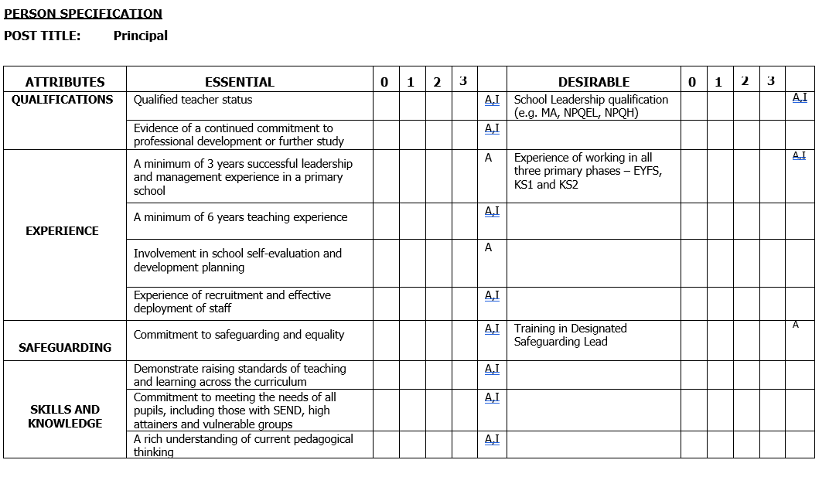
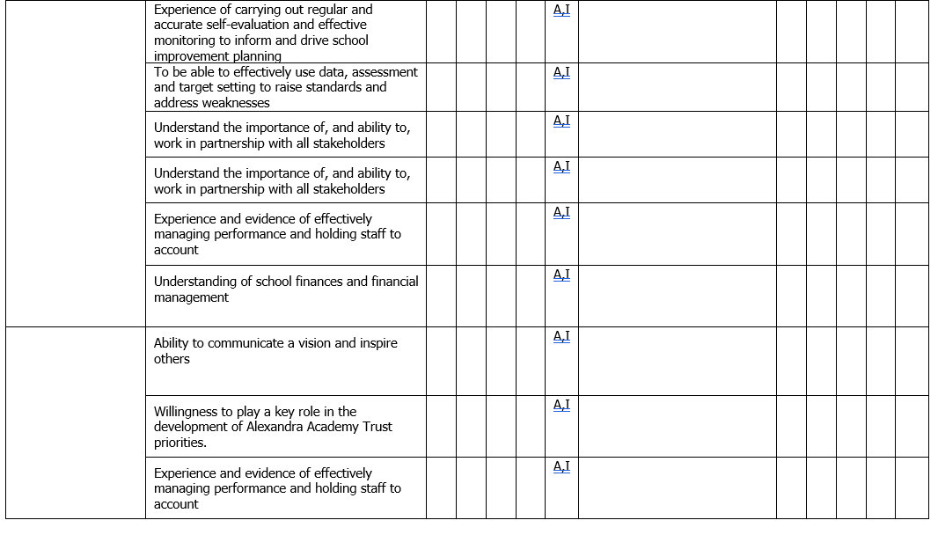

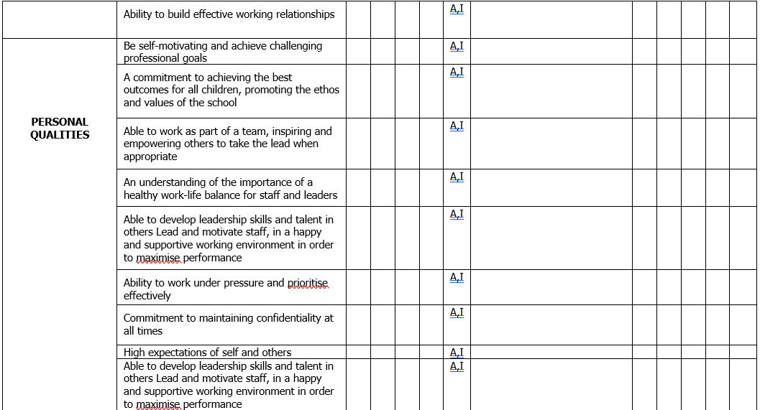
What our children think about our school

“The school gives you loads of opportunities to learn in different ways. We have great resources and equipment.”

“I like this school because it’s a vibrant and exciting place to learn.”

“We are lucky that there are so many after school clubs, they are fun.”

“The resources and equipment are brilliant, I love everything about the school.”
Recent parent comments about our school

“Our son has learned a lot during this school year, home learning was prepared very well. He was supported by great staff throughout this year. He has gained confidence he talks a lot with his friends. Most importantly, he loves going to school. We would like to thank you for your continuous support and creating a great atmosphere for children.”

“Our daughter’s report was amazing! We are so pleased with her progress this year and couldn’t have asked for any more. Thank you to everybody who has put their hard work and effort into our daughter, she has made amazing academic and social progress.”

“My son has come such a long way in his first year and is blossoming all the time. I am very happy with his progress and am super proud of everything he has achieved in his first year at Monks Coppenhall Academy.”

