JOB PROFILE
Job Title: | Programme Leader – Head of French | School/Department: |  | Harrogate Grammar School
Salary Grade: | National Teacher PayScale with TLR2b | Working Hours: |  | Full time
Contract Type: | Permanent | Location: |  | Harrogate
Responsible to: Faculty Leader
Role summary:
We are looking to appoint a highly motivated and effective Programme leader to support the Faculty Leader in leading and managing the learning programme, staff and resources within the MFL faculty. Your role is to maximise the educational outcomes for young people through effective leadership and a deep passion for your subject.
Red Kite Learning Trust is committed to safeguarding and promoting the welfare of students and expects all colleagues and volunteers to share this commitment
Special conditions of service:
No smoking policy, including e-cigarettes.
Occasional requirement to work outside of school hours and off school premises
Role specific responsibilities:
- Support and lead the school’s core purpose in providing ‘Excellence for all’ by modelling our REACH values in all aspects of the role, being and supporting colleagues and students to be the best version of themselves by leading with professional drive and humility.
- Effectively lead and communicate a vision of excellence within the faculty, with a relentless drive to improve the quality of teaching and learning and as a result, outcomes in the faculty; encouraging staff to be reflective in their practice, engage with instructional coaching and by using all the quality assurance tools at their disposal.
- Support the Faculty Leader in ensuring the effective leadership and management of the physical and human resources at the faculty’s disposal, working within budgetary constraints to get best value at all times.
- Support and lead all members of the faculty to develop positive and respectful relationships with all students, in line with the school’s ‘Positive Relationships Policy’; ensuring connection before correction and supporting students to develop ‘Excellent Learner Habits’.
- Support the Faculty Leader in leading the personal and professional development within the area, by ensuring all faculty colleagues, including ITT and ECT teachers, have access to timely, high quality performance review opportunities, which support their continued professional development, identifying any issues promptly, offering support and being prepared to challenge underperformance, ensuring high levels of retention and job satisfaction.
- Work alongside senior leaders, the faculty leader and fellow programme leaders to support the development and implementation of whole school strategies, contributing ideas and providing honest feedback and reflection.
- Support the faculty leader in leading the planning, development, effective resourcing and regular review of our aspirational and inclusive curriculum, which provides excellence for all, and which offers experiences which develop character, encourages diversity and develops understanding of British Values and citizenship.
- Ensure the needs of all learners are met, through careful planning of the curriculum and assessment opportunities; supporting staff to meet the needs of disadvantaged students, working towards the ambitious school goal of zero gaps; offering wider experiential opportunities, designed to develop cultural capital and increase participation.
- Keep up to date with educational research both within the subject discipline but also in the wider context, to share findings with colleagues and encourage them to engage with research and development in order to improve their practice.
- Ensure positive and professional communication within the faculty, with all colleagues within the school and wider Trust and with parents; positively representing the school when working with those in the wider community.
- In addition to the specific duties above as Programme Leader the post-holder will comply with the duties of a Main Scale Teacher.

RK People responsibilities:
- Contribute to the overall aims and values of our Trust, appreciate and support the roles of other members of the wider team and attend and participate in relevant meetings as required
- Comply with all Trust policies and procedures including child protection, health, safety, welfare, security, confidentiality and data protection, reporting any concerns to the appropriate person
- Contribute to ensuring safeguarding procedures are in place and used effectively at all times

The role holder must demonstrate a flexible approach to the delivery of the role. Consequently, the role holder may be required to perform work not specifically identified in the job profile but which is in line with the general scope, grade and responsibilities of the role.
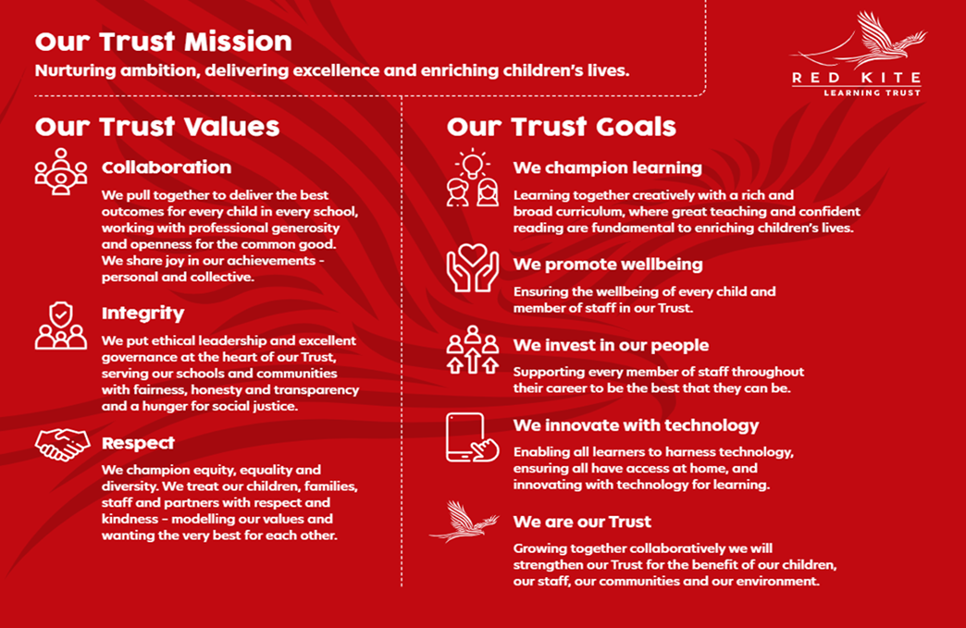

PEOPLE PROFILE
Aptitudes and Characteristics |  |  | Essential |  | Desirable
Skilled classroom practitioner |  |  | E
Highly effective communication skills |  |  | E
Ability to form good working relationships and influence others |  |  | E
Ability to lead and inspire colleagues |  |  | E
Capacity to evaluate and improve |  |  | E
High level of skill in dealing with issues relating to student behaviour |  |  | E
Ability to forge and maintain educational partnerships |  |  | E
Passionate belief in the ability of every student to achieve |  |  | E
A clear educational vision and sense of direction |  |  | E
Good organisational skills and high levels of self-motivation |  |  | E
Energy, self-confidence and ability to ‘give more’ when the occasion demands it. |  |  | E
Ability to work under pressure and to meet deadlines |  |  | E
Record of good attendance and punctuality |  |  | E
A desire for further promotion |  |  | E
Qualifications, Knowledge and Experience |  |  | Essential |  | Desirable
Degree level qualification in related subject plus PGCE |  |  | E
Ability to teach up to French up to A Level |  |  | E
Ability to teach up to Spanish or German to KS3 |  |  | E
Ability to teach Spanish or German to KS4 |  |  |  |  | D
Further post graduate study and leadership training |  |  |  |  | D
Experience in raising standards at middle leadership level |  |  | E
Experience of leading, motivating and monitoring other members of staff |  |  | E
Experience of managing students with challenging behaviour |  |  | E
Up to date knowledge of curriculum related issues 11-19 |  |  | E
Competent in ICT including analysis of performance data and knowledge and application of MIS |  |  | E
Detailed knowledge of pedagogical practice in relation to Teaching and Learning |  |  |  |  | D
Thorough understanding of best practise in raising student attainment |  |  |  |  | D
Knowledge of current guidance and regulations in relation to inclusion |  |  |  |  | D
Safeguarding and Promoting the Welfare of Students |  |  | Essential |  | Desirable
An appropriate motivation to work with children and young people |  |  | E
Ability to maintain appropriate relationships and personal boundaries with children and young people |  |  | E
Emotional resilience in working with challenging behaviours and appropriate attitudes to the use of authority and maintaining discipline |  |  | E

