

Castle Donington College
Pupil Support Assistant
Scale: 5 (NJC points 13-17)
£28,163 - £30,060 per annum pro rata
Permanent / Term Time (37 Hours PW)
Start date: Autumn Term 2025

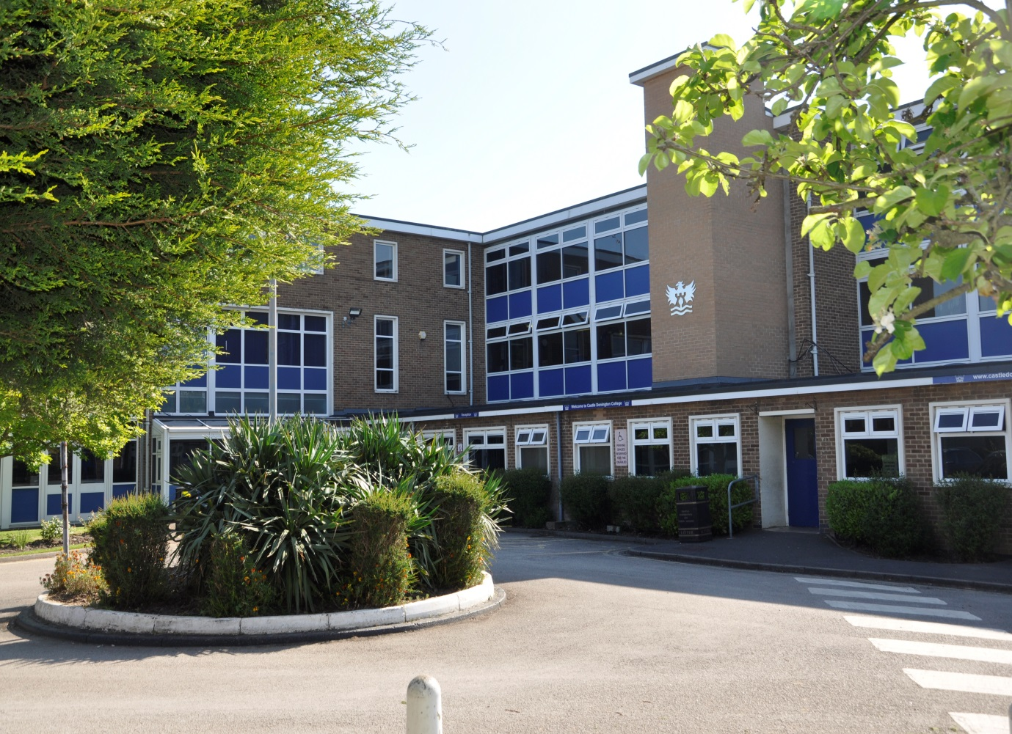


Castle Donington College

July 2025

Dear Applicant,
Pupil Support Assistant

Thank you for your interest in the post of Pupil Support Assistant at Castle Donington College. I hope this Information will be of interest to you and I look forward to receiving your completed application.

Castle Donington College is an 11-16 secondary school. We have just under 700 pupils on role across five-year groups (Years 7 to 11). The College is situated on the north west edge of Leicestershire on the Leicestershire, Derbyshire, and Nottinghamshire border and within 30 minutes’ drive of Nottingham, Derby, Leicester, Loughborough and Burton, being close to the M1 and A50.
We chose to join the East Midlands Education Trust, a successful and thriving partnership of high achieving schools in January 2022. In June 2024 we received an Ofsted rating of ‘Good’ and we are very proud of our community and the pupils we serve. We have high aspirations for everyone in our community whether pupil or staff. We are therefore seeking to appoint a Pupil Support Assistant who has a clear desire to contribute to the future success of the College and to support our young people to become the best they can be. The future is exciting, and we invite you to join us on the journey.
All our staff work collaboratively to support each other, share best practice and drive school improvement. We are committed to a happy, purposeful and secure environment that provides the opportunity for all to grow and develop. Our staff are highly valued, well regarded and fully supported. We can offer a coherent programme of induction and we have a strong commitment to professional development. Your development will be a key priority for us, regardless of your experience.
The job description and person specification will give you further details about what we require. We welcome and encourage prospective candidates to come and visit, to meet our staff and pupils and to experience first- hand the ethos and values of the College. If you believe you have the skills and qualities to help us continue to be successful, then I look forward to receiving your application.

Best wishes,
Vickie Beeby
Principal

Mount Pleasant, Castle Donington, Derby, DE74 2LN
T: 01332 810528 Email: postroom@cdcollege.uk

 | JOB DESCRIPTION & PERSON SPECIFICATION
 | Role: Pupil Support Assistant
 | Scale: 5 (NJC points 13-17)
 | Responsible to: Senior Pastoral Leader
JOB DESCRIPTION
Main Purpose of the Job:
To support to pupils and parents/carers with pastoral care to ensure positive behaviour, attitude and attendance as well as social, emotional and physical wellbeing.
To particularly work with pupils with Emotionally Based School Avoidance to foster the participation of these pupils in the social and academic processes of the school by recognising individual pupils’ needs, and identifying and implementing appropriate responses
Main Responsibilities of the Job:
- To provide pastoral support to pupils experiencing difficulties on a day-to-day basis, and to ensure that pupils have timely access to effective pastoral support when needed.
- To adopt a keyworker role for pupils with Emotionally Based School Avoidance, to include monitoring their progress, attendance, behaviour and wellbeing, reporting any concerns to the SENDCo, Head of Year and Senior Leadership Team and attending any relevant meetings.
- To liaise with colleagues to identify pupils that require additional pastoral support and plan an approach accordingly.
- To provide information, advice and structured interventions, with a particular focus on Anxiety Related Non Attendance, to enable pupils to make positive choices about their behaviour, attendance and social, emotional and physical wellbeing.
- To provide innovative support strategies appropriate to individuals and their families and to regularly review the impact of these strategies, including the reporting of information for sharing at reviews and other meetings
- To support pupils to access the breadth of the curriculum, in both planned and responsive situations
- To develop and maintain positive relations with parents and carers, fostering an open-door culture to encourage active involvement in their child’s education.
- To liaise with outside agencies to ensure the best support and provision for pupils, including compiling reports when required.
- To maintain confidentiality and keep accurate records of interactions with pupils, interventions and contact with parents, colleagues and outside agencies.
- To work independently and use own initiative when dealing with unexpected pupil problems and emergencies, referring more complex concerns to the Senior Leadership Team and ensuring that any safeguarding issues are escalated in line with school policy.
- To support the Pastoral Team with any other duties, for example locating pupils who are missing from lessons or collecting pupils who have been removed from lessons in line with the behaviour policy.
- To have a can-do attitude and develop positive relationships with colleagues, providing consistent and effective support and working constructively as a member of the school staff team.
- To attend and participate in departmental and other staff meetings and to participate in training and other learning activities offered by the school to further knowledge.
- To support, as appropriate, in instances where pupils are unwell whilst at the school.
- To carry out other associated duties as are reasonably assigned by the Principal.
PERSON SPECIFICATION
Qualifications | Essential | Desirable | How assessed
- Level 2 qualifications in maths/numeracy and English/literacy. |  |  | App/Ref/Int
- Emotional Literacy Support Assistant (ELSA) qualified.
- A relevant mental health qualification
Experience | Essential | Desirable | How assessed
- Experience of working with young people in a voluntary or professional capacity. |  |  | App/Ref/Int/ Doc
- Experience of working in a busy environment with conflicting priorities requiring high levels of accuracy.
- Experience of working with pupils who have SEMH needs
- Experience of working in a school setting.
- Experience of working with external agencies.
Skills | Essential | Desirable | How assessed
- Ability to set high standards to staff and pupils by personal example. |  |  | App/Ref/Int
- Ability to work effectively under pressure.
- Ability to be proactive, prioritise workload and meet deadlines.
- Ability to act quickly and decisively.
- Good interpersonal skills and ability to build effective relationships with pupils, parents, colleagues and external links.
- Effective communication skills and ability to communicate effectively to a range of audiences both verbally and in writing.
- Ability to work effectively independently and as part of a team.
- Ability to maintain confidentiality.
Knowledge | Essential | Desirable | How assessed
- Understanding of how to support pupils with social, emotional and wellbeing needs. |  |  | App/Ref/Int
- Good ICT skills.
- Understanding of school procedures and policies in particular safeguarding, attendance, equal opportunities and inclusion.
- Working knowledge of SIMS and CPOMS.
- Understanding of the range of complex needs that young people may have accessing education, and a knowledge of the range of approaches to cater for these complex needs and barriers to learning

Personal Attributes | Essential | Desirable | How assessed
- Enthusiastic, self-motivated and a positive can-do attitude. |  |  | App/Ref/Int
- Demonstrate a commitment to equal opportunities.
- A willingness to relate to the local community.
- Commitment to continued personal development.

App Application form and letter
Doc Documentation
Ref References
Int Interview

Responsibilities of all Staff:
- To make the education, safety and happiness of the pupils in the College your primary purpose
- To ensure the need to safeguard pupils’ well-being is understood and followed in accordance with statutory provisions and in line with College procedures
- To promote the College aims values and ethos and to abide by policies and procedures in all situations
- To maintain high standards of punctuality and attendance
- To act as a role model by demonstrating a professional level of dress, appearance and behaviour
- To treat all members of the College community (staff, pupils, parents, Governors and visitors) with respect and dignity and at all times observe proper boundaries
- To know and always act within the statutory frameworks which set out your professional duties and responsibilities
- To show a tolerance of and respect for the rights and beliefs of others. To ensure that personal beliefs are not expressed in ways which exploit pupils’ vulnerability or might lead them to break the law and do not undermine fundamental British values, including democracy, the rule of law, individual liberty and mutual respect and tolerance of those with different faiths and beliefs
- To participate and engage fully in relevant college-based meetings and training activities, within contracted hours, including the appraisal process
- To respond speedily and appropriately to parental concerns, as appropriate to the role

Safer Recruitment Statement
Castle Donington College is committed to safeguarding and promoting the welfare of pupils and young people and expects all staff and volunteers to share this commitment. This post is subject to a number of checks being carried out including references and an enhanced level check by the Disclosure & Barring Service regarding any previous criminal record.

Equality Statement
Castle Donington College is seeking to promote the employment of disabled people and will make any adjustments considered reasonable to the above duties under the terms of the Disability Discrimination Act 1995 and the Equality Act 2010 to accommodate a suitable disabled candidate.

This job description is current at the date shown, but following consultation with you, may be changed by the Principal to reflect or anticipate changes in the job which are commensurate with the salary and job title.

July 2025

