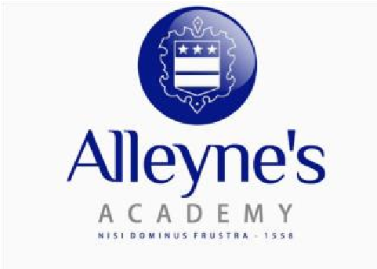

PUPIL SUPPORT ASSISTANT (MEDICAL NEEDS) (Grade 8)

Statement of Purpose

To help students to develop their basic skills and overcome barriers to academic progress.

Support to Students

- To assist in the identification of those students who would benefit most from help with basic skills or academic intervention and, working with others or independently, draw up and implement an action plan for each student or small group of students who need particular support.
- To support students with special educational needs, both within and outside the classroom.
- To develop an effective relationship with students needing particular support aimed at achieving the goals defined in the action plan.
- To maintain regular contact with families/carers of students in need of extra support, to keep them informed of the student's needs and progress.
- To assist students with physical needs, i.e. lifting, toileting, etc.
- Monitor homework and coursework completion for selected students.
- To contribute to the provision of special programmes for identified students, such as one-to-one support, numeracy/literacy programme, coaching/mentoring, etc.
- To be responsible, under the oversight of the SENCo, for drawing up the Individual Learning Passports for identified students as required.

Support to Strategic Management

- To liaise with the senior leadership team and the SENCo regarding best practice for helping students with underdeveloped basic skills.
- To liaise with the teaching staff regarding best practice for helping students who are underachieving in identified areas of study.

Support on First Aid / Medical Needs

- In accordance with the agreed Care Plan, attend to a student’s specific medical needs, including the administration of medication when required.
- Participate in the comprehensive on-going medical assessment of a student, including during the school lunch break, to determine when the child is in need of particular medical help, including close observation of general wellbeing, monitoring blood glucose levels at specific times and checking for ketones as/when required, all as defined within the agreed Care Plan.
- Respond appropriately to the findings of the comprehensive ongoing medical assessment, including administering medication when required, as outlined in the agreed Care Plan.
- Develop and maintain effective and supportive contact with parents, exchanging information and liaising with them as required before, during and at the end of the school day.
- Be responsible for keeping and updating accurate medical records as outlined in the individual
Care Plan.
- Be responsible for supplying / sharing medical records with appropriate external agencies as required.
- Promote a supportive, inclusive environment for students with additional needs.
- Communicate effectively with students with additional needs, providing reassurance and support in times of distress as and when required.
- Attend the necessary medical training required to support a student’s specific medical needs.
- Participate on the first aid rota, as required.

Support to School (this list is not exhaustive and should reflect the ethos of the school)

- Promote and safeguard the welfare of students and young persons you are responsible for or come into contact with.
- Comply with policies and procedures relating to child protection, health, safety and security, confidentiality and data protection, reporting all concerns to an appropriate person.
- Be aware of, support and ensure equal opportunities for all.
- Contribute to the overall ethos/work/aims of the school.
- Attend and participate in meetings as required.
- Participate in training and other learning activities and performance development as required.
- Recognise own strengths and areas of expertise and use these to advise and support others.

Person Specification
Pupil Support Assistant
(Medical Needs)

Essential Criteria | Measured By
Experience  • Experience of working in an education setting to support the learning of students.  • Experience of working with students with Special Educational Needs.  - Experience of working with students demonstrating challenging behaviour or dealing with disadvantaged circumstances.  - Experience of assisting students with physical requirements. | AF/I
Qualifications/Training  • NVQ Level 3 or equivalent in relevant area. | I
Knowledge/Skills  - Strong numeracy and literacy skills.  - Ability to manage own workload and work on own initiative.  - Ability to work constructively as part of a team.  - Excellent interpersonal skills.  - Good ICT and record keeping skills.  - Ability to communicate effectively both orally and in writing.  - Good organising, planning and prioritising skills.  - Methodical with a good attention to detail.  - Ability to relate well to students and to adults.  - Excellent communication skills. | AF/I
Behavioural Attributes  - Identifies and promotes best practice and encourage the sharing of ideas.  - Understands the school’s development plan and how it relates to team and individual objectives.  - Proactively seeks opportunities to increase job knowledge and understanding  - Requires minimum supervision  - Identifies and overcomes barriers and manage risks  - Demonstrates focused implementation of role and responsibilities  - Is accountable for own development.  - Works with others to resolve differences of opinion and resolve conflict. | AF/I

AF - Application form I - Interview

Note 1:
In addition to the ability to perform the duties of the post, issues relating to safeguarding and promoting the welfare of students will need to be demonstrated these will include:

- Motivation to work with students and young people.
- Ability to form and maintain appropriate relationships and personal boundaries with students and young people.
- Emotional resilience in working with challenging behaviours and
- Attitudes to use of authority and maintaining discipline.

