CURRICULUM LEADER

OF RELIGIOUS EDUCATION

1



Dear Candidate,

Thank you for showing interest in our school.

At McAuley there is a pattern. Staff join us and stay! It’s not just about the great pupils, or the 2.15pm finish. It’s the staff first approach which ensures we care and support staff like few other schools do.

We are looking for someone with BIG ideas! If you have a passion for Religious Education and have a compelling vision to further developing this important curriculum area, then we want to hear from you.

If successful, you will be joining McAuley, the biggest school in Doncaster and the biggest Catholic school in Hallam Diocese at a very exciting time.

As Head, I am committed to staff welfare and well- being and see my role as removing those obstacles that prevent staff being brilliant.

We have a well-developed Staff First Policy. We’re committed to bringing the very best people to work at McAuley to join a community of Learners committed to the values and vision of the school and dedicated to making a difference to the children we teach.

If you want to be part of something genuinely unique then we want to hear from you.

Informal discussions are positively welcomed by emailing [jtucker@mcauley.org.uk](mailto:jtucker@mcauley.org.uk)

James Tucker

Headteacher

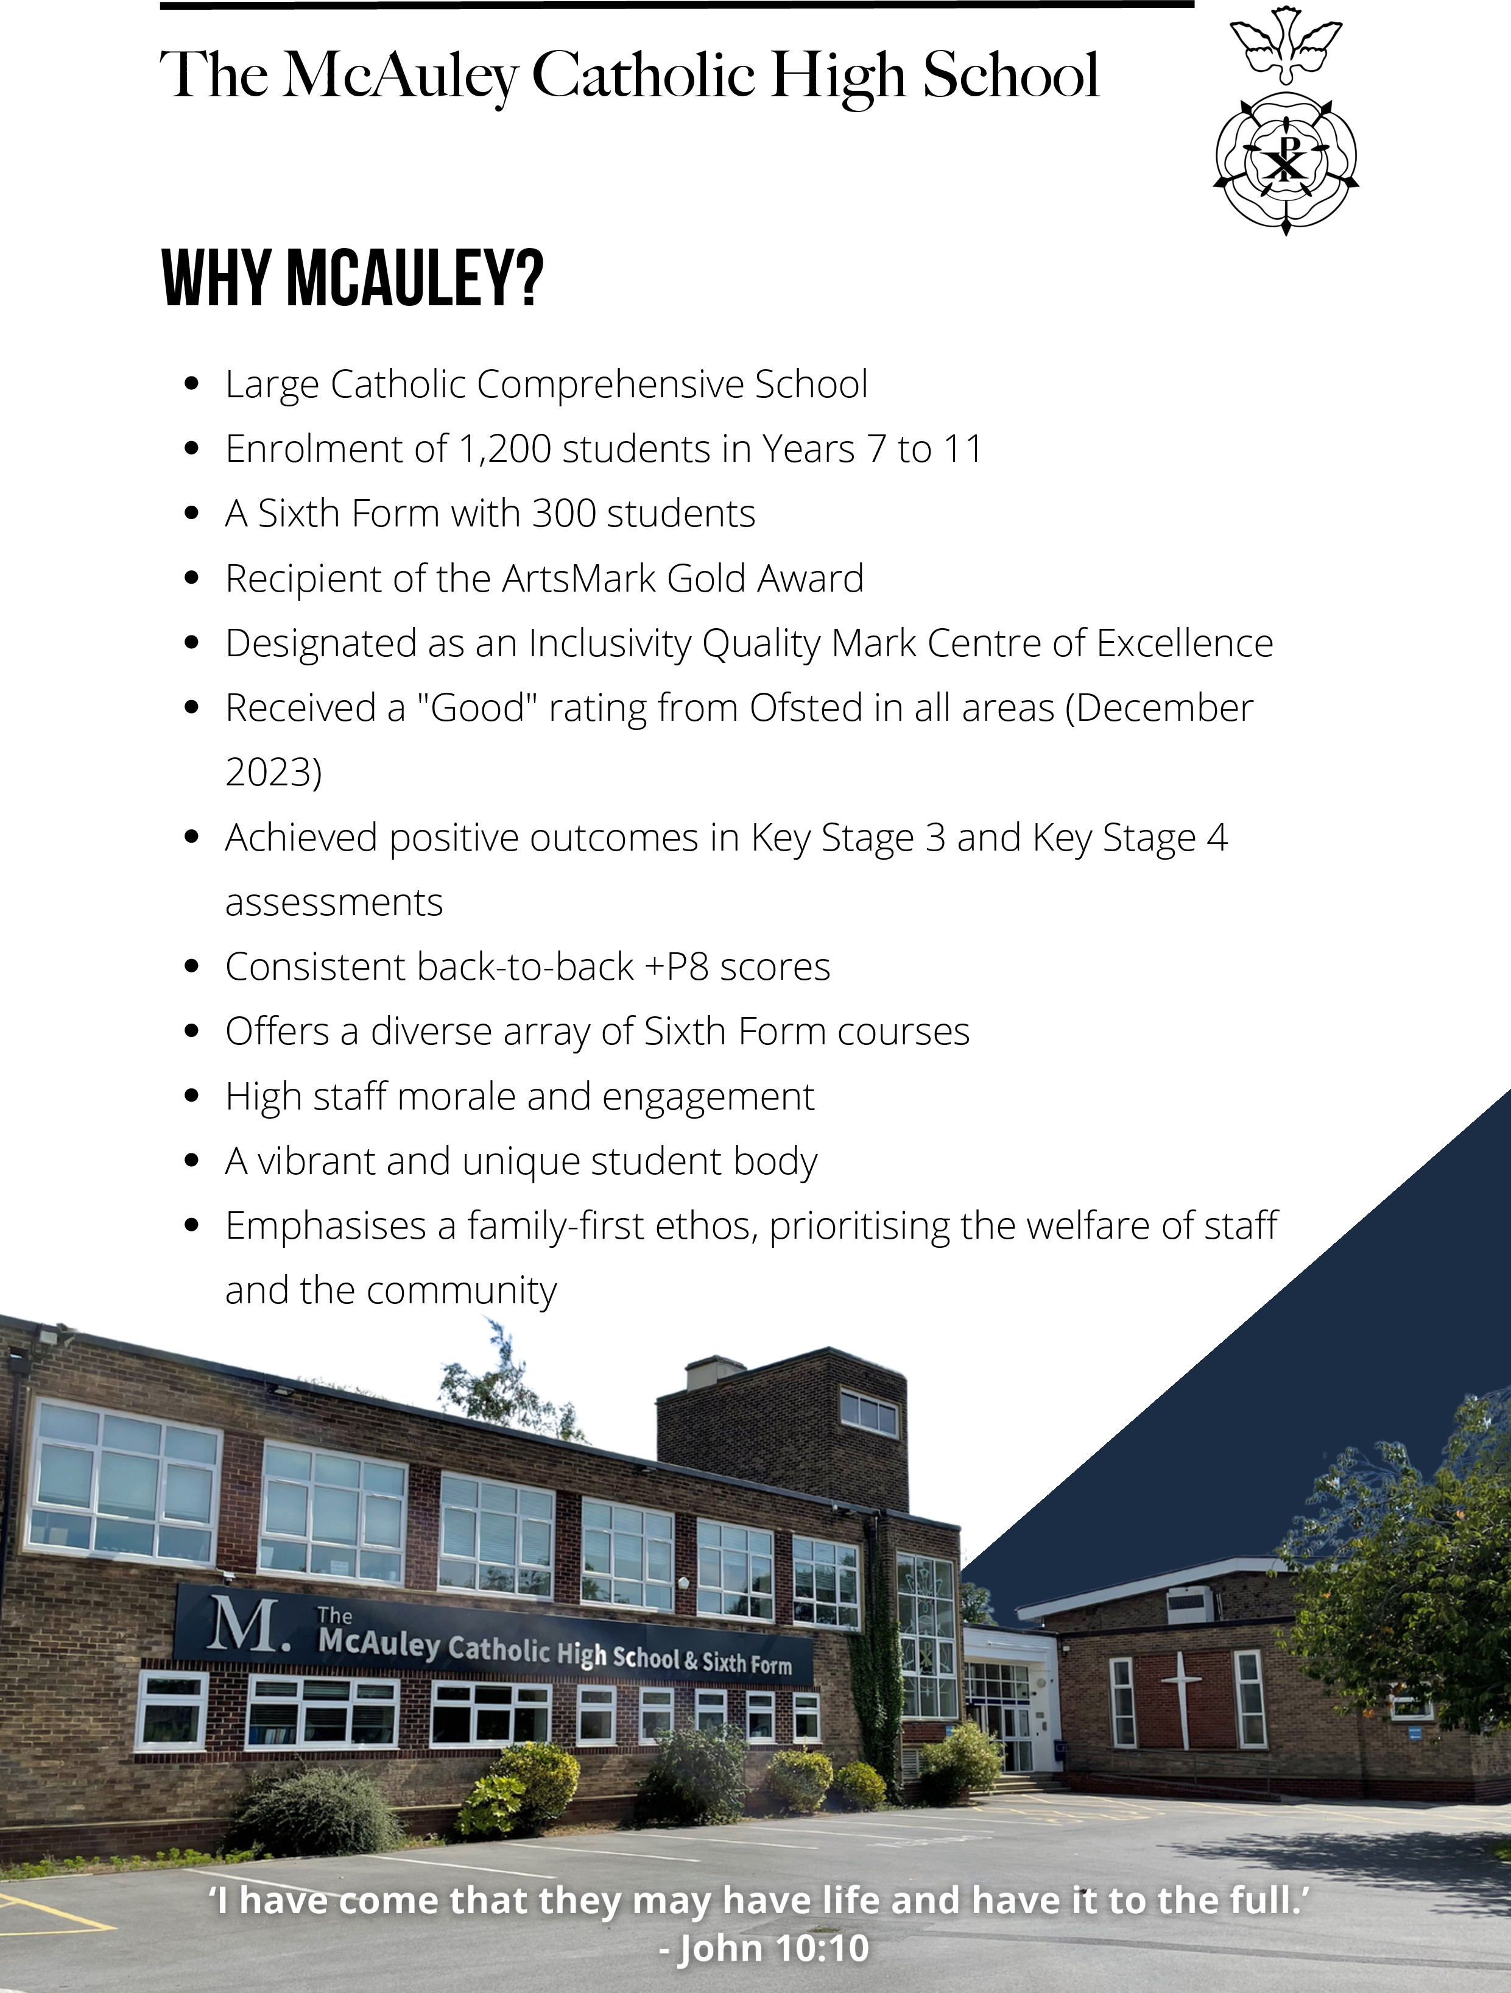

Religious Education at McAuley

The successful candidate will lead a supportive and welcoming Religious Education team who strive to deliver exceptional quality and engaging RE to our young people. As a Catholic school, RE is at the heart of our curriculum, as a core subject every student studies RE at GCSE and the number of students wishing to study philosophy and ethics is increasing. We are currently a department of 8 specialists who work collaboratively to support each other but also to ensure that pupils receive a positive experience of Religious Education.

As KS3 we study a broad, balanced and bespoke curriculum which challenges our students to think critically and work independently. The KS3 curriculum is rooted within SOLO taxonomy resulting in skills and knowledge acquisition, which prepares our students for the study of Religious Education at GCSE. At KS4 we study the Eduqas Route B specification which is a predominantly Catholic Theology specification. The course helps our students to develop knowledge and understanding of religious beliefs and practices, challenging students to reflect on their own values and beliefs and understand the impact of faith on the lives of all people. As part of this course we study Judaism which encourages students to develop empathy and tolerance for other faiths and traditions.

At KS5 we study the OCR Religious Studies course which develops a greater understanding of religious beliefs and teachings as well as the disciplines of ethics and philosophy of religion. Many of our students go on to study theology at degree level and some of them have become RE teachers themselves. All of our sixth form students study Core RE for 1 hour per week, this course written by the RE team, aims to widen their study of religion, philosophy and ethics, it encourages our students to think critically and develop skills of analysis and evaluation.

The department is an active contributor to the liturgical life of the school, providing support to our lay chaplain and encouraging students to become involved in all aspects of our faith community.

If you have any further questions about the RE department at McAuley then please do not hesitate to get in touch.

Please complete the application form and include a statement limited to two sides outlining how you meet those areas in the person specification highlighted in BOLD

**JOB DESCRIPTION FOR CURRICULUM LEADER**

Overview:

The school was founded by and is part of the Catholic Church. It is one of the formal mechanisms through which the Church’s educative mission is fulfilled and is to be conducted as a Catholic School in accordance with the canon law and teachings of the Roman Catholic Church, and in accordance with the Trust Deed of the Diocese of Hallam. The Head Teacher is the school’s leading professional.

Purpose:

The prime purpose of this role is to support the HEADTEACHER by:

Providing Departmental Leadership and Management.

Helping develop the school as a catechetical community.

Ensuring there are high standards of learning and achievement in a search for truth and freedom for the greater glory of God and benefit of all humanity.

Ensuring that at all times the activities for which you are responsible serve as a witness to the Catholic faith.

The general duties and responsibilities of the role are:

To carry out the statutory secular tasks laid down in the current School Teachers’ Pay and Conditions of Service Document in the light of procedures, policies and guidelines adopted by the Governing Body.

To contribute to the Catholic and liturgical life of the school community.

## **Purpose:**

To be accountable for the leading, managing and developing the Department.

To raise standards of student attainment and achievement within the whole Department and to monitor and support student progress

To be accountable for student progress and development To develop and enhance the teaching practice of others

To ensure the provision of an appropriately broad, balanced, relevant and differentiated curriculum for students studying in the Department, in accordance with the aims of the school and the curricular policies determined by the Governing body and the head teacher of the school.

To effectively manage and deploy teaching/support staff, financial and physical resources within the Department to support the designated curriculum portfolio.

**Reporting to:** SLT Members under SLT structure including line management **Responsible for:** teaching staff and other relevant personnel within the Department. **Liaising with:** Headteacher and SLT, Other Curriculum Leaders, Achievement Leaders,

SENCO and relevant staff with cross responsibilities, relevant non-teaching support staff, LA staff and parents.

**Working Time:** 195 days per year, full-time. **Disclosure Level:** Enhanced DBS **Communications**

To ensure that all members of the Department are familiar with its aims and objectives

To ensure effective communication/consultation as appropriate with the parents of students

To liaise with partner schools, higher education, industry, Examination Boards, Awarding Bodies and other relevant external bodies

To represent the Department’s views and interest

**Marketing and Liaison:**

To contribute to the school’s liaison and marketing activities e.g. the collection of material for press releases.

To lead the development of effective subject links with partner schools and the community, attendance where necessary at liaison events in partner schools and the effective promotion of subjects at Open Days/Evenings and other events.

To actively promote the development of effective subject links with external agencies.

Management of Resources:

To manage the available resources of space, staff, money and equipment efficiently within the limits, guidelines and procedures laid down, including deploying the subject budget, acting as a cost centre holder, requisitioning, organising and maintaining equipment and stock and keeping appropriate records

To work with the Assistant Headteacher timetabler in order to ensure that the Department’s teaching commitments are effectively and efficiently timetabled and roomed.

**Pastoral System:**

To monitor and support the overall progress and development of students within the Department

To monitor student attendance together with students’ progress and performance in relation to targets set for each individual, ensuring that follow-up procedures are adhered to and that appropriate action is taken where necessary

To act as a Form Tutor and to carry out the duties associated with that role as outlined in the generic job description

To ensure the Behaviour Management system is implemented in the Department so that effective learning can take place.

**Teaching:**

To undertake an appropriate programme of teaching in accordance with the duties of a standard scale teacher.

**Additional Duties:**

To play a full part in the Catholic life of the school community, to support its distinctive mission and ethos and to encourage and ensure staff and students to follow this example.

# Other Specific Duties:

To contribute to S48 self evaluation

To continue personal development as agreed. To engage actively in the Appraisal process.

To undertake any other duty as specified by School Teacher’s Pay and Conditions Document not mentioned in the above.

Whilst every effort has been made to explain the main duties and responsibilities of the post, each individual task undertaken may not be identified.

Employees will be expected to comply with any reasonable request from a manager to undertake work of a similar level that is not specified in this job description.

Employees are expected to be courteous to colleagues and provide a welcoming environment to visitors and telephone callers.

**PERSON SPECIFICATION: Curriculum Leader of RELIGIOUS EDUCATION**

|  |  |  |
| --- | --- | --- |
|  | **ESSENTIAL** | **DESIRABLE** |
| Education, Qualifications & Training | * Degree * Qualified Teacher Status | * Evidence of commitment to own continuing professional   development |
| Knowledge & Experience | * Leadership experience * Experience of teaching pupils of all abilities and aptitudes * Clear understanding of the use of assessment and data to support teaching and learning and the tracking of pupil * Experience of developing new resources for teaching * **Experience of managing/contributing to a successful section 48 inspection** | * Experience of teaching at KS5 * **Experience of contributing to**   **Liturgies** |
| Personal Skills and Abilities | * Excellent teacher * Evidence of developing teaching and learning * Evidence of using data effectively * Evidence of managing workload and maintaining effective working relationships * Demonstrate excellent interpersonal, oral and written communication skills * Evidence of the use of ICT both in the curriculum and for administrative purposes * Be passionate about teaching, in   particular in your subject area. |  |
| Other Requirements | * Practising Catholic * A commitment to safeguarding and promoting the welfare of children & young people * A commitment to and ability to implement the principles of equal opportunities and inclusion * **An understanding of the distinctive nature of Catholic Education and a willingness to lead and support our**   **school ethos** |  |



**Working at McAuley. What’s in it for you?**

Our ‘staff first’ policy means that we invest in our people. Our staff tell us what they value.

* Wellbeing time – this is time off for all staff up to one day a year to engage in wellbeing or family occasions that would not normally be covered under the leave of absence policy
* Wellbeing CPD for all staff – from the McAuley Minds working group, through to staff wellbeing sessions, we encourage all colleagues to participate in the programmes that we offer this could be learning how to make a curry through to menopause awareness, crafting, darts. There is something for everyone even reminding people how to laugh!
* Staff Wellbeing suggestion boxes – these are regularly emptied!
* Staff Wellbeing surveys – regular surveys allow us to see how we are doing and what we need to change stop doing or consider.
* Membership of Westfield Health – the school pays for level one of a cash policy so you can claim for optical, dental and other therapies such as physio and chiropractic appointments. In addition, you will have access to Doctor Line which offers our staff general appointments with a private GP when you are unable to see your own doctor at short notice.
* Employee assistance programme – from practical legal support through to face-to-face counselling, the 24 hour counselling and advice line offers our staff access to a range of issues such as mental health, physical health, financial health and debt management, trauma, parental support and relationship support any time of the day or night 365 days a year.
* Westfield Rewards – being a member of Westfield Health also gives you access to a range cash back or percentage discounts off high street retailers and supermarkets when you shop online or reloadable auto top up vouchers for your weekly shop helping you budget and save with a large range of retailers.
* Working Day – The timing of our school day, means a 2.15pm finish for students and means that staff have a significant part of the afternoon to do what they want to do, whether that is pick your own children up from school, engage in some form of exercise or go to that appointment you have been putting off. It gives staff extra flexibility to manage that work life balance.
* Email protocol – Our email policy takes the pressure off receiving emails at unacceptable times. We do not expect you to receive or send emails outside of your working day and we have an email embargo in between the hours of 7pm to 7am and weekends. Our policy is to speak to each other!
* Leave of absence policy – We know that there are times when we need to have time off work for whether that is because of an emergency or if you are taking your driving test. Our generous leave of absence policy allows you to request an absence during the school day when you find it is not possible to manage outside of working hours. Depending on your request, this will be either paid or unpaid, however we will always try and support your work life balance by doing what we can to give you that time. If we can’t, we will explain why.