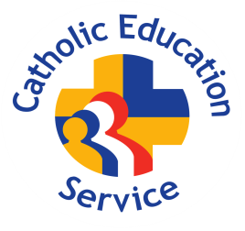
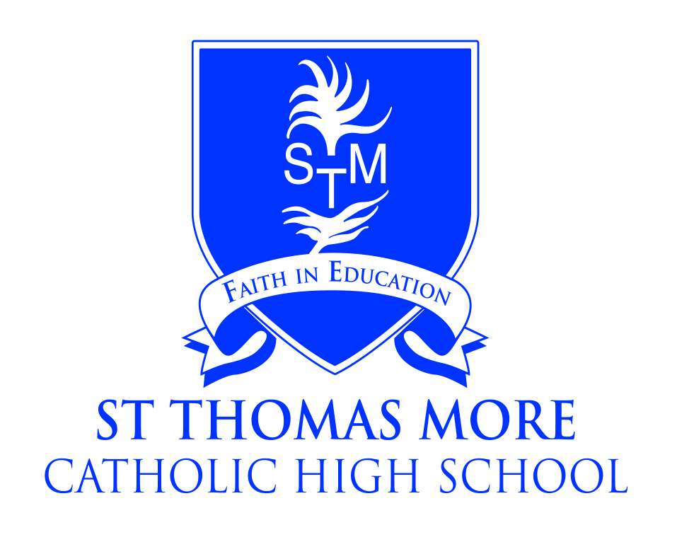

St Thomas More Catholic High School, Crewe
A Catholic Voluntary Academy

Teacher of RE
Full Time Maternity Cover

Salary: Teachers Pay Scale
Required: April 2025

The Governors of St Thomas More Catholic High School are seeking to appoint a good honours graduate to teach RE to the full ability range in Years 7-11.

The RE Department at St Thomas More Catholic High School is an outstanding Department which achieves excellent results. This is an exciting opportunity for an inspiring teacher to contribute further to an already successful team and build on the high standards and encourage students across the age and ability range.

We are a friendly and caring community placing the academic progress and welfare of our students at the heart of everything we do.

Applications from newly-qualified and experienced teachers are welcomed.

Further details and recruitment documents are available from the school website:
www.st-thomasmore.cheshire.sch.uk

or by e-mailing:
recruitment@st-thomasmore.cheshire.sch.uk

Closing date: Friday 24th January 2025 at 12pm

Please send completed applications to recruitment@st-thomasmore.cheshire.sch.uk
Please do not apply online or download Cheshire East’s Application Form.

The academy is committed to safeguarding children and successful candidates will be subject to an Enhanced DBS check. Our commitment to safeguarding is underpinned by robust processes and checks which are in place.

