Reception Teacher/Early Years Leader
MPS/UPS TLR2a
0.67 FTE to be worked over 3 days Weds - Friday

From January 2022

Information for Candidate

Birmingham Lane

Meltham

Holmfirth

HD9 5LH

Tel: 01484 859032

With Compliments

Liz Woodfield
Headteacher

Please note that this vacancy is being advertised with a quick turnaround to meet the 31 October resignation date.
- Completed forms should be handed in at the school or emailed to office@melthammoor.org by 9.30am on the Wednesday 20th October 2021.
- A CV is not required.
- Shortlisting will take place on Wednesday 20th October 2021 (will be notified by noon Thursday if successful)
- Observations and interviews will be held on Friday 22nd October 2021

MELTHAM MOOR PRIMARY SCHOOL

Birmingham Lane, Meltham, Holmfirth. HD9 5LH

Head Teacher – Liz Woodfield
Tel: 01484 859032
e-mail: office@melthammoor.org
website: www.melthammoor.org

October 2021

Dear Applicant,
Thank you for your interest in the post on offer at our school. We hope this information pack containing details of the position and the school is helpful.
To assist you in making a successful application, the points below are given for your guidance:
- A supporting letter should address all criteria in the Personnel Specification.
- This letter should be no more than two sides of A4 using Arial font no less than size 11
- Completed forms should be handed in at the school or emailed to office@melthammoor.org by 9.30am on the Wednesday 20th October 2021.
- A CV is not required.
- Shortlisting will take place on Wednesday 20th October 2021 (will be notified by noon Thursday if successful)
- Observations and interviews will be held on Friday 22nd October 2021.
- Please mention to your referees that references for shortlisted candidates will be requested at short notice and will be required before interview.

Yours sincerely,

Liz Woodfield
Headteacher

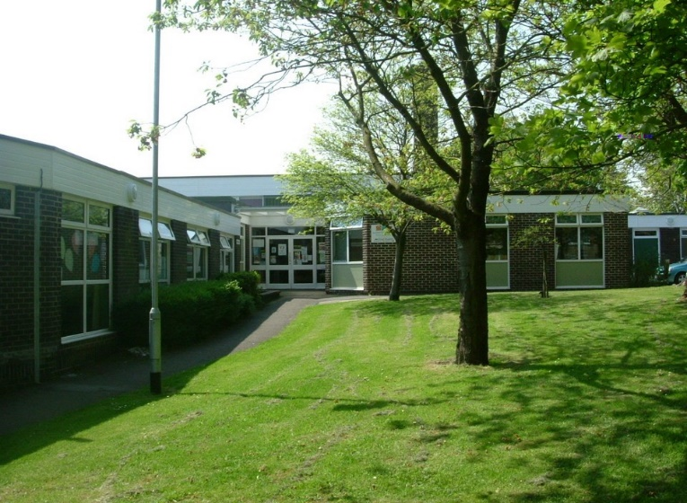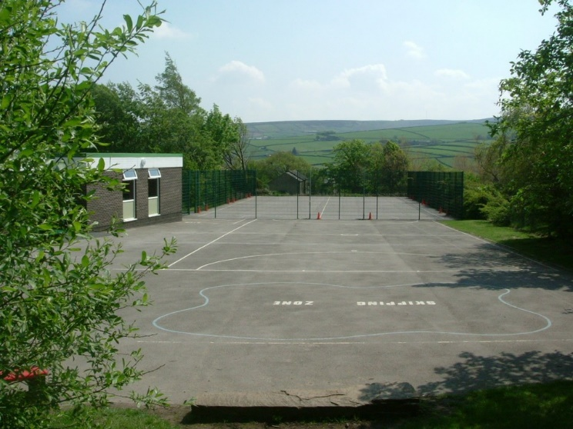

Meltham Moor is a through primary school set in beautiful surroundings on the edge of the Peak District National Park. We have approximately 220 children in classes ranging from Nursery to Y6.
Our school vision statement is clear:
‘At Meltham Moor we will endeavour to ensure that every child can achieve their best personally, socially and academically’.
Our values are:
Aspiration - encouraging everyone to be the best that they can be.
Confidence - being prepared to take risks, without fear of failure, and developing self-esteem from recognising achievements.
Resilience - being able to bounce back and try again.
Compassion - being friendly, caring, well-mannered and behaving appropriately, supporting and respecting each other.
A love of learning.

Trustees, Governors and staff believe that children work better and learn more effectively in an atmosphere of friendliness but within a framework of good order which engenders good behaviour. Emphasis is placed upon the establishment of good relationships between staff and children and between home and school.

In September 2019, Meltham Moor entered the newly formed Together Learning Trust. Being part of the Together Learning Trust will enable our schools to continue to flourish and develop within a supportive school focused community, where the expertise of those who have a hands on understanding of our children will lead the way forward.

At Meltham Moor we aim for children to develop awareness of responsibilities towards themselves, others and their environment. The children are actively encouraged to make positive contributions to their own education, school and community in general. We are a happy, positive school and we look forward to a productive time and successful future. We believe strongly in the partnership between home and school and want families to be actively involved in supporting children's learning and the school.

Applications are invited for the post of:

Reception Teacher/Early Years Leader
MPS/UPS TLR2a pro rata
0.67 FTE to be worked over 3 days Currently Wednesday – Friday (this may change with the needs of the school)

Required from the beginning of the Spring term, a motivated and driven candidate, who can in turn inspire and support others in developing their practice.
We are seeking to appoint an effective, creative classroom teacher with the experience, vision, commitment and enthusiasm to lead our Early years team. If you could be this inspirational individual, we would like you to join our successful team.
We can offer:
- Happy, enthusiastic children who are eager to learn.
- Friendly and supportive staff, governors, trustees and parents.
- A highly committed team that embraces change.
- Exciting opportunities to work with colleagues across the Together Learning Trust.
- A strong local partnership of schools
- outstanding resources and facilities.
- An outstanding working environment.
- Excellent professional development opportunities.
- Leadership time as required
In return, we are looking for candidates who are:
- Outstanding classroom practitioners with high expectations.
- Committed to raising standards by being passionate about enabling every child to fulfil their potential.
- Willing to be fully involved in the life of the school.
- Excellent at building good working relationships with children, parents, staff and governors.
- Knowledgeable and experienced in delivering the Early Years Curriculum.
- Interested in professional development and progression
- Passionate about leading the Early Years team in the delivery of the Creative Curriculum.
- Willing and able to be responsible for Early Years pupils’ pastoral and academic welfare.
- Ready to be a member of the School Leadership Team and make a significant contribution to the strategic development and direction of the school.
We are committed to safeguarding and promoting the welfare of children and young people and expect all staff and volunteers to share this commitment. All staff are subject to an enhanced DBS check. A conviction may not exclude candidates from appointment but will be considered as part of the recruitment process.

If you require further information about the role, please contact the school on telephone 01484 859032 or you can visit the school website at www.melthammoor.org

Completed application forms must be returned by 9.30am Wednesday 20th October 2021. Shortlisted candidates will be notified by noon Thursday 21st October, Interviews will take place Friday 22nd October

We are committed to safeguarding and promoting the welfare of children and young people and expect all staff and volunteers to share this commitment. All staff are subject to an enhanced DBS check.

The appointment of a Teacher is subject to QTS status and the current conditions of employment for teachers contained in the School Teachers’ Pay and Conditions Document (STCPD) and other current legislation.

This job description may be amended at any time following discussion between the Headteacher and the member of staff and will be reviewed annually as part of the appraisal process.

This job description includes references to:

♣ The School Development Plan
♣ Professional Standards for Teachers
♣ Teacher Appraisal
♣ Ofsted’s School Inspection Framework

General description of the post

The holder of this post is expected to carry out the professional duties of a teacher as described below, as circumstances may require and in accordance with the school’s policies under the direction of the Headteacher. The post-holder is required to fully support the vision, ethos and policies of the school.

Values and behaviour

Teachers make the education of their pupils their first concern and are accountable for achieving the highest possible standards in work and conduct. Teachers act with honesty and integrity; have strong subject knowledge, keep their knowledge and skills as teachers up-to date and are self-critical; forge positive professional relationships; and work with parents in the best interests of their pupils.

Job Title: Reception Teacher/Early Years Leader
Scale: MPS/UPS plus TLR2a
Responsible to: The Headteacher and the Governing Body of the school

General duties as a Class Teacher
- Under the direction of the Headteacher, carry out the professional duties of a school teacher as set out in the current School Teachers’ Pay and Conditions Document (STPCD) and, as a class teacher,
• actively promote equality of opportunity within an inclusive and diverse classroom
• maintain an attractive, dynamic and emotionally safe learning environment
• work to inspire in all children a desire for success and a passion for learning
• deliver learning to meet the needs of all groups of learners
• manage behaviour with consistency and fairness in line with our school Behaviour Policy, to ensure a safe, ordered atmosphere for all • effect regular and efficient formative assessment to inform planning and learning ; using data to identify gaps in learning, to inform teaching and, therefore, to maximise pupils’ progress
• be a proactive member of a Curriculum Team, taking the lead in a subject to inform and monitor curriculum content, standards and resources
• show a willingness to be involved in the extra-curricular life of the school
• foster and maintain an efficient and productive relationship between home and school

- Undertake any tasks as reasonably required by the Headteacher.

- Specifically, in relation to the role of EYFS Leader to undertake the following responsibilities:
• provide vision, direction and leadership of Early Years
• ensure high quality early education that improves outcomes and narrows the gap between those children who are most vulnerable and the rest.
• monitor and evaluate the impact of policies, practices, etc in the EYFS, identifying developments needed and constantly seeking strategies for improvement; working in partnership with the early years team and senior leaders to achieve them
• ensure the successful development and implementation of high quality, developmentally appropriate, inclusive learning environments in the Nursery and Reception which promote a balance between learning through play, providing learning activities which will challenge and develop and preparedness children for Year 1.
• work in partnership with senior leaders in the cycle of school evaluation and development planning
• work with colleagues in external settings and in Year 1 to ensure high quality transitions between phases
• ensure the Early Years meets the criteria for a successful Ofsted inspection Teaching and Learning
• demonstrate consistently outstanding teaching skills, managing pupils and maintaining high standards of behaviour across the EYFS, and act as a role model for all staff
• lead the EYFS team in the development and delivery of a creative and stimulating EYFS curriculum
• lead the EYFS team in the development and maintenance of a stimulating teaching environment that ensures optimum use of time, space and facilities
• work with the EYFS team to ensure that the requirements of the EYFS are met, including arrangements for assessment and moderation Staffing
• be a role model for staff in all aspects of their work
• be prepared to challenge when necessary.
• support the leadership team of the school in the performance management of staff in the EYFS
• ensure that staff development needs are identified and that appropriate programmes are designed to meet such needs
• establish the process of the setting of targets within the EYFS
• manage the collection of data in the EYFS
• make use of data analysis; evaluate performance data and formulate strategies to address areas of concern
• attend and contribute to appropriate phase, senior leadership and governing body meetings
• develop and maintain links with LA and other external support services and other local EYFS settings
• ensure parents are well informed about the EYFS curriculum, attainment and progress and are fully engaged as partners in the EYFS

School Development Priorities
2021-2022

Focus | Aim
Quality of Education:  Implementation | Complete the development of all curriculum subject areas
 | Develop strategies to reduce cognitive load in order to improve outcomes for all (Cognitive Load Theory)
Quality of Education:  Impact | Improve outcomes in Phonics and Early Reading
 | Children catch-up from missed learning (including the bottom 20% and more able)
Behaviour and Attitudes | Excellent provision for SEMH learners
Personal Development | Introduce wellbeing warriors
Leadership and Management | Implement new quality assurance programme (GEL Framework)
 | Implement the Trust Development Programme
 | Develop subject leaders in their roles
Early Years | Plan and implement the new Early Years curriculum

Aims in blue are priorities from previous Ofsted inspection

Post Title: Reception class Teacher / Early Years Leader – Meltham Moor Primary School
A-Essential B- Desirable
 | Criteria | Rank | How Identified
Relevant Experience | Recent evidence of excellent teaching experience in Foundation Stage  Recent experience of planning, delivering and assessing the Early Years Foundation Stage (EYFS)  Recent experience of organising a high quality learning environment  Recent experience of using data to track pupil progress and manage intervention  Recent evidence of good liaison with parents and community  Recent experience of leading Early Years teams | A  A  A  A  A  B | Application Form  Interview  References
Education and Training | Qualified Teacher Status  Knowledge of current educational issues  Evidence of commitment to Continuing Professional Development  Recent relevant CPD particularly in relation to EYFS | A  A  A  B | Application Form
General and Special Knowledge and Skills | A clear philosophy of Early Years Education (3-8) and the ability to translate it into practice  Sound knowledge of Early Years Foundation Stage (EYFS) and KS1 education  Excellent classroom management, organisational and teaching skills  A knowledge of and ability to utilise a range of teaching styles  An understanding of language development and its impact on learning across the curriculum  Good working knowledge of ICT and its use across the curriculum  Understanding of the importance of involving parents in their children’s education  Knowledge of SEN Code of Practice and its implementation  Awareness of recent and forthcoming educational developments and their implications  Ability to work as part of an effective leadership team  Ability to influence the quality of teaching and learning  Ability to inspire, lead and motivate the children and staff in the pursuit of excellence  Ability to develop staff and manage their performance  Ability to analyse, understand and interpret Early Years Foundation Stage performance data | A  A  A  A  A  A  A  A  B  A  A  A  A  A | Application Form  Interview
Any Additional Factors | Enthusiastic, creative and committed approach to learning and teaching  Ability to manage support staff, students and volunteers effectively to maximise learning  Excellent communication and inter-personal skills  Commitment to working in partnership with parents, governors and the community  A positive and enthusiastic approach to children’s learning and development  Ability to implement strategies to promote positive behaviour  Willingness to contribute fully to the life of the school including the development of extra curricular activities  A positive approach to parental involvement in school and their children’s education  Ability to work positively with children and colleagues, be flexible and adaptable in accordance with school ethos  Have a positive approach to change | A  A  A  A  A  A  A  A  A  A | Application form  Interview  References
Please make sure that you demonstrate your ability to meet requirements of the job by giving clear, concise examples of how you meet each criterion on your application form. The letters A and B in the Rank column refer to the importance we will give your answers when we read your application. You must have all the A’s on day 1 to be able to do the job. If a large number of people apply for the post, we will only shortlist those who have the Bs as well as the As. We recognise and welcome our responsibility to remove any barriers in our Recruitment and Selection process for disabled people. We have tried to do this but if you have a disability and identify any barriers in the job description or employee specification, please tell us of these in your application. We are committed to making reasonable adjustments to the job wherever possible and it would help us to know your needs in order to do this.

