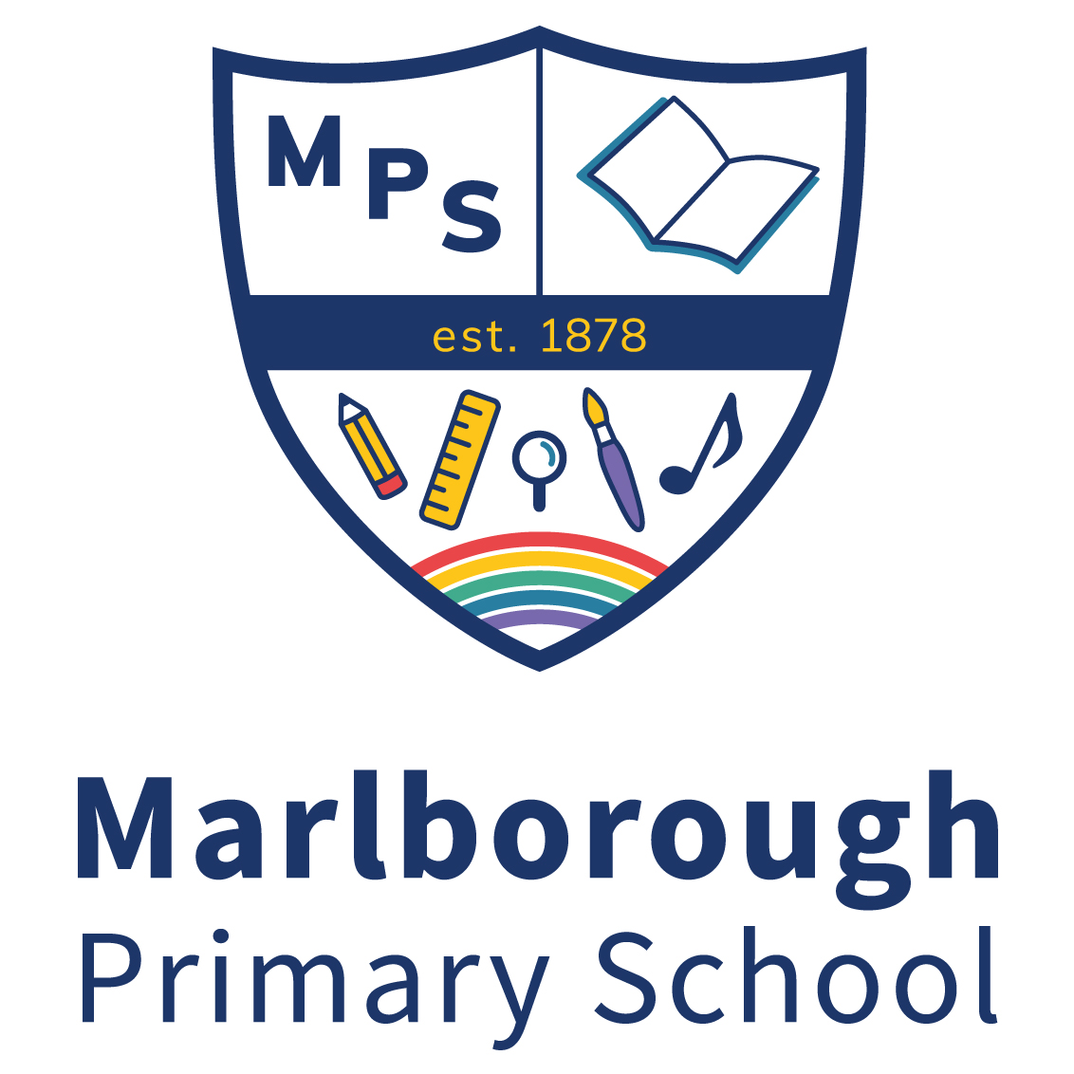

RECEPTION CLASS TEACHER FTE: 1.0
Required for September 2022
M1 – M6

Marlborough Primary School, is a ‘good’ school with the ambition to be ‘outstanding’. We are committed to providing a broad, balanced and exciting educational experience for all our children in order to promote their full academic and social development. We are seeking to appoint a Reception Class teacher to join our strong in-house team who also benefit working with colleagues in our partner school, Colville Primary. The post is initially for one year, but could lead to a permanent position. This post is not suitable for ECTs.
We are seeking to appoint a teacher who:
- is ambitious and energetic
- can ensure high quality provision
- is committed to ensuring achievement for all through equal access, opportunity and aspiration for all children
- has excellent interpersonal skills and qualities that motivate children

We can offer you:
- a state of the art school building with amazing facilities for learning
- a supportive, collegiate and motivated in-house team
- high quality CPD with opportunities for career progression
- enthusiastic, friendly children with a love of learning
- an inclusive school with a ‘can do’ ethos where success is recognised
- strong and ambitious leadership with a clear sense of strategic direction
- an opportunity to innovate and take risks
- supportive parents and governors

Learn more about the school by visiting our website www.marlborough.rbkc.sch.uk or visiting our Twitter feed @marlboroughsw3. Visits to the school are encouraged.

Please email janet.wallace@marlborough.rbkc.sch.uk for an application pack.

Closing date: 20th May 2022 @ Noon
Interviews: 24th May 2022

We are committed to safeguarding and promoting the welfare of children. The successful candidate will undergo full DBS checks.

