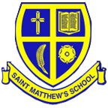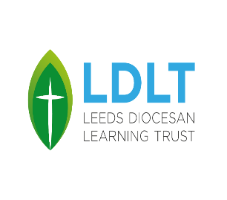St. Matthew’s CE Primary School

Wood Lane, Chapel Allerton

Leeds, LS7 3QF

**Tel**: 0113 2681489 **E-mail**: [headteacher@st-matthews.leeds.sch.uk](mailto:headteacher@st-matthews.leeds.sch.uk)

**Headteacher**: Miss Gemma Crawford **Chair of Governors**: Mr Nick Burrows

**Reception Class Teacher**

**MPS1 to UPS3 (£31,650 to £49,084)**

**Temporary – 1st September 2025 to 31st August 2026**

Required from September 2025, a teacher to join our large, friendly and successful multicultural church primary school. The school, governors and LDLT are looking for somebody who:

* is enthusiastic and hard working.
* is committed to high standards of attainment and behaviour.
* can work well with parents and families new to school.
* has a good understanding of how children learn.
* can inspire others.

We can offer:

* a friendly school with strong links to St. Matthew’s Church.
* hardworking, dedicated and supportive colleagues.
* a supportive governing body and leadership team.
* an eclectic and vibrant school population.
* a commitment to your professional development.

The successful candidates will be expected to support the Christian ethos of the school.

Potential applicants are welcome to visit the school by prior arrangement.

The successful candidate will be required to undertake an enhanced DBS check.  Our school is committed to safeguarding and promoting the welfare of children and expects all staff and volunteers to share this commitment. The successful candidate will be subject to a Disclosure and Barring Service (DBS) check.

We promote diversity and want a workforce which reflects the population of Leeds.

Closing Date for Applications: Thursday 15th May 2025 at 12 noon

Shortlisting: Thursday 15th May 2025

Interviews: Tuesday 20th May 2025

Tours of the school can be arranged by contacting:

headteacher @ stmatthewsleeds.co.uk

or alternatively calling the school office on 0113 268 1489.