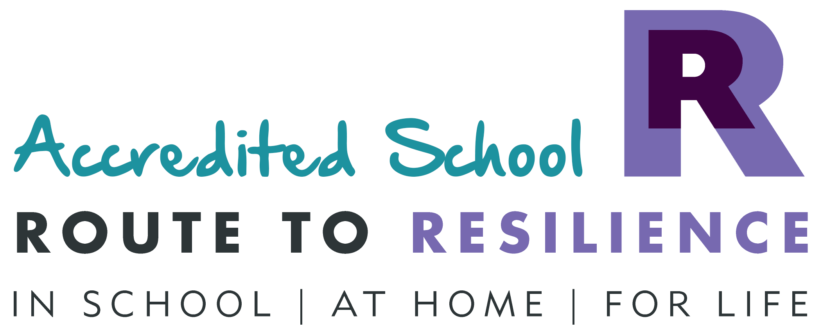
Thank you for showing an interest in joining our team. Following the promotion of the existing post holder within the Trust we are looking to recruit an exceptional teacher to join our EYFS team.

Our school was rated “Good” by OFSTED in January 2020 and graded “Excellent” by SIAMS in March 2019. We are very proud of the incredible education that our children receive and staff work hard to make this a great school to attend.

Our school is a founding member of the Inspiring Primaries Academy Trust. Working in close partnership with the other 8 schools in the trust has enabled us to widen opportunities for pupils and staff. The trust offers fantastic professional development and active network groups enable professionals to hone their practice and ensure that staff in all phases do not feel isolated.

Over the past few years staff have collaborated to develop an exciting and relevant knowledge rich curriculum. An important focus has been embedding a new phonics scheme to ensure that every child becomes a competent reader enabling them to discover more about the world in which they live. It is essential that the successful candidate has an unwavering belief that every child can become a proficient reader.

Our vision as a church school is to Strive for excellence in everything we do, working under God’s guidance and endeavouring to enable all to flourish, bear fruit and live well together. There is a very special atmosphere at Gilmorton School making it a great place to learn and work. The community values the school; parents are involved and supportive in developing well rounded children ready to take on any challenge. Many opportunities are provided for all members of the school community to come together to learn and make a difference.

I would encourage potential candidates to arrange to visit the school to experience the school ethos in action. I will be very happy to talk to you if you are interested in this post or have any questions.

Yours sincerely,

Adam Watson
Executive Principal

