Together we aspire, learn and grow
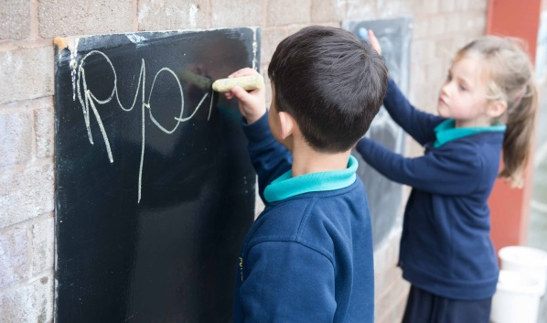
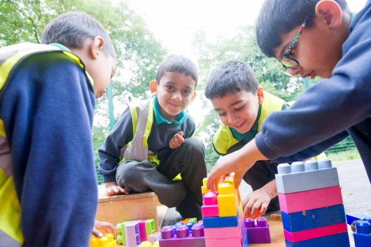
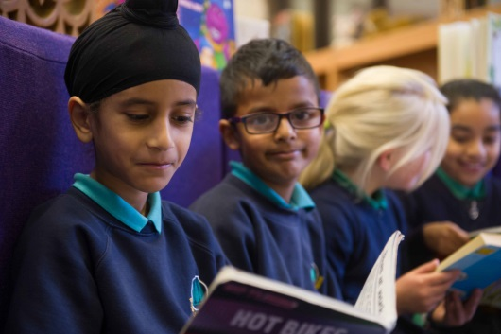

RECEPTION TEACHER – SEPTEMBER 21 (MATERNITY COVER)
MAIN PAYSCALE
Poplars Farm Primary School is a friendly, inclusive and outward facing primary school in Bradford, West Yorkshire. We require a teacher with vision, commitment and a positive outlook, who is committed to deliver the best outcomes for children and embed the good practices recognised in our latest Ofsted inspection.
At Poplars Farm, we strive to create a safe, creative and inspiring learning environment, where each pupil develops a genuine love of learning and an enquiring mind. We place a strong importance on the development of every pupil's personal and social awareness.
Embedded in our values system (GROW) are local and global perspectives; we provide our pupils with the necessary guidance and support so that they see themselves as unique individuals who celebrate diversity and develop as responsible citizens.
If you think this is the opportunity you have been looking for, you are warmly invited to visit the school. Please contact the school to arrange a convenient time.
For more information and to apply, please download the documents attached below.
Completed application forms should be returned to Mrs Tracey Simpson, School Business Manager – tsimpson@poplarsfarm.bradford.sch.uk

Reception Teacher for a maternity cover to start September 2021
The Governors of Poplars Farm Primary School are looking to appoint an experienced, enthusiastic, hardworking and motivational full time Reception Teacher, to start September 2021 for a maternity cover. We would welcome applications from practitioners who have high expectations for all children and believe in teaching and delivering a stimulating and creative curriculum.
The successful candidate will be a highly motivated person who will:
- Have a track record of high quality teaching and have the ability to make an impact on standards
- Will be an imaginative, creative and enthusiastic practitioner
- Understand how to inspire and engage children in their learning
- Be a team player, with an ability to motivate and support all members of the school community
- Have an understanding of child development and phonics
- Make a full contribution to the broader life of the school
In return, we can offer the successful candidate:
- The opportunity to receive the support of an experienced Senior Leadership team
- An excellent learning environment with motivated and happy children who have a genuine love of learning
- A school that seeks to offer children every opportunity to develop and express their individual talents
- A team of friendly, supportive and dedicated colleagues
- A school strongly committed to professional and career development
We promote diversity and want a workforce that reflects the population of Bradford. Our school is committed to safeguarding and promoting the wellbeing of all children, and expects our staff and volunteers to share this commitment. All posts are subject to a DBS check.
Deadline for Applications: Wednesday 30 June 2021 (12pm)
Shortlisting: Wednesday 30 June 2021
Interviews: Thursday 8 July 2021
We warmly welcome visits to the school, arrangements for visits can be made through the school office (01274 307490). We look forward to meeting you.

