St. Alban’s Catholic Primary School 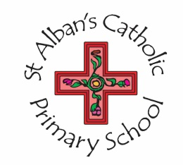
Reception Class Teacher Person Specification

What follows is a summary of the training, qualifications and experience, as well as the knowledge, understanding and qualities that the successful candidate will be expected to possess.

(Please note: Candidates failing to demonstrate all of the below essential criteria will automatically be excluded from consideration)

Criteria: | Essential or Desirable
Qualified Teacher status | E
Knowledge and understanding of the distinctive nature of a Catholic School | E
An ability to actively support and promote spirituality and the school’s Catholic aims positively. | E
Teaching experience in EYFS | E
Knowledge and understanding of the monitoring, assessment, recording and reporting of pupils’ progress | E
Evidence of commitment to continuing professional development. | E
Knowledge and understanding of the statutory requirements of legislation concerning Equal Opportunities, Health & Safety, SEND and Child Protection. | E
Knowledge and understanding of the need to safeguard and promote the welfare of children. | E
Knowledge and understanding of effective teaching and learning strategies | E
An ability to apply a range of behaviour and classroom management techniques effectively. | E
An ability to develop good personal relationships within a team. | E
An ability to communicate effectively (both orally and in writing) to a variety of audiences. | E
An ability to create a happy, challenging and effective learning environment. | E
An ability to prioritise, plan and organise self and others working under your direction | E
An ability to prioritise, plan and organise self , whilst working under the direction of other staff | E
An ability to maintain and develop good relationships between home and school. | E
An ability to maintain and develop good relationships with Governors, Parish, local community, other schools, LA and other agencies. | E

